**CS 135 Module Notes**

**Module 1:**

Course Structure

* Self- study (for marks)
* Q and A with instructors
* Assignments (for marks)
* Exams (for marks)

The primary materials are slides with commentary and video.There is also a free, on-line textbook.

Marking Scheme

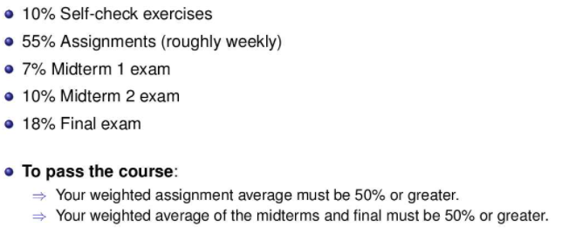

Self Check

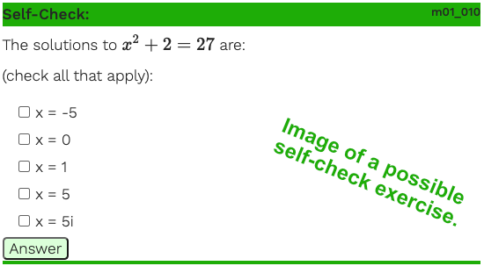

* Self-check exercises are usually “check all that apply” questions. For example, the previous question has two answers. You need to check both of them (and no others) for it to be considered correct.

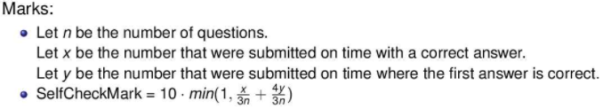

* Self Check Mark of full 10 marks can be attained if all answers correct and more than half of answers are correct on first try

Q and A

* Q and a for module 1: [here](https://online.cs.uwaterloo.ca/courses/course-v1:UW+CS135+2021_09/courseware/9d5ea8c75fc74ac4a3ff519c670dc774/fe039dae362c443c9631c4562d0671ad/3?activate_block_id=block-v1%3AUW%2BCS135%2B2021_09%2Btype%40vertical%2Bblock%402eb3fe03b823497c828b27cd0021ecc2)
* Post questions about the module’s content there
* If you specifically want your question taken up in Q&A, say so and indicate your section.

Assignments

* Open book
* Found on assignment section on edX
* Submitted to MarkUs
* You can (and should!) submit as soon as you have a partial result on one of the questions.
* We deduct 1% for each minute your assignment is late.
* You can submit an assignment as many times as you want before the due date
* We mark the most recent submission that occurs before the posted due date/time + 100 minutes.
* Review assignment on MarkUs
* Make sure to follow the style guide: [here](https://online.cs.uwaterloo.ca/assets/courseware/v1/83c513e7256f1eaca187f6417a19c3b2/asset-v1:UW+CS135+2021_09+type@asset+block/cs135_style_2021-09-09b.pdf)
* Make sure that you:

Do coding questions using DrRacket.

Use the exact filenames specified for assignment questions.

Use the Racket language level stated.

Check the Basic Test results.

Exam (online)

* Midterm 1 (oct 8)
* Midterm 2 (nov 12)
* Final (TBD)

**Module 2:**

What is computation

* A set of instructions to complete a particular task
* Most of these tasks will be mathiremical so they contain mathematical values
* Ex: finding the factors of 5218303 is too hard to do by hand. Thus we can create a function that will factor any number which requires computation
* Computation is the algorithmic thinking process that is applicable to all programming languages while programming is specific to a programming language

Programming Language Design

* Imperative: based on frequent changes to data
  + Ex: machine language, java, turing, python, c++
  + With variables, you have a box that contains 5, then we can change that box to have a new value of 6 by adding 1
* Functional: based on the computation of new values rather than transforming old ones
  + Ex: Racket, LISP, ML
  + You can have a box that has a value of 5, but instead changing the value of the box, we make a new box with value 6
  + Closely related to math

DrRacket Environment

* Two windows: definitions (top) and interactions (bottom)

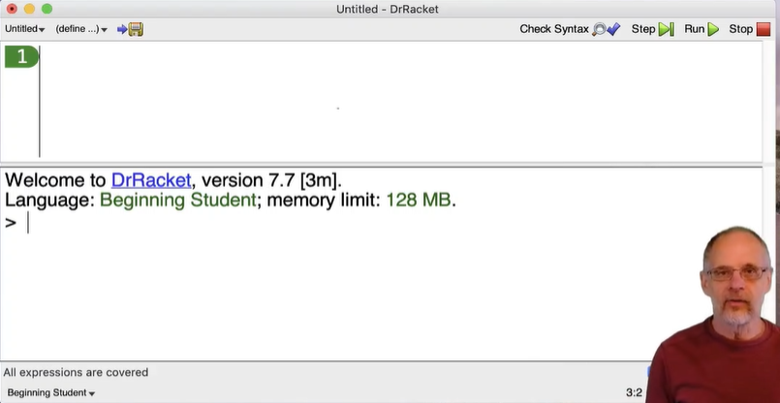

* The > sign means that DrRacket is able to accept an input
* 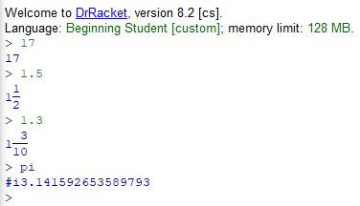
* When it gets an input, it reads it, processes it, then outputs it
* Notice pi prints #i to show that it is not an exact number as it cannot be expressed as a mixed fraction
* 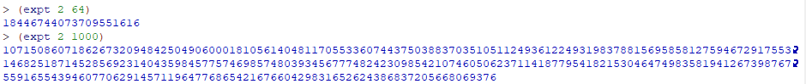
* Most programming languages have a max value of 2^64 while numbers in racket are unbounded (no max or min size) and it uses the same techniques of big or small numbers so it can easily compute 2^10000

Values, Expressions, and Functions

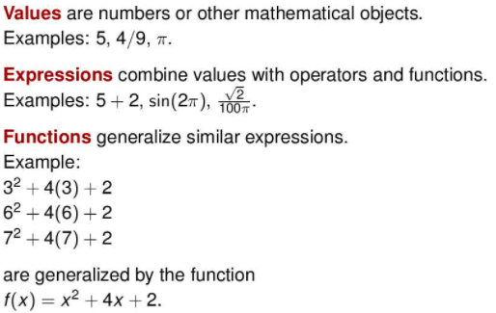

Values

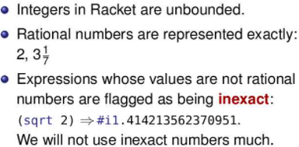

* While a calculator won't distinguish between rational and irrational numbers, racket does

Functions

* Ex: f(x) = 3x if we do f(1), 1 is the argument that corresponds to parameter x
* 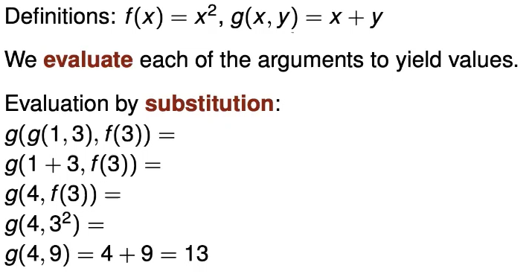
* However, the above has a problem.
* 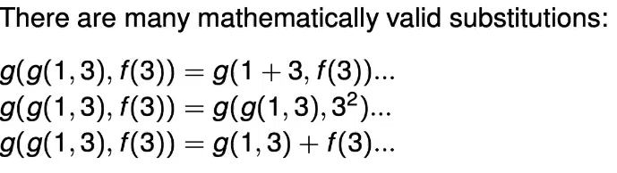
* Since all the different methods are mathematically valid to solve the nested functions, what method do we follow? We use canonical form.

Canonical form

* **Canonical form:** a natural unique representation of an object, or a preferred notation of some object
* Canonical form is effective since it’s easier to verify code as there is only 1 choice at each step. Also, while the subsitions we chose lead to the same answer in math, it might not in programming
* Thus we can follow the below rules
* 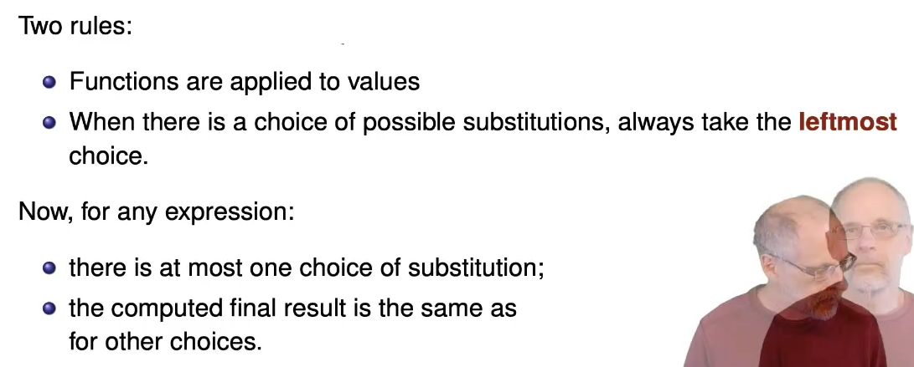
* Now when we look at the below image, we can’t choose the 3rd option since g(1,3) and f(3) are not values. Then, we can’t choose the 2nd option of g(g(1,3), 3^2) since we evaluate the leftmost choice first. The first option follows all the rules we defined so we use the first method
* 

Parentheses

* Prefix

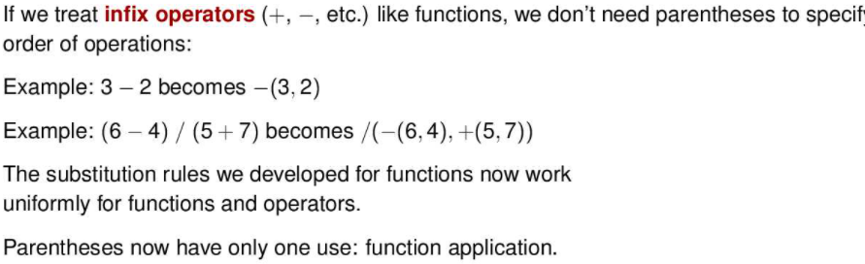

* Parentheses in racket:

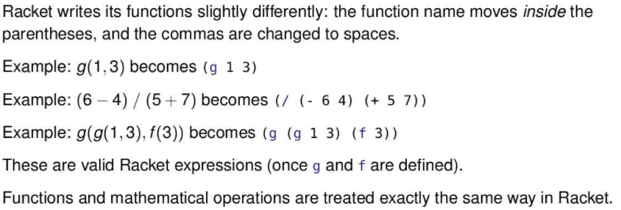

* Expressions in Racket

Notice the spacing is important ex: (+ 1 2)

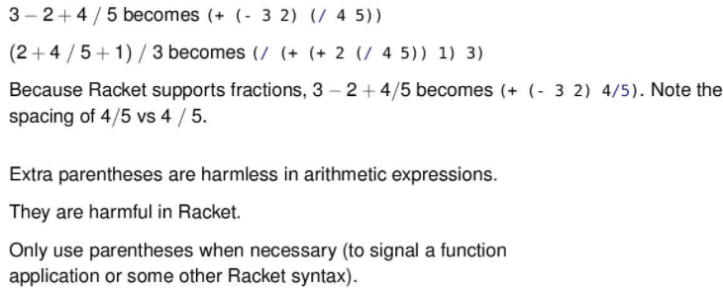

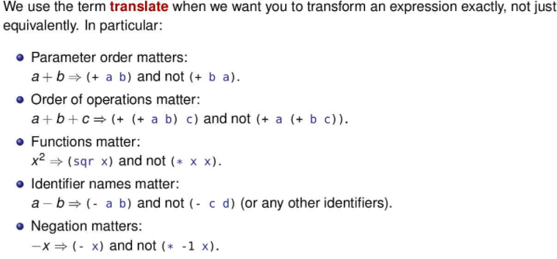

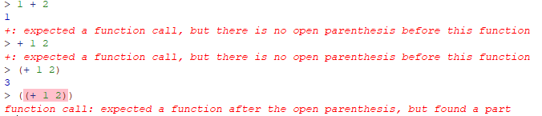

* Prefix to Infix

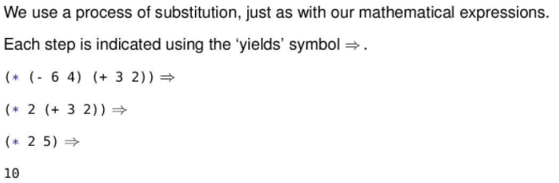

* Expressions that cause errors:

Below are syntactic errors: error discovered when reading an expression

Ex:



Ex:



Ex:



Ex: (+ (* 2 4))

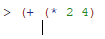

Notice it’s tricky, it doesn’t have an error yet since racket knows we still need to close the brackets. But once we do, it’ll have an error since there is no 2nd argument for the +.

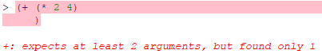

If we add a second argument, it’ll be fine

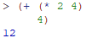

Below is a run-time error: error when evaluating an expression

Ex:

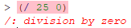

DrRacket Documentation

* To find all the built in functions, in DrRacket, select Help → Racket Documentation which pops up a browser, go to teaching → how to design programs languages → beginning student
* Or click [this](https://docs.racket-lang.org/htdp-langs/index.html) link

Defining Functions

* The term define is a special form which binds a name to an expression, essentially define is an equal sign
* As well, the variables x and y aren’t defined, they are parameters

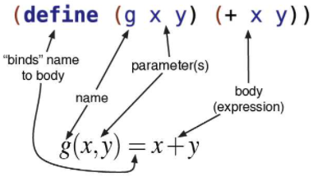

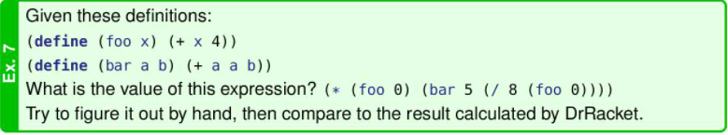

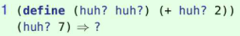

this gives a value of 9, first hun is function name, second is a arguement

Parameter Names

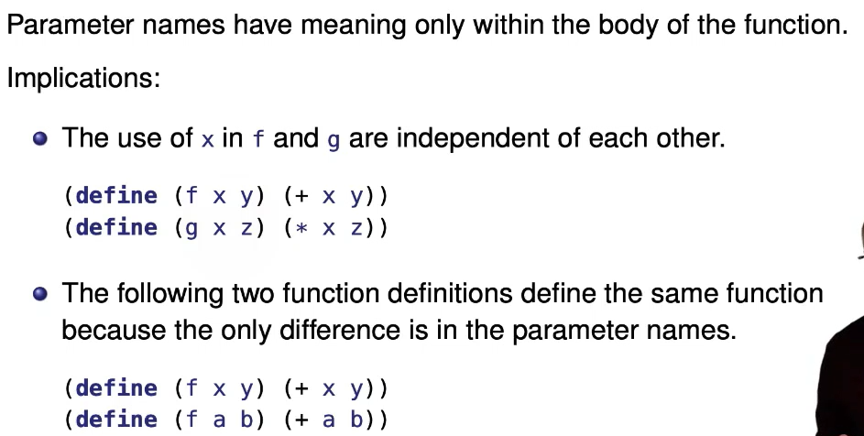

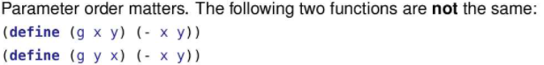

Constants

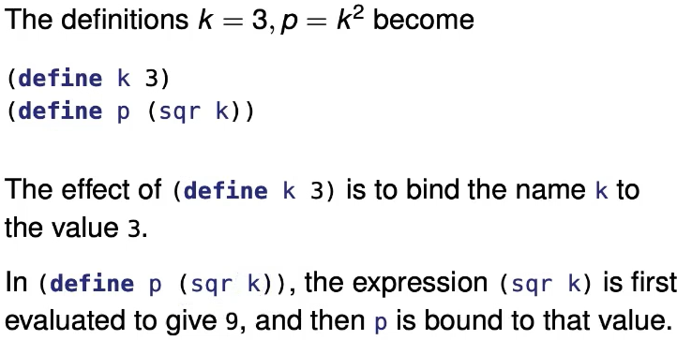

* Constants can be used anywhere, including body of function definition
* Advantages of constants:
* Give meaningful names to values
* Only need to change in one place
* Makes programs easier to understand

Identifiers

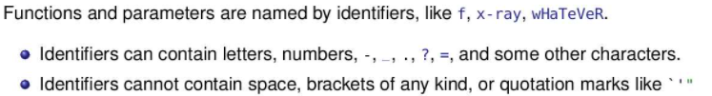

Scope

* The scope of an identifier is where it has effect within the program
* There is global (in green below) and function scope (in red below)
* The smallest enclosing scope has priority

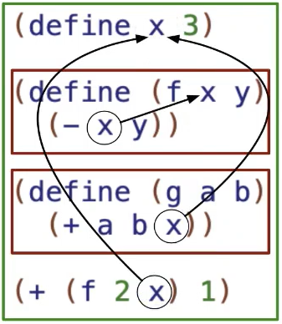

* Duplicate identifiers within the same scope will cause an error

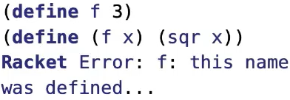

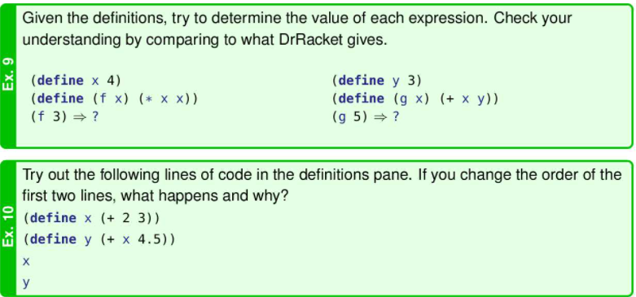

Ex 9 above:

(f 3) prints 9 since x has function scope

(g 5) prints 8 which uses y that has global scope

Ex 10 above: when your change the order, you get an error is not defined, but it’s being used in define y

Helper Function

* A function that helps to implements another function
* In the example below, distance is the helper function

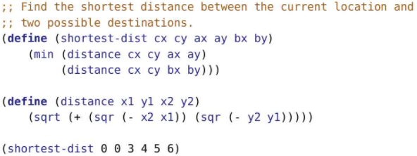

* Purposes of helper functions:
  + Reduce repeated code (reduce typing)
  + Factor out complex calculations (bugs can easily be fixed)
  + Give meaning names to operations (makes programs easier to understand)
* Helpers are placed after the function that uses them unless
  + The helper function is used in defining constants, for this case, helpers must be defined before defining the constant
  + Helpers used in several functions in the same file are placed first
  + For assignments, functions in for part a) will be placed before functions in part b)

Tools in DrRacket

* In the tabs click racket, then click reindent all to format, or use shortcut ctrl-i
* Notice if some code is never used, its font color is gold with a black background

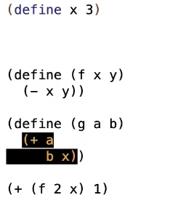

* Click step and keep clicking next to program trace

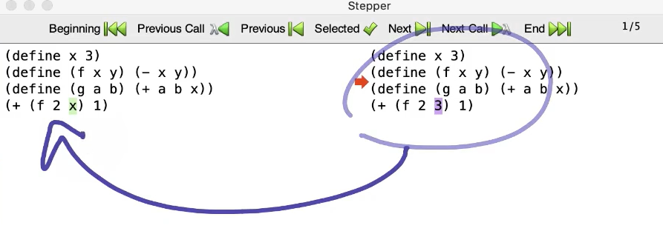

* To help with scoping, click check syntax and when we hover over a value of x, it shows what it corresponds to

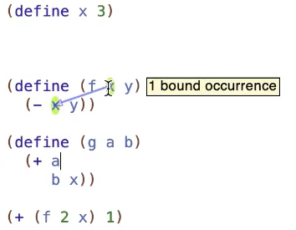

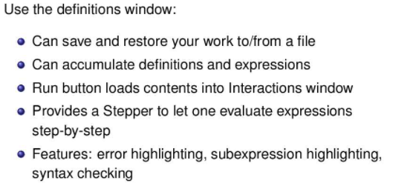

Built in Functions

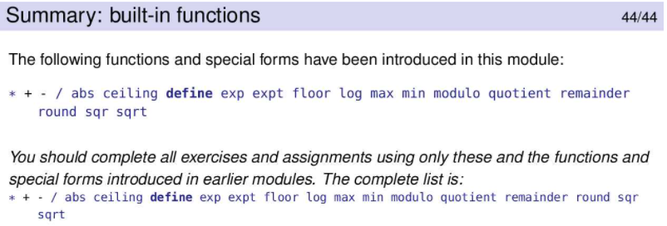

**Module 3:**

Programs as communication

* Programs helps to communicate between you and the computer, your future self, and others

Comments

* Start each line with 2 semicolons



* Comments after code use 1 semicolon



Design Recipe

* To before you create any assignment
* The purpose is to help you understand the problem, write understandable code, and write tested code

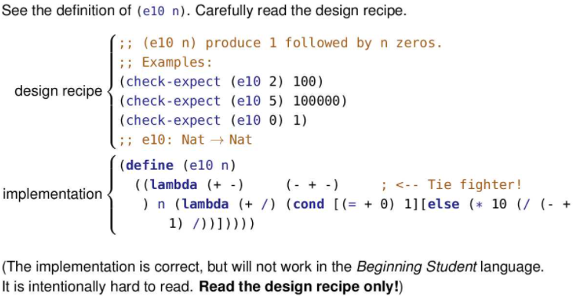

Check-expect

* A special form for examples and tests in the design recipe
* Checks if a function works by testing by providing a given input and output and seeing if the function produces the same thing
* syntax :

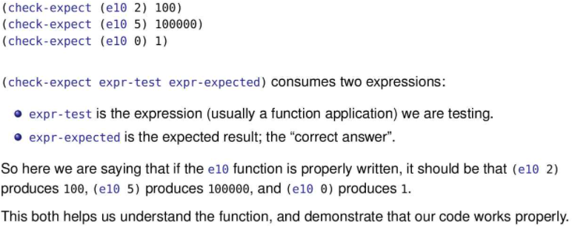

Check Within

* The last parameter to check-within is the tolerance.

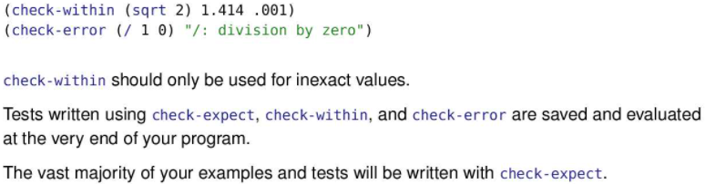

* The example is actually checking that 1.414 - 0.001 <= (sqrt 2) <= 1.414 + 0.001 is true.

Design Recipe Components

* Purpose
  + In comments
  + Describes what the function is to compute, it doesn't say how it computes it
  + more English-like

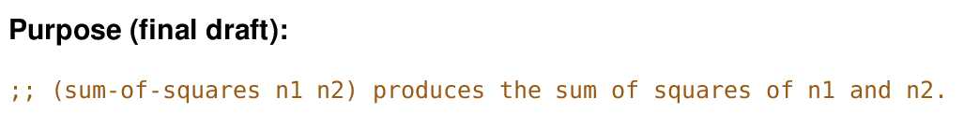

* Examples
  + Illustrates the typical use of the function
  + is a simple test to ensure it does what it is supposed to do
  + goes through the process of finding the answer used for that simple test
  + Boundary cases could be good

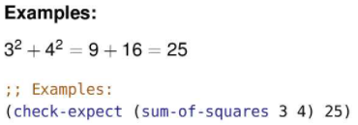

* Contract
  + Describes what types of arguments the function consumes and what value it produces
  + More Math-like
  + The left side of the arrow will contain a data type for each parameter. The right side will contain the data type the function produces.
  + To make the arrow, use a dash and greater-than sign (->) in your code
  + 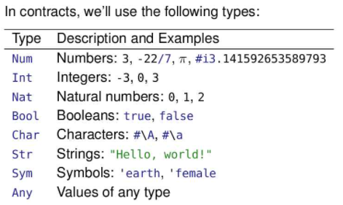
  + 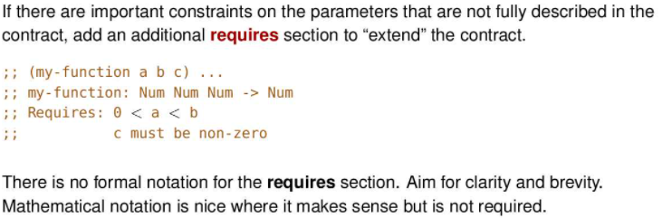
* Definition
  + The racket definition of the function (header and body)
  + The header is the function name, parameters and the define keyword
  + The body is the expression that computes the result.
* Test
  + A representative set of function applications and their expected values.

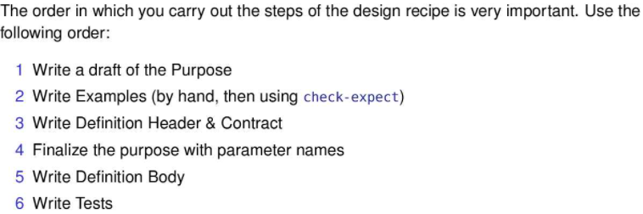

Examples Vs Tests:

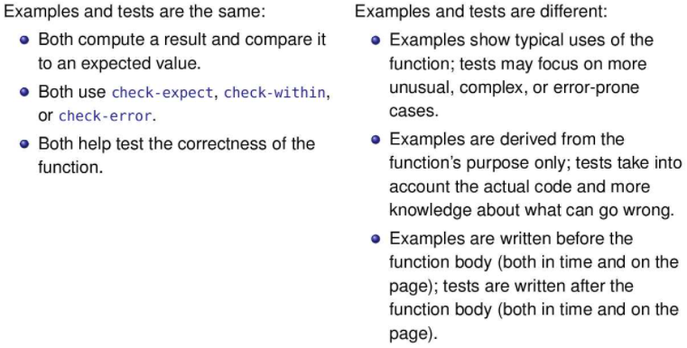

Applying the design recipe



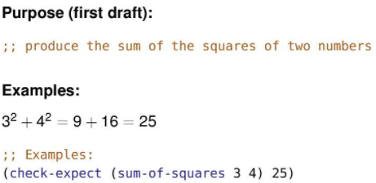



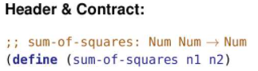



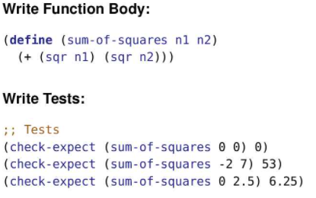





Example of Design Recipes:

Example 1

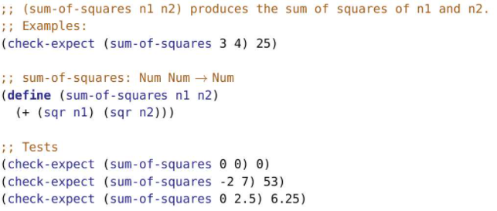

Example 2

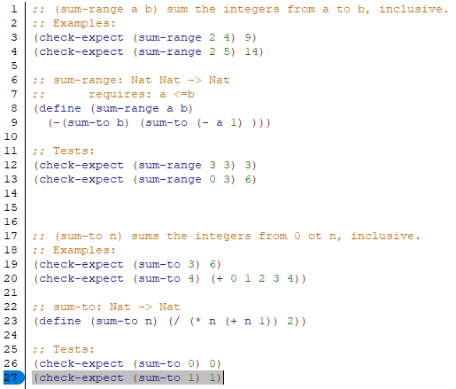

Contact Enforcement

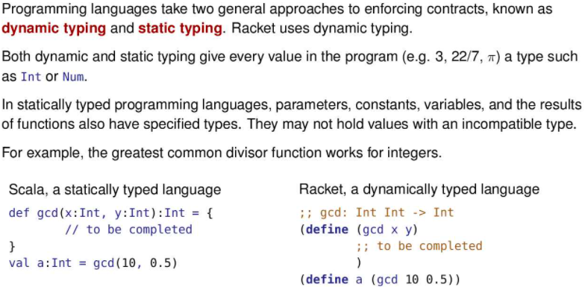

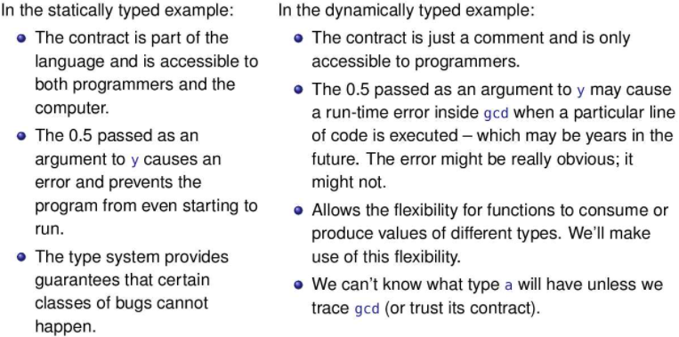

Style Guide

* <https://online.cs.uwaterloo.ca/assets/courseware/v1/83c513e7256f1eaca187f6417a19c3b2/asset-v1:UW+CS135+2021_09+type@asset+block/cs135_style_2021-09-09b.pdf>

Built-in Functions

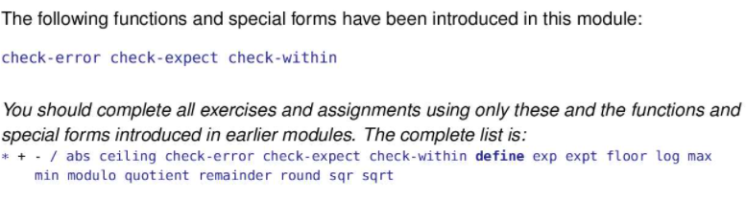

**Module 4:**

Course Structure

* Booleans have a literal value of true or false
* Symbols are words that begin with a single quote in front such as ‘earth or ‘female
* Strings are words surrounded by double-quotes “This is a string”.

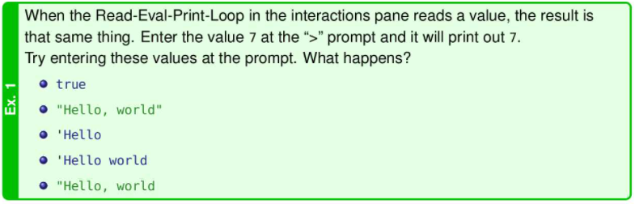

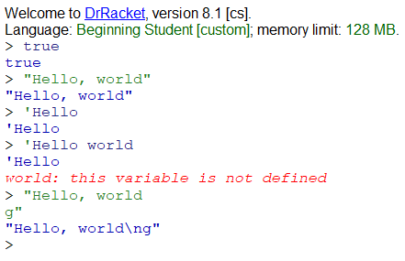

Booleans

* <, >, <=, >=, and = are new functions that produce a Boolean value
* (< x 5) returns true of x<5 and false if x>= 5
* 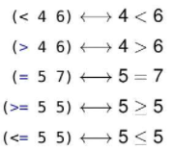
* Each of the above produce true of false
* A function that produces a bool is called a predict, they often end with ?

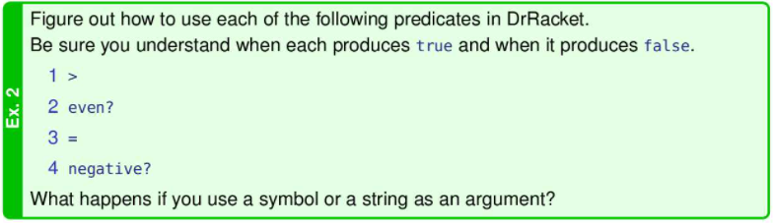

String

* Predict
  + We can tell if two strings are the same

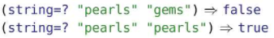

* We can tell if strings are in lexicographic order which includes alphabetic order, and also gives an order for all UNICODE characters

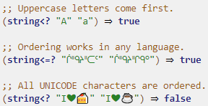

Condition Expressions

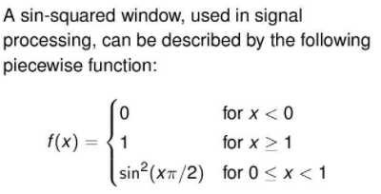

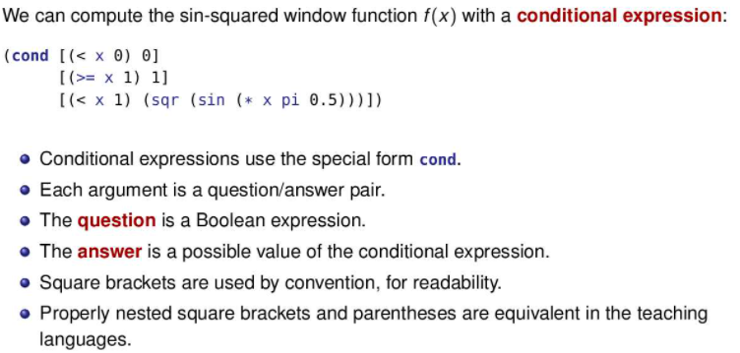

* There is a condition (boolean) and then on the right, what is executed if the condition is true: [(< x 0) 0]
* Put the most specific cases first, then more general cases last
* Read from first condition to next, first condition that tis true will be executed and the following conditions are not read

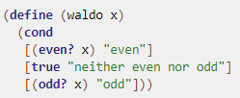 (waldo 5) would be “neither even nor odd”

* If no condition is true, there will be an error, so we probably want to add an else

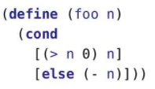

* When testing, make sure to have one test for each possible answer in the conditional expression
* Make sure to check boundary cases as well
* Combining Predicts

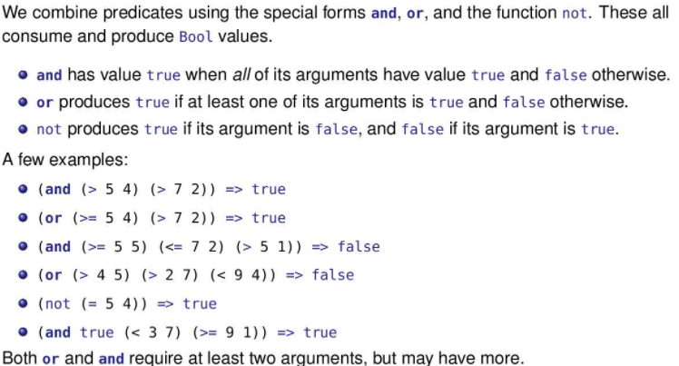

* Short circuiting occurs for the word and since both clauses need to be true. Once the first clause is false in an and statement, the 2nd clause isn’t even evaluated
* Similarly for or statements, if the first clause is true, the 2nd clause isn’t even evaluated
* 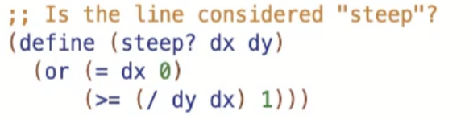
* Notice above, short circuiting allows us to bypass errors such as dividing by 0 since the division never occurs since the first clause will be true, making the entire statement true
* We can use this to our advantage by putting clauses with greater time complexity last in an and/or statement and faster clauses first
* 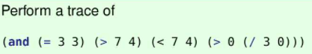
  + evaluates to false, doesn't even evaluate (> 0 (/ 3 0)) since once (< 7 4) is false, the and statement is false
* 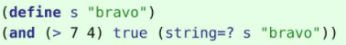
  + Evaluates to true
* 
  + Evaluates to true. once (= 3 3) is true, the rest isn’t evaluated
* 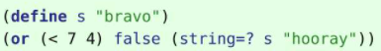
  + Evaluates to false since all clauses are false
* Testing or/and
  + or: enough tests to make the expression true for each clause, and one test that makes the entire or expression false.
  + and: enough tests to make the expression false for each clause, and one test that makes the entire and expression true.

Simplifying Conditional Expressions

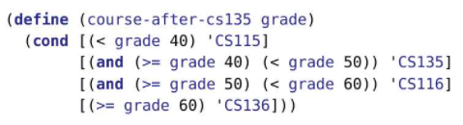

* But when (>= grade 40) is evaluated in the second question/answer pair, we already know that grade is at least 40. Because of Racket’s top-to-bottom evaluation of a cond, we cannot reach the second question/answer pair unless grade is at least 40. We don’t need to test it again.

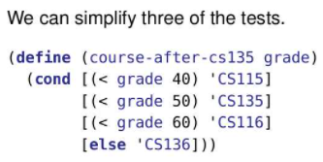

* Note that the code as given on the previous slide will produce the correct answer if the order of the question/answer pairs is rearranged. This code depends on the order. Rearrange it and you’ll get wrong answers.

Nested Conditions

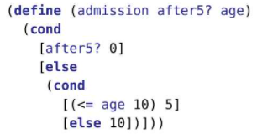

Symbolic Data

* We define symbols to have meaning for us, (not for Racket)
* A symbol is defined using a single quote in the front: ‘CS115
* Symbols allow us to avoid using constants to represent names
* Comparing Symbols using symbol=?
  + Use the predict symbol=?
  + The contract for symbol=? is Sym Sym -> Bool. It consumes two symbols and produces a Boolean result.
  + Only function that is applied only to symbol

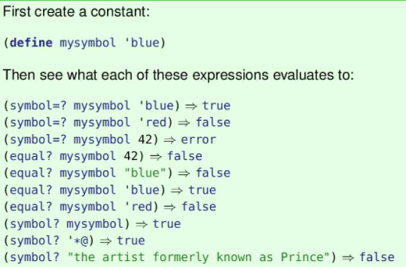

Characters

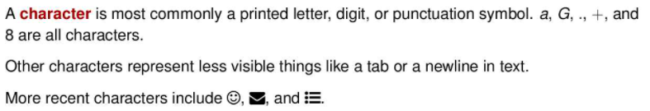

String

* Sequences of characters between double quotes
* Ex: “blue” and “These are shows. Lol”
* String Functions:
  + 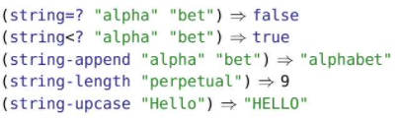

Strings vs Symbols

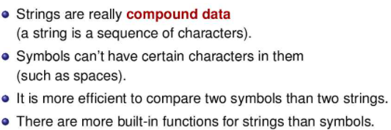

Contracts



Type Predicts

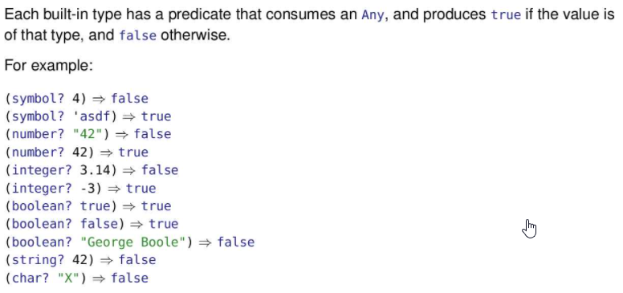

General Equality Testing

* 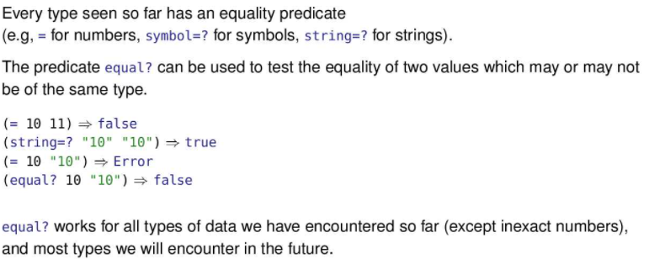
* However, do not overuse equal? . If you are comparing numbers, use =. If you are comparing strings, use string=?, and so on

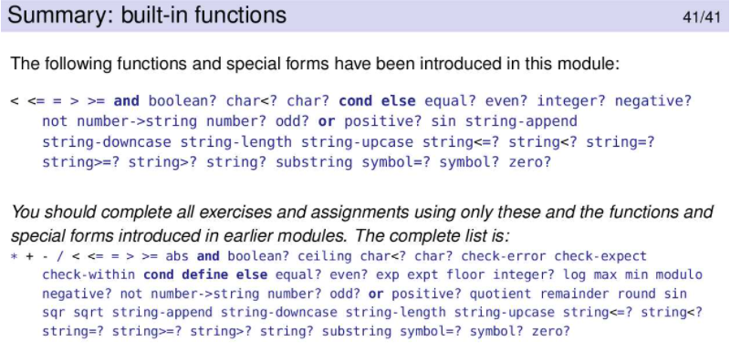

**Module 5:**

Spelling

* Identifiers (names of constants, parameters, etc) are made up of letters, numbers, hyphens, underscores, and other punctuation
* They must contain at least one non-number
* They must not contain spaces or any of the following: () , ; {} [] ‘’ “”.
* Symbols start with a single quote and obey the same rules for identifiers

Syntax

* Has to do with the form/structure
* The way we’re allowed to say things
* Example: In english, ‘?is This sentence Correct’ is not syntactically correct

Semantics:

* the meaning of what they say
* Example: In english, ‘Trombones fly hungrily’ is syntactically correct, but the sentence has no meaning as trombones don’t fly nor get hungry.

Ambiguity:

* valid sentence have exactly one meaning
* Example: In english, ‘Sally was given a book by Joyce’ is ambiguous whether the person giving the book was named Joyce or the person who wrote the book was named Joyce.

Semantic Model

* Will rigorously solve the problem with semantics
* Provides a method of predicting the result of running any program
* The model will repeatedly simplify the program using substitution
* A substitution set finds the leftmost subexpression eligible for rewriting, and rewrites it with a set of rules
* After all the substitution, all that remains is a sequence of definitions and values

Substitution Rules

Basically treat constants as functions.

USE Step to check, note that for boolean expressions, it won't get rid of false and true but it should

Ex: (and true (> 2 100) (> 2 -10))=>(and true false (> 2 -10)) will be displayed but this is wrong

Correct: (and true (> 2 100) (> 2 -10))=>(and (> 2 100) (> 2 -10))

1. When substituting a function application with the function’s body, all arguments must be values. They cannot be constants.

Ex: (g 3 4) is ready to be substituted while (g 3 (+ 2 2)) is not ready.

1. When given a choice of which subexpression to evaluate and substitute back, choose the left-most subexpression.

Ex: We evaluate (+ 1 1) first in (g (+ 1 1) (* 2 2))

Ex:

(define a 4)

(define b 5)

(g a b)=>(g 4 b)=>(g 4 5) (the values of a and b have to be evaluated, a is left so it comes first, then b.

1. (f v1...vn) ⇒ v where f is a built-in function and v is the value of f(v1, …, vn). Basically, we just “know” what the built-in functions do.

Ex: (+ 3 5) ⇒ 8

1. (f v1 … vn) ⇒ exp’ where f-is a user-defined function and exp’ is the expression of f(v1,...vn) with the values of v1,..,vn being substituted into the function expression. Basically, the name and arguments of a user-defined function will be replaced by its expression. If constants are used in the expression of a user-defined function, the replacement of the constant with it’s value does not occur at the same step as replacing parameters with arguments. Constants are replaced when necessary, according to step 1.
2. id ⇒ val when defining constants such as (define id val)
3. (cond [false exp] [next conditions]) ⇒ (cond [next conditions])
4. (cond [true exp] [next conditions]) ⇒ exp
5. (cond [else exp]) ⇒ exp

(cond) => error

1. (and false [other conditions]) ⇒ false
2. (and true [other conditions]) ⇒ (and [other conditions])
3. (and) ⇒ true
4. (or true [other conditions]) ⇒ true
5. (or false [other conditions]) ⇒ (or [other conditions])
6. (or) ⇒ false

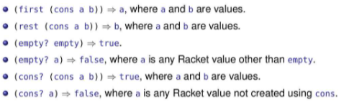

Ex: (define (foo x y) (+ x x y))

(foo 1 2)

⇒ (+ 1 1 2)

⇒ 4

Ex:

(define (term x y) (* x (sqr y)))

(term (- 3 1) (+ 1 2))

Rule 1 needs values, so it gets Rule 2 to evaluate the expressions. Rule 2 evaluates the left-most subexpression which is (- 3 1). To evaluate it, Rule 3 says subtract is a built in function and evaluates it.

⇒ (term 2 (+ 1 2))

Rule 1 needs values, so it gets Rule 2 to evaluate the expressions. Rule 2 evaluates the left-most subexpression which is (+ 1 2). To evaluate it, Rule 3 says addition is a built in function and evaluates it.

⇒ (term 2 3)

Rule 1 is satisfied as it has values in the arguments, so now it uses Rule 4 to replace the user-defined function with the expression and values in place of the parameters.

⇒ (* 2 (sqr 3))

Rule 1 needs values, so it gets Rule 2 to evaluate the expressions. Rule 2 evaluates the left-most subexpression which is (sqr 3). To evaluate it, Rule 3 says sqr is a built in function and evaluates it.

⇒ (* 2 9)

Rule 1 has values, so it can use Rule 3 to evaluate the built-in * function.

⇒ 18

Ex:

(define (term x y)

(* x (sqrt y)))

(define (fact t q)

(+ (term q t) t))

What is the first step in the substitution for (fact 16 14)?

(fact 16 14)

Rule 1 is satisfied as it has values in the arguments, so now it uses Rule 4 to replace the user-defined function with the expression and values in place of the parameters.

⇒ (+ (term 14 16) 16)

Ex:

(define x 3)

(define y (+ x 1))

⇒ (define y (+ 3 1))

⇒ (define y 4)

Ex:

(define a 4)

(define b 5)

(define (g x y)

(- (* x a) y))

(g a b)

⇒ (g 4 b)

⇒ (g 4 5)

⇒(- (* 4 a) 5)

⇒(- (* 4 4) 5)

⇒(- 16 5)

⇒11

Ex:

(define p 2)

(define q 3)

(define (f x)

(+ x (* x q)))

(f (+ p q 1))

⇒ (f (+ 2 q 1))

⇒ (f (+ 2 3 1))

⇒ (f 6)

⇒ (+ 6 (* 6 q))

⇒ (+ 6 (* 6 3))

⇒ (+ 6 18)

⇒ 24

Ex:

(define a 4)

(define b 5)

(define (g x y)

(- (* x a) y))

(g 2 3)

⇒ (- (* 2 a) 3)

⇒ (- (* 2 4) 3)

⇒ (- 8 3)

⇒ 5

Ex:

(define n 5)

(define x 6)

(define y 7)

(cond [(even? n) x] [(odd? n) y])

⇒ (cond [(even? 5) x] [(odd? n) y])

(notice 5 only replaces first cond since that is the first expr to be evaluated, x is not even replaced yet since x is not needed in evaluating the first cond)

⇒ (cond [false x] [(odd? n) y])

⇒ (cond [(odd? n) y])

⇒ (cond [(odd? 5) y])

⇒ (cond [true y])

⇒ y

⇒ 7 (if y is not defined, an error will be raised)

Ex:

(define (foo x)

(cond

[(odd? x) "odd"]

[(= 2 (remainder x 10)) "strange"]

[(> x 100) "big"]

[(even? x) "even"]))

(foo 102)

(Notice since this cond is the expr for a function, x is replaced in all the places, even if it isn’t being evaluated yet)

⇒ (cond

[(odd? 102) "odd"]

[(= 2 (remainder 102 10)) "strange"]

[(> 102 100) "big"]

[(even? 102) "even"]))

⇒ (cond

[false "odd"]

[(= 2 (remainder 102 10)) "strange"]

[(> 102 100) "big"]

[(even? 102) "even"]))

⇒ (cond

[(= 2 (remainder 102 10)) "strange"]

[(> 102 100) "big"]

[(even? 102) "even"]))

⇒ (cond

[(= 2 (remainder 102 10)) "strange"]

[(> 102 100) "big"]

[(even? 102) "even"]))

⇒ (cond

[(= 2 2) "strange"]

[(> 102 100) "big"]

[(even? 102) "even"]))

⇒ (cond

[true "strange"]

[(> 102 100) "big"]

[(even? 102) "even"]))

⇒ "strange"

Ex:

(cond [(symbol=? 'night 'day) 'moon]

[(symbol=? 'dusk 'dusk) 'sunset])

⇒(cond [false 'moon]

[(symbol=? 'dusk 'dusk) 'sunset])

⇒(cond [(symbol=? 'dusk 'dusk) 'sunset])

⇒(cond [true 'sunset])

⇒'sunset

Ex:

(and (> 2 3) (> 2 100) (> 2 -10))

⇒ (and false (> 2 100) (> 2 -10))

⇒ false

Ex:

(and (> 2 1) (> 2 100) (> 2 -10))

⇒ (and true (> 2 100) (> 2 -10))

⇒ (and (> 2 100) (> 2 -10))

⇒ (and false (> 2 -10))

⇒ false

Ex:

(and (> 2 1) (> 2 -10))

⇒ (and true (> 2 -10))

⇒ (and (> 2 -10))

⇒ (and true)

⇒ (and)

⇒ true

Ex:

(define (foo x y) (or (> x 0) (and (= x 0) (< y 0))))

(foo 10 -20)

⇒ (or (> 10 0) (and (= 10 0) (< -20 0)))

⇒(or true (and (= 10 0) (< -20 0)))

⇒true

Ex:

(+ (+ 2 3) (* 3 5))

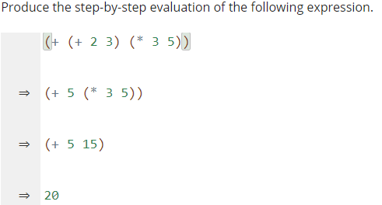

Ex:

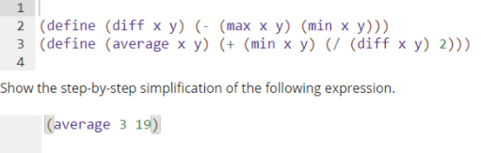

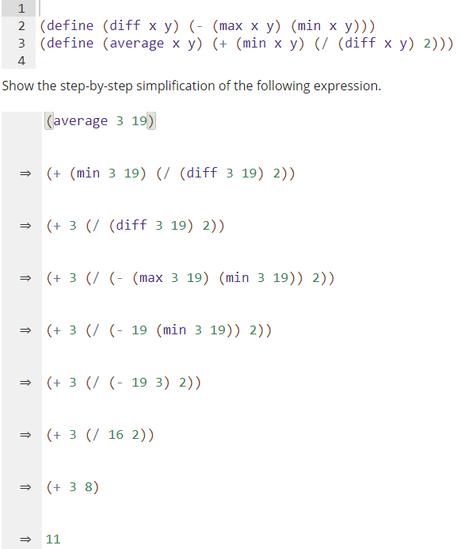

Ex:

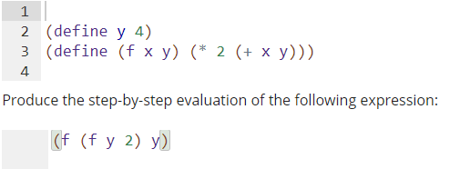

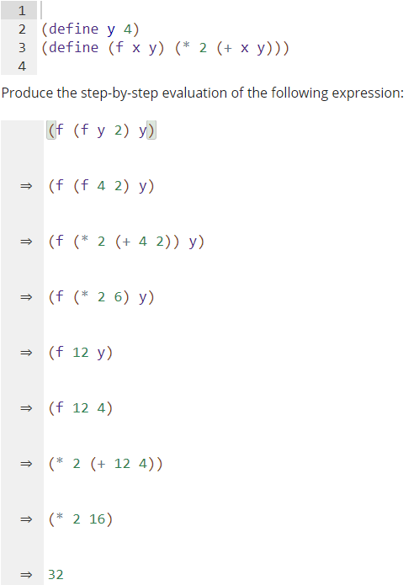

Ex:

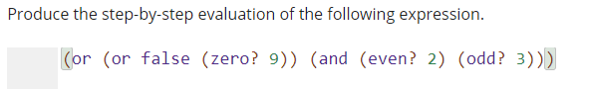

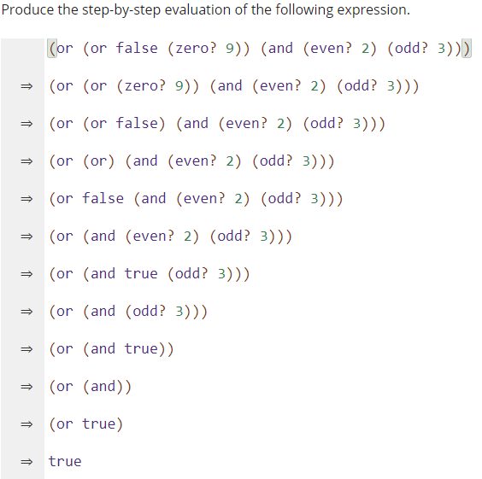

Ex:

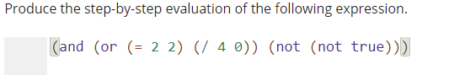

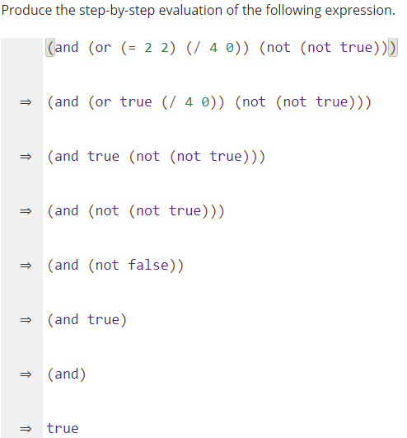

Ex:

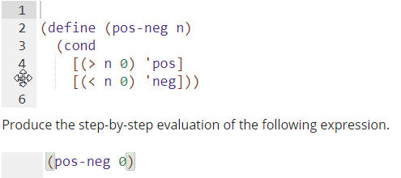

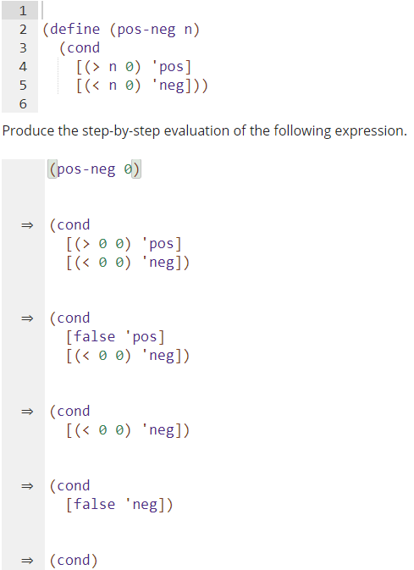

Ends with error

Ex:

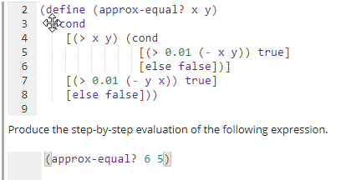

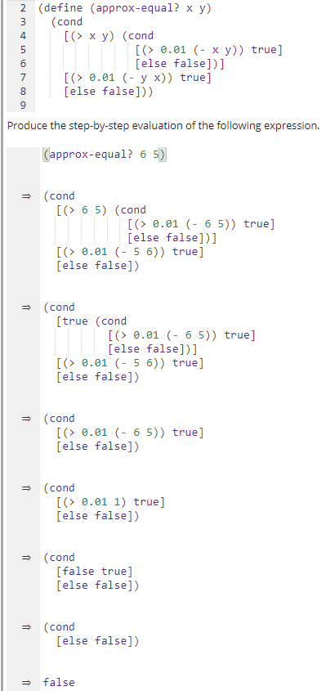

Ex:

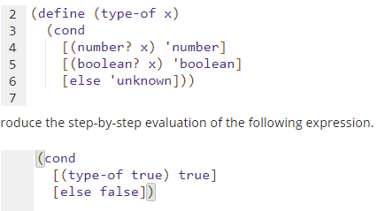

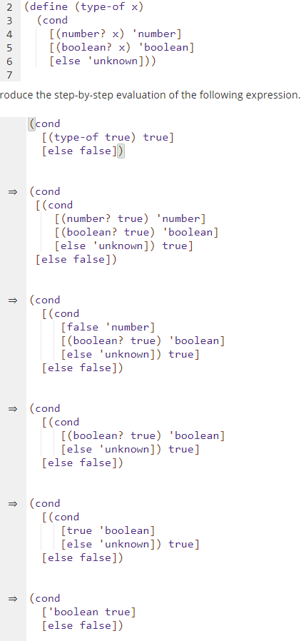

Ends with error

Stepping with Lists

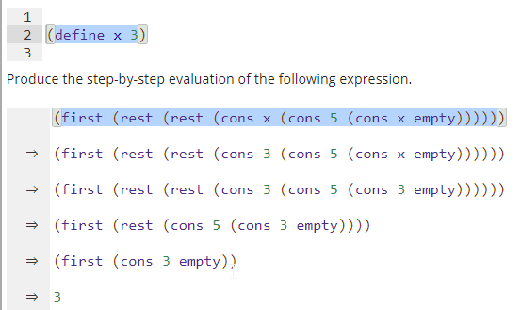



Ex:

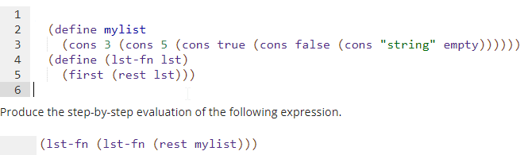

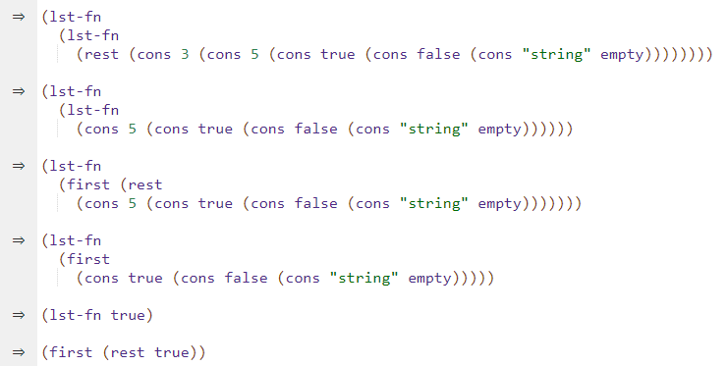

Ends with error

Ex: 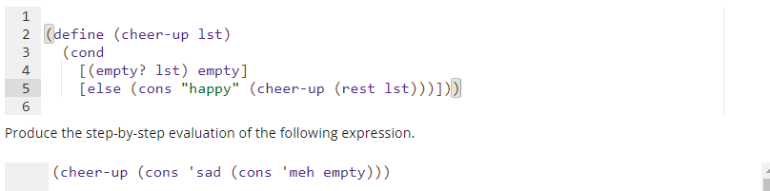

=>(cond

[(empty? (cons 'sad (cons 'meh empty))) empty]

[else (cons "happy"

(cheer-up (rest (cons 'sad (cons 'meh empty)))))])

=>(cond

[false empty]

[else (cons "happy"

(cheer-up (rest (cons 'sad (cons 'meh empty)))))])

=>(cond

[else (cons "happy"

(cheer-up (rest (cons 'sad (cons 'meh empty)))))])

=>(cons "happy"

(cheer-up (rest (cons 'sad (cons 'meh empty)))))

=>(cons "happy"

(cheer-up (cons 'meh empty)))

=>(cons "happy"

(cond

[(empty? (cons 'meh empty)) empty]

[else (cons "happy"

(cheer-up (rest (cons 'meh empty))))]))

=>(cons "happy"

(cond

[false empty]

[else (cons "happy"

(cheer-up (rest (cons 'meh empty))))]))

=>(cons "happy"

(cond

[else (cons "happy"

(cheer-up (rest (cons 'meh empty))))]))

=>(cons "happy"

(cons "happy"

(cheer-up (rest (cons 'meh empty)))))

=>(cons "happy"

(cons "happy"

(cheer-up empty)))

=>(cons "happy"

(cons "happy"

(cond

[(empty? empty) empty]

[else (cons "happy" (cheer-up (rest empty)))])))

=>(cons "happy"

(cons "happy"

(cond

[true empty]

[else (cons "happy" (cheer-up (rest empty)))])))

=>(cons "happy"

(cons "happy"

empty))

Ex:

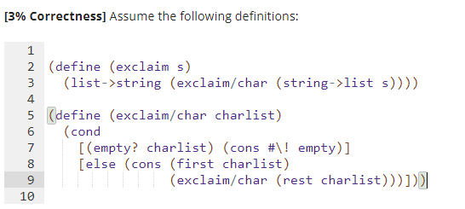

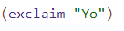

=>(list->string (exclaim/char (string->list "Yo")))

=>(list->string (exclaim/char

(cons #\Y (cons #\o empty))))

=>(list->string

(cond

[(empty? (cons #\Y (cons #\o empty))) (cons #\! empty)]

[else (cons (first (cons #\Y (cons #\o empty)))

(exclaim/char (rest (cons #\Y (cons #\o empty)))))]))

=>(list->string

(cond

[false (cons #\! empty)]

[else (cons (first (cons #\Y (cons #\o empty)))

(exclaim/char (rest (cons #\Y (cons #\o empty)))))]))

=>(list->string

(cond

[else (cons (first (cons #\Y (cons #\o empty)))

(exclaim/char (rest (cons #\Y (cons #\o empty)))))]))

=>(list->string

(cons (first (cons #\Y (cons #\o empty)))

(exclaim/char (rest (cons #\Y (cons #\o empty))))))

=>(list->string

(cons #\Y

(exclaim/char (rest (cons #\Y (cons #\o empty))))))

=>(list->string

(cons #\Y

(exclaim/char (cons #\o empty))))

=>(list->string

(cons #\Y

(cond

[(empty? (cons #\o empty)) (cons #\! empty)]

[else (cons (first (cons #\o empty))

(exclaim/char (rest (cons #\o empty))))])))

=>(list->string

(cons #\Y

(cond

[false (cons #\! empty)]

[else (cons (first (cons #\o empty))

(exclaim/char (rest (cons #\o empty))))])))

=>(list->string

(cons #\Y

(cond

[else (cons (first (cons #\o empty))

(exclaim/char (rest (cons #\o empty))))])))

=>(list->string

(cons #\Y

(cons (first (cons #\o empty))

(exclaim/char (rest (cons #\o empty))))))

=>(list->string

(cons #\Y

(cons #\o

(exclaim/char (rest (cons #\o empty))))))

=>(list->string

(cons #\Y

(cons #\o

(exclaim/char empty))))

=>(list->string

(cons #\Y

(cons #\o

(cond

[(empty? empty) (cons #\! empty)]

[else (cons (first empty)

(exclaim/char (rest empty)))]))))

=>(list->string

(cons #\Y

(cons #\o

(cond

[true (cons #\! empty)]

[else (cons (first empty)

(exclaim/char (rest empty)))]))))

=>(list->string

(cons #\Y

(cons #\o

(cons #\! empty))))

=>"Yo!"

**Module 6:**

What is a list

* A recursive structure that is defined in terms of a smaller list

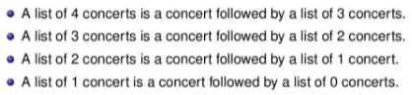

* In general, a list of n items is an time followed by a list of n-1 items
* The list of zero consents is called the empty list which is represented in Racket with the word ‘empty’
* Note lists are different from arrays since an array can access the i-th index, but lists can’t

const

* (const v l) returns a list whose value is the list, l, but with the value, v, in the beginning
* 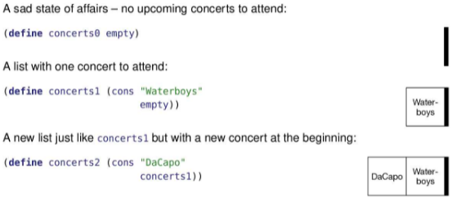
* Notice to create a list with no elements initially, we use the word empty
* The empty list is represented by a black bar
* Elements of a list are show in boxes
* Notice we bound lists to constants. Ex: concerts1 has a value of “Water-boys”

List Functions:

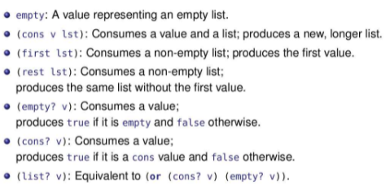

* Applying first to an empty list produces an error, so we need to test for the empty list and handle it specially
* A con value is true if a list was created via the cons function
* Ex:

(define li0 empty)

(define li1 (cons 1 li0))

(cons? li0) ; prints false since li0 was not created with a cons function

(cons? li1) ; prints true since li1 was created with a cons function

(cons? 0) ; prints false since 0 was not created with a constant function even tho it is a value of a list that was created by the cons function

(list? li0) ; prints true since li0 is a list

(list? li1) ; prints true since li1 is a list

* There are different ways to define a list
  + Ex: (define list1 (cons 1 (cons 2 (cons 3 empty))))

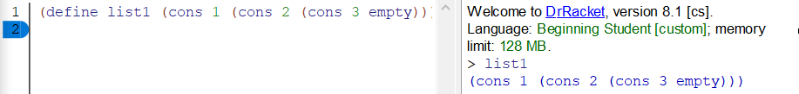

* Ex:

(define shopping (cons "milk" (cons "eggs" (cons "bread" empty))))

(first (rest shopping))

⇒(first (rest (cons "milk" (cons "eggs" (cons "bread" empty)))

⇒(first (cons "eggs" (cons "bread" empty)))

⇒ “eggs”

* Ex:

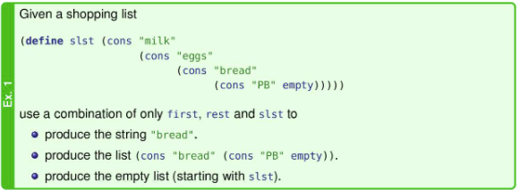

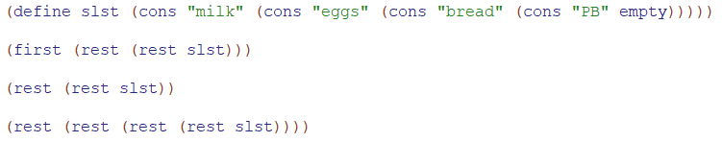

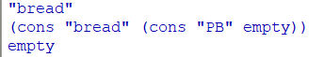

* Ex:

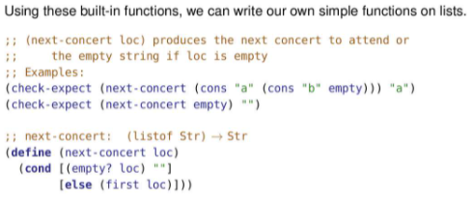

Note that applying first on an empty list gives an error so we check it first in the cond

Contracts in Design Recipe For Lists

* (listof X) is used in contracts where X can be any type
* (listof X) always includes the empty list
* (listof Str), (listof Int), (listof Bool), (listof Any)
* next-concert: (listof Str) -> Str

Formalities

* List values are either empty, or a cons value
* Value: (const 2 empty)
* Expression: (const (+ 1 1) empty)

Substitution Rules



data def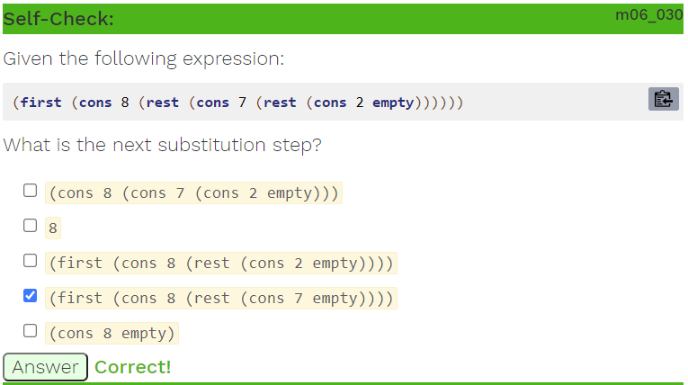

List Data Definition

* A list of strings is either empty, or consists of a first string followed by a list of string

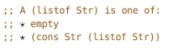

* Notice this definition is recursive with a base case of empty
* We can generalize Str to other types, denoted by X
* 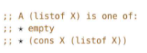

Design Recipe Template for Lists

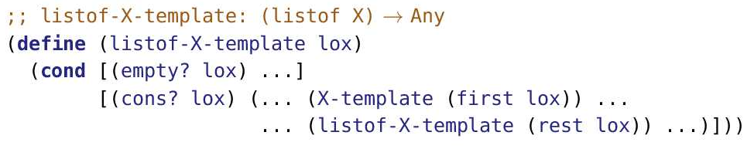

* X-template is a helper function
* The function definition takes in a list
* If it’s empty, do whatever you want for the specific case of an empty list
* If it’s not empty, do whatever you want for the first element, and pass the rest of the list back into the function recursively
* The type of recursion used is called simple recursion

Processing Lists

* Suppose we want to figure out the number of concerts in a list of concerts

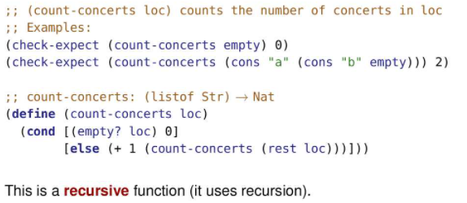

* Tracing the count-concerts function

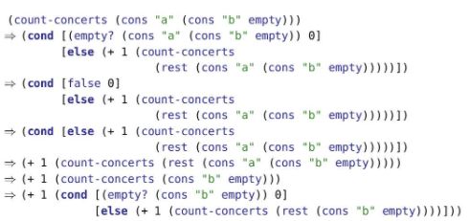

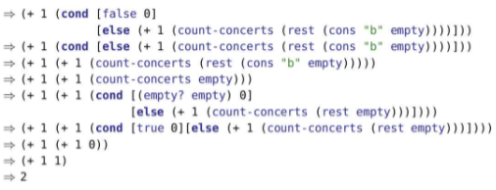

* Clearly, this is a pain to look at so we used condensed trace instead

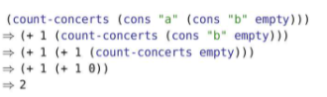

Simple Recursion

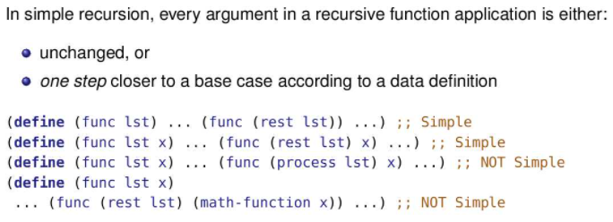

* Identifying Simple Recursion
* Based entirely on the recursive call which is the place where the function calls itself again
* In the first example, the only argument is one step closer to the base case (lst with the first element removed). Note that the data definition is in terms of the first element and the rest of the list. So “one step closer to the base case” means removing the first element. A list that is one item shorter is not “one step closer to the base case” unless it is shorter because it’s missing the first element. Removing the second element doesn’t count!
* The second example is like the first except that there is an additional parameter that is passed along unchanged. The count-string exercise is an example of this.
* In the third example, process is meant to capture doing something to lst other than removing an element.
* In the fourth example, math function applied to x indicates that x is changed. In both cases, the function is no longer “simple recursion”.

Producing Lists from Lists

* List functions can produce a single value, but can also produce a list
* Ex: The below function removes all non-even numbers from a list

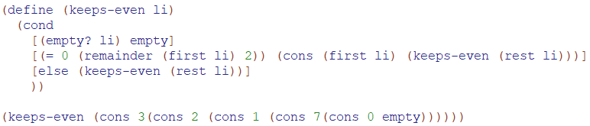

Template for non-empty Lists

* Below nelst is an non-empty list
* In the design recipe, (ne-listof X) can be used alongside (listof Str) and other data definitions

(define (nelist-template nelst)

(cond

[(empty? (rest nelst)) (... (first nelst) ... )]

[else (... (first nelst) ...

(nelist-template (rest nelst)) ... )]))

String

* A sequence of characters
* string->list converts a string into a list of characters
* list->string converts a list of characters into a string
* Built-in String functions
  + string-append
  + string-downcase
  + string-length
  + substring
* notation for ‘a’ is #\a
* notation for ‘ ’ is #\space
* (string->list “test”) => (cons #\t (cons #\e (cons #\s (cons #\t empty))))
* Counting characters in a string

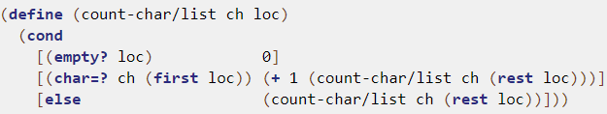

Wrapper Functions

* Short functions that calls another function
* Sets up the proper inputs/conditions for calling the other function
* Ex:



The below is a wrapper function

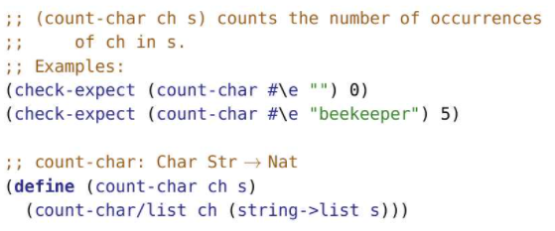

**Module 7**

Natural Numbers

* 0 is a natural number
* For every natural number n, S(n) produces a natural number, specifically the next natural number.
* 1 = S(0)
* 2 = S(1) = S(S(0))
* In racket, S(n) is add1

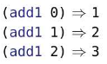

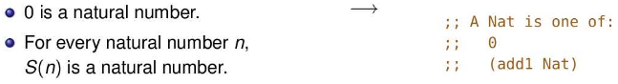

* The inverse of add1 is sub1

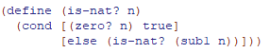

* 0 is a natural number by definition (first clause).
* 1 is a Nat because it’s 1 more than 0, which is a Nat (second clause).
* 2 is a Nat because it’s 1 more than 1, which is a Nat (second clause).
* 3 is a Nat because it’s 1 more than 2….
* 4 is a Nat because it’s 1 more than 3….

Ex: consume a natural number n and produce a decreasing list of all natural numbers than or equal to n.

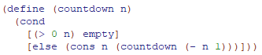

(countdown 3) =>(cons 3 (cons 2 (cons 1 (cons 0 empty))))

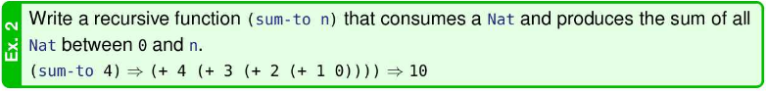

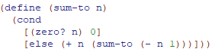

Intervals

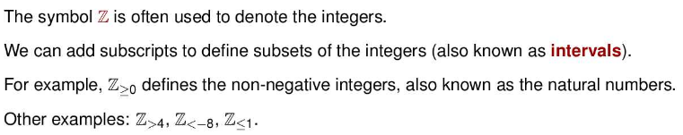

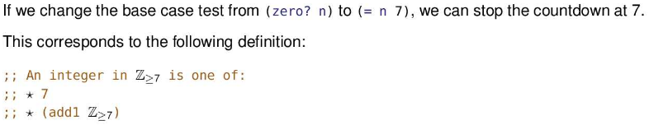

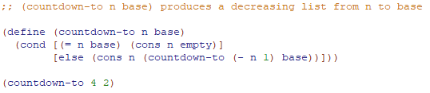

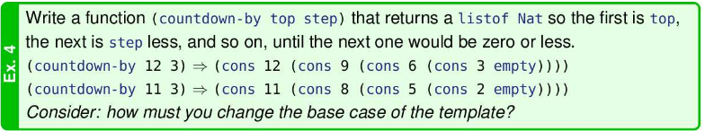

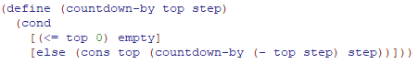

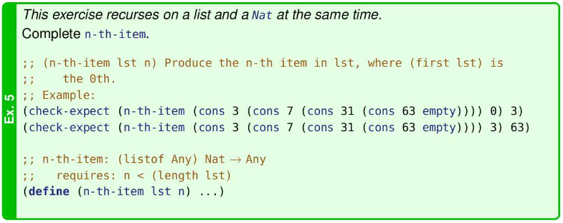

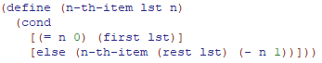

Module 8

Sorting

* Below we will use the insertion sort algorithm
* 2 2 3 2 1
* 2 | 2 3 2 1
* 2 2 | 3 2 1
* 2 2 3 | 2 1
* 2 2 2 3 | 1
* 1 2 2 2 3
* We will sort in non-decreasing order so (sort (list 2 2 3 2 1)) => (list 1 2 2 2 3).
* To sort a list, we will use a (sort num-list) function which uses a helper function, (insert num num-list)

Insert Helper Function

* 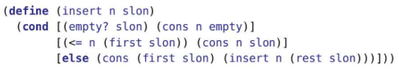
* ;; (insert num num-list) inserts a number into a sorted list

(define (insert num num-list)

(cond

[(empty? num-list) (cons num num-list)]

[(<= num (first num-list)) (cons num num-list)]

[else (cons (first num-list) (insert num (rest num-list)))]))

* Consider the case where we add a number, n, to an empty list:
  + Since the list is empty, the first condition will be satisfied
  + n is added to the front of the list, as it is the only element in the list after being added
  + (cons n empty)
* Consider the case where we add 1 to a list, (cons 2 (cons 2 (cons 5 empty)))
  + Since (first num-list) is the smallest number in the list as it’s already sorted, and since 1 is less than (first num-list), then 1 would be the smallest element if it were to be added. Thus we just put 1 in the front
* Consider the case where we add 3 to a list, (cons 1 (cons 2 (cons 5 empty)))
  + Since (first num-list) is the smallest number in the list as it’s already sorted, and since 1 is greater than (first num-list), then 1 would be placed somewhere after (first num-list).
  + Thus, we can add (first num-list) to the rest of the list which includes 1 being inserted in there somewhere.
  + Eventually, 1 will either be smaller than a number or be the biggest number.
  + If 1 is smaller than a num, f, it is inserted in front of the list starting with f. Then all the numbers that came before 1 will be added back on from the recursion in the reverse order they were removed.
  + If 1 is the biggest number, then it will be added to the empty list. Then all the numbers that came before 1 will be added back on from the recursion in the reverse order they were removed.
* (insert 4 (cons 1 (cons 2 (cons 5 empty))))

;; Since 4 is bigger than 1, then 4 belongs somewhere after 1

;; So 1 will be added to the rest of the list which includes 4 in there somewhere

=> (cons 1 (insert 4 (cons 2 (cons 5 empty))))

;; Since 4 is bigger than 2, then 4 belongs somewhere after 2

;; So 2 will be added to the rest of the list which includes 4 in there somewhere

=> (cons 1 (cons 2 (insert 4 (cons 5 empty))))

;; Since 4 is less than 5, then 4 can be added right in front of 5.

;; Now, all the previous elements, namely 1 and 2, will be added in front of 4

=> (cons 1 (cons 2 (cons 4 (cons 5 empty))))

Sort Function

* 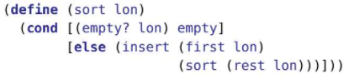
* ;; (sort num-list) sorts num-list in non-decreasing order

(define (sort num-list)

(cond

[(empty? num-list) num-list]

[else (insert (first num-list)(sort (rest num-list)))]))

* Each element is added into the the list of numbers that follows it after the list of the numbers that follows has been sorted
* Tracing

(sort (cons 2 (cons 4 (cons 3 empty))))

=> (insert 2 (cons 4 (cons 3 empty)))

=> (insert 2 (insert 4 (cons 3 empty)))

=> (insert 2 (insert 4 (insert 3 empty)))

=> (insert 2 (insert 4 (cons 3 empty)))

=> (insert 2 (cons 3 (cons 4 empty)))

=> (cons 2 (cons 3 (cons 4 empty)))

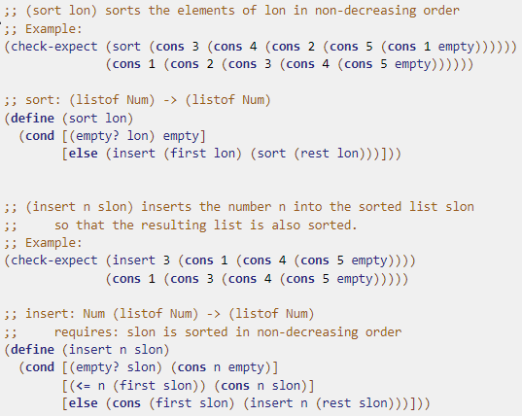

List Abbreviations

* Change DrRacket’s language level from “Beginning Student” to “Beginning Student with List Abbreviations” to gain full access to these features.
* 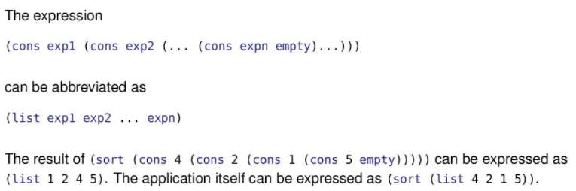
* cons vs list
  + list is used to construct lists of fixed sizes (length is known when writing the program)
  + cons is used to construct lists of arbitrary size (length is known when running the program)
  + list will not show the empty list at the end
  + cons will show the empty list at the end
* When to use list vs cons
  + 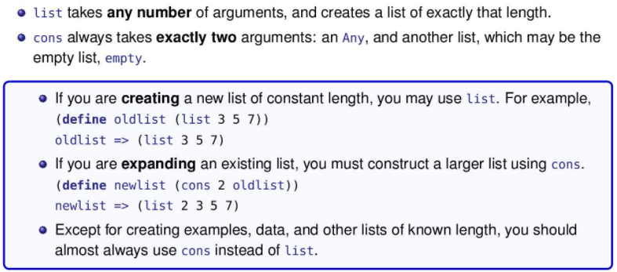
* Questions
  + You want to add 1 more element to the list [lst]. Do you use cons or list?
    - You want to use cons
    - Ex:

(define lst (cons 3 (cons 4 empty)))

(cons 3 lst) = > (list 3 3 4)

(list 3 lst) => (list 3 (list 3 4))

* Notice that if you use cons, the new list has 3 elements (not including empty) which is what you want.
* Notice that if you use list, the new list has 2 elements (not including empty) which is not what you want as the second element itself is a list
* Ex: (cons 2 (list 3 (cons 2 (list 6 (cons 1 empty))))) => (list 2 3 (list 2 6 (list 1)))
  + Why is (list 1 2) legal but (cons 1 2) is not?
    - Because cons requires the second argument to be a list
* What’s the difference between (cons 1 empty) and (list 1 empty)?
  + (cons 1 empty) has 2 elements, 2 followed by empty
  + (list 1 empty) has 3 elements, 1 followed by empty followed by empty
* (second my-list)
  + An abbreviation for (first (rest my-list))
  + third, fourth, and so on up to eighth are also defined

List of Lists

* We can have lists as elements within another list
* Below is a list that has one element. That one element is a list of two elements. Both diagrams represent the same thing.

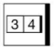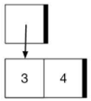

* Ex:

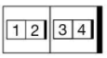

* (list (list 1 2) (list 3 4))
* (cons (cons 1 (cons 2 empty)) (cons (cons 3 (cons 4 empty)) empty))
* The above two lines are equivalent
* Consider the list (define lst (cons "a" (cons "b" empty))). lst is clearly a two-element list. Replace "a" with (cons 1 (cons 2 empty)) and replace "b" with (cons 3 (cons 4 empty)) to get (cons (cons 1 (cons 2 empty)) (cons (cons 3 (cons 4 empty)) empty))
* Ex:

(define lst (list (list 1 2) (list 3 4)))

(first lst) => (list 1 2)

(rest lst) => (list (list 3 4))

* Ex:

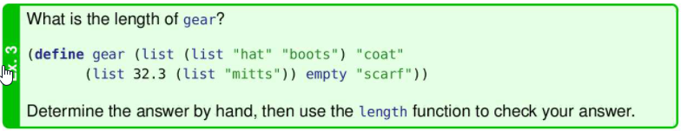

* 5

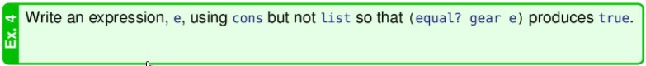

* 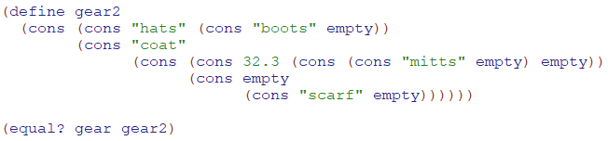
* Ex:

;; wrong-double: (listof Num) -> (listof Num)

(define (wrong-double lon)

(cond

[(empty? lon) empty]

[else (list (* 2 (first lon))

(wrong-double (rest lon)))]))

(wrong-double (list 7 1 -3))

=> (list 14 (wrong-double (list 1 -3)))

=> (list 14 (list 2 (wrong-double (list -3))))

=> (list 14 (list 2 (list -6 (wrong-double (list )))))

=> (list 14 (list 2 (list -6 empty)))

Data Definitions

* Example using Payroll
* 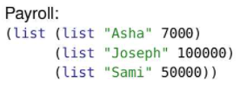
* Recall the (listof X) data definitions:
* 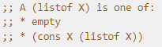
* Notice a Payroll is the same as a (listof X) where X is a two-element list that we represent with (list Str Num)
* Because the data definition has been made more specific, we give it a specific name: Payroll.
* 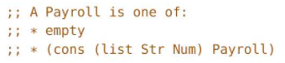
* Note the use of (list Str Num) instead of (list X Y)
* Instead of writing this data definition we could write (listof (list Str Num)) in contracts. But that doesn’t help us derive the template (and therefore code that consumes a Payroll) and a contract of Payroll -> TaxRoll is more expressive (easier to write and understand) than
* 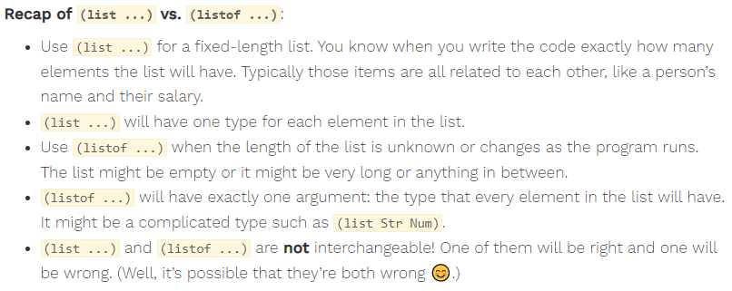
* 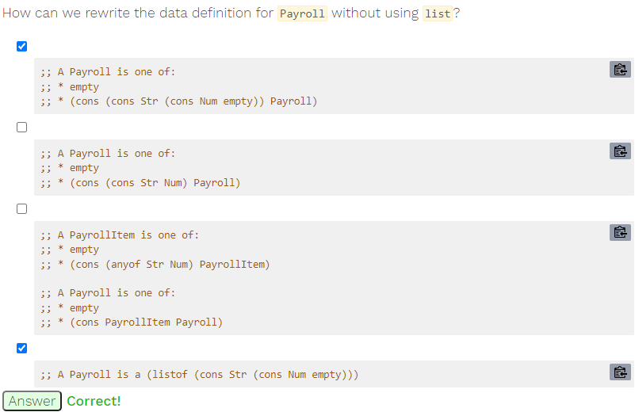

Template

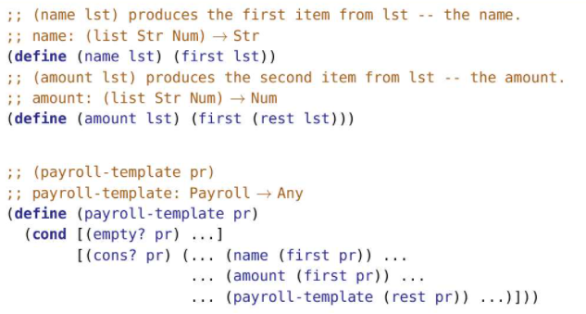

Alternate Template (Uses name and amount helper functions from previous template)

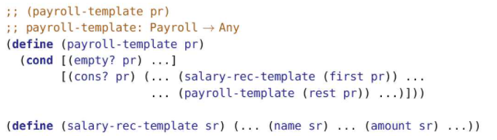

Template in Action

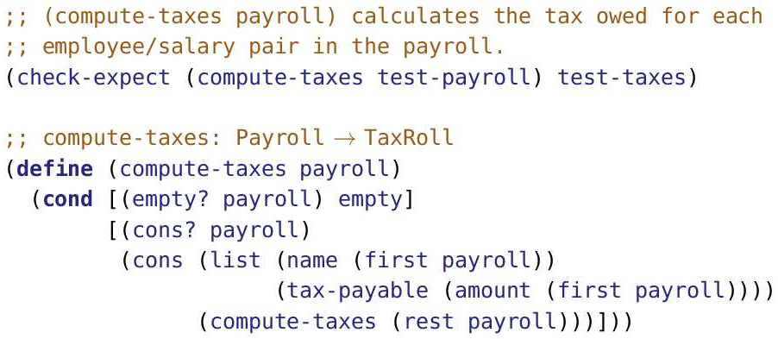

* What do you do in the base case?
  + There are no taxes owed if no one earned a salary. The contract says to produce a (listof X). empty fits both observations.
* How do you transform the first element on the list?
  + In this case, compute the taxes on the salary. Put that number together with the name into a two element list.
* What value is produced by the recursive processing of the rest of the list?
  + A list of taxes owed by the employees on the rest of the list.
* How do you combine the value produced in 2 with the value produced in 3?
  + Add the newly calculated taxes owed to the beginning of the list.

Alternate Solution

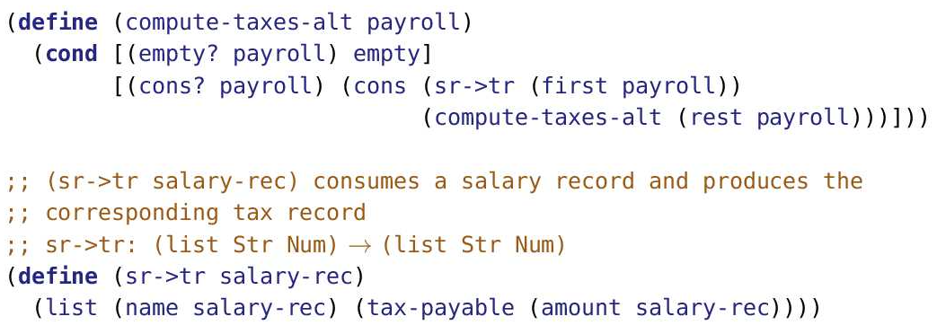

A really useful strategy is to break the problem into two parts:

* the part that handles the list and
* the part that handles one item from the list.

Dictionaries

* Contains a number of unique keys, each associated with a value
* Ex: Course marks: keys are userids, values are marks
* Ex: Stocks: keys are symbol, values are prices
* Many two-column tables can be viewed as a dictionary
* Keys must be unique, but values can be duplicated such as the marks below

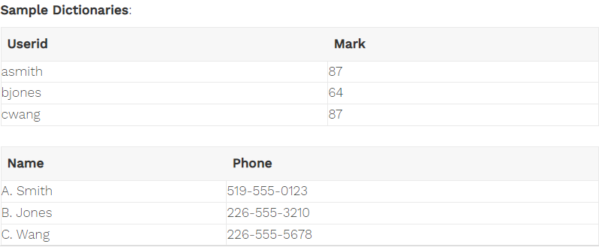

* Operations

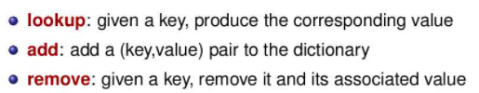

* lookup is also commonly called find or search.
* add is sometimes called insert
* Association Lists

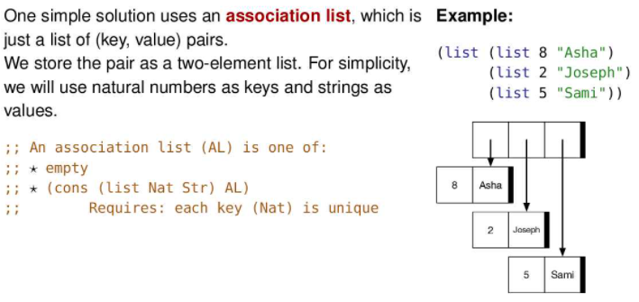

* The big advantage of an association list is that it is simple to implement.
* The big disadvantage is being increasingly slow as the dictionary gets larger (has more entries)
* Templates

;; An AL (association list) is a `(listof (list Nat Str))`

;; Requires: each key (Nat) is unique

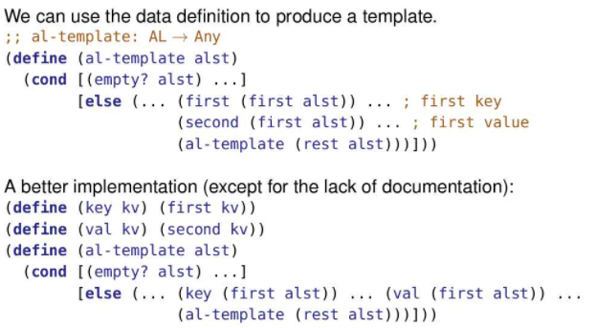

* lookup-al Implementation

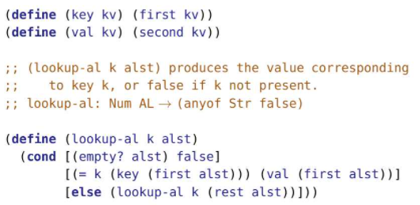

* For lookup the two stopping situations are (1) when we get to the end of the list(returns false) and (2) when we find what we’re looking for (returns the value that corresponds to the key).
* (anyof …) notation in contracts
  + Use (anyof X Y …) to mean any of the listed types of values
  + Ex: (anyof 1 2 3)
  + A contract of (anyof Sym Str) -> Num means the function could consume a symbol or it could consume a string. Both work, but a number does not.
  + We’re now allowing values into our contracts. To say that lookup-al on the previous slide produces (anyof Str Bool) is correct. If the key is found, it produces a string. If the key is not found, it produces a Boolean. But lookup-al never produces true, so it’s more accurate to say that it produces (anyof Str false). We now allow our contracts to include specific values.

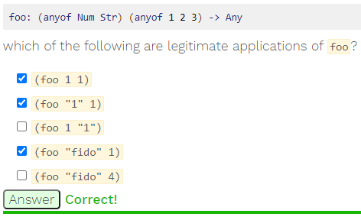

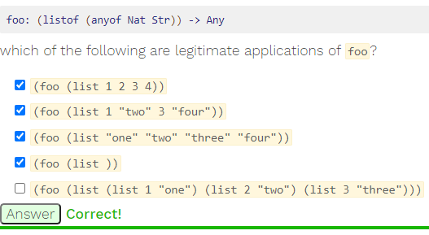

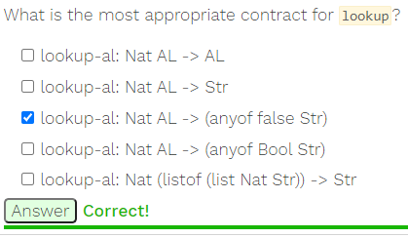

* add-al implementation

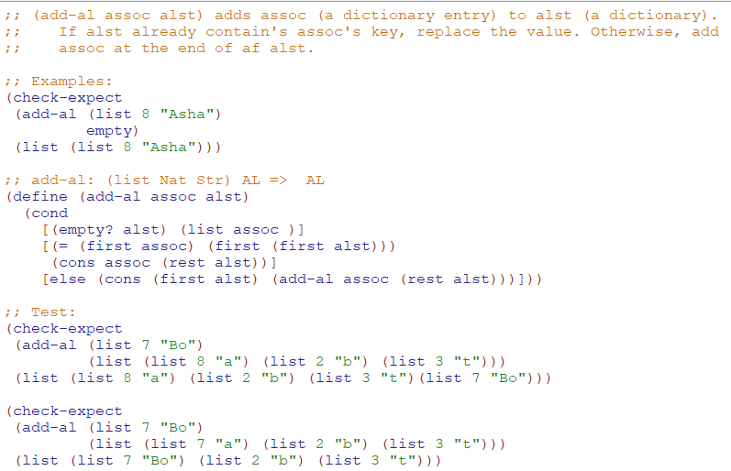

* remove-al implementation

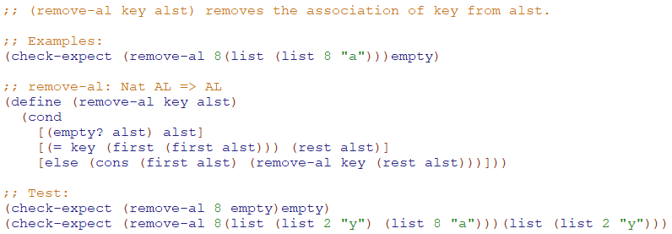

2D data

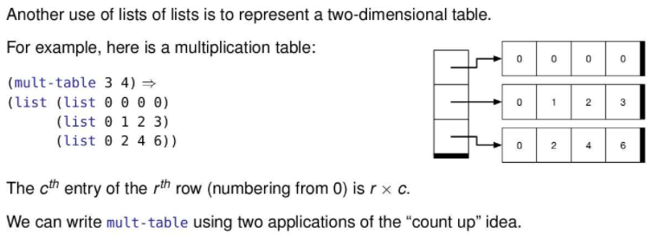

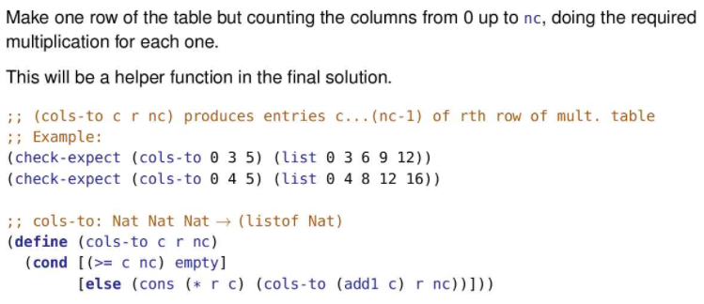

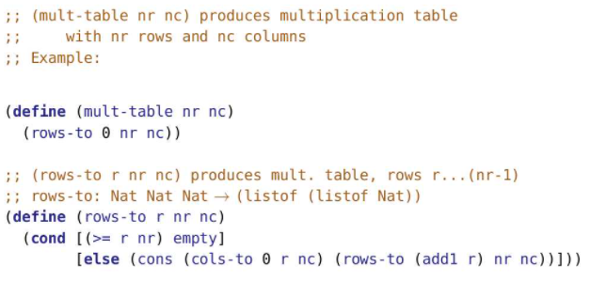

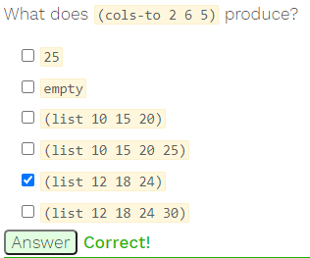

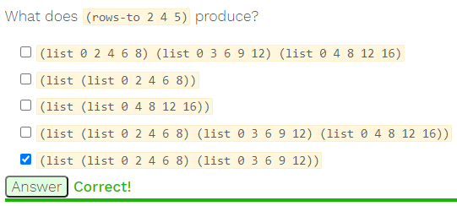

Processing two lists

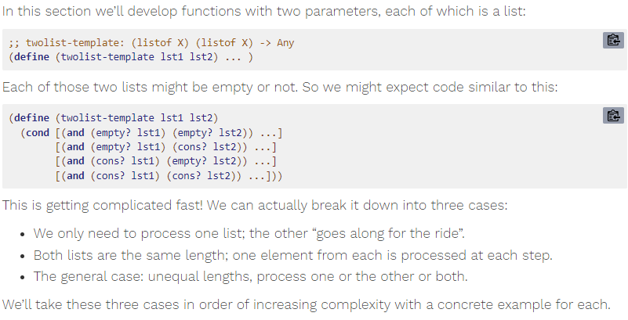

Case 1: Processing Just One List

Ex: add lst2 to the end of lst1

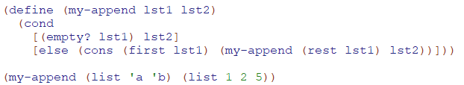

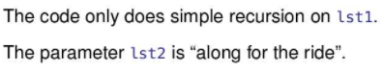

Trace

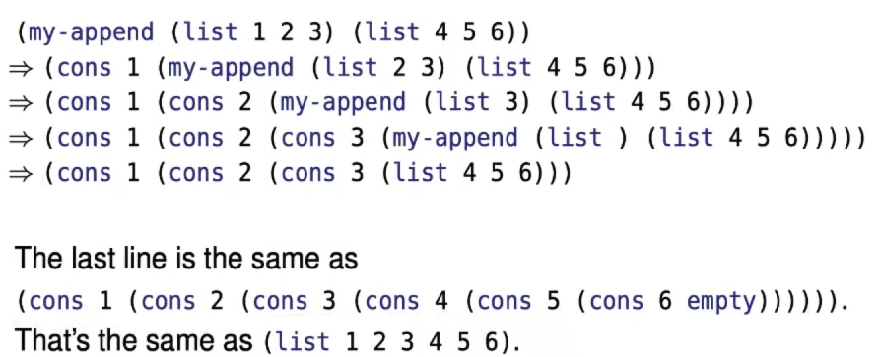

Ex:

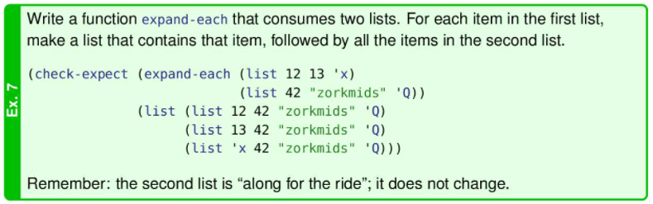

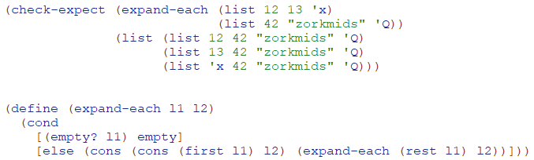

Case 2: Processing In Lockstep

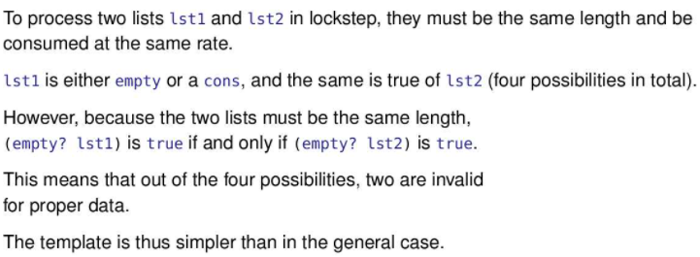

Ex:

Suppose we want to find the dot product of two vectors. Recall v1 = [a,b,c] and v2=[d,e,f], their dot product is ad+be+cf.

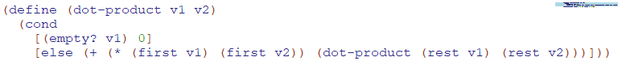

Trace

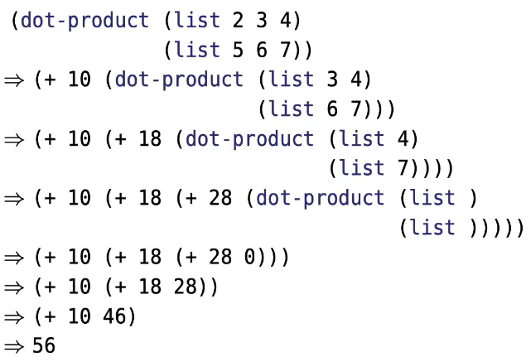

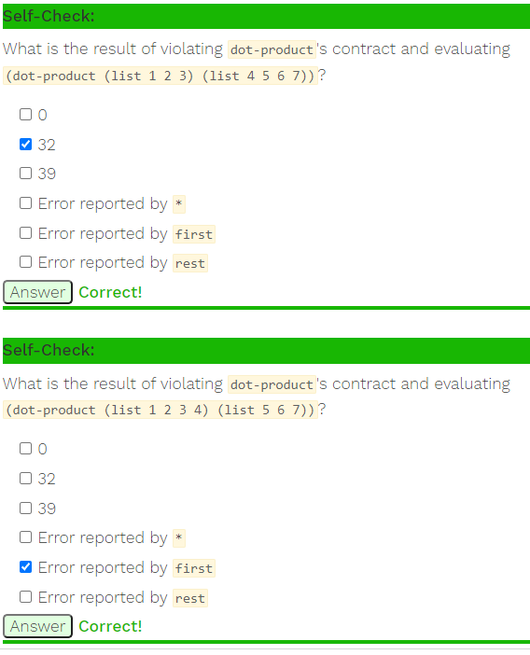

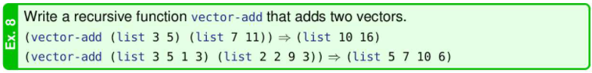



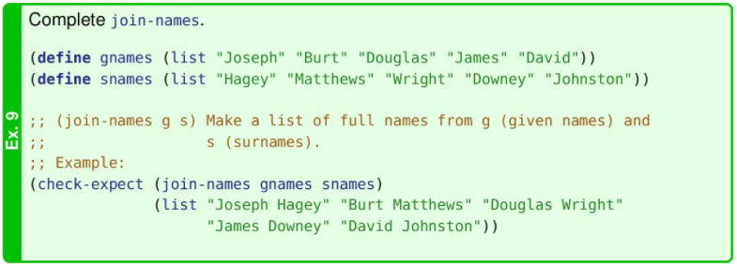

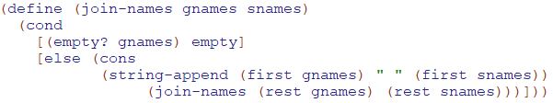

Case 3: Processing at different rates

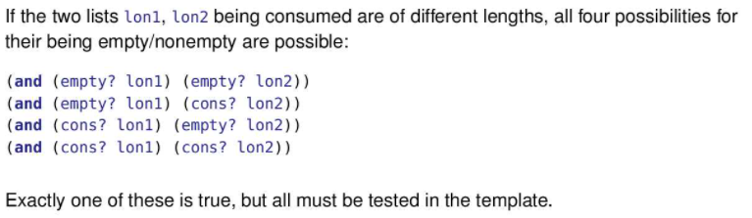

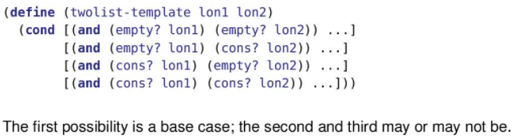

Ex: Merge two sorted lists

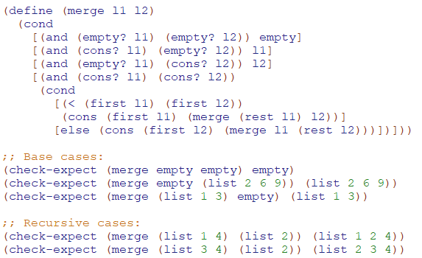

Ex: See if two lists are identical

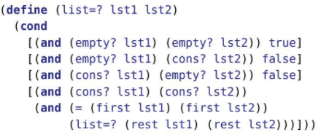

Ex: See if a list has at least n instances of an element

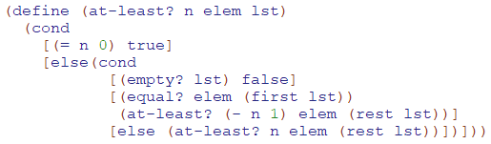

* The idea is we check the first item and if it is an instance of a the target element, we check if there are n-1 instances of the target element in the rest of the list
* We made (= n 0) condition first since this allows us to terminate the function once we know there is at least n items so we don’t have to keep looking through the rest of the list.

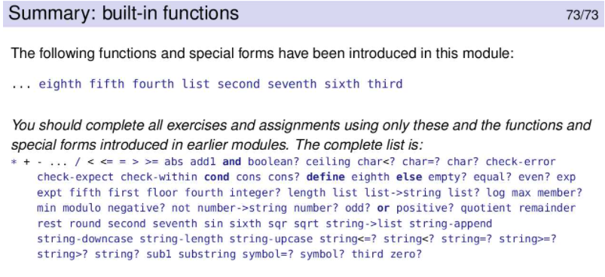

**Module 9**

Simple Recursion



* Note: recursive function application is where the function calls itself
* Identifying Simple Recursion
* To identify simple recursion, look at the arguments to the recursive function application – those places where the function applies itself recursively.
* In the first example, the only argument is one step closer to the base case (lst with the first element removed). Note that the data definition is in terms of the first element and the rest of the list. So “one step closer to the base case” means removing the first element. A list that is one item shorter is not “one step closer to the base case” unless it is shorter because it’s missing the first element. Removing the second element doesn’t count!
* The second example is like the first except that there is an additional parameter that is passed along unchanged. The count-string exercise is an example of this.
* In the third example, process is meant to capture doing something to lst other than removing an element.
* In the fourth example, math function applied to x indicates that x is changed. In both cases, the function is no longer “simple recursion”.
* Limits of Simple Recursion
  + Consider the following function that returns the max number in a list of numbers
  + 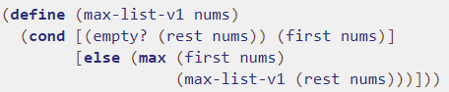
  + It uses simple recursion and works correctly.
  + Now consider the following reasoning:
    - The application of any function, including max, requires some overhead. Since max is so simple I’ll just write max-list using > to find the maximum of the two numbers without max function and the associated overhead.
    - Note: Overhead is the combination of excess or indirect computation time, memory, bandwidth, or other resources required to set up an operation. It might seem unrelated, but necessary.
  + This logic would result in the following code
  + 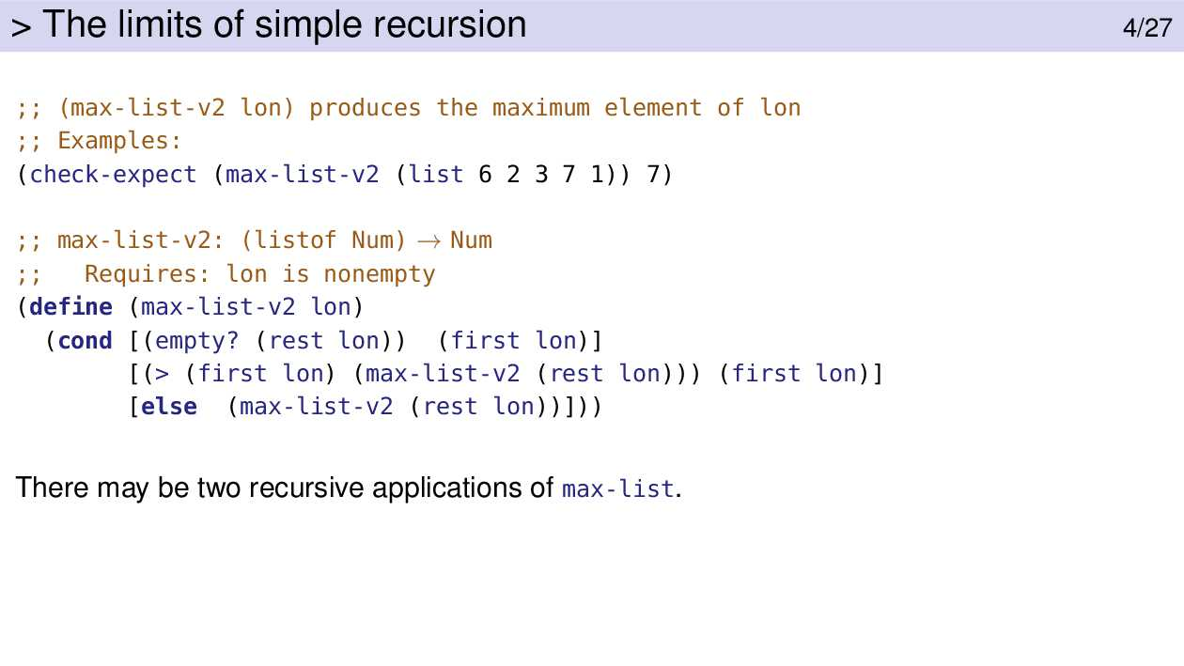
  + Notice that it calls max-list-v2 twice, once in the 2nd condition, and once in the expression for the else condition.
  + THIS IS MUCH SLOWER.
  + Let l-25 be a list with length 25
  + Take the example we are trying to find (max-list-v2 l-25)
  + The initial application is on a list of length 25
  + There are two recursive applications on the rest of this list, which is of length 24
  + Each of those makes two recursive calls
  + Below are examples where the input list has length 3 and length 25
  + 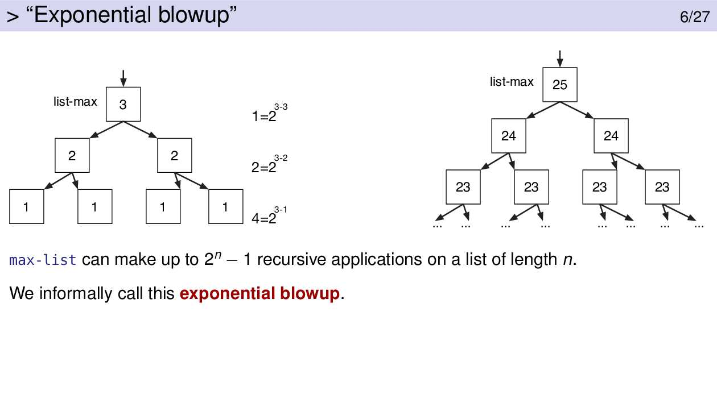
  + Max-list-v2 can make up to (2^n)-1 recursive applications on a list of length n.
  + We call this exponential blowup

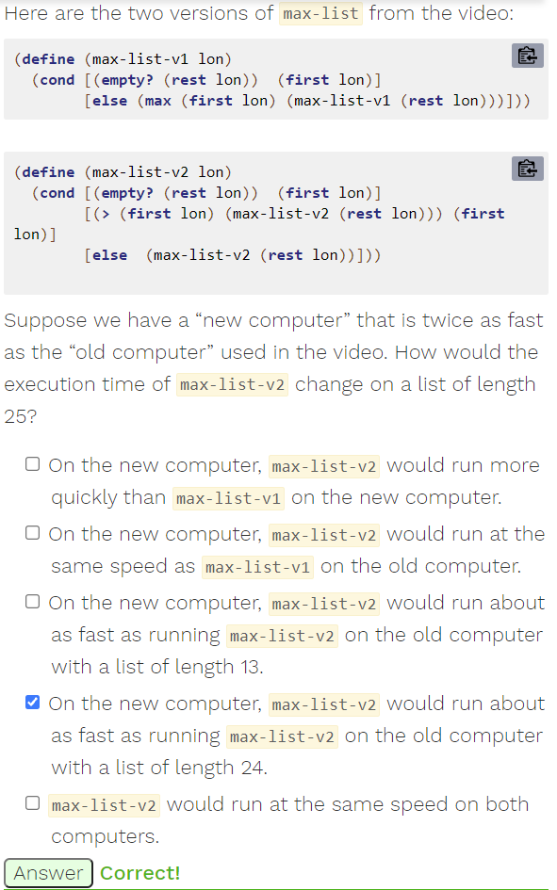

For a list of length n, max-list-v2 takes (2^n)-1 calls

If the ‘old computer’ runs max-list-v2 on a list of length 24, it would take (2^24)-1 calls

If the ‘new computer runs max-list-v2 on a list of length 25, it would take (2^25)-1 calls

Since the ‘new computer’ is twice as fast, it can make two recursive calls in the time it takes the ‘old computer’ to make 1 recursive call.

Time for 1 recursive call on old computer = Time for 2 recursive calls on new computer

Multiplying both sides by (2^24)-1,

=> Time for (2^24)-1 recursive call on old computer = Time for 2((2^24)-1) recursive calls on new computer

Expanding the right hand side,

=> Time for (2^24)-1 recursive call on old computer = Time for (2^25)-2 recursive calls on new computer

Note: Time for (2^25)-2 recursive calls on a new computer is about the time for (2^25)-1 recursive calls on a new computer (differs by 1 call). (2^25)-1 recursive calls is the number of recursive calls for a list of length 25

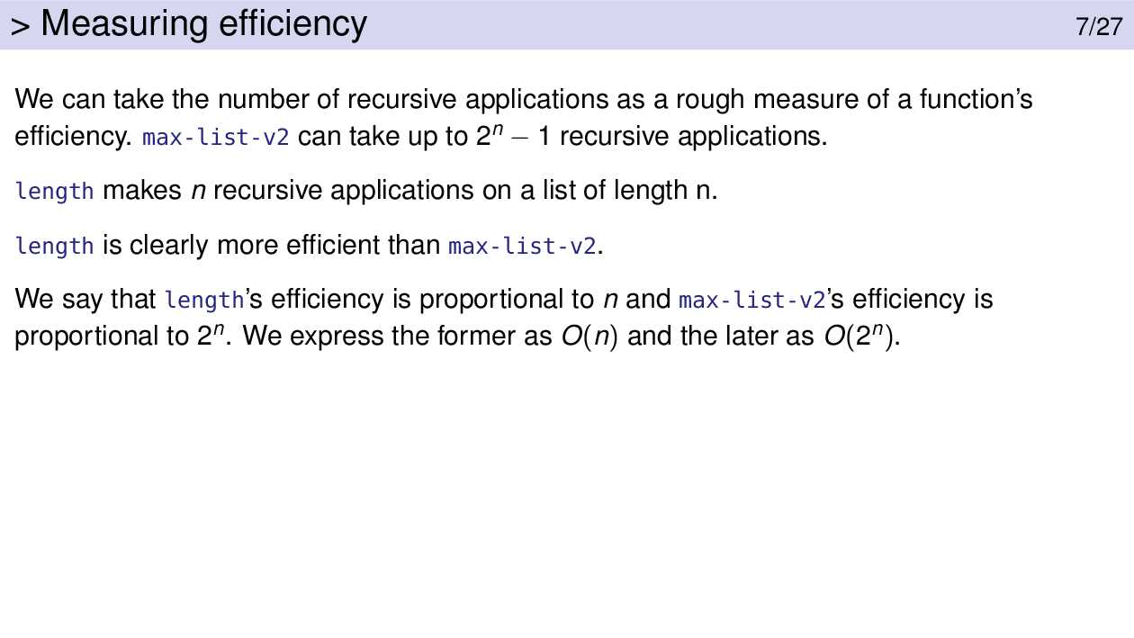

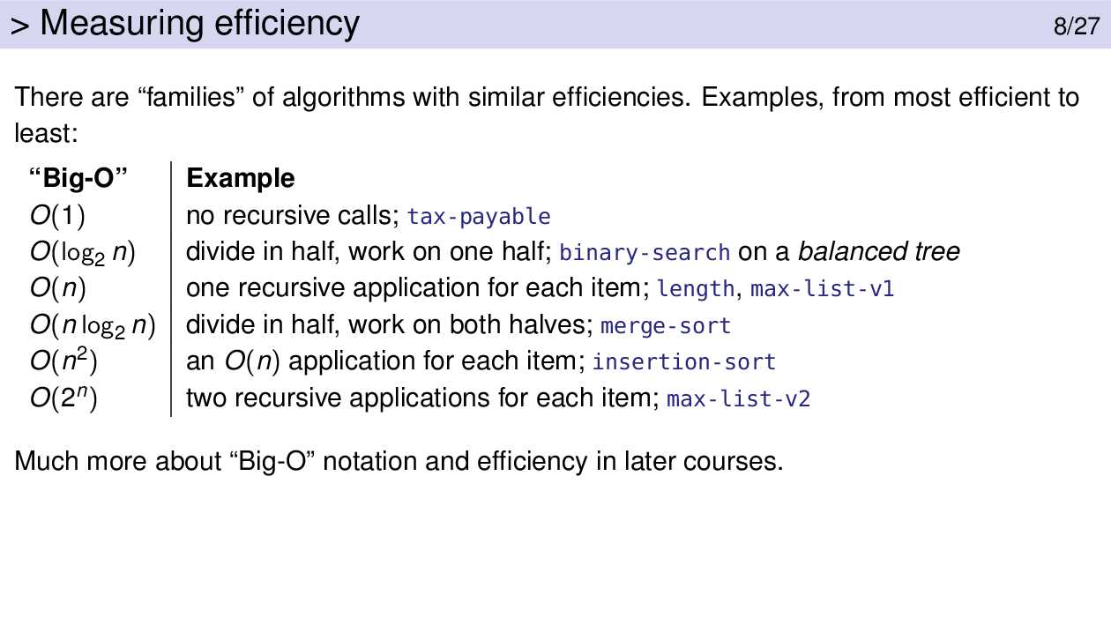

As of now, we need to know that functions can be placed into different “families” of efficiency and that some of those families are considerably more efficient (faster) than others.

We need to know how to recognize when your function applies itself recursively twice and to be able to avoid that. Note that the following code is not necessarily a problem:

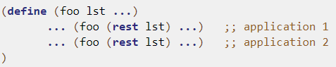

It’s OK if one application of (foo ...) applies foo at either application 1 or application 2. It’s a problem if one application of foo does both of them.

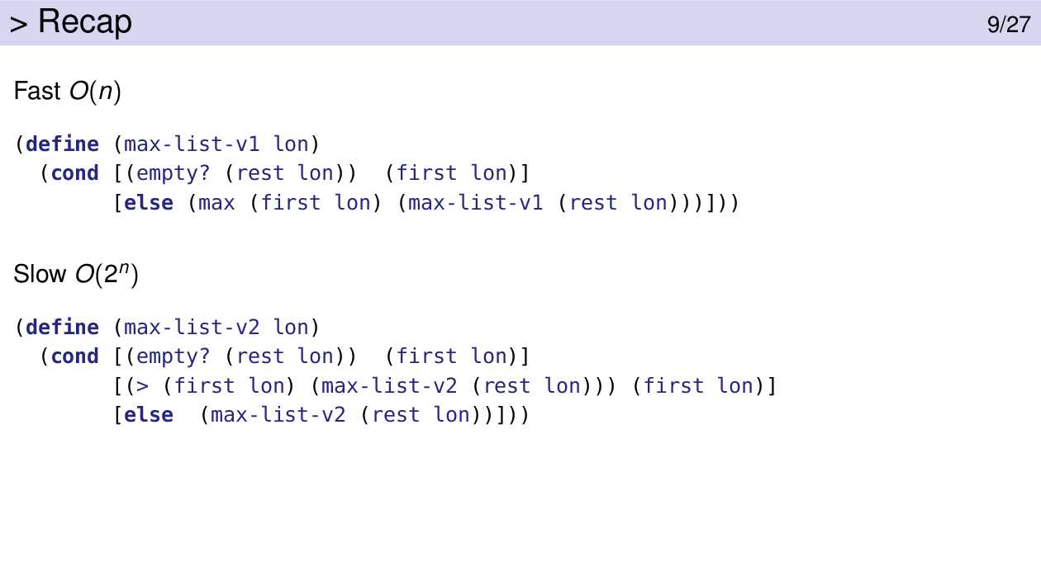

In many cases the slow version does the exact same computation twice: (max-list-v2 (rest lon)). That leads to exponential blowup.

The fast version does the computation (max-list-v1 (rest lon)) and passes that result to a helper function. The helper function can make use of that value as often as it needs to without calculating it again, thus avoiding exponential blowup.

Accumulative Recursion

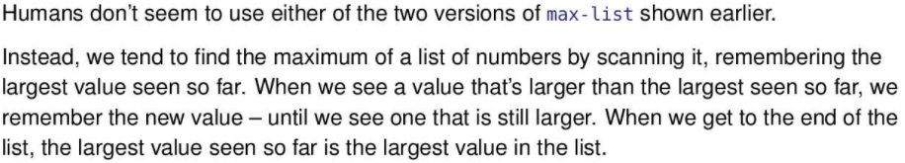

In the fast version of the two versions of max-list shown earlier, it compares the n-th element with the biggest of all the other elements. It does not compare the n-th element with the biggest element of the entire list as there are elements before the n-th element that are not being compared to the n-th element.

The human algorithm compares the n-th element with the biggest element. It does not compare the n-th element with any other element.

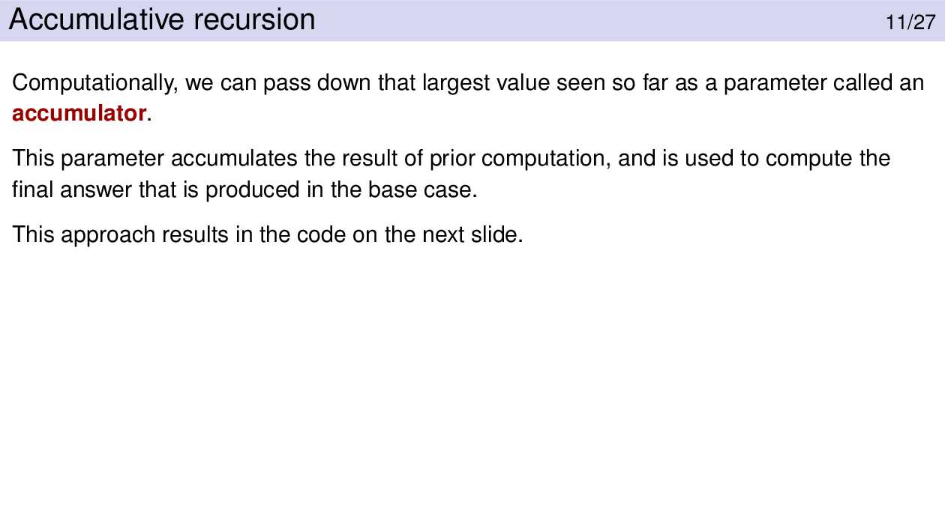

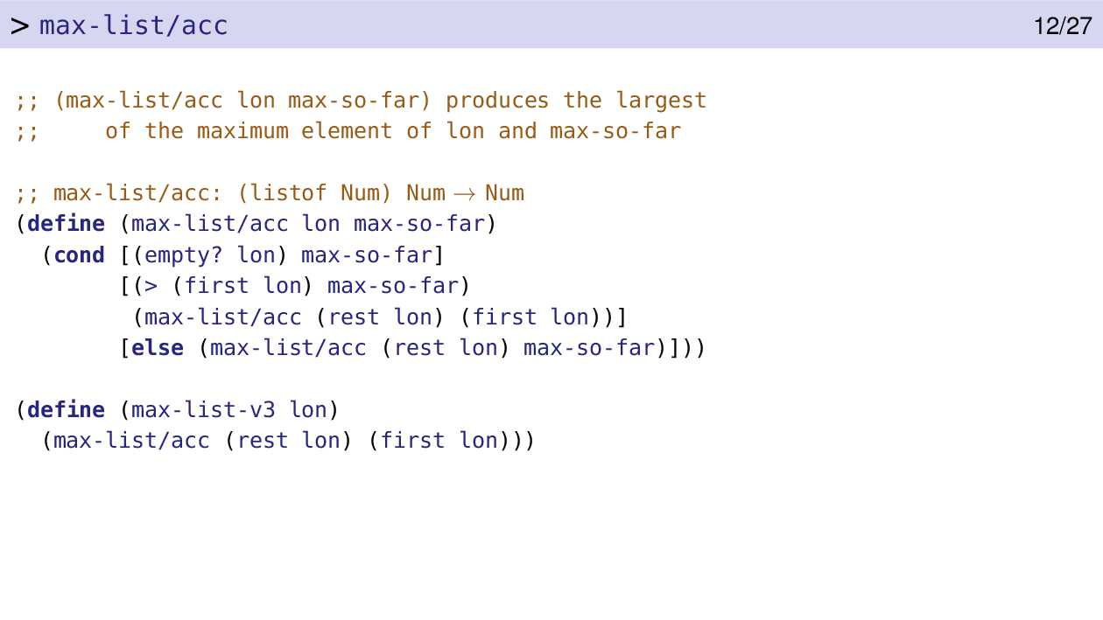

max-list/acc is not simple recursion! In simple recursion the arguments where max-list/acc is applied would be either one step closer to the base case or unchanged. The first argument, (rest lon), is one step closer to the base case. But the second argument is sometimes max-so-far (that is, unchanged) and sometimes (first lon). It’s that last one that kills it. (first lon) is neither one step closer to the base case nor is it unchanged. Therefore this isn’t simple recursion.

max-list-v3 is a simple wrapper around max-list/acc, which does the actual work. Wrappers are often used with accumulative recursion due to the extra parameters which need to be initialized.

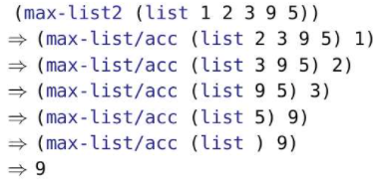

The first time max-list/acc is applied the max-so-far parameter is set to 1, the first element on the list. The lon parameter is set to the rest of the list.

That first application of max-list/acc looks at the first element of lon, the remainder of the list, and realizes that it’s bigger than the maximum value seen so far. So max-list/acc is applied with that new value (2) and the rest of the list. This happens 2 more times with 3 and 9. At each stage max-so-far is the maximum value seen in the list so far.

When the first value of lon is 5, it is not bigger than max-so-far and so max-so-far is left unchanged in the next function application.

When the list is empty we’ve examined the entire list and max-so-far is the answer produced by the base case.

This technique (human algorithm) is known as accumulative recursion which is harder to write. Simple recursion will continue to be the main tool in our programming toolbox. However, sometimes accumulative recursion will be easier or yield a more efficient or elegant solution. In such cases we strongly encourage you to use it.

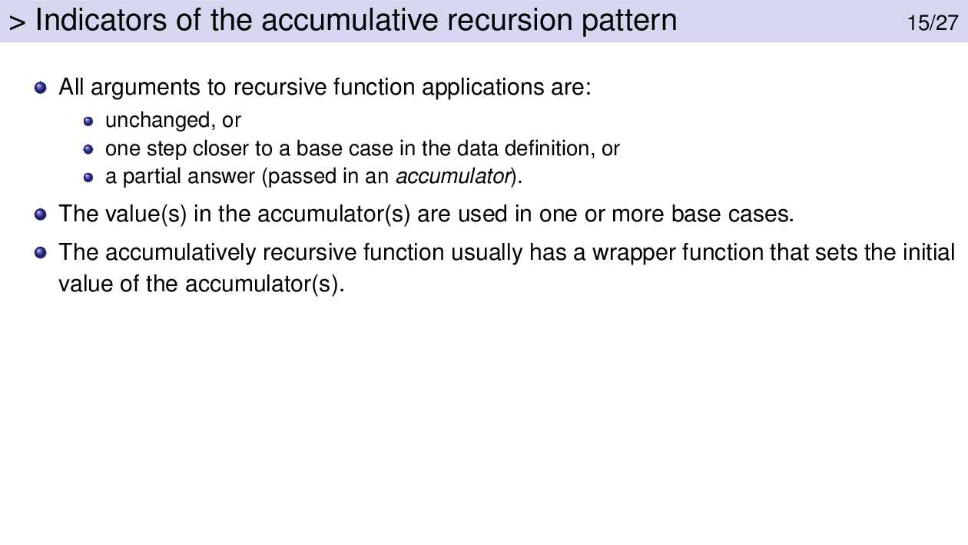

An accumulative function requires at least one accumulator; there may be more than one.

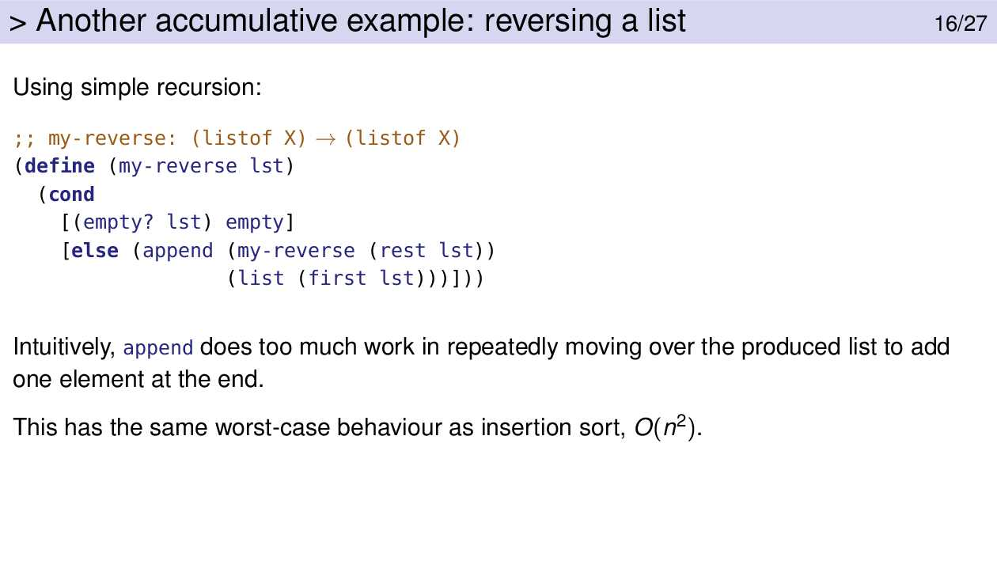

Note, to append an item to the end of a list, we have to traverse to the end of the list, then cons it on. Thus simple recursion is inefficient since uses append over and over. Since append is not constant time, the many appends will make a difference.

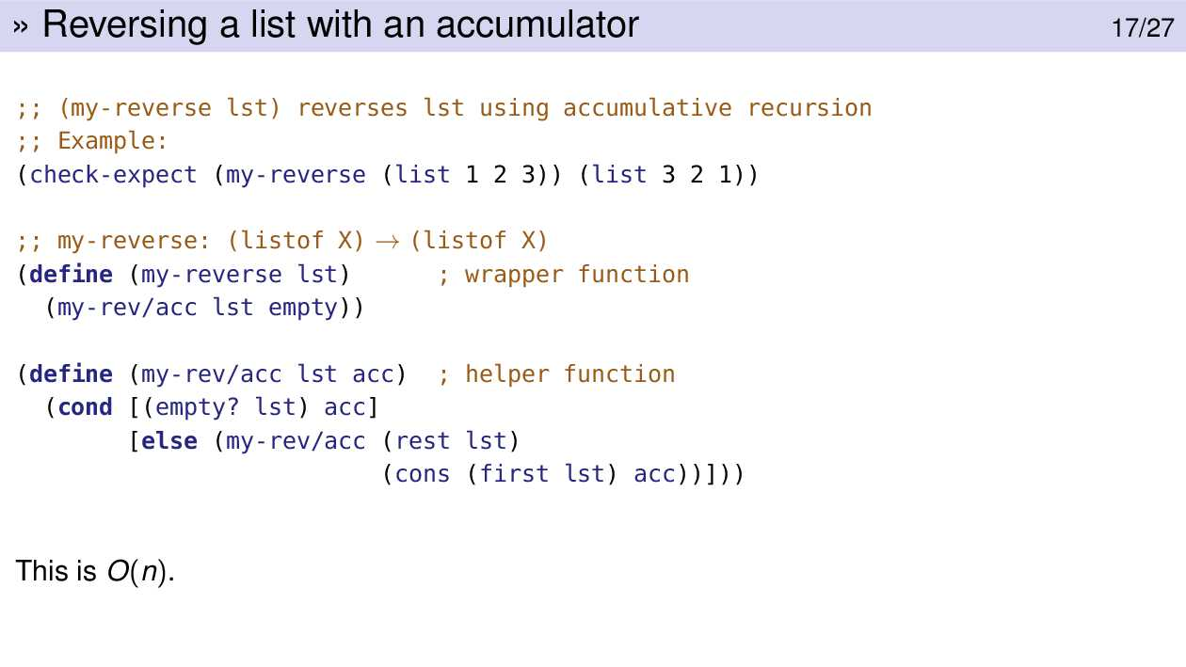

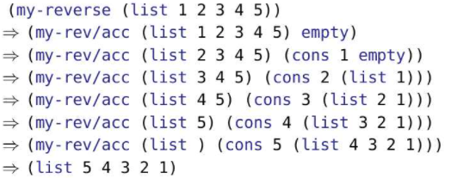

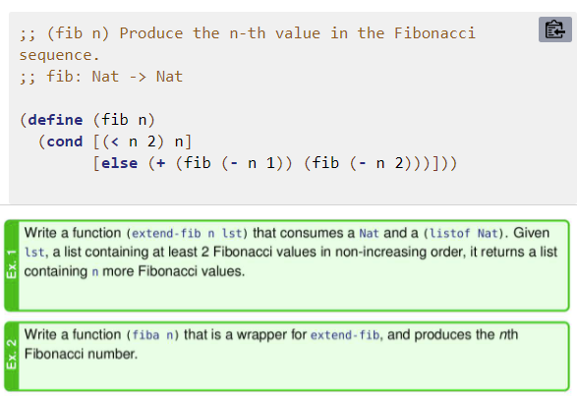

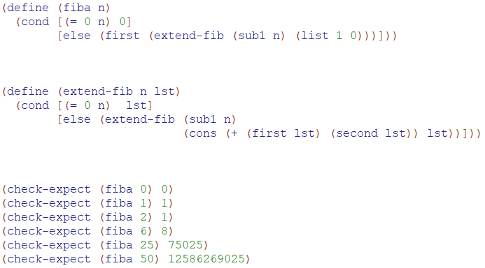

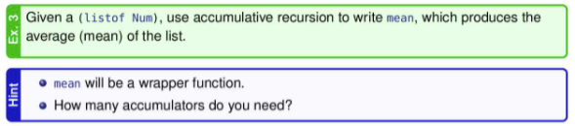

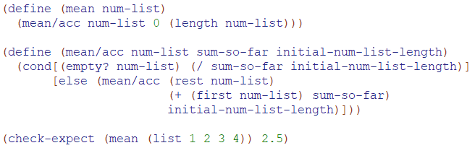

Generative Recursion

* Below is an example of generative recursion

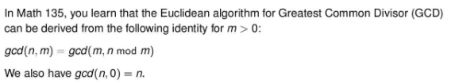

* 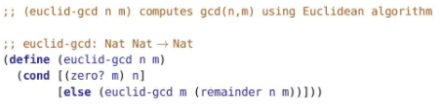
* How does one come up with the idea to do this? That is why generative recursion is hard
* 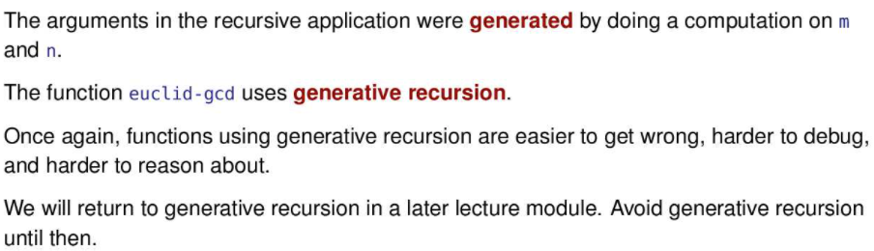

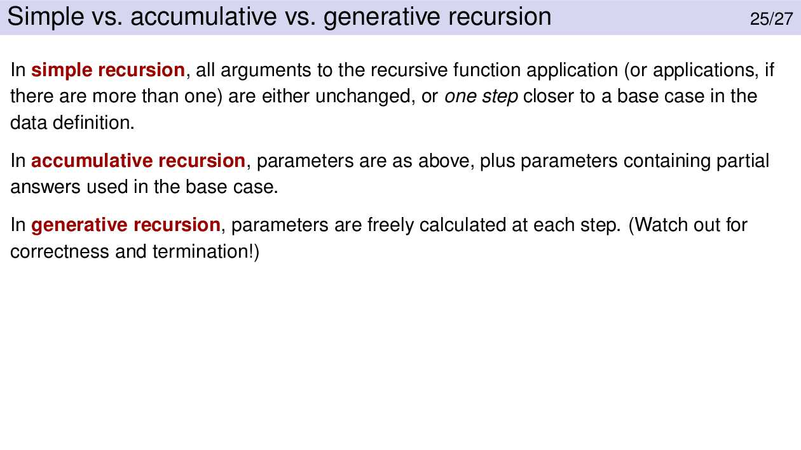

Freely calculated” means that there are no constraints.

Simple recursion has the constraint that the calculation must give a result that’s one step closer to the base case.

Accumulative recursion has a constraint that the calculation must be closer to the solution.

With generative recursion, there are no constraints on the calculations.

In CS135, if it’s not the simple recursion pattern and it’s not the accumulative recursion pattern, then it must be the generative recursion pattern.

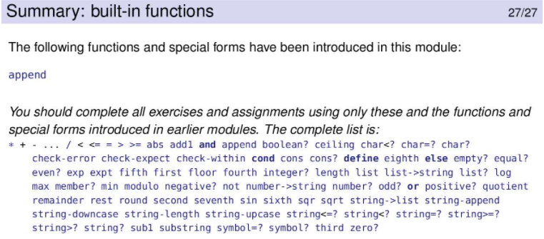

Module 10

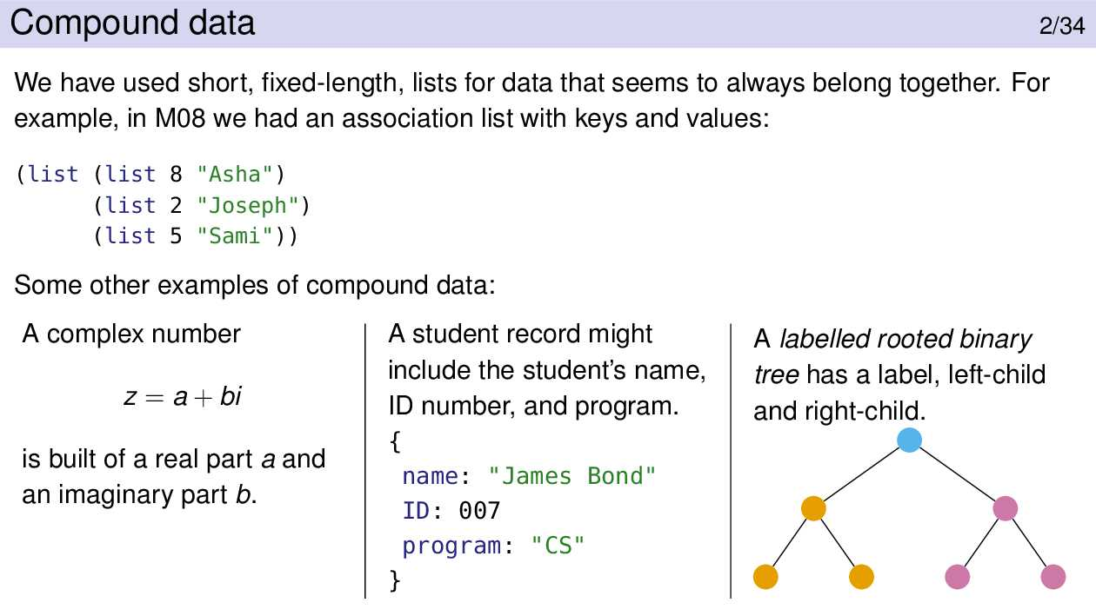

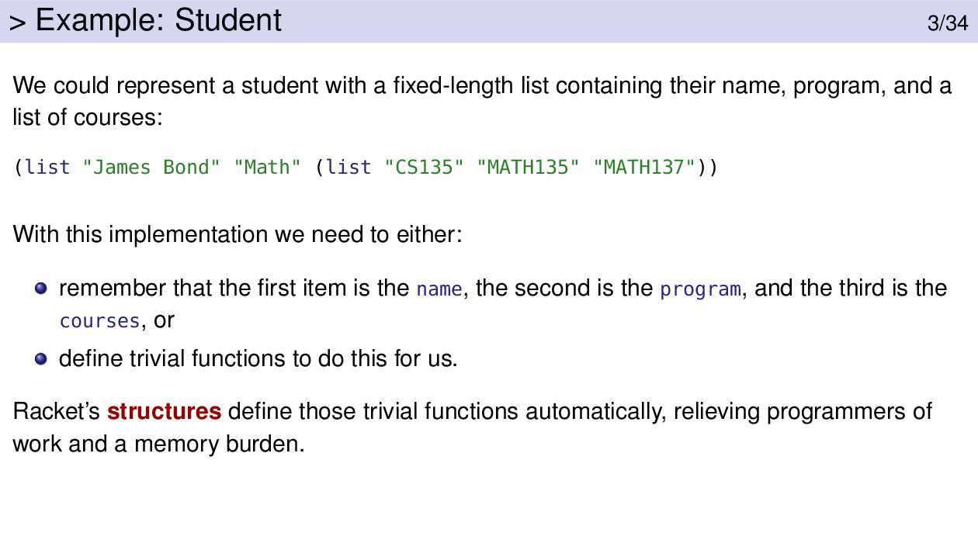

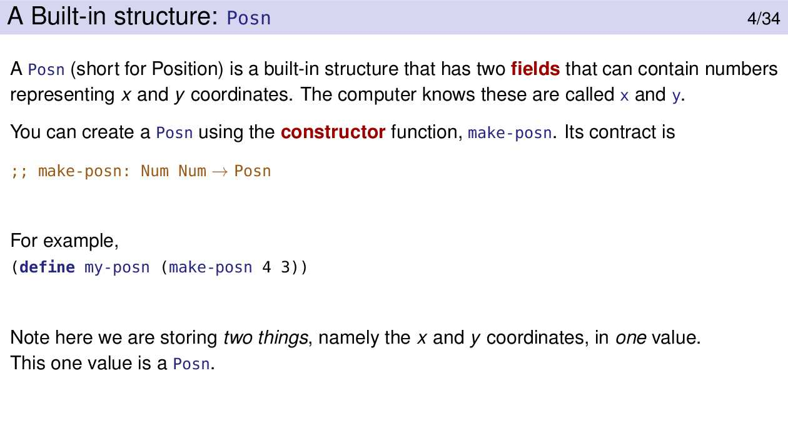

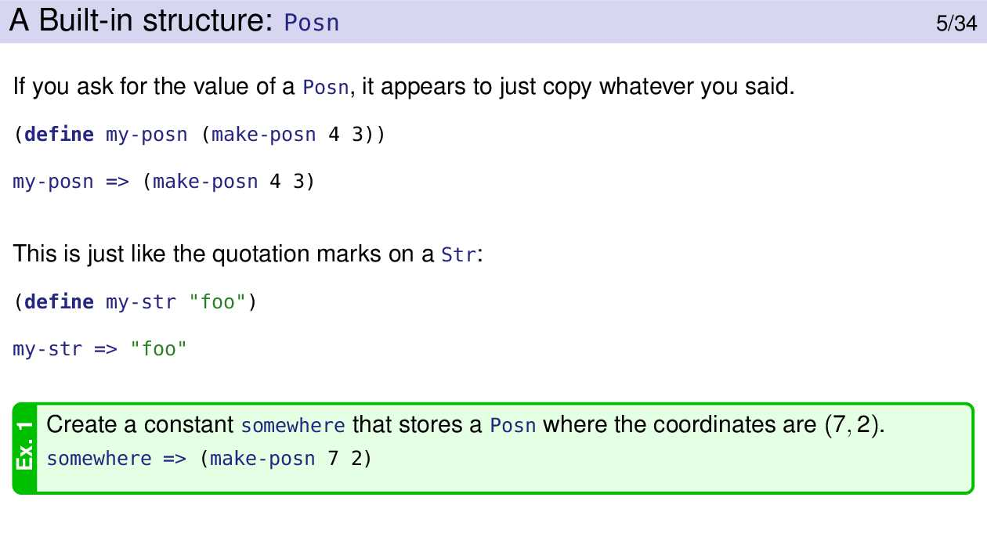

(define somewhere (make-posn 7 2))

Structures like (make-posn 4 3) are values, just like 3, true, "Hello World" and (list 1 2 3) are values.

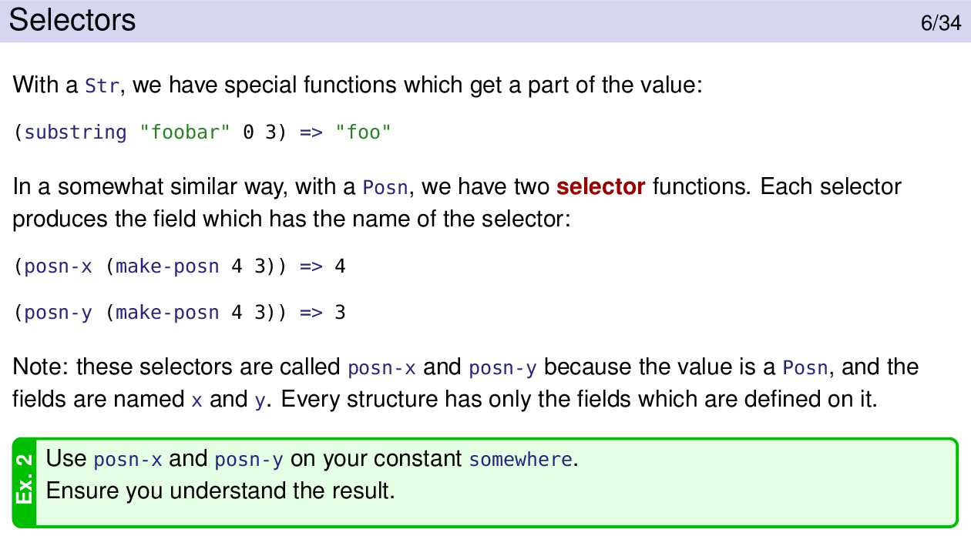

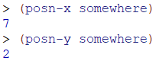

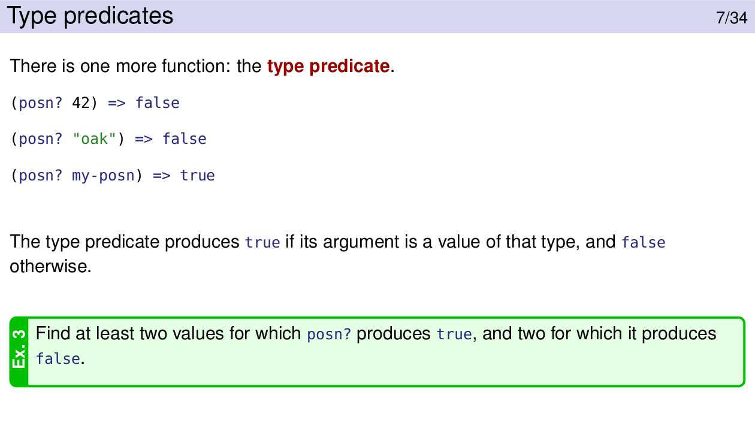

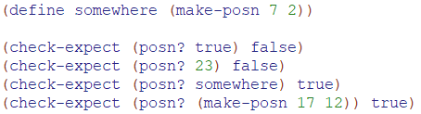

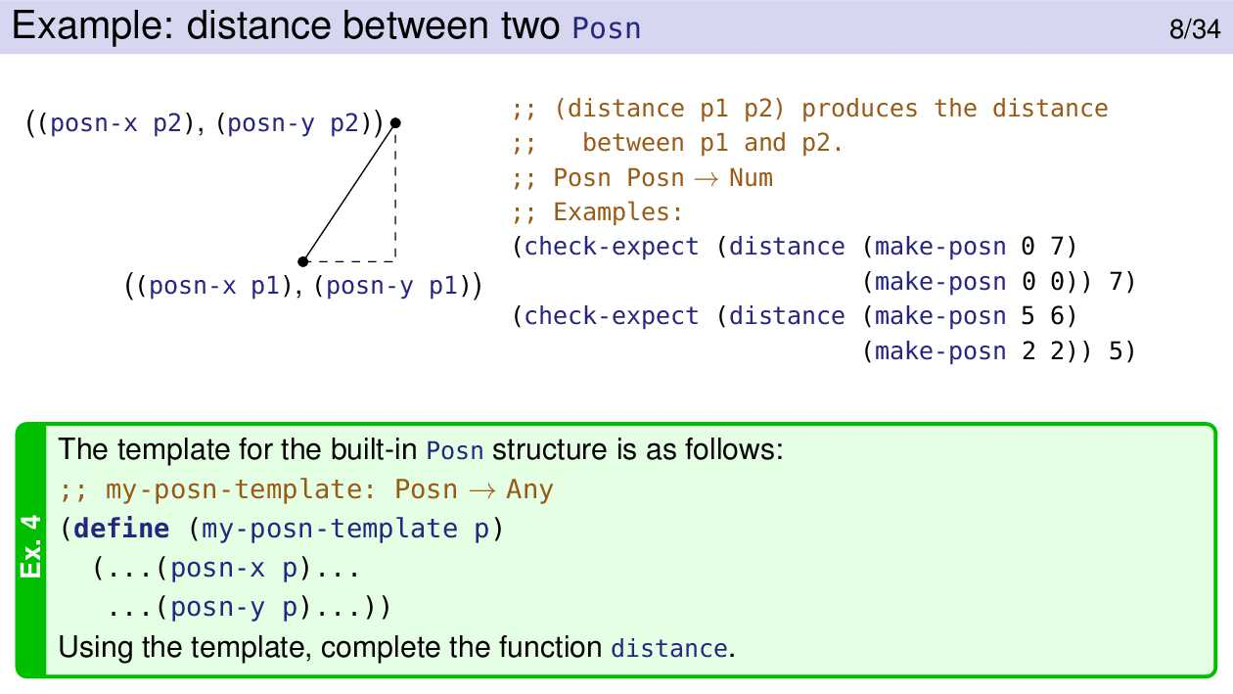

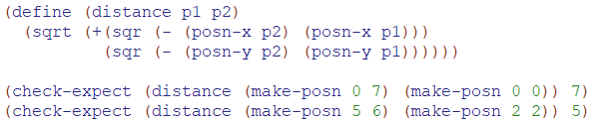

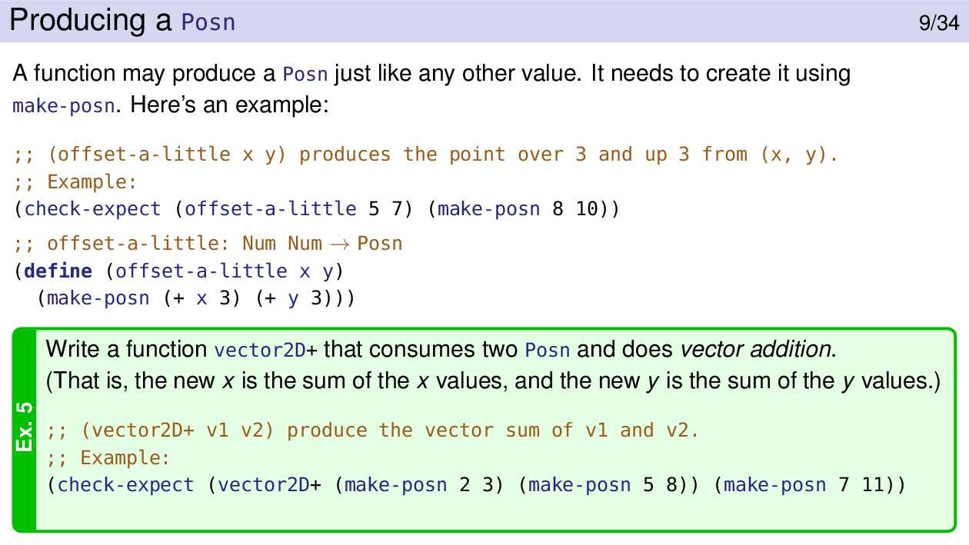

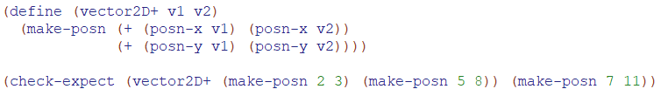

(define-struct)

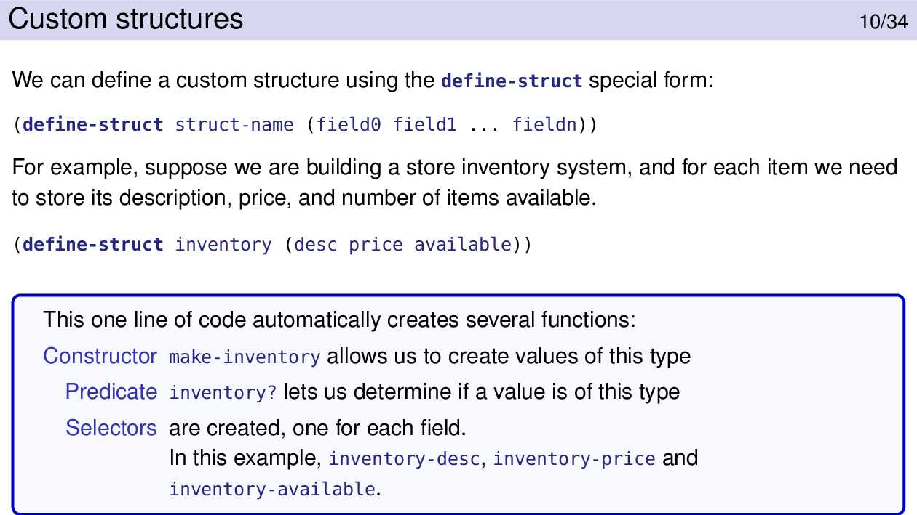

* When define-struct is given n field names, it defines n+2 functions: one constructor, one predicate, and n selector functions.

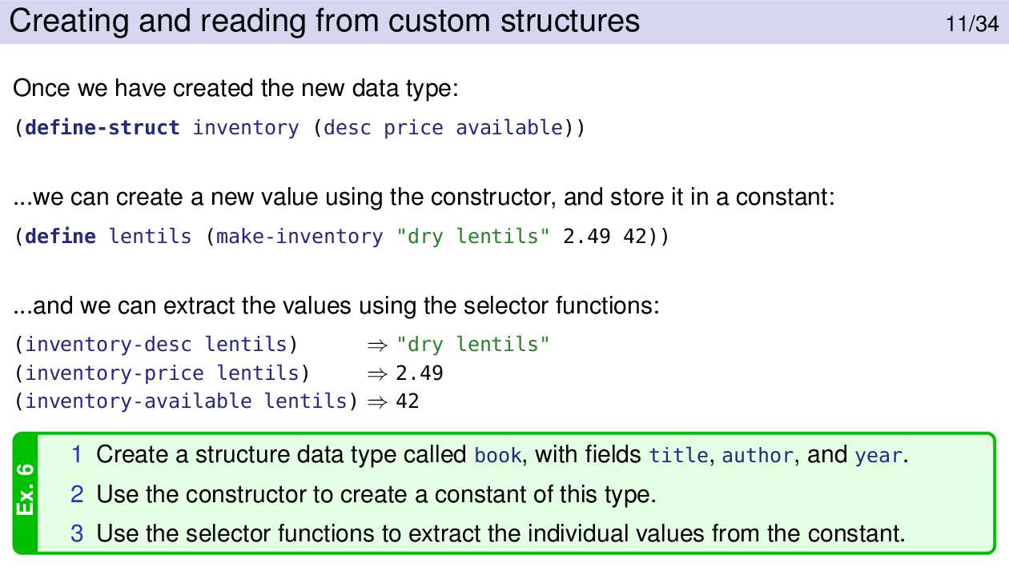

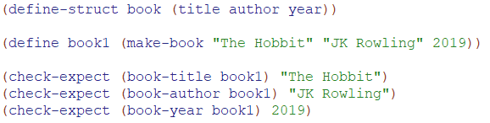

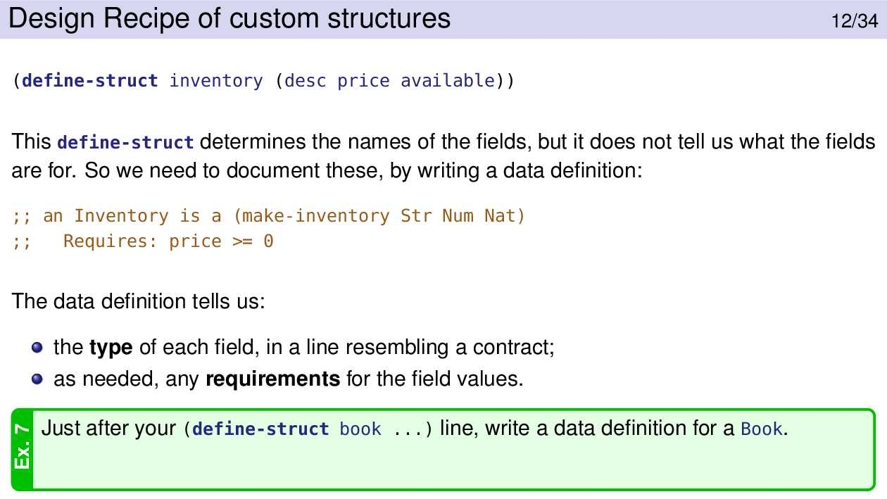



The define-struct is followed by a data definition that says what types each of the structure’s fields are expected to be. The data definition for a structure is of the form

;; A <type-name> is a (make-<sname> <type> ...)

where you fill in the parts between angle brackets. <sname> is the first argument to define-struct. Snake (note the capitalization may be used in contracts)

The relationship between the define-struct and its data definition is similar to a function and its contract. Just as you wouldn’t dream of writing a function without a contract, you shouldn’t have a structure definition without a data definition.

The data definition is just a comment, so it has no meaning to Racket. Therefore, Racket does not know what types we expect each field to have. It can’t check, for example, that the name and program are strings and that classes is a list.

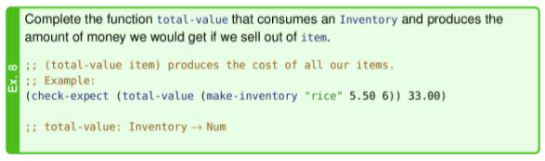

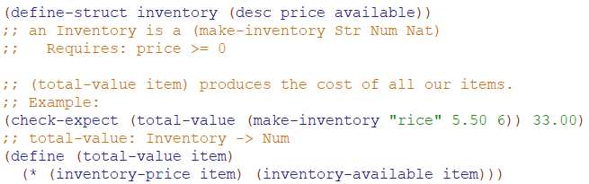

Substitution Rules For Structures

* 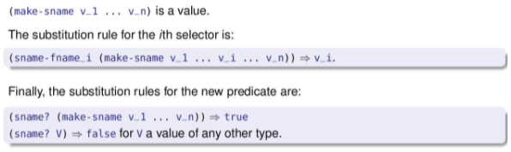
* Ex:

(define-struct std (name program classes))

(define (add-class s class)

(make-std (std-name s)

(std-program s)

(cons class (std-classes s))))

(define jo (make-std "Jo" "CS" (cons "MATH 137" empty)))

(add-class jo "CS 135")

=>(add-class (make-std "Jo" "CS" (cons "MATH 137" empty)) "CS 135")

=>(make-std

(std-name (make-std "Jo" "CS" (cons "MATH 137" empty)))

(std-program (make-std "Jo" "CS" (cons "MATH 137" empty)))

(cons "CS 135" (std-classes (make-std "Jo" "CS" (cons "MATH 137" empty)))))

=>(make-std

"Jo"

(std-program (make-std "Jo" "CS" (cons "MATH 137" empty)))

(cons "CS 135" (std-classes (make-std "Jo" "CS" (cons "MATH 137" empty)))))

=>(make-std

"Jo"

"CS"

(cons "CS 135" (std-classes (make-std "Jo" "CS" (cons "MATH 137" empty)))))

=>(make-std

"Jo"

"CS"

(cons "CS 135" (cons "MATH 137" empty)))

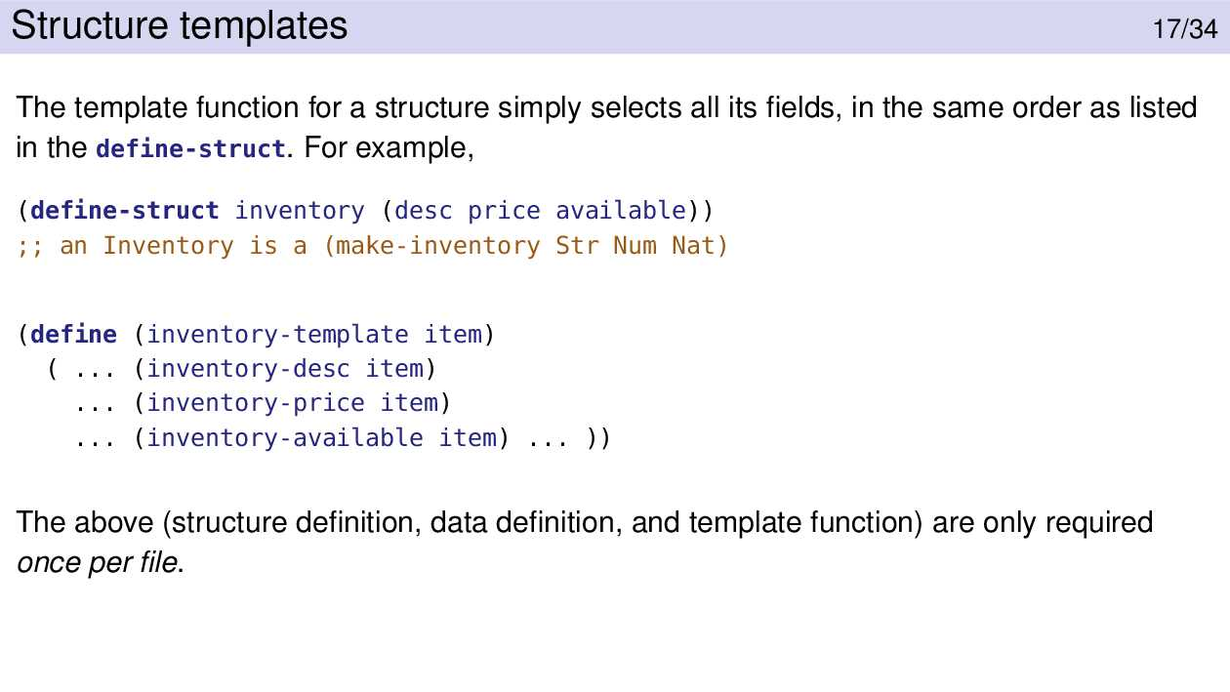

The fields are listed in the same order in the template as in the define-struct so a new structure can be easily constructed with them.

Students who have programmed in an imperative language will often ask how to change the contents of a field. The answer is that you don’t. You create a new structure with the same information except for the field(s) you want to change.

Mixed Data

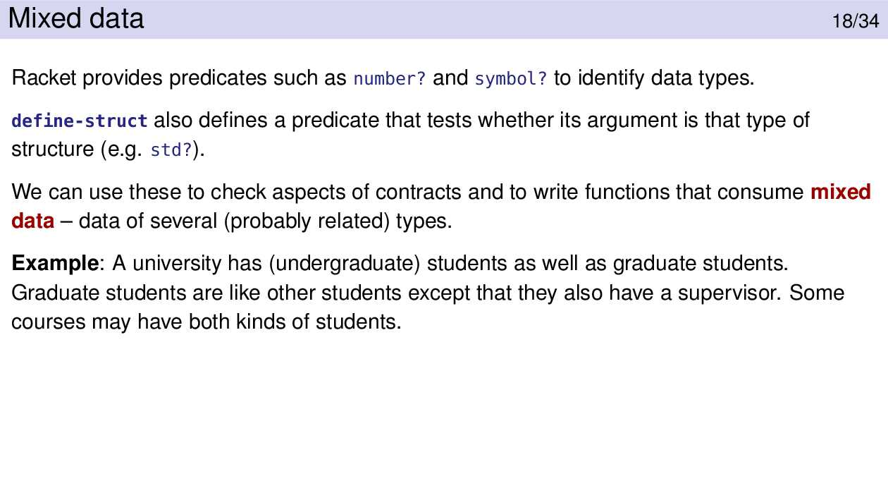

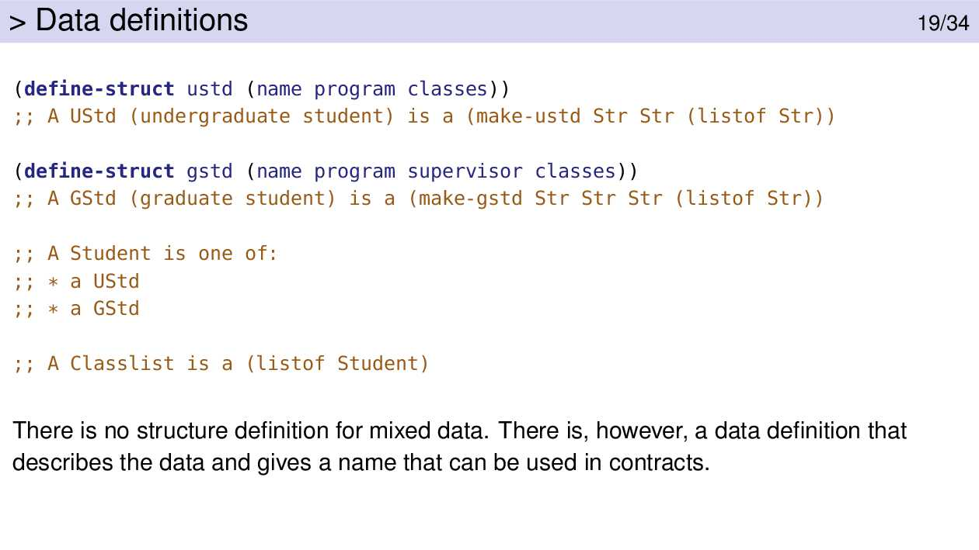

Types like Student and Classlist are for our benefit only. They help us understand the data that our functions consume and produce.

However, DrRacket doesn’t know anything about them; they only appear in comments. That’s different than the structures ustd and gstd. Racket does know about them, thanks to the define-struct expressions.

An alternative definition of Student is ;; A Student is (anyof UStd GStd). We tend towards the other definition because it translates more neatly into the template (and code) for handling Students, but you should be prepared to work with either form and understand why they are equivalent.

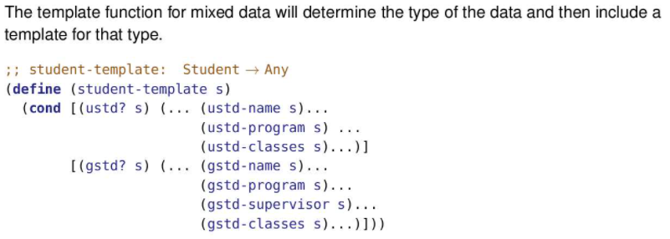

An alternative for student-template would define and then use ustd-template and gstd-template:

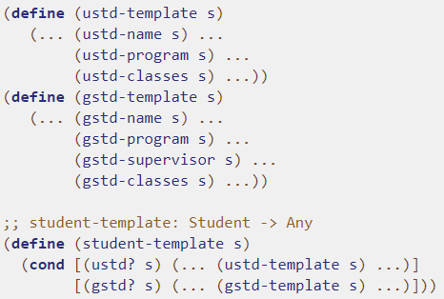

Implementing a function would then mean writing three functions based on these templates. For a simple function it may not be worth the work. But for a more complex function, breaking the problem down into parts makes the solution more approachable, easier to test, and in general easier.

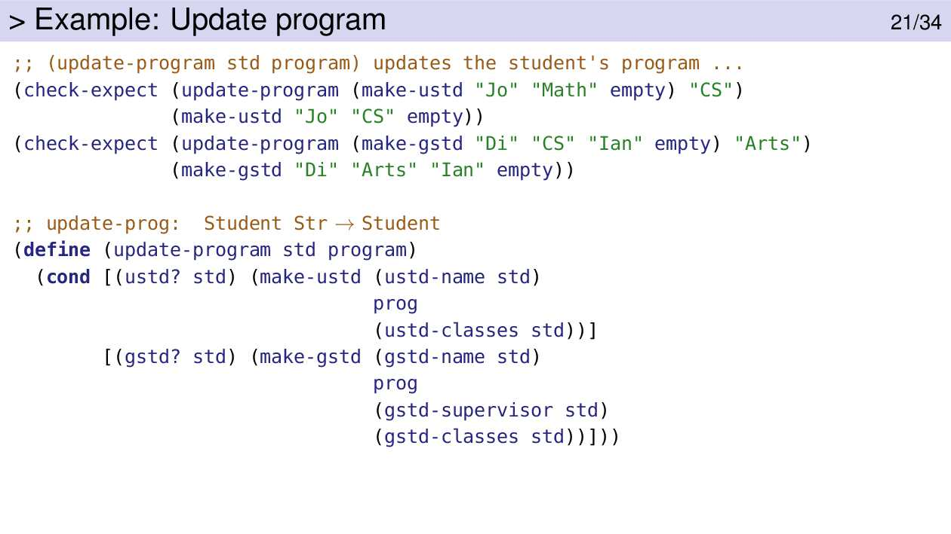

Like the template, the first thing update-program does is use the type predicates to determine what type of data it has. It then makes a new student structure using the appropriate constructor.

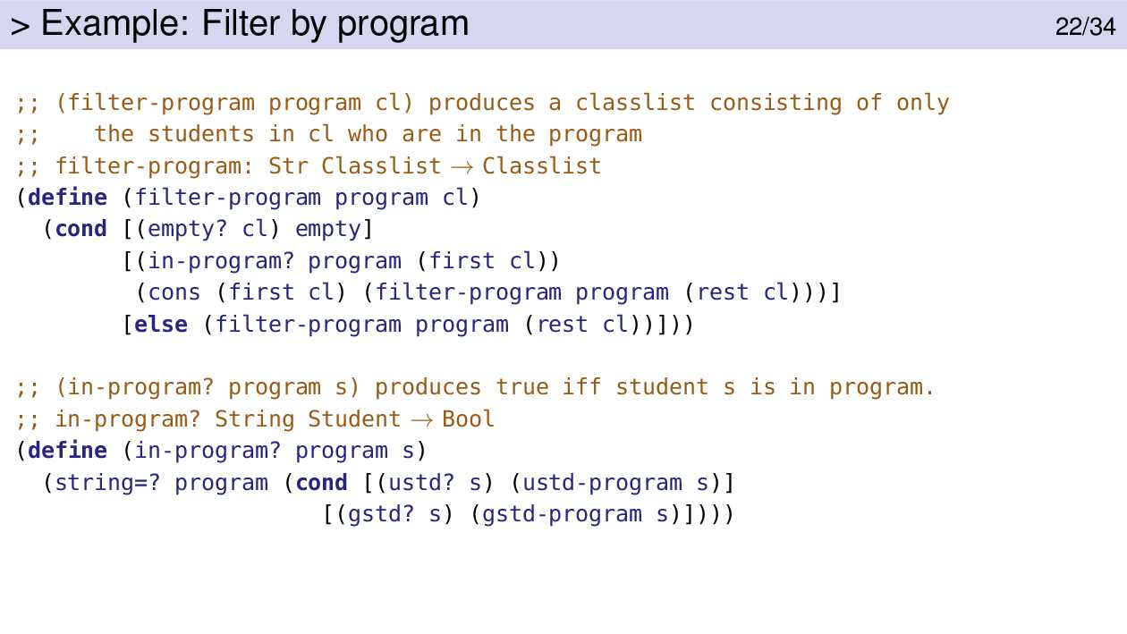

filter-program is a straight-forward application of the list template.

The mixed data comes into play with the helper function, in-program?. It tests whether the student is an undergrad or a grad student, and applies the appropriate program selector function to select the program.

Towards the end of the course we’ll study “higher order functions”, including the built-in function filter. Using filter we can substantially reduce the amount of code to solve this problem.

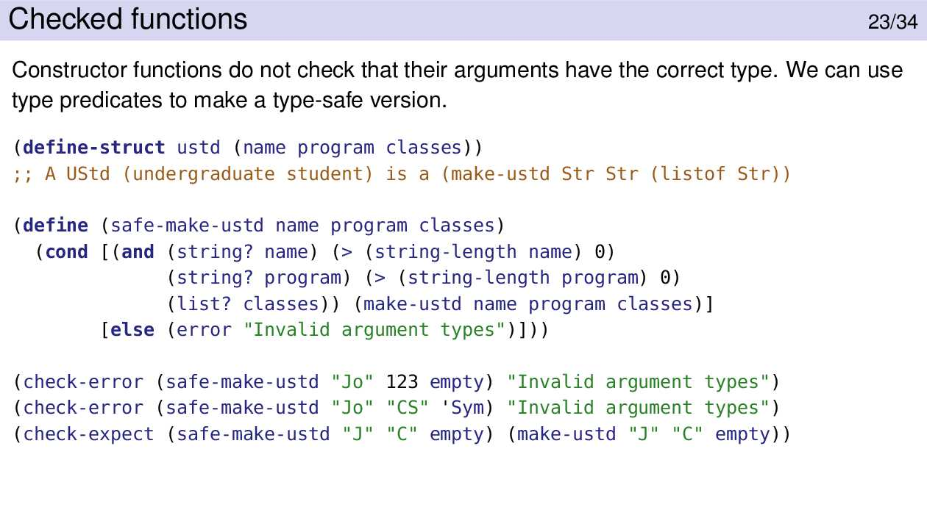

Unless we specifically say otherwise, we do not expect you to write checked functions in your programs. In general we assume that contracts are obeyed.

Structures vs Lists

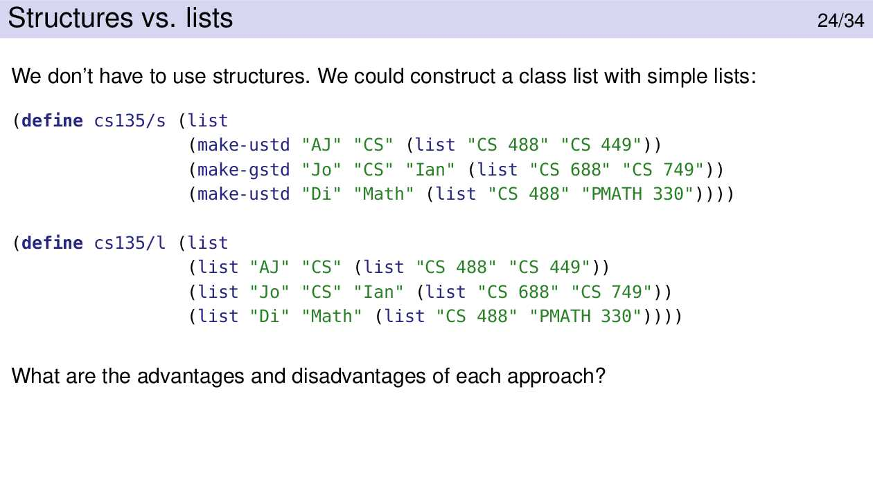

Here are two different ways to construct a class list. The first uses a list of structures. The second uses a list of lists.

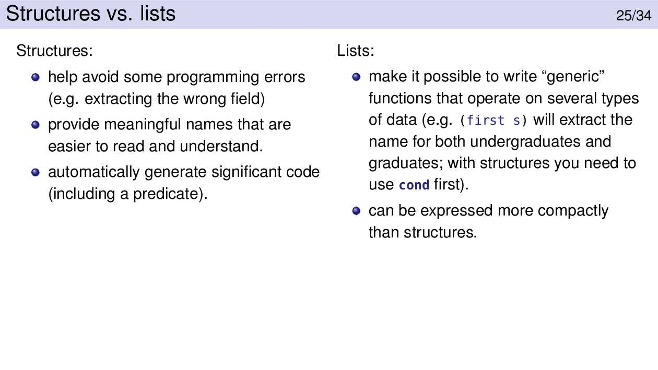

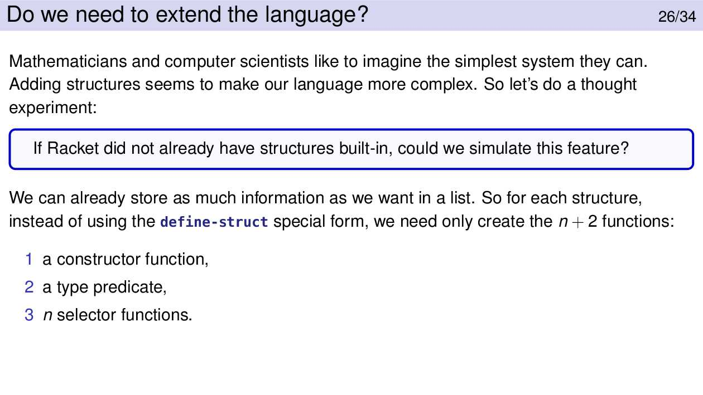

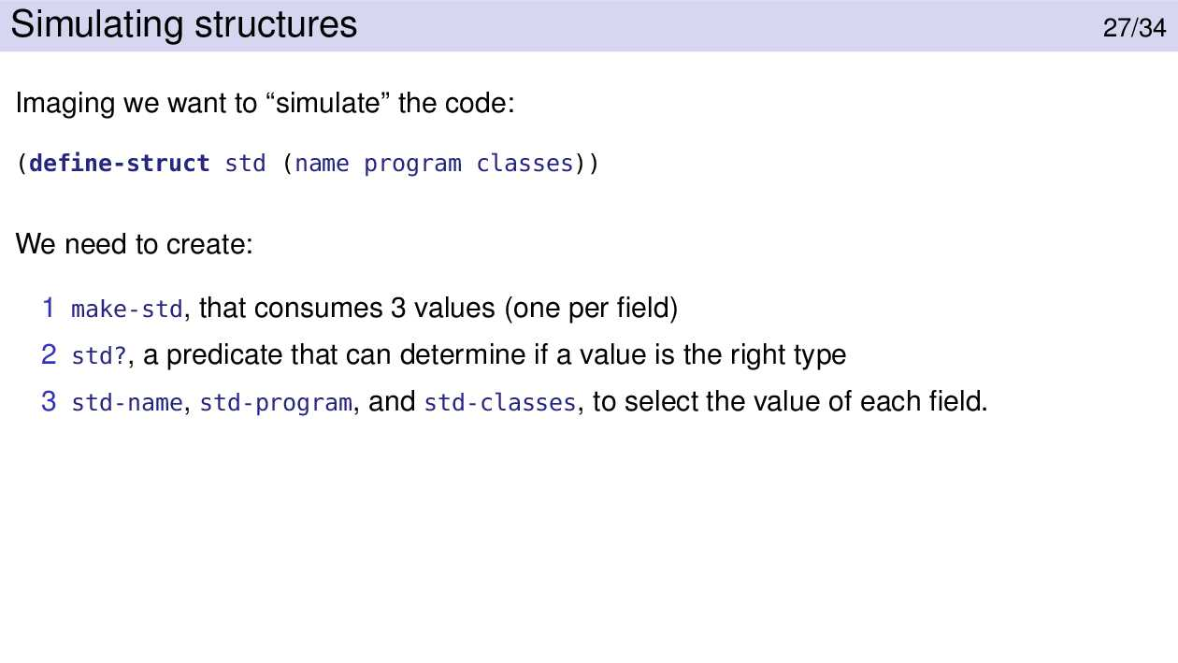

How can we make a Std? function? We can’t just check for a three-element list. There are lots of lists that fit that description. What we’ll do is embed an extra value in the list that is highly unlikely to be in any other list. If that value is present, then we’ll assume the list represents a student. Otherwise, we’ll assume it does not.

We will use define-struct, and the functions created by this. But we’ve demonstrated that this language feature is not strictly necessary. Anything we can do with it, we could do without it; it just takes a bit more work.

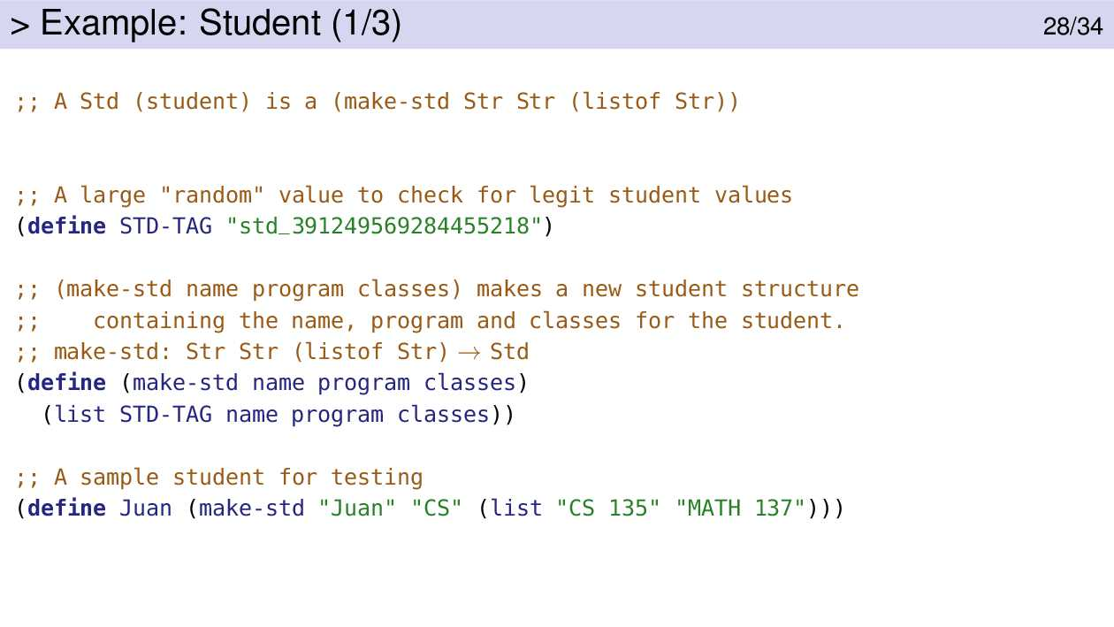

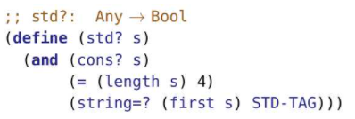

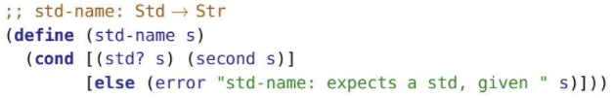

Quoting

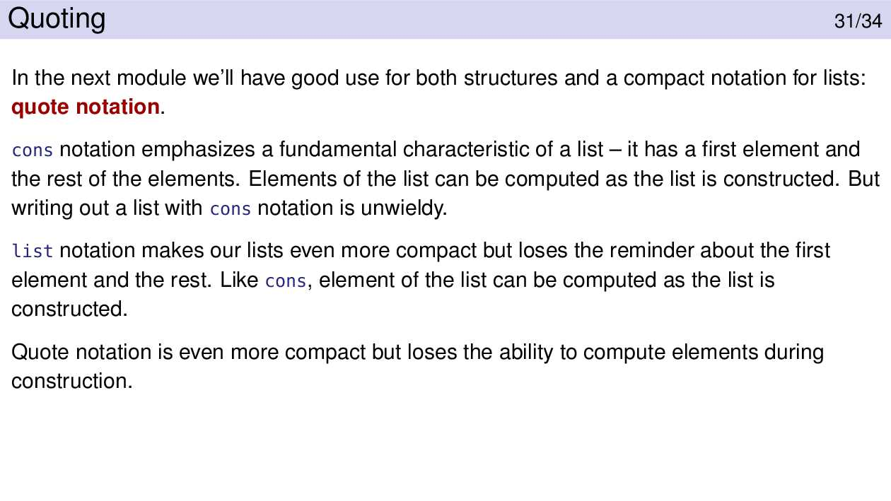

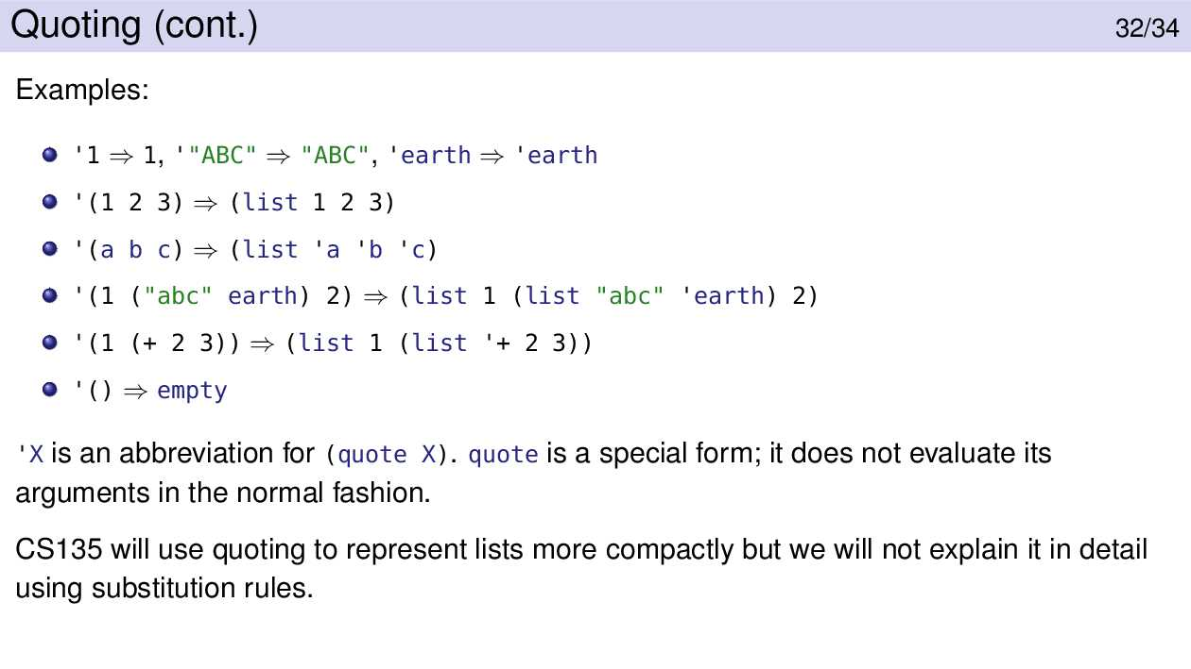

Items of note:

* Quoting applies to more than lists (which was our motivation). Quoted numbers, strings, and characters remain unchanged. Quoting is an inherent part of representing symbols

‘6 =>6

‘ '"hi" => "hi"

'#\A => #\A

‘earth => ‘earth

* Quoting (...) turns the ... into a list.

'(1 3.9 "hi" #\a) => (list 1 3.9 "hi" #\a)

* A list of symbols “factors out” the quote to the front of the list.

(list 'a 'b ‘c) <=> '(a b c)

* Parentheses nested inside a quoted list are also turned into a list. They should not be quoted.

'(1 2 (3 4) 5) => (list 1 2 (list 3 4) 5)

* Because nested parentheses turn into sublists, we cannot (easily) include function applications. Racket turns the function into a symbol.

'(+ 2 3) => (list '+ 2 3)

* The way we write Boolean values does not work well with quoting; 'true looks like a symbol and is interpreted that way.

'("hi" true) => (list "hi" 'true)

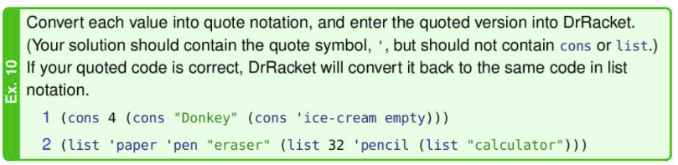

'(4 "Donkey" ice-cream)

(list 'paper 'pen "eraser" (list 32 'pencil (list "calculator")))

Module 11

* To store information in more complicated ways, we can use binary trees
* Trees can often represent some problems better, or make our code run faster
* Ex: We can express math strings as a tree

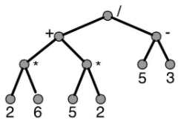

Tree Terminology

* A tree is a set of nodes(often drawn as circles) and edges where an edge connects two distinct nodes:
* 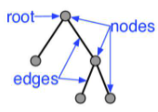
* A tree has three requirements:
  + One node is identified as root (oftentimes the top node in our diagram)
  + Every node other than the root node, we’ll call c, us connect by an edge to some other node, we’ll call p. p is the parent and c is the child. A child node can only have 1 parent node. A parent node can have several child nodes.
  + A tree is connected:
    - For every node, n, other than the root, either the parent of n or the parent of the parent of n or the parent of the parent … of n will be the root. (if we keep finding the parent of a given node, we’ll eventually end up at the root node).

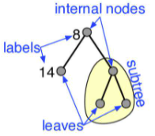

* Leaves: nodes with no children
* Internal nodes: nodes that have children
* Labels/Keys: data attached to a node
* Ancestors of node n: n itself, the parent of n, the parent of the parent of n, etc, up to the root
* Descendendants of n: all the nodes that have n as an ancestor
* Subtree rooted at n: n and all of its descendants
* Characteristics of a Tree
* 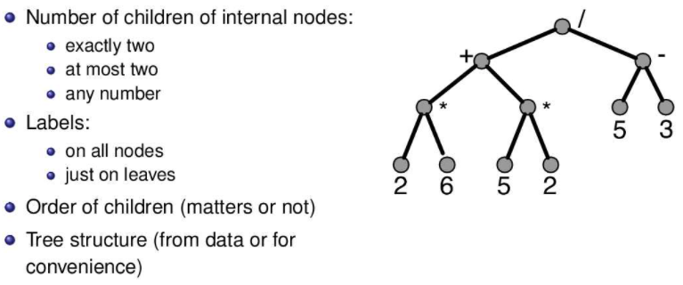
* Number of children:
  + Ex: binary trees have 2 children per internal node.
  + Ex: Some arithmetic expression trees can represent (+ 1 2 3 4) as a ‘plus’ node with 4 children
* Order of Children
  + Ex: If we swapped the children of the division operator, we would get a different result when evaluating the expression.
* Tree Structure
  + All of the trees we’ve looked at so far derive their structure from the data. That won’t be the case for a binary search tree (BST). In that case the structure will be very important to enable fast searching, but it will be a structure that we decide rather than one that comes from the data itself.

Binary Trees

* A tree with at most two children for each node
* Characteristics:
  + Each internal node has at most two children.
  + Our examples will have labels on all the nodes, although that’s not a requirement of binary trees.
  + Order of the children does not matter.
  + Structure is for convenience.
* Ex: we could store a set of natural numbers

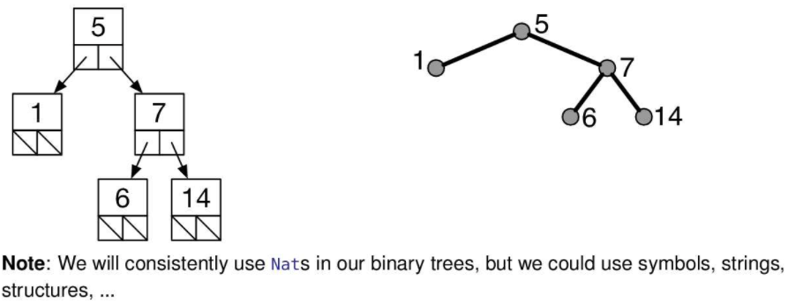

* Data Definition

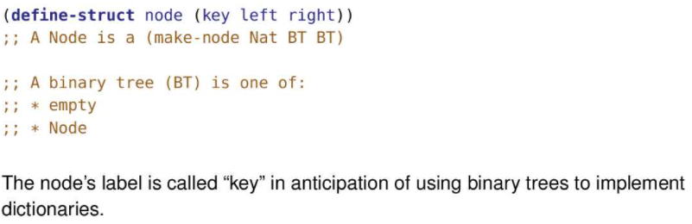

* The BT data definition is an example of mixed data, which we studied in the previous module. One case is a particular kind of list, an empty list. The other case is a structure.
* We could have used many other values instead of empty – any value that we can distinguish from a Node. We could have used 0 or false or 'empty-tree. We chose empty simply because its an existing value that strongly suggests “empty tree”. The fact that empty has significance for lists is not relevant here.

Ex: Is the following a BT according to the data def below?

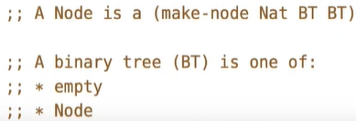

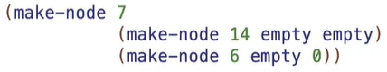

As this is clearly not empty, it is a BT only if (make-node 7 (make-node 14 empty empty) (make-node 6 empty 0)) is a Node. In order for (make-node 7 (make-node 14 empty empty) (make-node 6 empty 0)) to be a Node, 7 must be a Nat, (make-node 14 empty empty) is a BT, and (make-node 6 empty 0) is a BT.

Checking if 7 is a Nat:

7 is a Nat so that is good.

Checking is (make-node 14 empty empty) is a BT:

* In order for (make-node 14 empty empty) to be a BT, it must either be empty or a Node
* Since (make-node 14 empty empty) is clearly not empty, it is a BT if it is a Node
* (make-node 14 empty empty) is a Node if 14 is a Nat, empty is a BT, and empty is a BT
* 7 is indeed a Nat, empty is indeed a BT by definition, and empty is indeed a BT by definition
* Thus, (make-node 14 empty empty) is a BT:

Checking if (make-node 6 empty 0) is a BT:

* In order for (make-node 6 empty 0) to be a BT, it must either be empty or a Node
* Since (make-node 6 empty 0) is not empty, it is a BT if it is a Node
* (make-node 6 empty 0) is a Node if 6 is a Nat, empty is a BT, and 0 is a BT
* 6 is indeed a Nat and empty is indeed a BT by definition
* As 0 is not empty, it is a BT if it is a Node, but it clearly isn’t
* Thus, (make-node 6 empty 0) is not a BT

Since 7 is a Nat, (make-node 14 empty empty) is a BT, but (make-node 6 empty 0) is not a BT, therefore (make-node 7 (make-node 14 empty empty) (make-node 6 empty 0)) is not a Node, thus the final answer is that the following is not a BT

Binary Tree Template

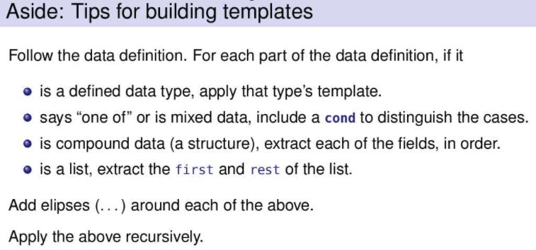

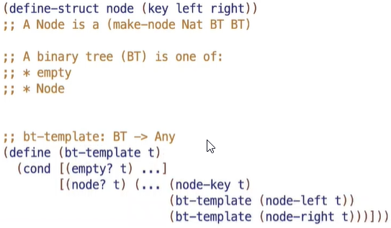

Example Problems

* It is important to break a binary tree into 3 important parts, the node we’re currently at and the left subtree of the node and the right subtree of the node

Ex: Create a function that returns the sum of all the keys in a BT

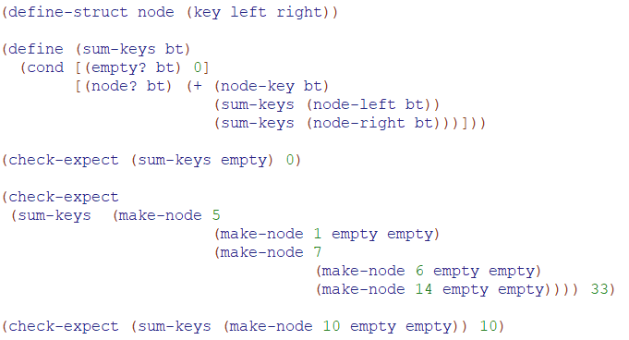

Ex: Create a function that counts the number of nodes in a BT that have a key equal to k

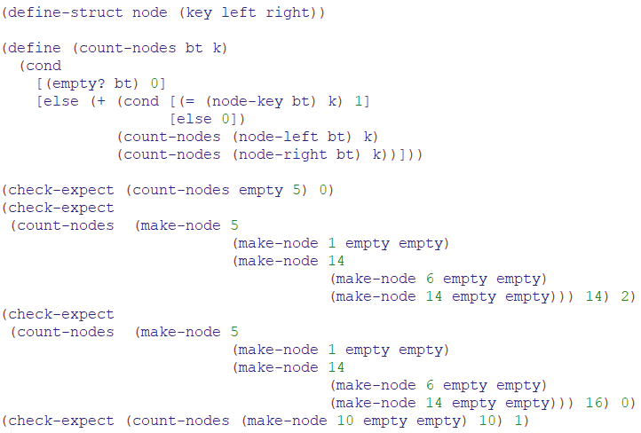

Ex: Create a function that adds 1 to each key in a BT

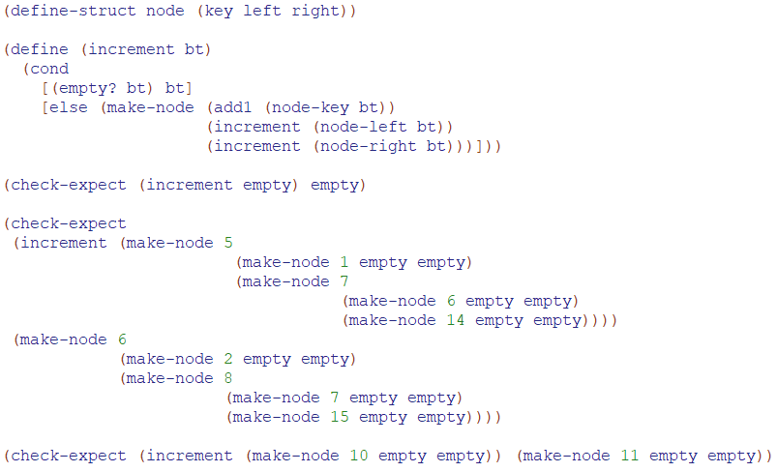

Ex:

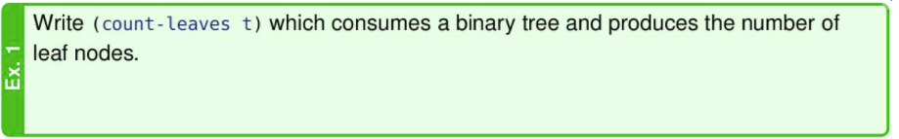

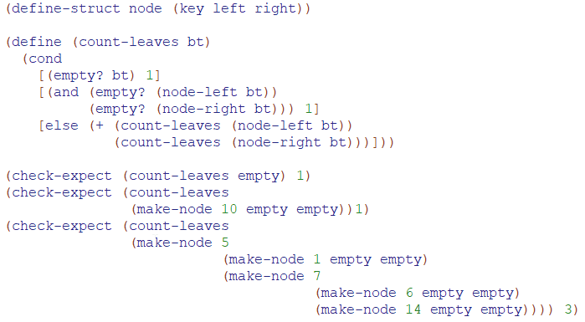

Ex:

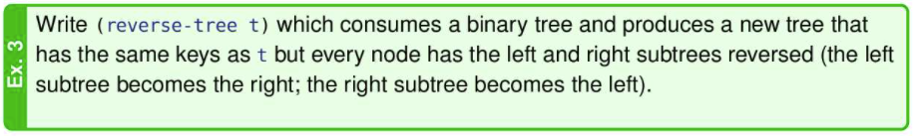

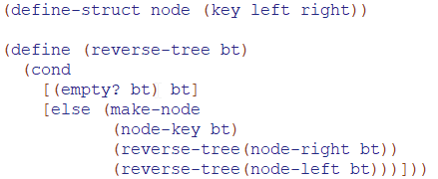

Searching Binary Trees

Ex: Produce true if a node with label k is in the tree; false otherwise (using cond)

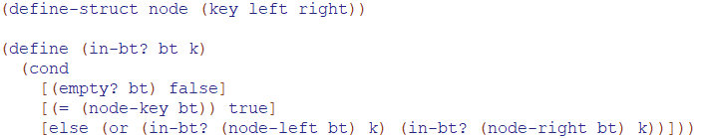

Ex: Produce true if a node with label k is in the tree; false otherwise (using boolean expressions)

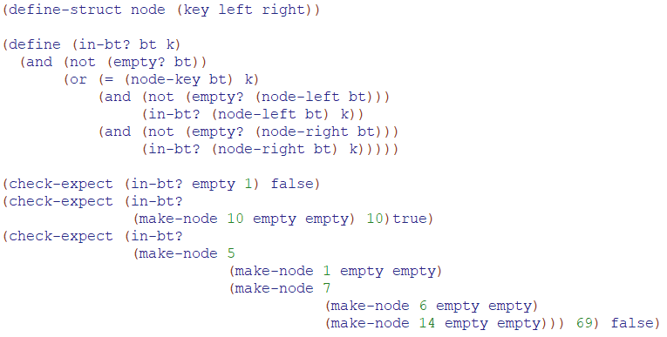

Ex:

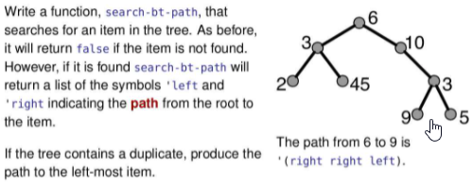

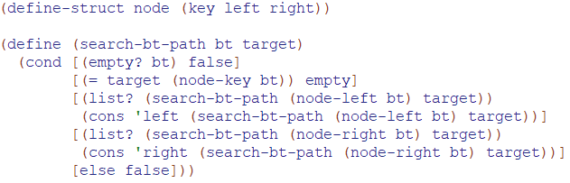

Strategy:

* Well, a non-empty tree has three important parts: the root, the left subtree and the right subtree.
* If the root contains k, the value we’re searching for, produce empty and we’re done.
* Otherwise, if only we could find a path to k in the left subtree, we could cons 'left onto that path and we’d have the answer from the root.
* If we can’t find k in the left subtree, we could look in the right subtree. If we can find a path there, all we need to do is cons the value 'right on to that path and we’d have the path from the root to k.
* If k isn’t in the root, isn’t in the left subtree, and isn’t in the right subtree, then it’s not in the tree at all and we should produce false.
* How do we check if k is in the left subtree? Apply search-bt-path. If it produces a list, we know k was found. We could also check for the result to be not empty.

Evaluation of strategy

* However, after we’ve checked if k is in the left subtree we still need to have the path to k so we can produce (cons 'left path-to-k). To get the path to k we need to call search-bt-path a second time.
* This strategy leads to the code shown on the slide. The code is correct and works as intended. However, that second application leads to incredibly inefficient run-time,
* TLDR: The problem is that we had to calculate the same value, (search-bt-path (node-left bt) target) twice and (search-bt-path (node-right bt) target).

Improved Strategy

* We could use either a helper function or an accumulator to solve this efficiency problem, too. The helper function approach is simpler and is the approach pursued here.
* The insight is that once a value is passed to a parameter it can be used multiple times without recalculating it. So we search for k in both the left and right subtrees, passing the results to the helper function. choose-path can use those values multiple times without incurring the efficiency penalty.
* Notice now, we don’t evaluate (search-bt-path (node-left bt) twice, but rather this time, we evaluate (search-bt-path (node-left bt) once and pass that value (no longer an expression or function, but a concrete value) into the helper function. This differs from before where we had to evaluate (search-bt-path (node-left bt) and then re-evaluate (search-bt-path (node-left bt) even though we evaluated already.
* One might object that this always searches the entire tree. In particular, the right subtree is always searched even if k has already been found in the left subtree. Isn’t that wasteful? Yes. But not nearly as wasteful as those double applications we got rid of. We could improve this further, but it would be a pain. Besides, we’ll see better approaches in the next module.

Binary Search Trees

* For any given collection of keys, there is more than one possible tree, and how these keys are placed in a tree can improve the searching time of a key in the tree
* A BST is a BT the key of the current node is greater than every key in the left subtree and the key in the current node is less than every key in the right subtree
* 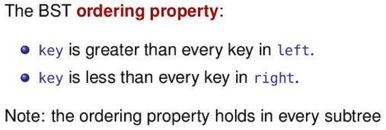
* This ordering property can avoid recursive function calls for certain computations, which can sometimes make your function considerably more efficient
* If a BST has all left subtrees empty, it looks and behaves like a sorted list, and the advantage is lost.
* Data Definition
* 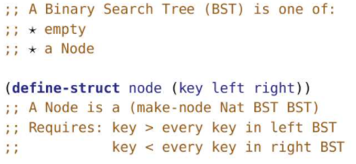
* Notice the requirement on the keys means that each key is unique
* Example of making a BST:
* 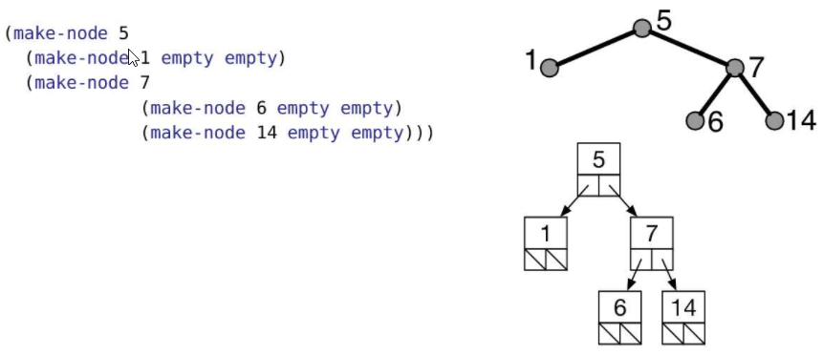
* Note: There can be many BST to represent same set of numbers as shown in the example below
* 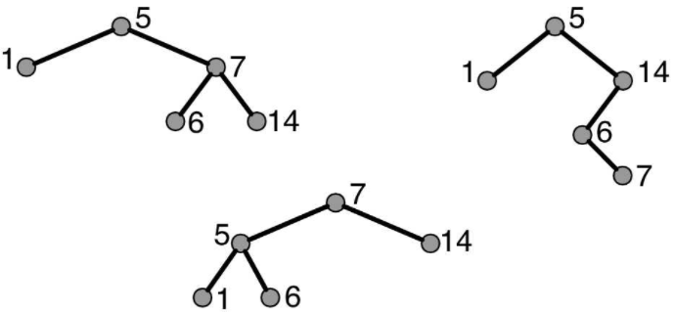
* In fact, the total number of possible Binary Search Trees with n different keys is:
* 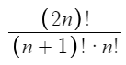
* Searching in a BST

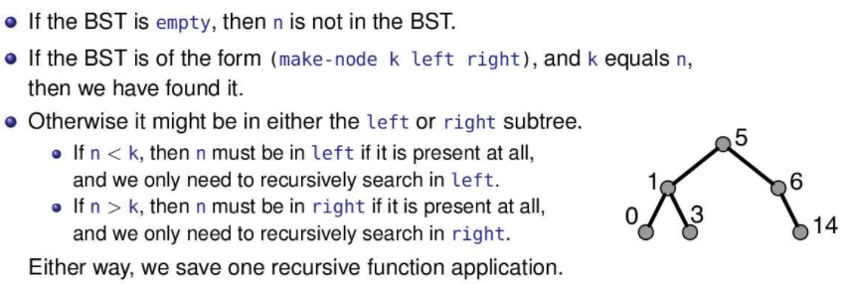

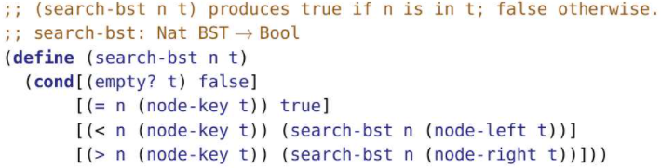

Ex: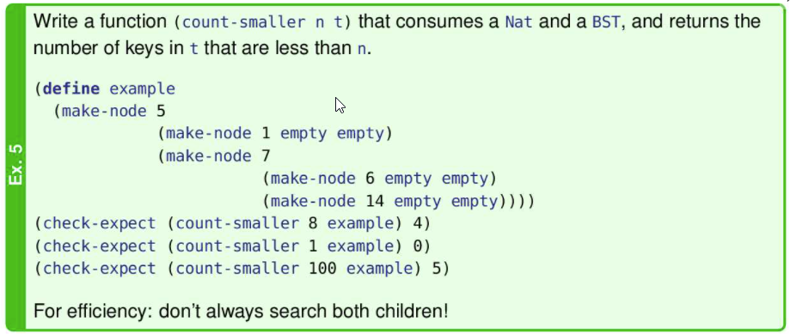

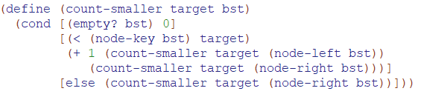

Adding node to a BST

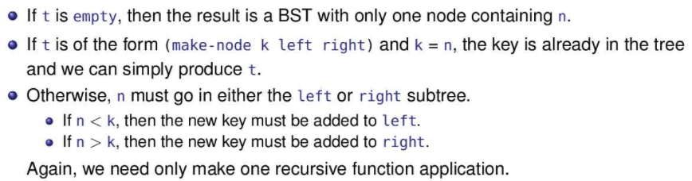

Creating a BST from a list

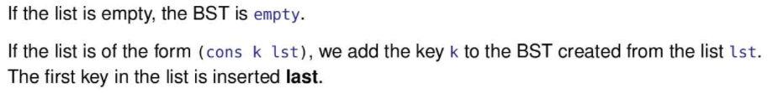

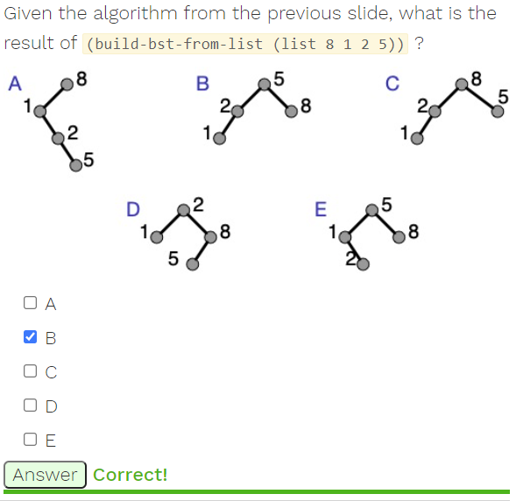

Extra Problems:

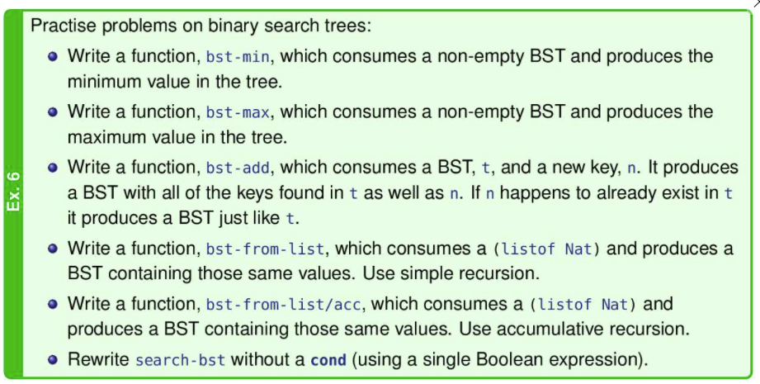

bst-min:

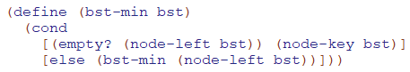

bst-max:

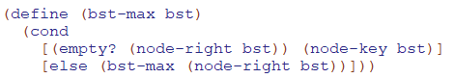

bst-add:

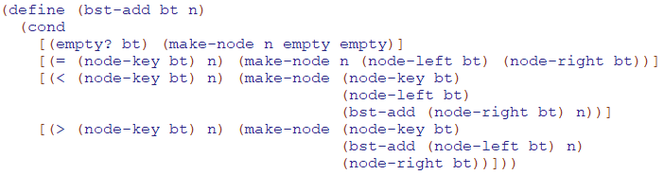

bst-from-list

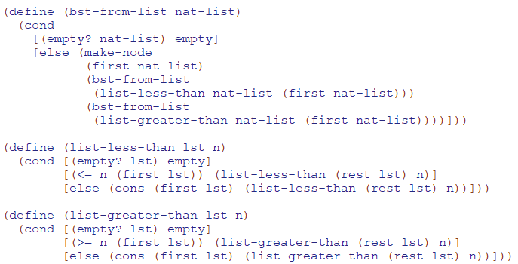

bst-from-list/acc:

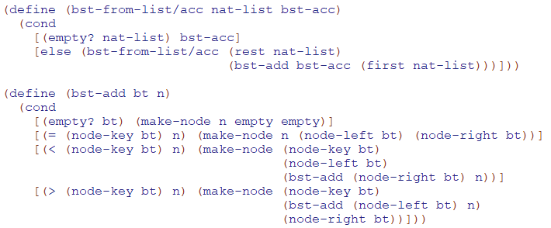

search-bst:

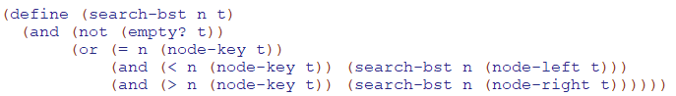

Augmenting Trees

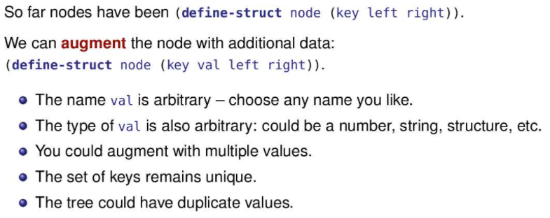

BST Dictionaries

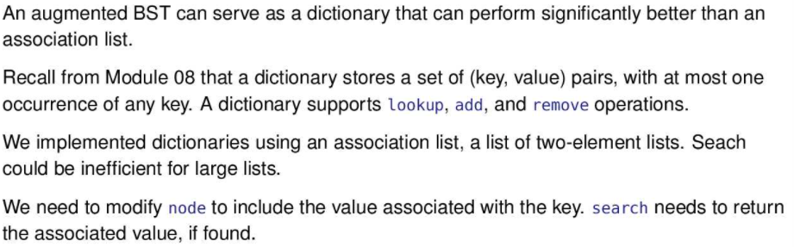

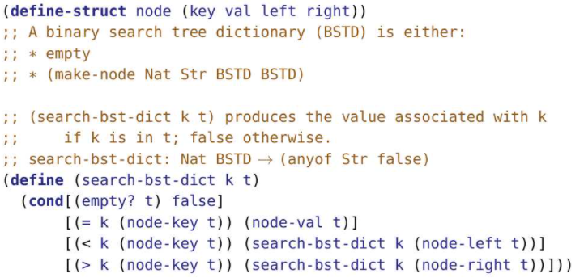

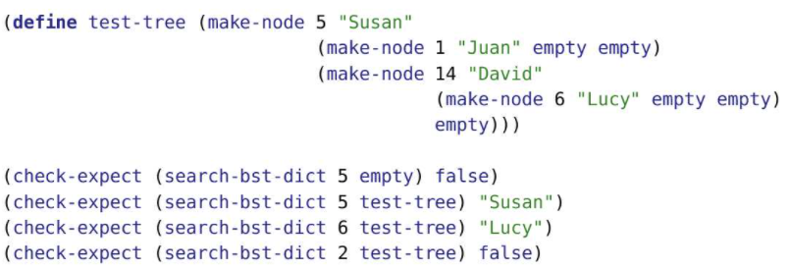

Evolutionary Trees

* Evolutionary trees are augmented trees that show the evolutionary relationship between species
* Leaves represent a current species (augmented with a name and whether the species is endangered)
* Internal nodes represent a hypothesised common ancestor species that split into two new species. (augmented with a name and an estimate of how long ago the split took place (in millions of years))
* 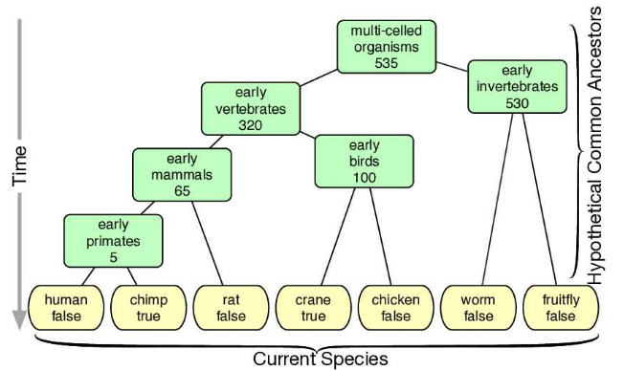

Representing Evolutionary Trees

* 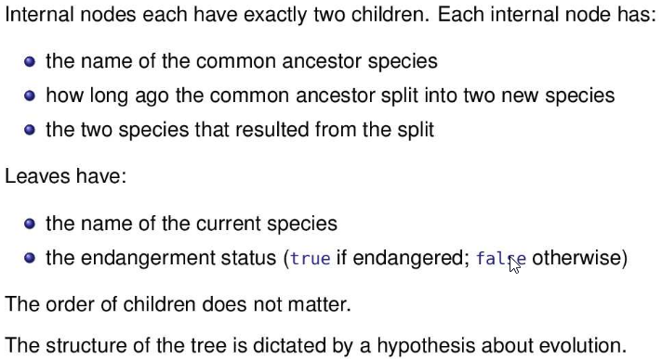

Binary Tree vs EvoTree

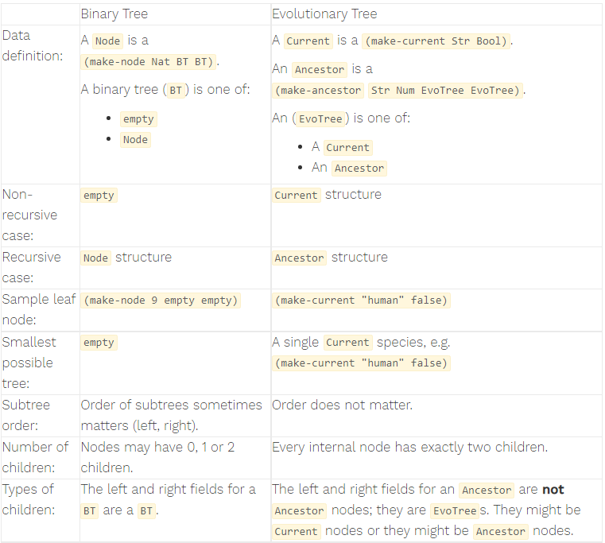

EvoTree Data Definition

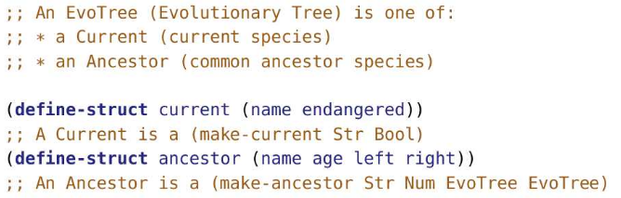

Constructing an Example EvoTree

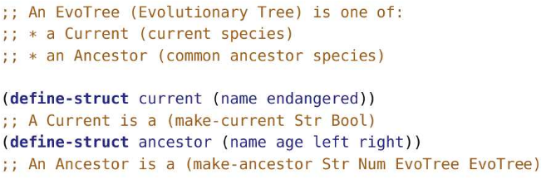

;; below, current species are defined

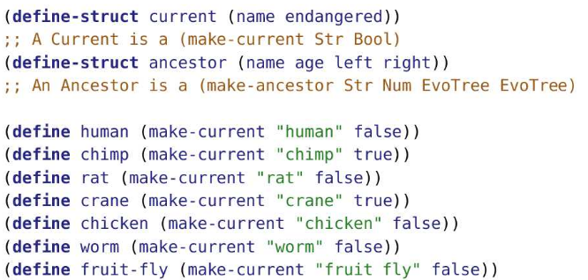

;; below ancestors are defined

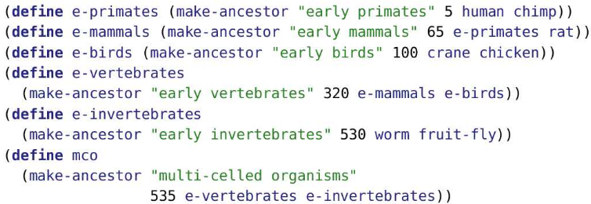

EvoTree Template

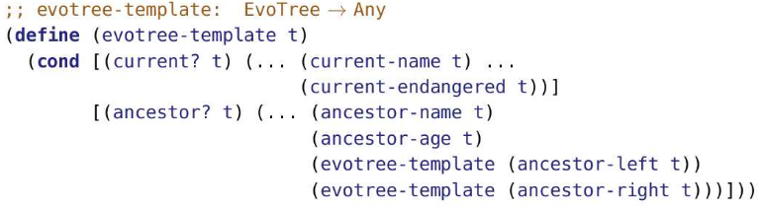

EvoTree Problems:

* Ex: Count the number of current species in an EvoTree

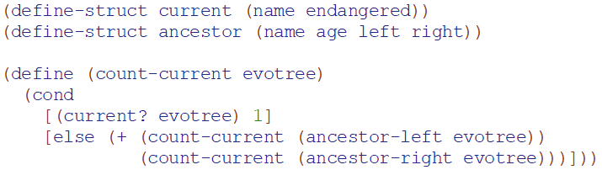

* Ex:
* 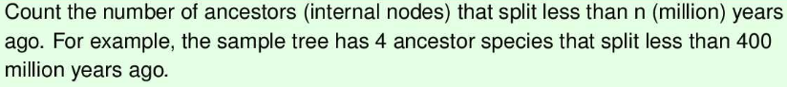

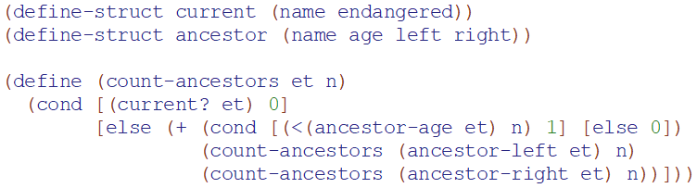

* Ex: 
* 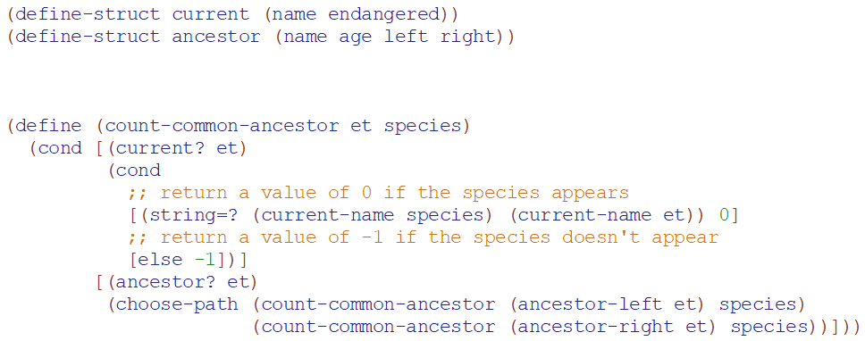
* 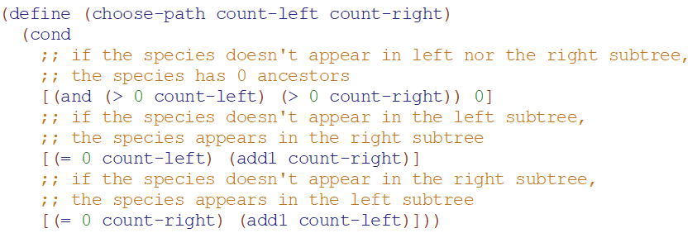
* Ex:
* 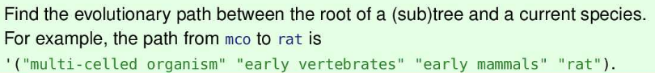
* 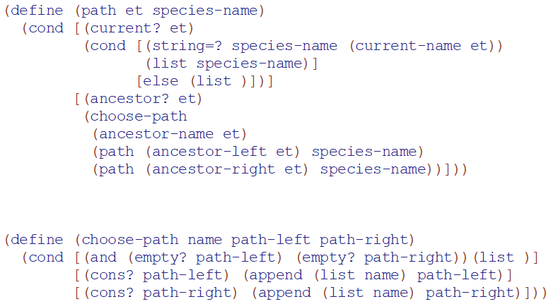

Binary Arithmetic Expression Trees

* 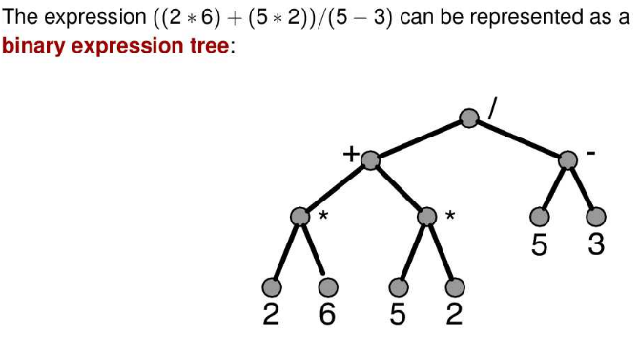
* 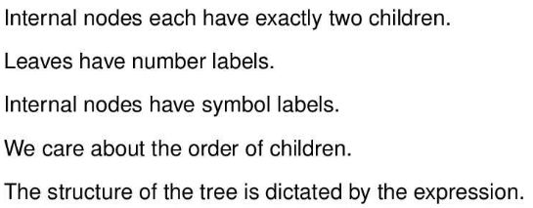
* a binary expression tree structures arithmetic expressions into a tree which makes it easy to calculate the value of the expression.
* Binary: We’re not even trying to handle all arithmetic expressions, only those that have two operands. So functions like square root or cosine are out. So is the unary minus operator. In our example, we’ll focus on the classic four: +, -, *, /.

Data Definition

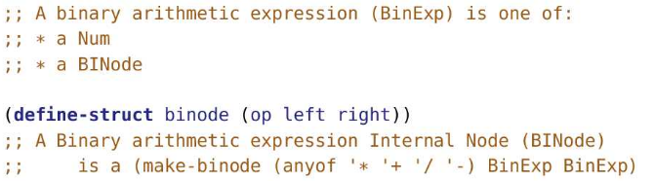

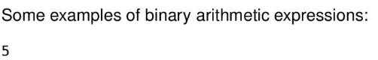

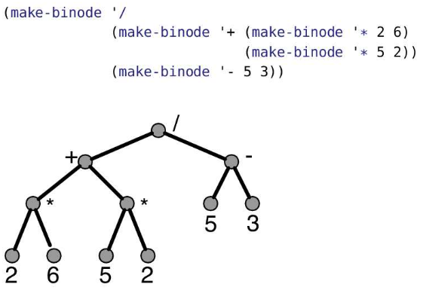

* The smallest possible binary arithmetic expression tree is a single number (the first example). The next smallest tree is two numbers and an operator (see the second example). A binary arithmetic expression tree can grow to be arbitrarily large.
* Leaf nodes in a BinExp will always be numbers. Internal nodes will always have an operator with left and right subtrees that are binary arithmetic expressions.
* Calculating the value of this BinExp is simple: calculate the value of the left subtree, calculate the value of the right subtree, and then divide.
* When an expression is represented as a tree, it automatically encodes the precedence rules. For example, our usual rules interprets 1 + 2 * 3 as 1 + (2 * 3) or 7. That corresponds to an expression tree with + at the root and 2 * 3 in the right subtree. If we wanted the other interpretation, (1 + 2) * 3, the expression tree would have the * at the root and 1 + 2 in the left subtree. Either way, the tree eliminates the need for the parentheses or special rules.
* Ex: Write a function that produces the value of a BinExp
* 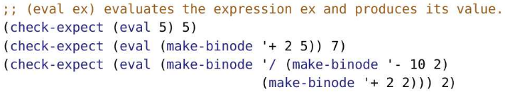

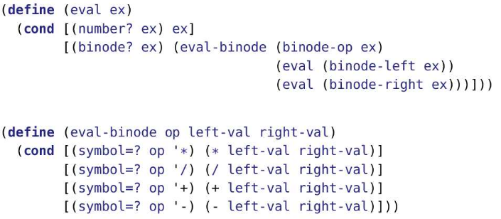

Consider the following code (which is wrong and inefficient)

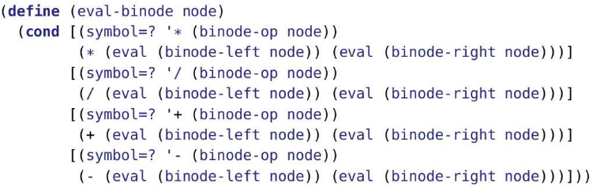

* Unfortunately, there is a lot of repeated code in eval-binode on the previous slide:
* We evaluate the left subtree at four different places.
* We evaluate the right subtree at four different places.
* We extract the operator from the binode structure at four different places.
* The code on this slide pulls those three operations into eval and passes the results to eval-binode instead of the subtree itself. The result is much cleaner code without the repetition.

Mutual Recursion

* When two or more function apply each other
* Ex: f applies g and g applies f
* Mutual recursive can often be merged into a single function, but mutual recursion often leads to simpler code
* 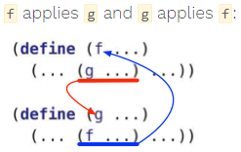

Mutual Recursion on Nat

* A number is even if it is one more than an odd number
* A number is odd if it is one more than an even number
* 0 is even (and thus, not odd)
* We can use the above 3 observations to write (is-even? n) which produces true if n is even and false otherwise
* 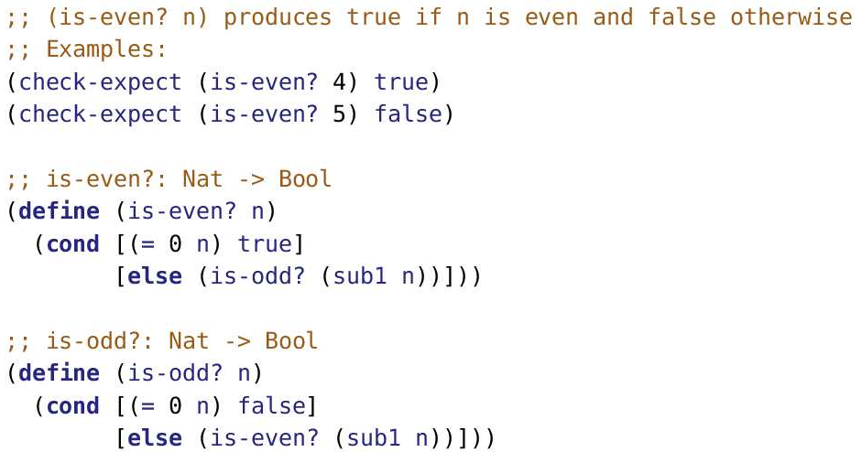
* 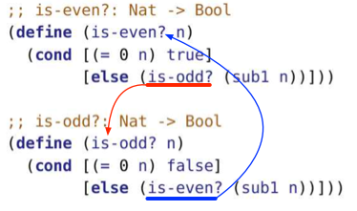
* Each of these definitions follows from the observations that an even number is one more than an odd number, and so on.
* These functions are mutually recursive because is-even? applies is-odd? and is-odd? applies is-even?.
* 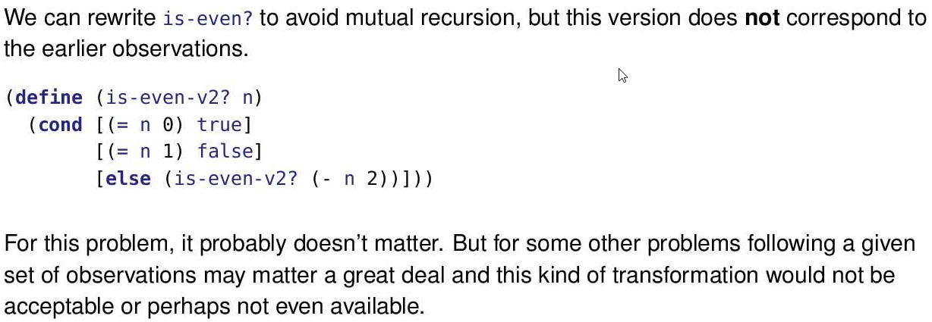
* Just to be clear, none of these three approaches are a good way to actually determine the evenness of a Nat. Just use the builtin even?! These are here as illustrations of mutual recursion.
* 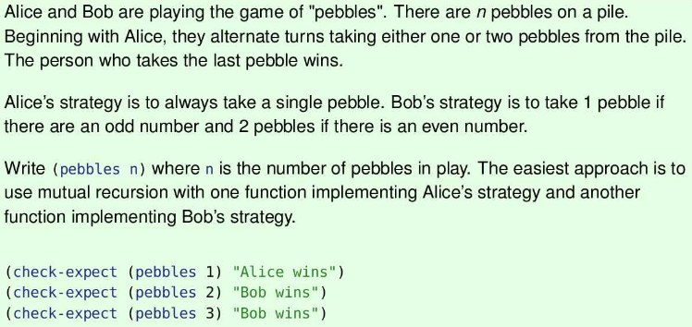
* 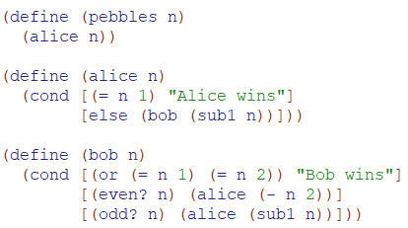

Mutual Recursion on Lists

* Suppose we want to divide a list into two equal or nearly equally long lists
* We could write a function, keep-alternates, that keeps every other element of a list, we could apply it to the entire list and the rest of the list to divide it into two:
* 
* Approach 1:
  + 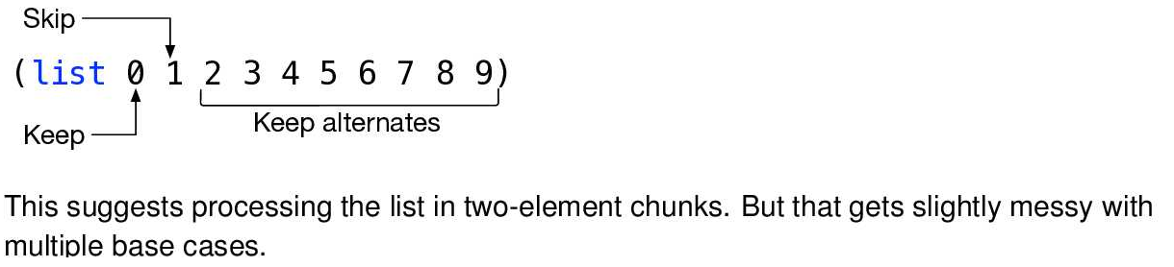
* Approach 2:
  + Keep the first element of the list, skip the second, keep the 3rd element, skip the fourth
  + 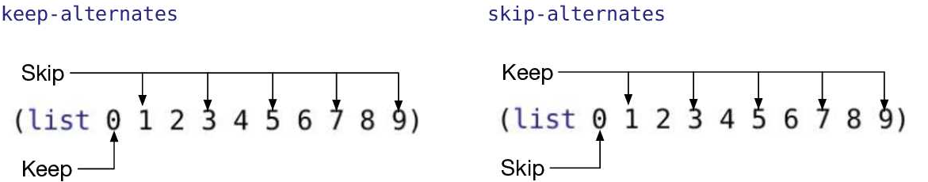
  + keep-alternate([1,2,3,4,5])
  + = [1, skip-alternate([2,3,4,5])]
  + = [1, keep-alternate([3,4,5])]
  + = [1, 3, skip-alternate([4,5])]
  + = [1, 3, keep-alternate([5])]
  + = [1, 3, 5, skip-alternate ([])]
  + = [1, 3, 5]
  + 
  + 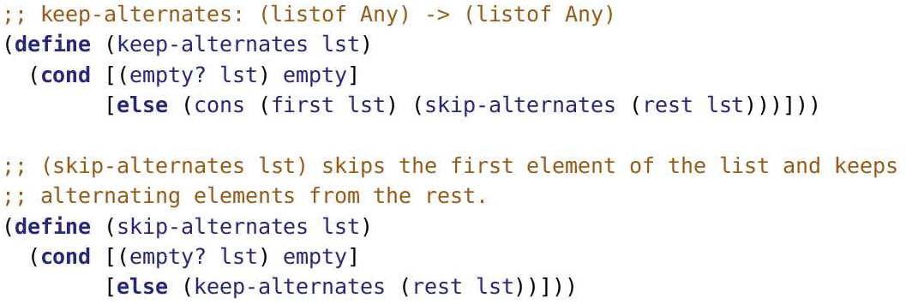
  + keep-alternates and skip-alternates are mutually recursive. Each one applies the other in classic mutual recursion style

Mutual Recursion and Trees

* We slipped in mutual recursion dressed as a helper function! eval applies eval-binode and eval-binode applies eval in classic mutual recursion style.
* 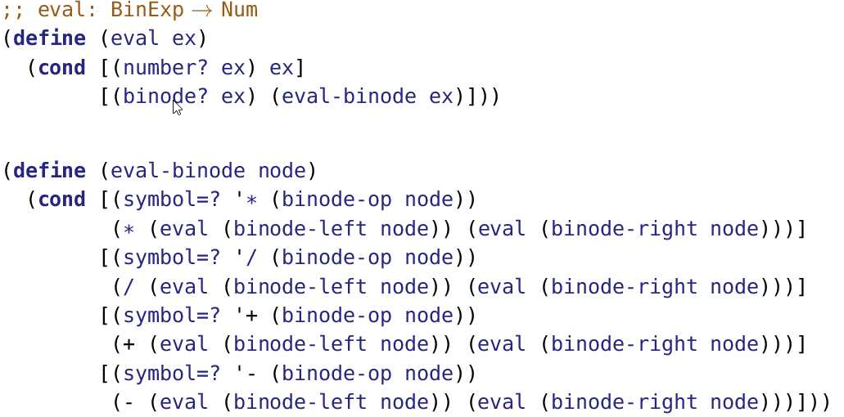

Self-Referential Data Definitions

* Notice BinExp references a BINode and BINode references a BinExp
* 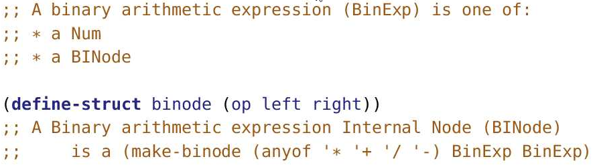

General Trees

* Binary trees can be restricted by the number of children
* What if we want a tree with an arbitrary number of children, then we need general trees
* General trees are trees with an arbitrary number of children (subtrees) in each node
* Ex: Arithmetic expressions can be expressed as a general tree
* Handling any number of children needs a better solution than just adding a bunch more fields to the node structure. The simplest solution we have for handling an unknown number of things is a list.
* So, we’ll put the children (subtrees) into a list.
* 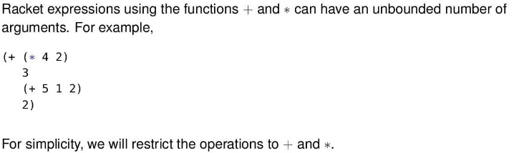
* 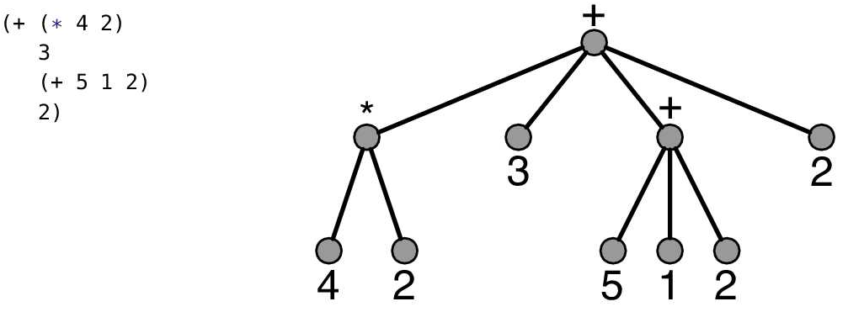
* For simplicity, we’ll stick with only addition and multiplication
* In the example, note that + at the root has four children and the subexpression (+ 5 1 2) has 3 children.
* To evaluate this tree, we evaluate all of the subtrees (four of them!) and then apply the operator at the root (+) to those values. Note that the operator must be able to handle a variable number of children.

Representing Binary Tree vs General arithmetic expression trees

* For a binary arithmetic expression, we defined a structure with three fields: the operation, the first argument, and the second argument.
* 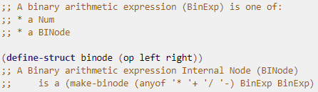

General arithmetic expression trees

* For a general arithmetic expression, we define a structure with two fields: the operation and a list of arguments (which is a list of arithmetic expressions).
* 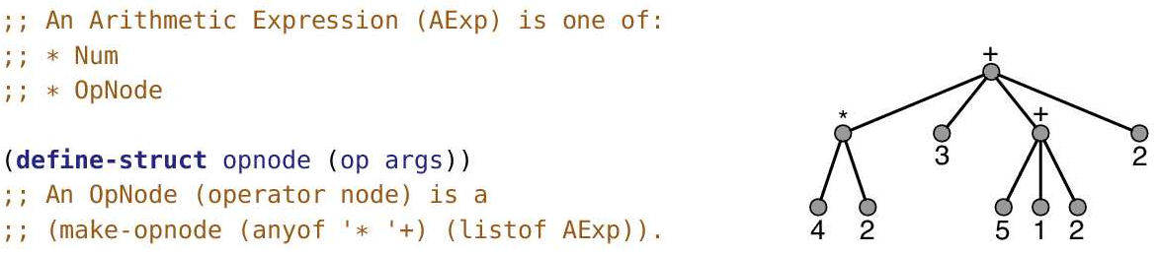
* Since AExp is defined using OpNode and OpNode is defined using AExp, mutual recursion will occur.
* Examples of AExp:
  + 3
  + (make-opnode ‘* (list 3 4 5))
  + (make-opnode

'+ (list (make-opnode '* '(4 2))

3 (make-opnode '+ '(5 1 2))

2))

* Most of these examples are using quote notation to conserve space.
* To help visualize our data definition, lets draw on the diagrams
* 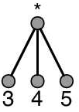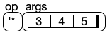
* 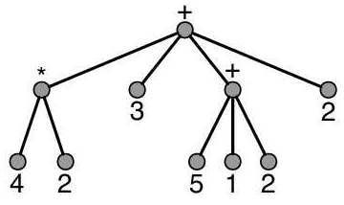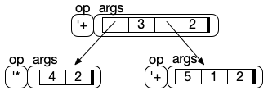

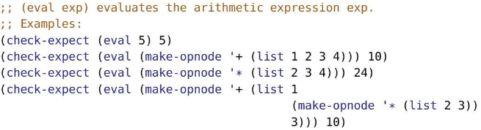

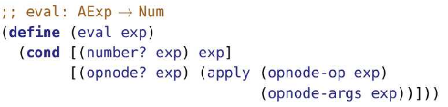

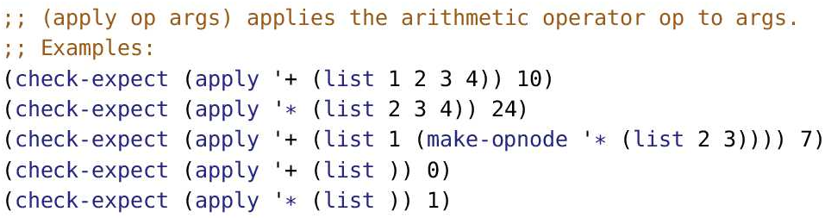

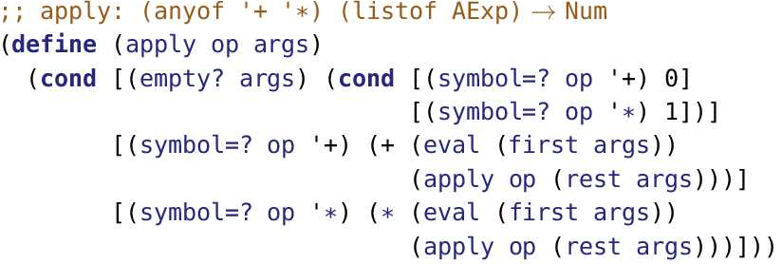

Example Trace

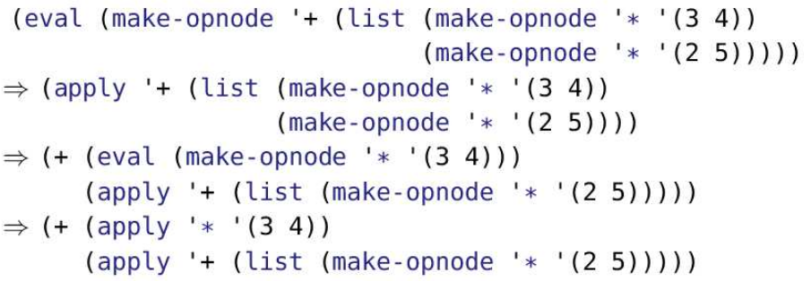

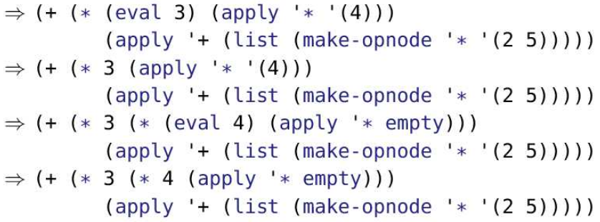

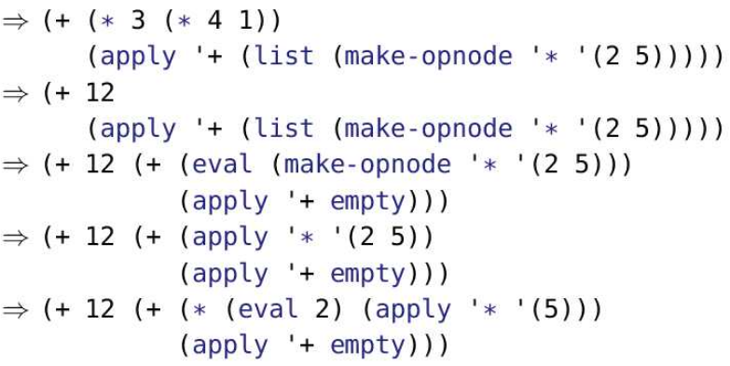

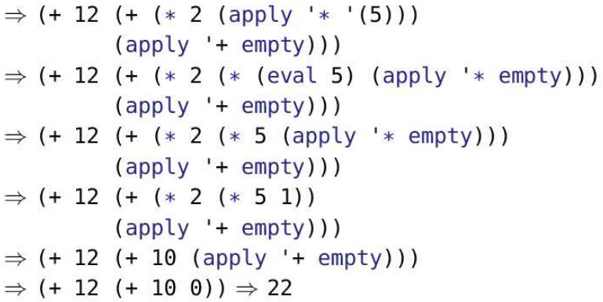

Alternate Data Definition

* Instead of using (define-struct) to create structures to represent AExp, we could use a list instead
* 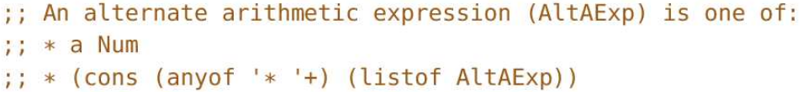
* 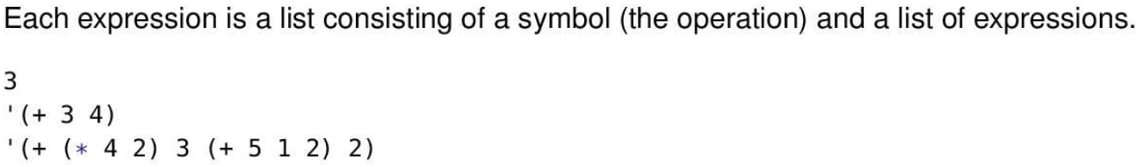
* 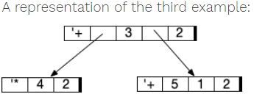
* Below is the alternative versions of eval and apply

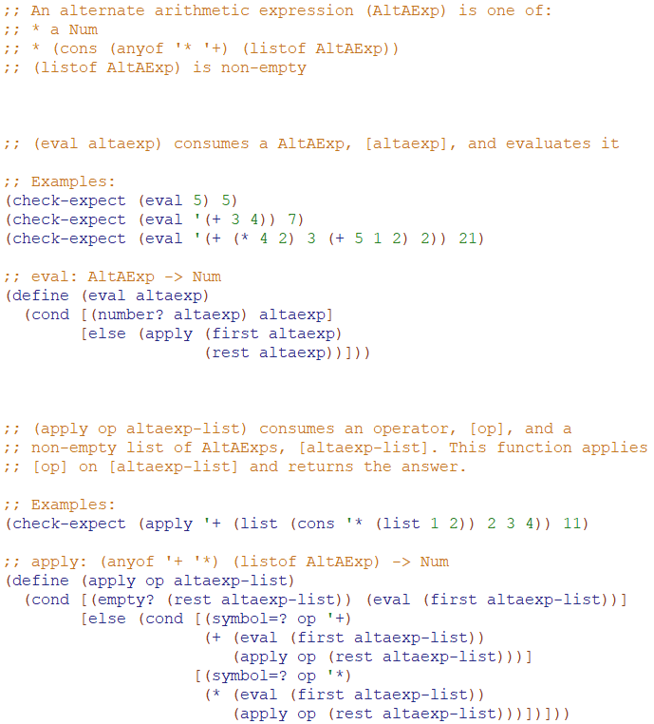

Nested Lists

* We have discussed lists (no nesting), lists of lists (one level of nesting) such as (list 1 2) and (list 1 (list 3))
* Now, we will consider nested lists (arbitrary nesting)
* (list (list (list (list (list 1) 2) 3) 4) 5)
* This topic is sort of a “list” topic and sort of a “tree” topic. The representation just makes use of lists. There are no structures to make nodes.
* But it’s helpful to visualize these nested lists as trees, in which leaves correspond to elements of the list, and the internal nodes indicate the nesting
* 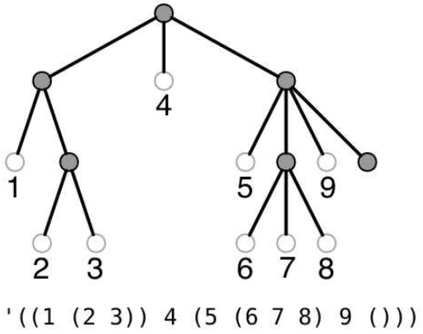
* This is an example of a “leaf-labelled tree”. Labels only appear on the leaves. Internal nodes are not labelled.

Data Definition

* 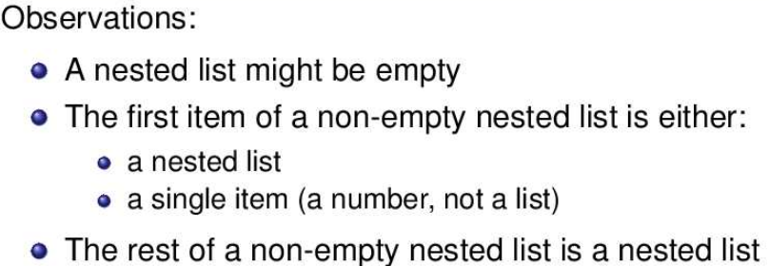
* 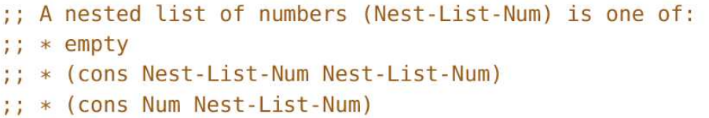
* We can generalize the nested list of numbers to a nested list of X where X is a single item, not a list
* 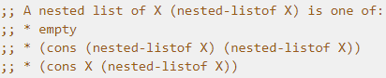
* The data definition flows from the observations made on the slide. Using empty for the base case seems obvious as soon as we see an example that’s empty.
* The last two parts of the data definition are a bit harder. They flow from breaking the non-empty examples into the first item of the list and the rest of the list. Then ask what each part is, using the terminology at our disposal (e.g. X and (nested-listof X)).

Template

* The data definition has three clauses, which show up as the three question/answer pairs in the template.
* 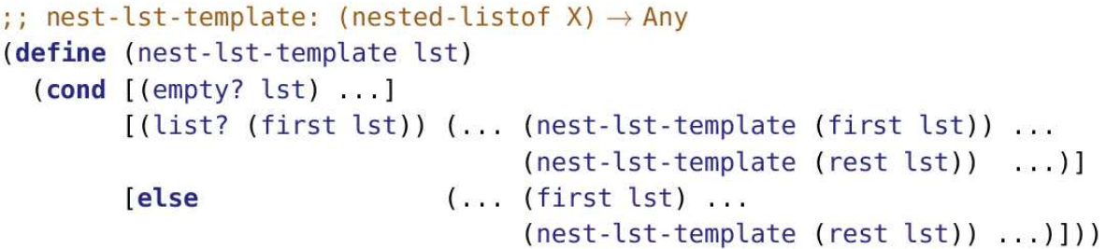
* Ex:

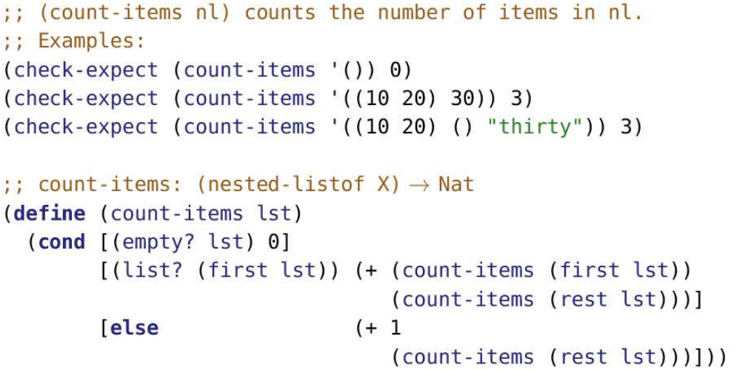

* Ex:
* 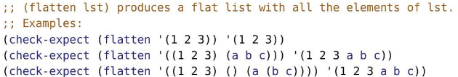
* 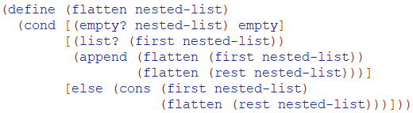
* Ex:
* 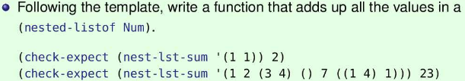
* 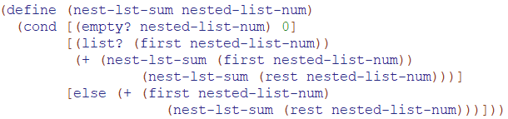
* 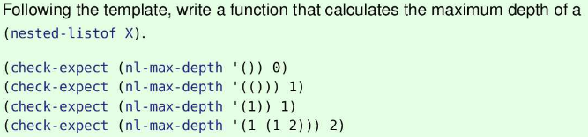
* 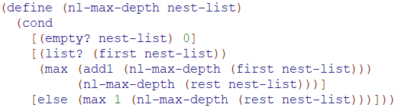
* 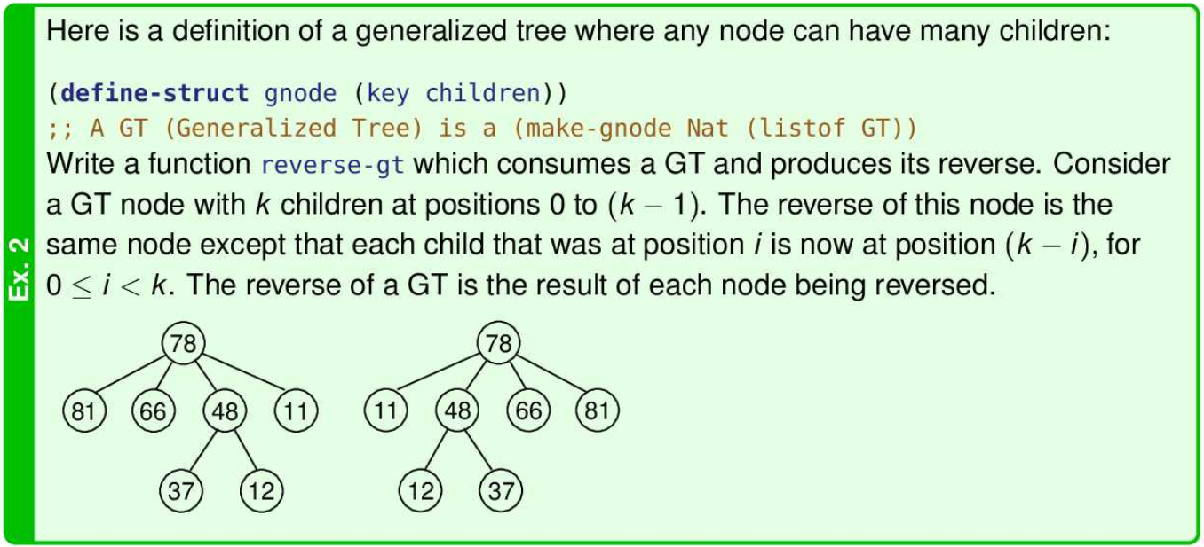
* 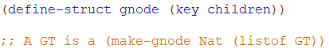
* 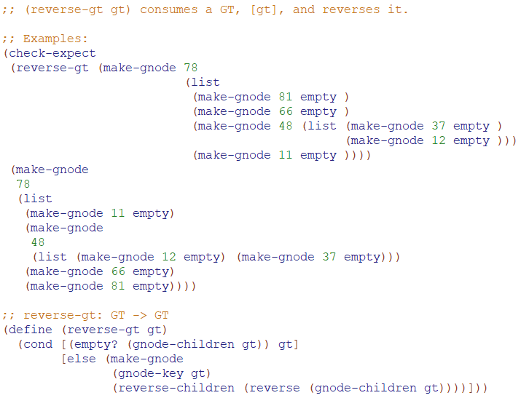
* 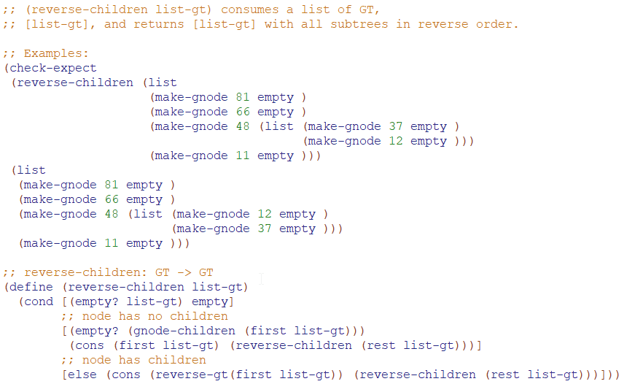
* 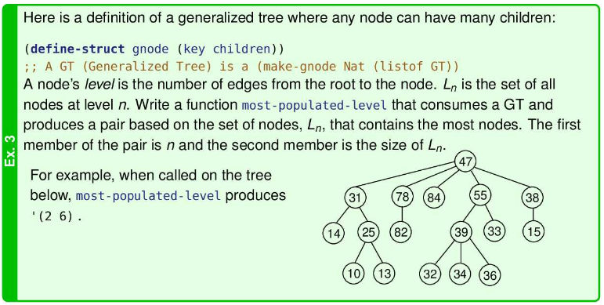

<https://github.com/ChenGrant/CS-135/blob/44c1309626fa7e17e4f94d4798d6feec35bf88d2/Module%20Excersises/module_13_ex3.rkt>

Local Definitions

* The functions and special forms we've seen so far can be arbitrarily nested—except define
* and check-expect. Arbitrarily nested” means expressions can have subexpressions, conds inside conds, lists can be nested within lists, lists can be inside structures (and visa versa), etc.
* So far, definitions have to be made “at the top level”, outside any expression. At the top level” simply means that it is outside of everything else; it’s not nested.
* We’re about to fix that for define.
* The Intermediate language provides the special form local, which contains a series of local definitions plus an expression using them.
* What use is this?: (local [(define x_1 exp_1)...(define x_n exp_n)] bodyexp)

DRY Vs WET

* P rofessional programmers try to follow the “DRY Principle”. DRY stands for “Don’t Repeat Yourself”.
* Repeating yourself:
  + Allows bugs to be fixed some places but not others.
  + Is often less efficient for the computer.
  + Involves more typing for the programmer.
  + Means the code must be understood again each time it occurs.
* violating the DRY principle results in a WET solution. WET is commonly understood to stand for “Write Every Time”, “Write Everything Twice”, “We Enjoy Typing”, or “Waste Everyone’s Time”.
* 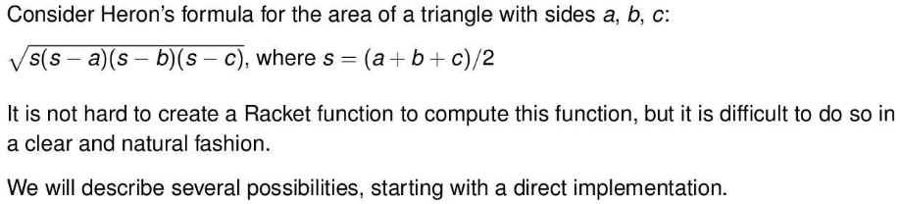
* The problem with implementing heron’s function mainly fall into three categories:
  + There’s too much repeated code!
  + But this doesn’t look like the formula we’re implementing!
  + The computations are separated and thus hard to understand!
* Direct Translation

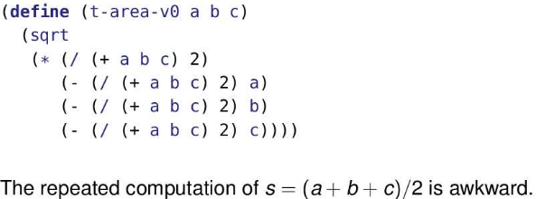

* Rewrite Expressions

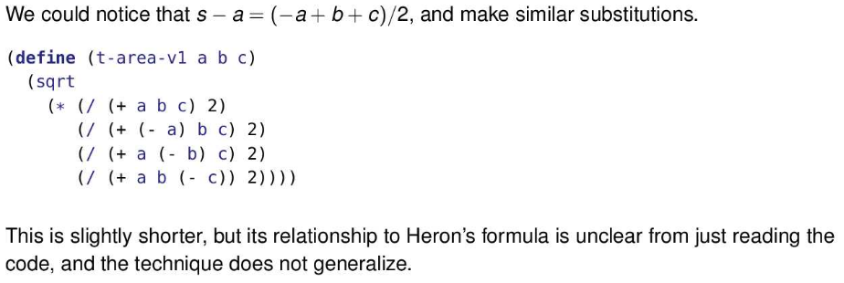

* Helper Functions (Version 1)

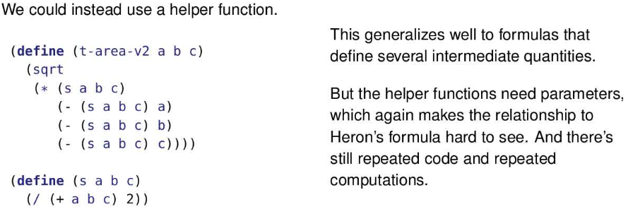

* Here, the helper function calculates the value of s in the original formula.
* Note that it’s called four times. This calculation is “cheap” to compute, but many others are not and repeating them four times could have a significant impact on the speed of the program.
* The helper function also has a terrible name. But what should you call it? It has no meaning outside of the calculation of Heron’s formula. So name it calc-s-for-herons-formula? Yuck!
* Helper Functions (Version 2)

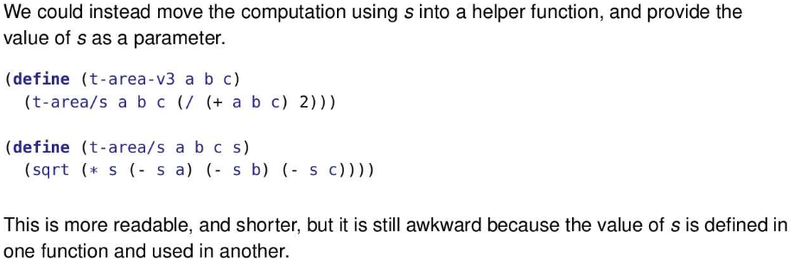

* In addition to being more readable and shorter, this solves the DRY problem. The code to compute s is not repeated. It doesn’t have to be typed multiple times and it doesn’t have to be executed multiple times.
* But we’d like to keep related code together, if at all possible

Local

* The ‘local’ special form provides a natural way to bring the definition and use together
* 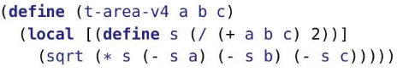
* We use square brackets around local for convention that makes it easier to read
* This function is nice and short, looks like heron’s formula, and has no repeated code or computations
* Advantages of this code:
  + It’s DRY. Nothing is repeated.
  + Calculations are only performed once.
  + It keeps everything related to calculating Heron’s formula together in a single function.
  + Because the definition of s is so contained, we don’t need to give as much thought to naming it.
* This code calculates the value of (/ (+ a b c) 2) and binds it to the identifier s. That value is then used in place of s everywhere in the expression (sqrt (* s (- s a) (- s b) (- s c))).

Semantics of Local

* Local definition permit reuse of names
* For example, consider the scope below
  + 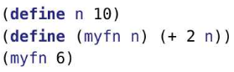this produces 8 not 12
* This same principle is extended to local. The following produces (+ 4 3), not (+ 4 5).
* 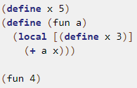
* Our substitution rules will need to handle these kinds of cases.
* (define n v) binds a value v to a name. However, if we have a function whose parameter is n, the function uses the n that is a parameter and not the definition. Notice how the name (n) is being reused.

Informal Substitution Rule for Local

* The substitution rule works by replacing every name defined in the **local** with a fresh name
* (a.k.a. fresh identifier) – a new, unique name that has not been used anywhere else in the
* program.
* Each old name within the **local** is replaced by the corresponding new name.
* Because the new name hasn't been used elsewhere in the program, the local definitions
* (with the new name) can now be “promoted” to the top level of the program without affecting
* anything outside of the **local**.
* We can now use our existing rules to evaluate the program.
* We'll state the rule rigorously towards the end of the module.
* Example:
* 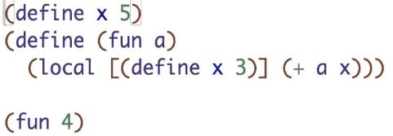
* Local introduces new identifies into a program, which might be the same as other identifies in the program (we need to make sure the right value is used)
* We locally defined an identifier x to have a value of 3. It just happens x is also the identifier of the value of 5. However, we want the x in the fun function to use x=3, not x=5.
* Substituting 4 into the function, we get the following
* 
* The next step of replacing the local with a new expression has 3 parts (but all happens in 1 step):

1. We will choose a fresh name (a name that has never been used before) for x, such as x_1 (x sub 1). Now, we replace all instances of x within local with x_1. (e.g. in (+ a x) and (define x 3)). It doesn’t matter what the fresh name is, just so long as it hasn’t been used anywhere else in the program (that is, it really is “fresh”). It could be zorgon_59 or j$%#222. Racket will choose it and we’ll never know what it chose. But in our stepping exercises, we’ll simply use the variable name followed by an _1. If we have a second identifier with the same name, we’ll use _2 and so on. We’ll assume that our programs won’t have both an x and an x_1, although Racket must handle that case.
2. We will lift the (define x_1 3) part outside of local and put it alongside other top level definitions.
3. After doing part 1 and 2, we would have (local [] (+ 4 x_1)). Part 3 get rids of the local and empty brackets to give (+ 4 x_1).

* Now, the step looks like the following
* 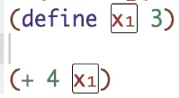
* Now, our rules proceed like before
* Example:
* 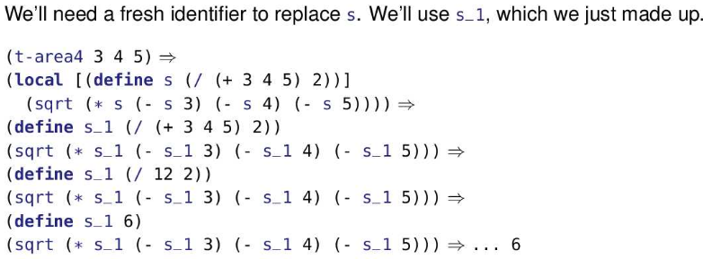
* The definition of s involves a computation. It will be performed after the definition is moved to the top level, using the same rules as before.
* The local definition, s, is used multiple times. So s_1 will also appear multiple times.
* Example:
  + A local expression can have multiple definitions. They are all handled together as a single step.

(define (foo x)

(local

[(define a (+ x x))

(define b (* x x))

(define c (+ a b))]

(+ a b c x)))

(foo 5)

=>

(local

[(define a (+ 5 5))

(define b (* 5 5))

(define c (+ a b))]

(+ a b c 5))

=>

(define a1 (+ 5 5))

(define b1 (* 5 5))

(define c1 (+ a1 b1))

(+ a1 b1 c1 5)

=>

(define a1 10) ;; note: we add this space to show a1 is done, we don’t do anything to it now

(define b1 (* 5 5))

(define c1 (+ a1 b1))

(+ a1 b1 c1 5)

=>

(define a1 10)

(define b1 25)

(define c1 (+ a1 b1))

(+ a1 b1 c1 5)

=>

(define a1 10)

(define b125)

(define c1 (+ 10 b1))

(+ a1 b1 c1 5)

=>

(define a1 10)

(define b1 25)

(define c1 (+ 10 25))

(+ a1 b1 c1 5)

=>

(define a1 10)

(define b1 25)

(define c1 35)

(+ a1 b1 c1 5)

=>

(define a1 10)

(define b1 25)

(define c1 35)

(+ 10 b1 c1 5)

=>

(define a1 10)

(define b1 25)

(define c1 35)

(+ 10 25 c1 5)

=>

(define a1 10)

(define b1 25)

(define c1 35)

(+ 10 25 35 5)

=>

(define a1 10)

(define b1 25)

(define c1 35)

75

Revising Function Substitution

* 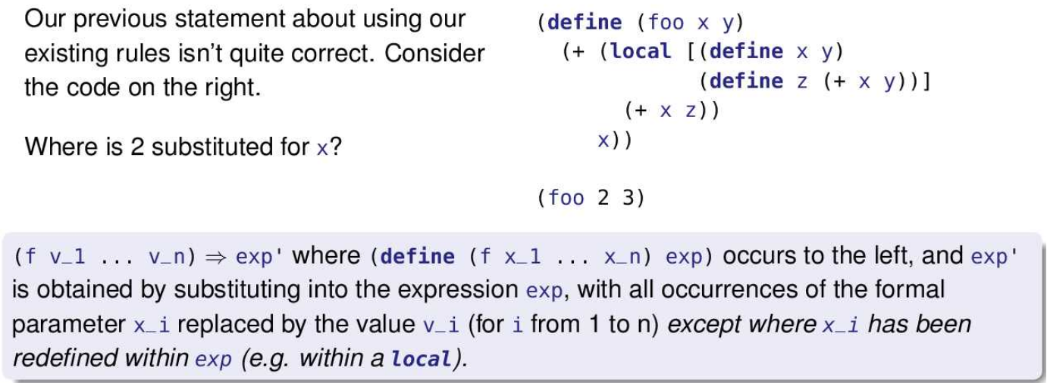
* A local definition can be nested in an expression, as seen in this example. Previously, the local was the entire function body, but that doesn’t have the be the case.
* pay particular attention to where x, the function parameter, is substituted and where x, the local definition, is substituted. Within the local, the (define x y) takes precedence over the parameter. Otherwise, the parameter is used. The picture below shows which x corresponds to the local definition and which corresponds to the parameter. It also shows the scope of the lo
* 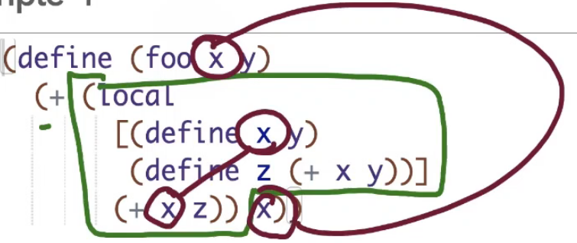
* Most programmers prefer to avoid having a local definition that “shadows” a parameter name. Why make things more complicated than they need to be?

(foo 2 3)

=>

;; notice how only the x outside the local was replaced with the value of 2 since that x was the parameter x. 3 was substituted for y as normal.

( + (local

[(define x 3

(define z (+ x 3))]

(+ x z)) 2)

=>

(define x1 3)

(define z1 (+ x1 3))

(+ (+ x1 z1) 2)

=>

(define x1 3)

(define z1 (+ 3 3))

(+ (+ x1 z1) 2)

=>

(define x1 3)

(define z1 6)

(+ (+ x1 z1) 2)

=>

(define x1 3)

(define z1 6)

(+ (+ 3 z1) 2)

=>

(define x1 3)

(define z1 6)

(+ (+ 3 6) 2)

=>

(define x1 3)

(define z1 6)

(+ 9 2)

=>

(define x1 3)

(define z1 6)

11

Example:

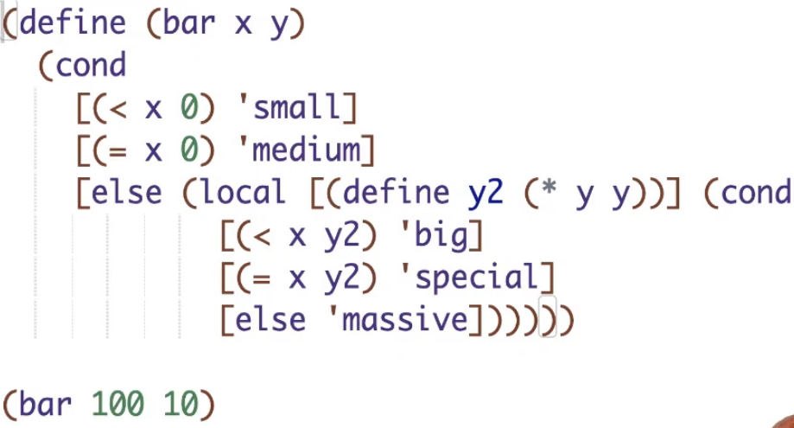

* This produces special

Using Local

Ex:

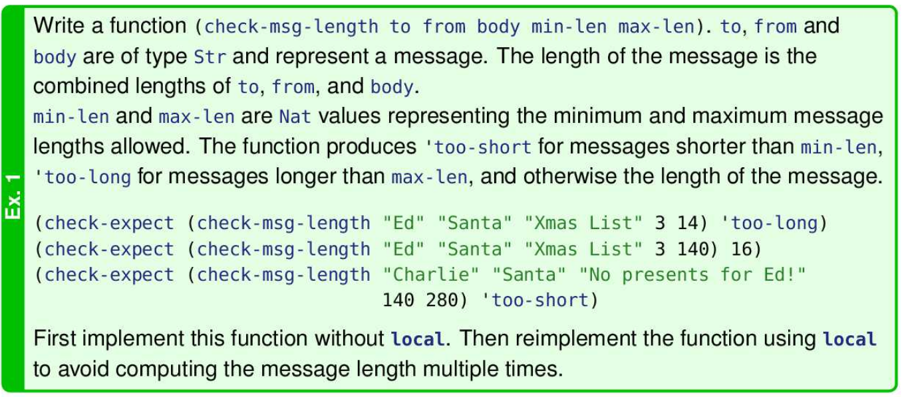

Without loca

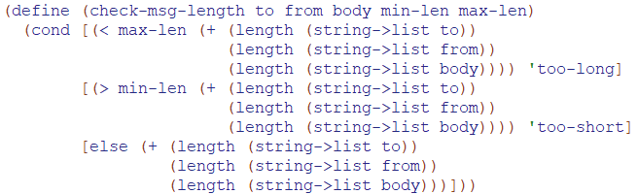

With local:

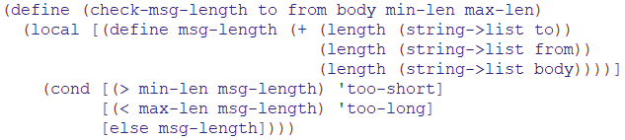

Reasons to use local

* Clarity: naming subexpressions
* Efficiency: Avoid repetition
* Encapsulation: Hiding stuff
* Scope: Reusing parameters

Clarity

* 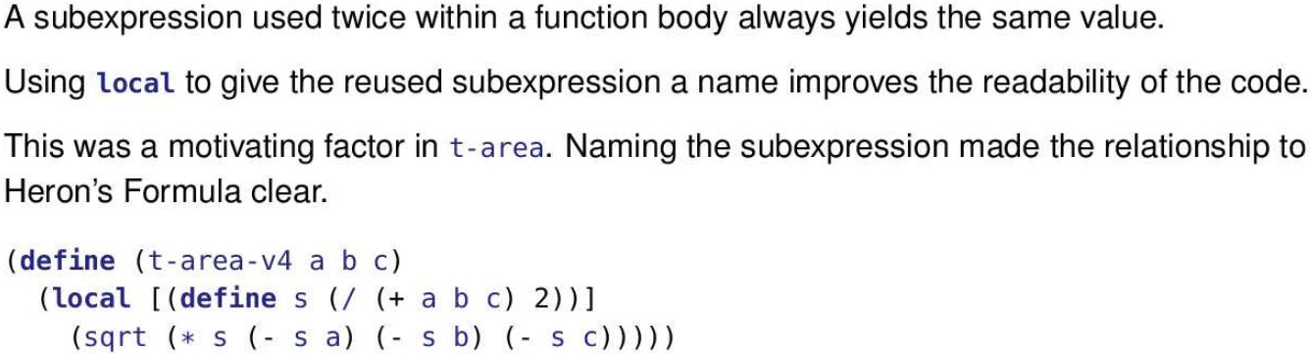
* 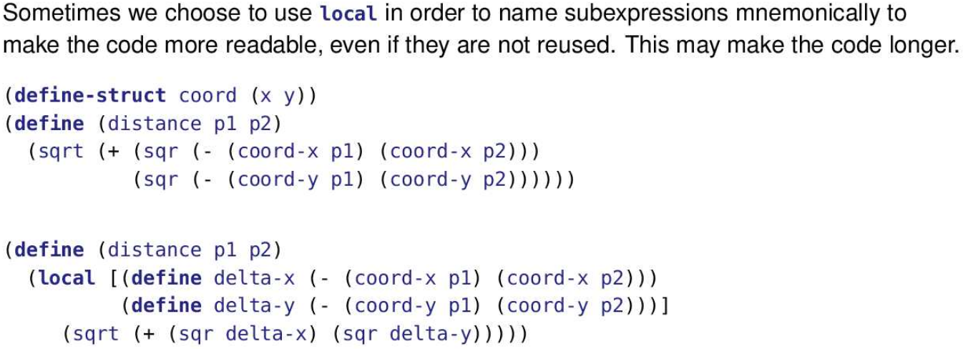

Efficiency

* Recall that in lecture module 09, we saw a version of max-fist that used the same recursive application twice. The repeated computation of values caused it to be very slow, even for lists ibf length 25.
* We can use local to avoid recomputations
* 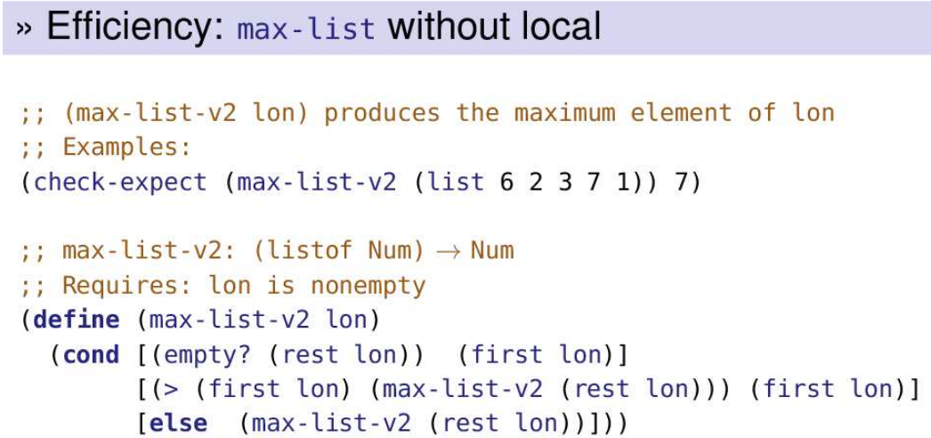
* 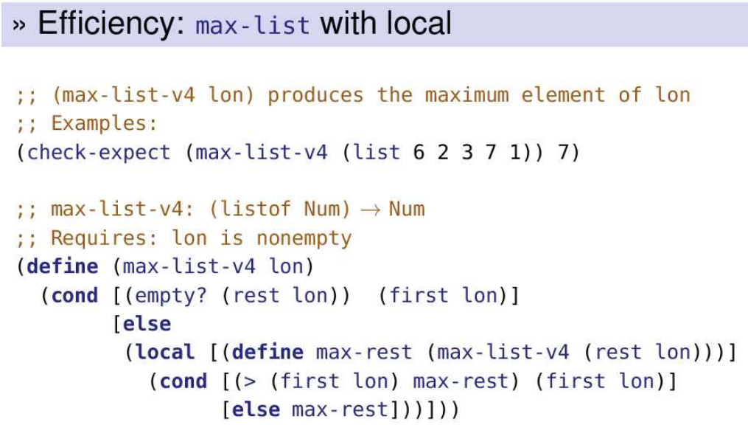
* In max-list-v4 we calculate the maximum of the rest of the list in the recursive case. Once that value has been calculated, the local allows us to use it multiple times without recalculation. Recall that it was recalculation that caused the efficiency issues with max-list-v2.
* This is the fourth approach we’ve seen to finding the maximum value in a non-empty list:
  + max-list-v1 used the built-in helper function, max.
  + max-list-v2 had two recursive applications that led to significant efficiency issues.
  + max-list-v3 solved the problem with an accumulator.
  + max-list-v4 solves the problem with local.
* Of the four, the first one is likely the best approach. Thanks to the built-in helper function max it’s a simple and direct approach that is also efficient. If max was not built in and we had to define it for ourselves, then either version 3 or version 4 would likely be considered the best choice.
* 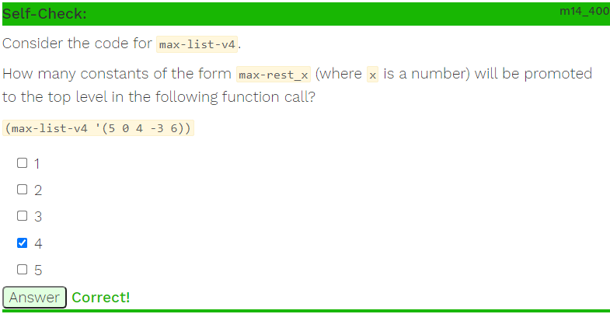
* Each time we lift a local definition, its value is a recursive call on the rest of the list
* Since the list initially has 5 elements, there are 4 constants since each of the sublists will create a new local definition on their recursive call except for (list 6) since that hits the base case
* 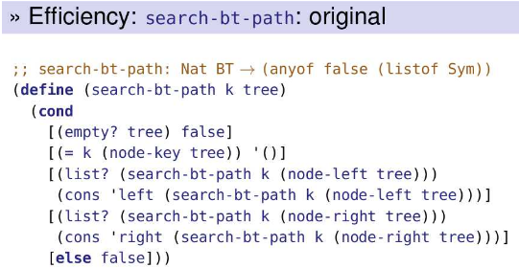
* This version of search-bt-path from Module 11, slide 18 suffers from the same problem as max-list-v2: it often applies itself twice to the same argument resulting in an explosive growth in the number of applications as the tree becomes larger.
* 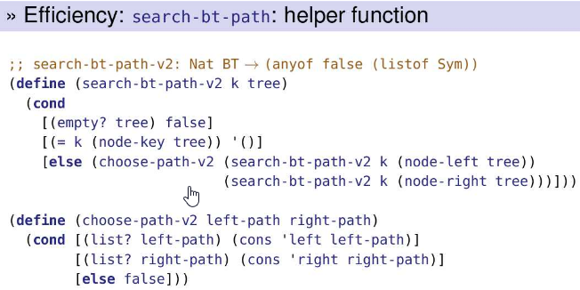
* This version parallels the solution in max-list-v1. It uses a helper method to avoid recomputing values.
* 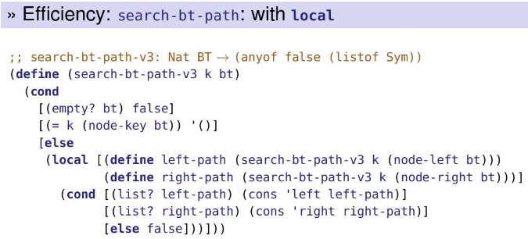
* This new version of search-bt-path avoids making the same recursive function application twice, and does not require a helper function. But it still suffers from an inefficiency: we always explore the entire binary tree, even if the correct solution is found immediately in the left subtree. (Since before the code, we use the define to search both the left and right subtree. However without define, it is possible that we first search the left subtree and get the answer, so we never actually need right-path, but we still evaluated it, making it inefficient)
* We can avoid the extra search of the right subtree using nested locals.
* 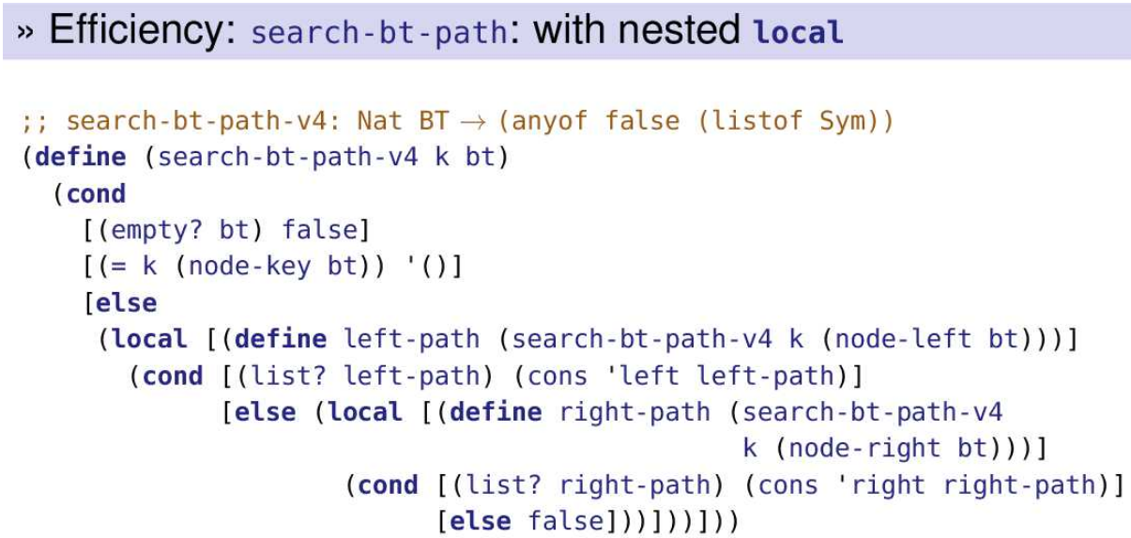
* The left-path is only computed if the outer else clause is reached. The path is checked and, only if required, is a second local evaluated and the right-path is computed.
* Note that this is not the else (cond pattern from Module 04, Slide 26 . There is a local in between.

Encapsulation

* Encapsulation is the process of grouping things together in a "capsule".
* We have already seen data encapsulation in the use of structures: we grouped several fields together into one "capsule", the structure.
* There is also an aspect of information hiding to encapsulation which we did not see with structures. The local bindings are not visible (have no effect) outside the local expression. Thus, they can "hide" information from other parts of the program.
* Local definitions can bind names to functions as well as values. Evaluating the local expression creates new, unique names for the functions just as for the values.
* This is known as behaviour encapsulation.
* Behaviour encapsulation allows us to move helper functions within the function that uses them, so they:
  + are invisible outside the function.
  + do not clutter the "namespace" at the top level.
  + cannot be used by mistake.
* We say the local function is “invisible” because it can’t be used outside of the local. For example, trying to run the following program
* Ex:

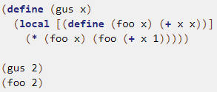

* results in an error: foo: this function is not defined.
* That means foo can’t be misused by applying it in an unintended context (outside of gus). It also means that foo can be removed from the list of functions most programmers need to worry about (that is, decluttering the top-level namespace).
* Ex:

(define (gus x)

(local

[(define (foo x) (+ x x))]

(* (foo x) (foo (+ x 1)))))

(gus 2)

=>

(local

[(define (foo x) (+ x x))]

(* (foo 2) (foo (+ 2 1))))

=>

(define (foo1 x) (+ x x))

(* (foo1 2) (foo1 (+ 2 1)))

=>

(define (foo1 x) (+ x x))

(* (+ 2 2) (foo1 (+ 2 1)))

=>

(define (foo1 x) (+ x x))

(* 4 (foo1 (+ 2 1)))

=>

(define (foo1 x) (+ x x))

(* 4 (foo1 3))

=>

(define (foo1 x) (+ x x))

(* 4 (+ 3 3))

=>

(define (foo1 x) (+ x x))

(* 4 6)

=>

(define (foo1 x) (+ x x))

24

* This makes the organization of the program more obvious and is particularly useful when using accumulators. local is often used with wrapper functions. The wrapped function – the one that does most of the work – is defined within the local.
* 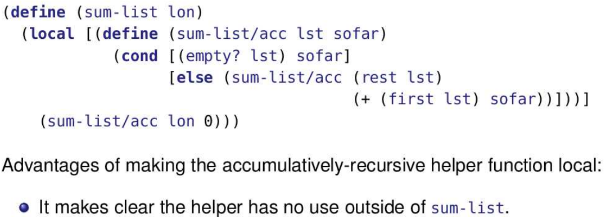
* 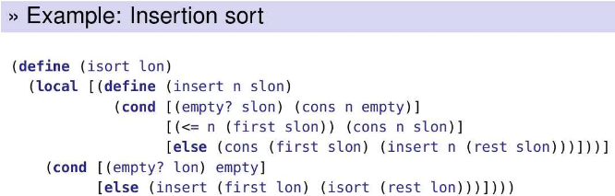
* Ex:
* 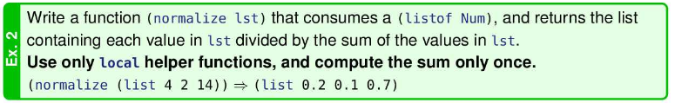
* This exercise is a bit more work than most of our exercises. However, once we introduce higher order functions in M16, this problem can be solved using local in only four lines of code! Without the techniques of M16 (and using local) it takes about 9 or 10 lines of code.
* 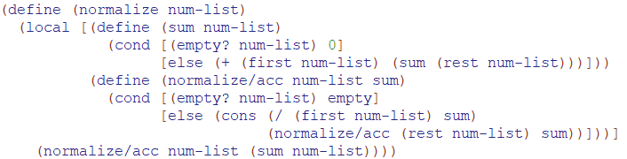

Mutual Recursion

* 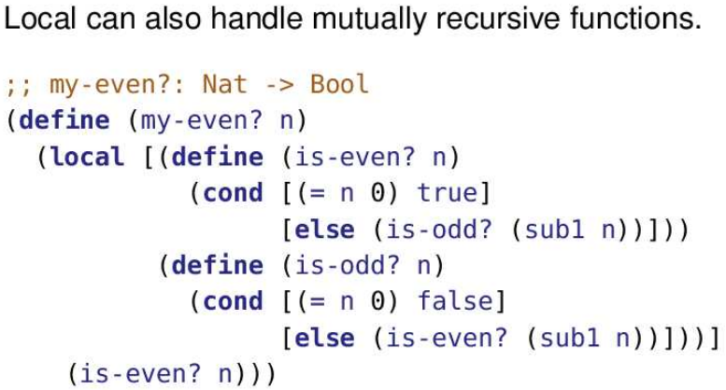
* is-even? and is-odd? are each given fresh names and lifted to the program’s top level. They then act just like any other pair of mutually recursive functions.
* The tracing is done below

(my-even? 4)

=>

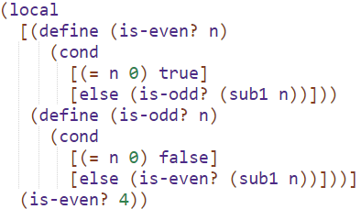

=>

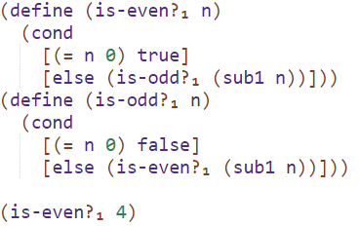

;; the following steps are evaluated like normal

Encapsulation and Design Recipe

* A function can enclose the cooperating helper functions that it uses inside a local, as long as these are not also needed by other functions. When this happens, the enclosing function and all the helpers act as a cohesive unit.
* Here, the local helper functions require contracts and purposes, but not examples or tests. The helper functions can be tested by writing suitable tests for the enclosing function.
* Ex:
* 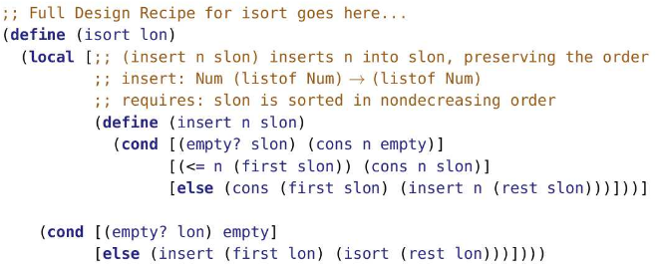
* Note that insert is only required to have a purpose statement and a contract. Examples and tests are not required (largely because check-expect can’t be nested).

Scope

* Making helper functions local can reduce the need for parameters to “go along for the ride”
* Ex: The below doesn’t use local helper functions
* 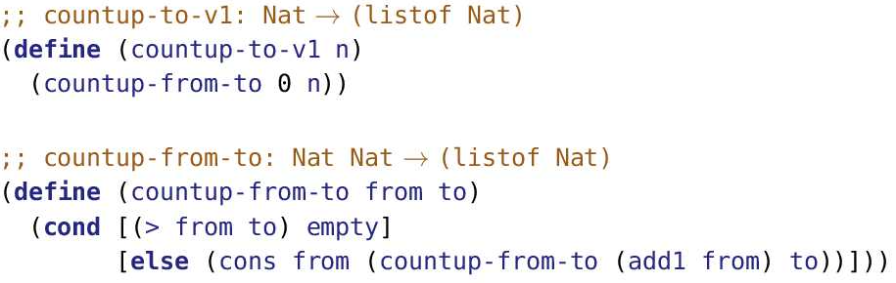
* Ex: The below uses local helper functions
* 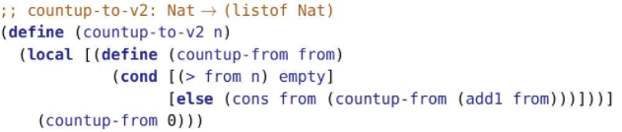
* Notice n is not a parameter of countup-from, because it is in scope
* The local definition of a function results in local functions being lifted to the top level. You may be wondering what happens to them after they have been evaluated and are no longer needed. There are two parts to the answer.
* First, the substitution model is not necessarily the way the computation is actually implemented in DrRacket. It may have a more efficient way to do it.
* Second, unneeded resources (including cons cells and lifted functions) are reclaimed in a process called “garbage collection”.
* 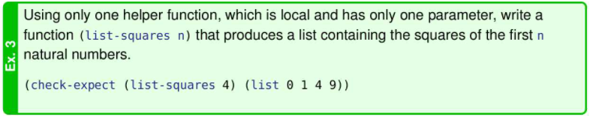
* 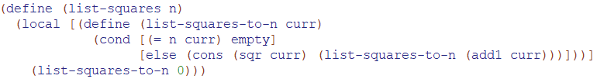
* Ex:
* 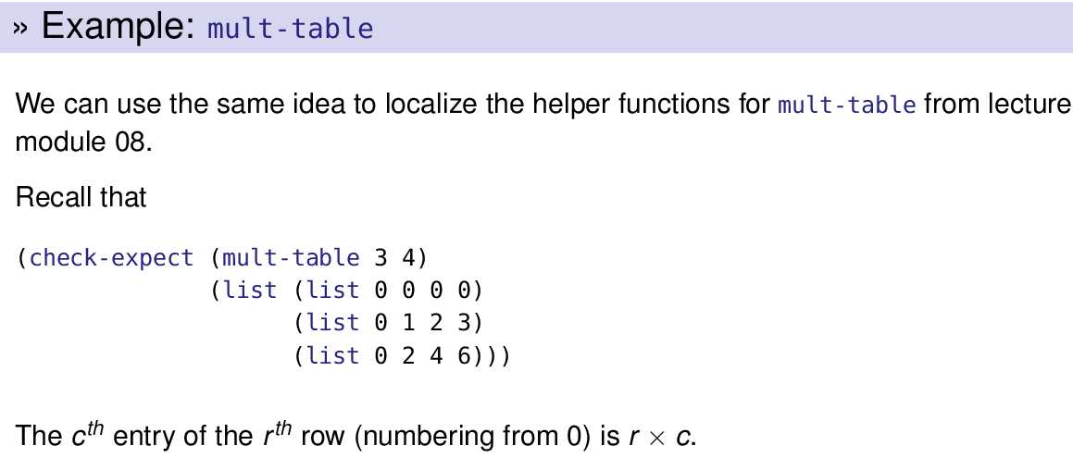
* 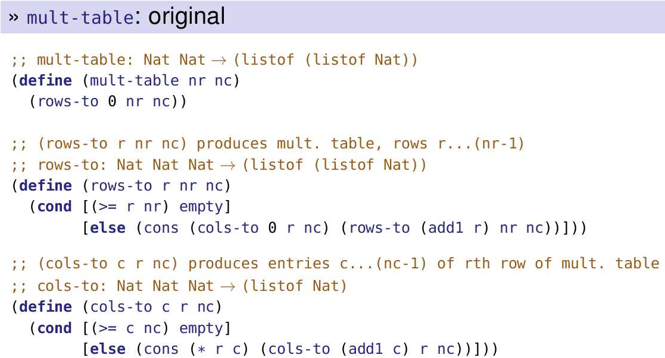
* 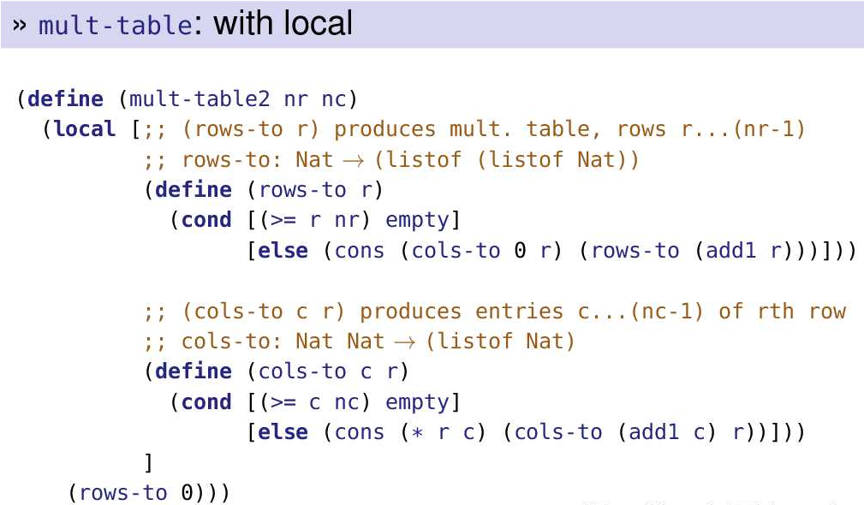
* when the functions rows-to and cols-to are lifted to the top level they will have the values for nr and nc “embedded” in the body of the function.
* Advantages to this version of mult-table include:
  + Making clear that rows-to and cols-to belong to mult-table and are not expected to have other uses.
  + Not needing to expend effort to determine that nc and nr really don’t change as the helper functions execute.
  + Simplifying the parameters for the helper functions and thus reducing the chances that they are mixed up.
* 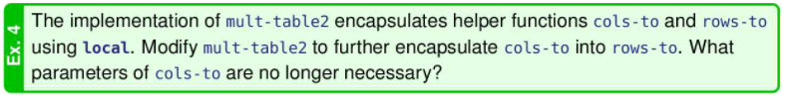
* 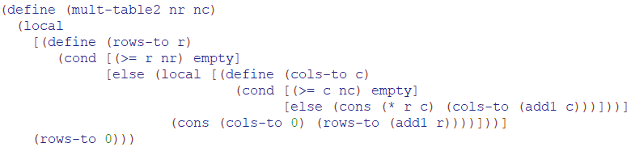
* 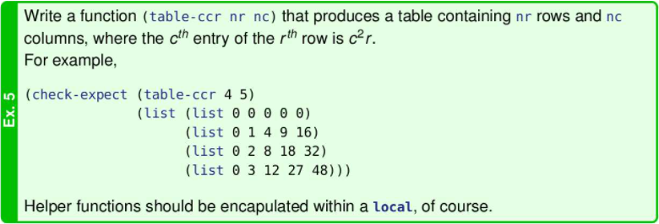
* 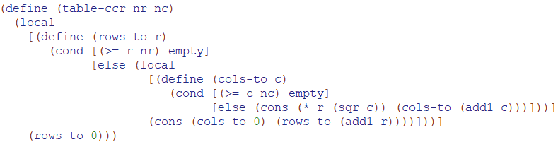

Formal Substitution Rule for Local

* 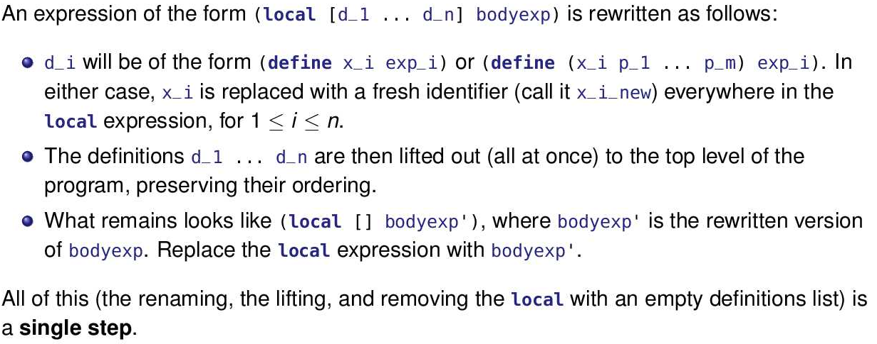
* 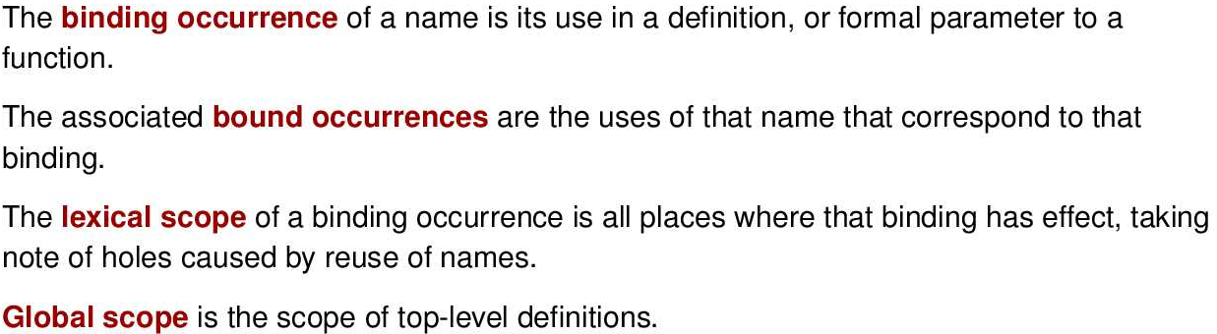
* DrRacket can help you with these. If you click “Check Syntax” and then hover your mouse over a binding occurrence, it will draw arrows to the bound occurrences.
* 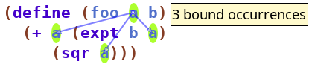
* Hovering over a bound occurence will draw an arrow from the binding occurrence and highlight the other bound occurrences.
* For an example of the “holes” mentioned in the definition of “lexical scope”, consider Example 4 from our earlier discussion:
* 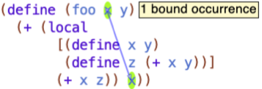
* The “holes” are the occurrences of x that are not highlighted due to (define x y).

Module 15

Functions as First Class Values

* Racket is a functional programming language since functions are first class values. This means functions are values just like 3, ¼, ‘earth, “Hello”, true, or (cons 1 (cons 2 empty)). Anything we can do with normal values, we can do with functions as well since functions are first class values.
* Functions can be
  + 1) consumed as function arguments
  + 2) produced as function results
  + 3) bound to identifiers
  + 4) stored in lists and structures
* We have written lots of functions that consume a list as an argument. Now, we’ll start writing functions that consume a function as an argument.
* Functions as first-class values have been missing from most non-functional programming languages

Consuming Functions

* A function can consume another function as an argument
* ex: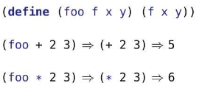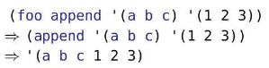
* Notice the function foo consumes a parameter f which is also a function. It doesn’t just have to be an operator, it could be other functions such as append (as shown on the right)

When is consuming a Function as an argument useful?

* Consider the following two functions:
* Eat-apples consume a list of symbols and removes all elements whose values are ‘apple
* Keep-odds consumes a list of numbers and keeps only the elements that are odd
* 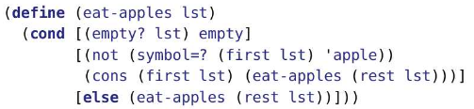
* 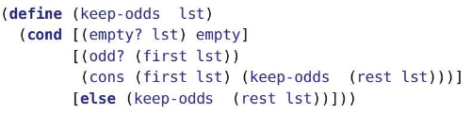
* Notice these two functions are really similar, the only differences are the function name in the definition and the recursive calls, and the specific predicate used to decide whether an item is removed or not (the second condition).
* To avoid having to write two functions, we can write one function to do both these tasks because we can supply the predicate (the second condition) to be used as an argument for the function
* Thus, the new function could look like below where pred? is a new argument for the function. (We have keep-odds shown again to show the similarity)
* 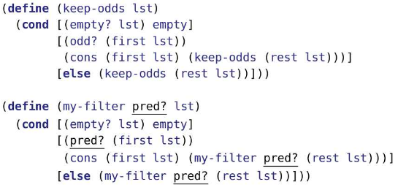
* Thus, if we passed even? as the value for pred? and (list 0 1 2 3 4) as the value for lst, the stepping would look as follows
* 
* Notice below, the substitution rule applies for functional arguments just like normal arguments
* 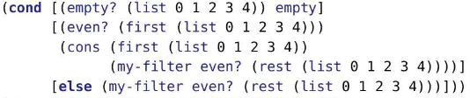
* 
* Eventually, we get 
* There is actually a built-in function called filter that does the same thing as our my-filter function
* Filter handles the general operation of selectively keeping items on a list
* 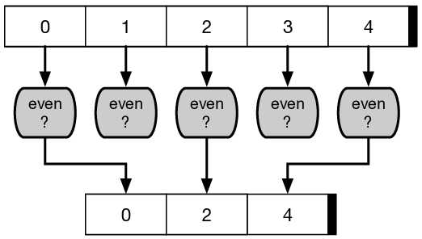
* Filter is an example of a higher order function. Higher order functions either consume function or produce a function (or both)

Using my-filter

* 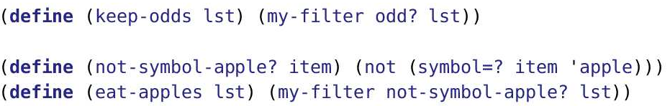
* Notice we define a function call not-symbol-apple? which consumes a symbol
* Notice we define the eat-apples functions which executes the my-filter function. The my-filter function consumes a predicate which is a function. The function we passed in was not-symbol-apple?. Notice how we didn’t also pass in the parameters for not-symbol-apple? which is a symbol, rather we just passed in the function name
* Notice we created a function, not-symbol-apple?, whose only purpose was to eventually be passed into my-filter as a predicate. Since not-symbol-apple? doesn’t have much meaning outside of the my-filter function which is inside the eat-apples function, we can just locally define the not-symbol-apple? function as shown below
* 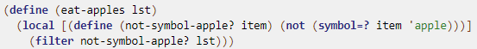
* 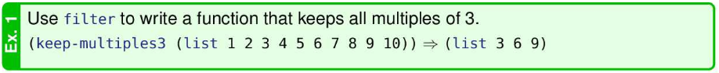
* 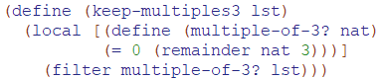
* 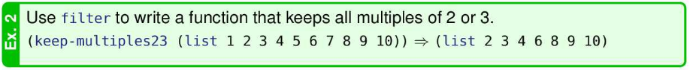
* 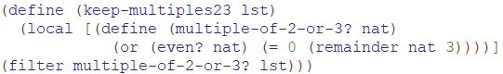
* 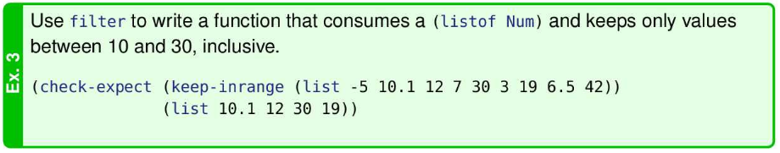
* 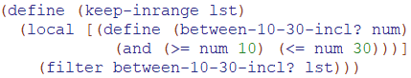
* 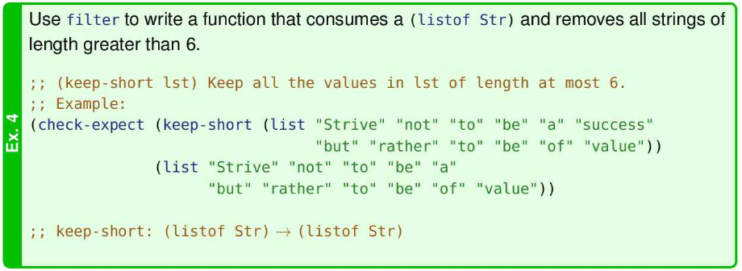
* 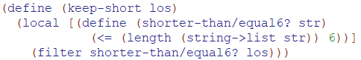
* 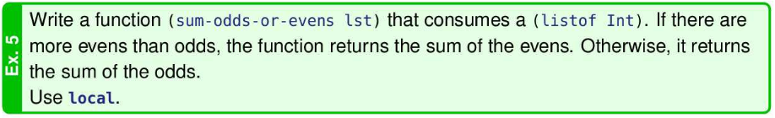
* Notice that the first local function returns built in functions (even? or odd?)
* 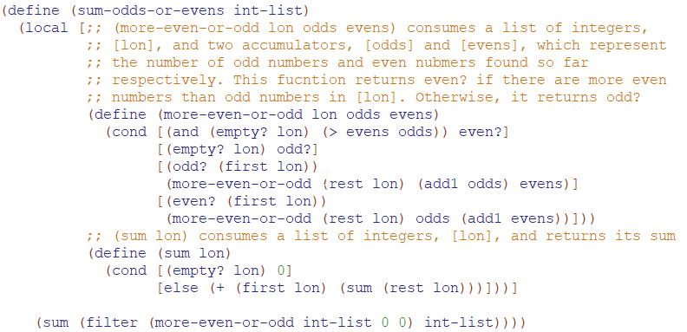

Advantages of functional abstraction

* Functional abstraction is the process of creating abstract functions such as filter
* The advantages include:

1. Reducing code size

* (define (keep-odds lst) (filter odd? lst)) is certainly more compact than the original version of keep-odds.

1. Avoiding copy-paste

* If a program already contains keep-odds and now needs keep-evens, a programmer will likely cut and paste the keep-odds function and then modify it. On the one hand, that’s good because it can save time and leverages work that’s already been done. On the other hand, it violates the DRY principle . Code is replicated; both sets of code must be maintained; bugs may be replicated and (more likely) needed changes missed. Abstracting out the common code addresses all these issues.

1. Fixing bus in one place instead of many

* Bugs: filter is pretty simple and hopefully doesn’t have any bugs. But if it did, fixing filter will fix that same bug across all the places where it is used. This isn’t limited to higher order functions. It applies to any time you’re being DRY and moving common code to a function.

1. Improving one functional abstraction improves many applications

* Other beneficial changes, besides fixing bugs, may be to increase the speed or increase the size of problem that can be handled by the function. Once again, doing it once spreads these benefits to each place the function is used.

Producing Functions

* Because functions are first class values, we can do anything with functions that we can do with other values. functions can be the return value of functions
* Consider the following function, make-adder:
* 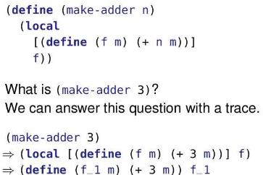
* Notice make-adder consumes n which is used to create a local function called f. The local function f is the output. However, f is not executed since there is no value for f to evaluate. Make-adder simply returns another function which can be used later on. Currently, make-adder returns a function which by itself is kinda useless.
* 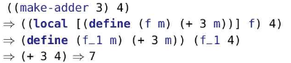
* Notice ((make-add 3) 4) has a double parenthesis. Usually, we expect a function name right after an open bracket. The reason we have a double bracket is because the first sub-expressions, (make-add 3), calculates and returns a function that will be used in ((make-add 3) 4). First position can be an expression (computing the function to be applied).
* Notice how we use make-adder to return a function that will have an input which is 4, leading to a value as the output.
* Note on Scope:
* 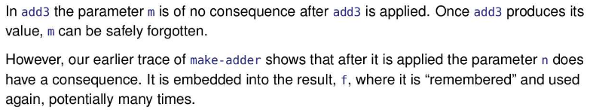
* Thus the scope of m sorta changes. M still only has context within the function called f. Before, f was only used once, so m never really got used again. However, since f can now be called many times, the value of m is tied to f and used many times as well, which sorta increases the scope of m.

Combing Producing and Consuming Functions

* Using local to produce a function gives us a way to create semi-custom functions to use in expressions, which is really useful for higher order functions such as filter
* Ex: 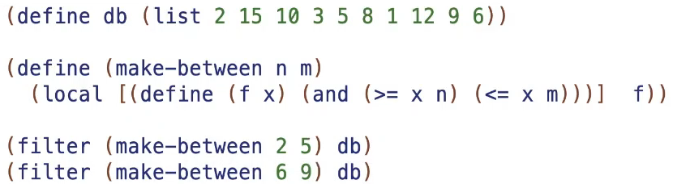
* We defined make-between which returns a predicate. we defined a function, f, which produces a predicate which is true when it is between two numbers. Thus, we are customizing our predicate by inputting the bounds of the predicate, n and m, which is used in making f, our predicate function. F, a predicate, is then being applied to each element in db through the filter function.
* Filter along with predicates allow for flexible and concise code
* 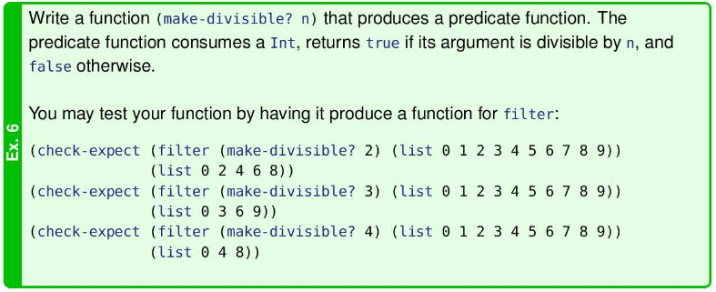
* 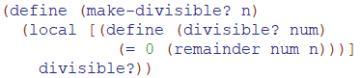

Binding functions to identifiers

* We can bind a value like 3 or "Hello, world!" to an identifier to make a constant. Because functions are values, we can do that with functions, too.
* (make-adder 2) produces a function. (define add2 (make-adder 2)) gives that function a name so it can be used over and over.
* Why wouldn’t we just define the function directly, like we always have? It would like likely have a lot more repeated code, more places to fix bugs, involve more typing, etc
* The result of make-adder can be bound to an identifier and then used repeatedly
* 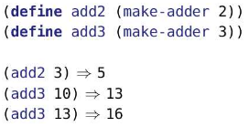
* Tracing a Bound Identifier
* 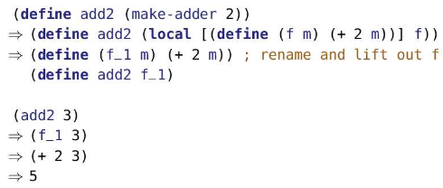

Storing functions in lists and structures

* 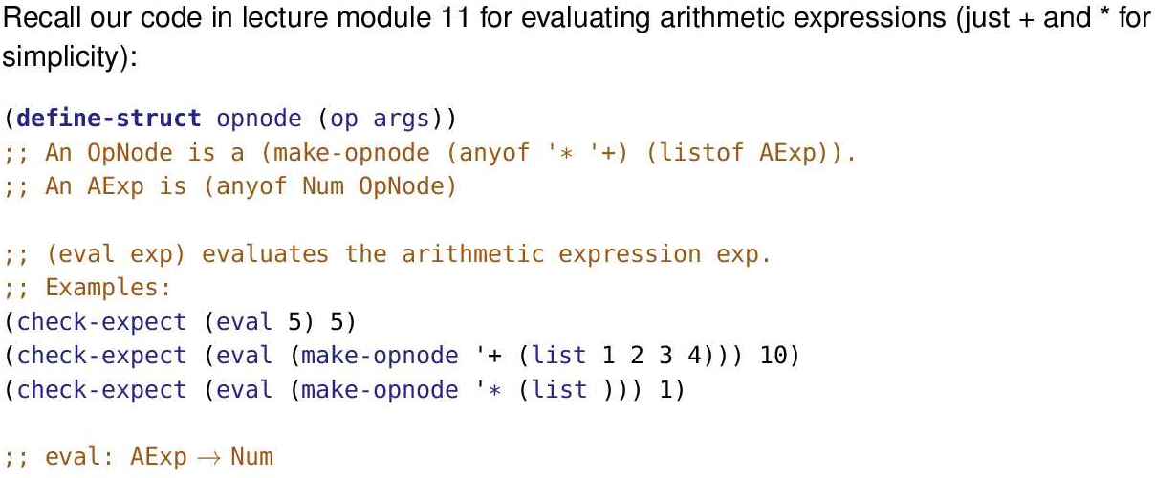
* 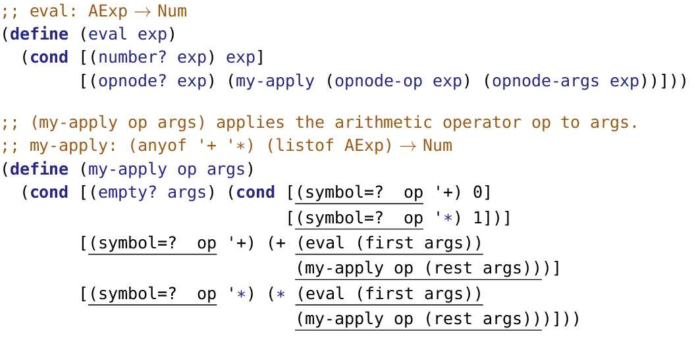
* Notice the underlined code, the code is basically repeated and the same, it’s just the operator (plus or multiply) that is different. This is a lot of boilerplate code. Boilerplate code are sections of code that are repeated in multiple places with little to no variation.
* This time, instead of using the symbols ‘+ and ‘* to represent the built-in functions + and *, we can directly pass in the built-in functions + and *. The key insight is that we’ll store the function itself (it is a first class value, after all!) in the OpNode structure.
* 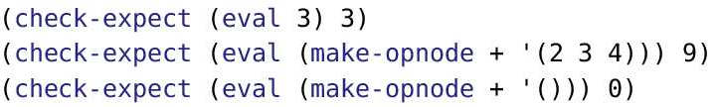
* Notice how we passed in a function as an argument to make-opnode and not a symbol representing the built-in function
* 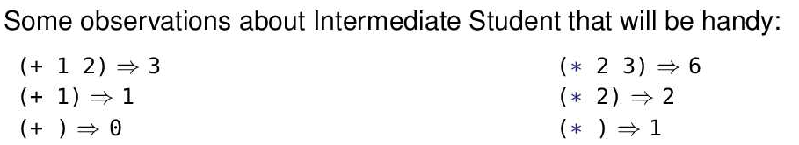
* The “observations” are simply recalling what we noted back in M11: (+ ) produces the additive identity (0) and (* ) produces the multiplicative identity (1).
* The eval function does not change, but my-apply does
* 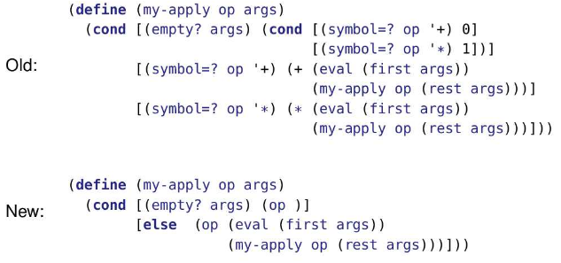
* Notice the in the new version, we longer have to consider what operator op is since the built-in function of that operator will be passed in.
* In the empty case, we return (op ) which is returning the multiplicative identity or additive identity, depending on the operator. Notice we don’t need to consider if the operator was add or multiply in the code, we’re able to consider both cases since the operator is a function that we passed in.
* Notice in the else, we evaluate to the first element in the list args and evaluate all the other elements in the list argos and add or multiply them depending on the operator. Again, notice we don’t need to consider if the operator was add or multiply in the code, we’re able to consider both cases since the operator is a function that we passed in.
* However, sometimes we cannot replace symbols that represent built-in functions with the built-in functions themselves. Say we want to condense the following:
* 
* We could condense it to the following by using lists and quote notation instead of structures (we can use lists to simulate structures). The first thing in any list is the operator, and the rest of the list are arguments. but there is a catch
* 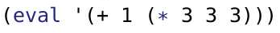
* The + and the * is a built in function, but the quote notation will make it a symbol, ‘+ and ‘*, which no longer makes it a built-in function. In fact, it is no longer even a function, but rather, a symbol
* Thus, we want to know can we have both this condensed version with quote notation and also the advantages of eliminating boiler plate code (mainly spent mapping an operator with its represented symbol)
* Aside: Why do we even bother with the eval function. If we want to evaluate (+ 1 (* 3 3 3)), why don’t we just write (+ 1 (* 3 3 3)) instead of (eval ‘(+ 1 (* 3 3 3)))? (eval ‘(+ 1 (* 3 3 3))) makes the expression, (+ 1 (* 3 3 3)), into *data* rather than code in our program. Data is more flexible than code. We can process data; we can’t process code. We can put data into a file, read the file, and process the data. It allows the program to ask the user for an expression that then gets calculated. As well, when (+ 1 (* 3 3 3)) is expressed as data using eval, we can write functions that might find the integrate, differentiate, etc the data.
* To have both this condensed version with quote notation and also the advantages of eliminating boiler plate code, we can use a translation table which maps a symbol that represents a mathematical operator to the mathematical function itself.
* Below we have a function called look-up which consumes a symbol and returns the function represented by the symbol
* We have a constant called trans-table which makes symbols to the corresponding function
* 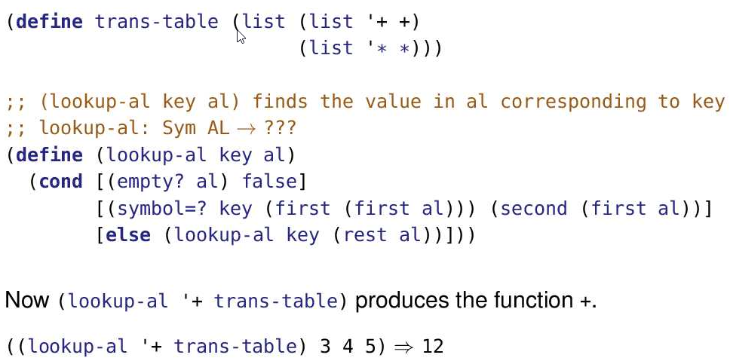
* Notice ((loopup-al ‘+ trans-table) 3 4 5) will look up the function represented by ‘+ which is +. Thus, the expression eventually becomes (+ 3 4 5)
* We can use lookup-al inside the eval function
* Notice below, the my-apply function was the same function as before. The eval function has changed a bit. Eval passes a function, the built-in mathematical operator in this case, to my-apply by using the lookup-al function. As well, since we use lists instead of structures to represent expressions, we use first to get the symbol that represents the operator and rest to get the arguments (children nodes).
* 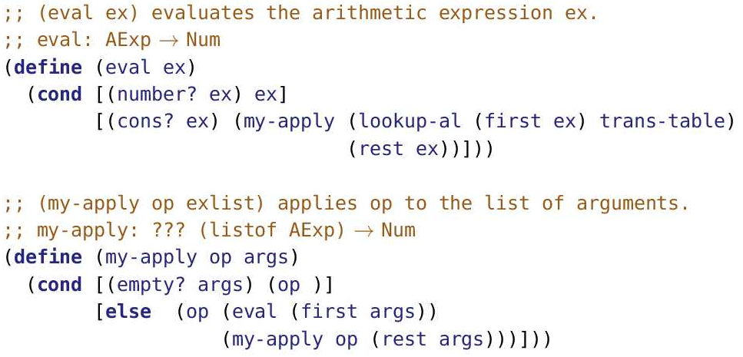
* This translation table is very useful as it easily allows us to add new functions such as - and /.
* Notice in this example,

1. Consume: my-apply consumes a function which is its op parameter.
2. Produce: Lookup-al looks up a symbol and returns a function
3. Bind: we’ve bound a function to an identifier as a parameter, results of lookup-al to op. We’ve also bound a function to an identifier as a constant. (recall what binding is in the local module)
4. Store: We’ve also stored functions in trans-table

Contracts for Functions as parameters or outputs

* 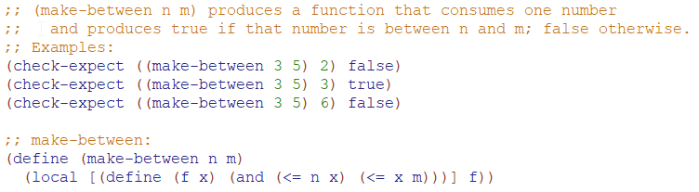
* What is the contract for make-between:
* The following aren’t formal steps, but they help
* Make-between consumes two numbers and returns the function f
* ;; make-between: Num Num -> f
* Since f is a function, we should need to think of the contract for f
* ;; f: Num -> Bool
* We can now replace the f in the contract for make-between with the contract for f to obtain the following. Also, use brackets to indicate where the arrows belong.
* ;; make-between: Num Num -> (Num -> Bool)
* 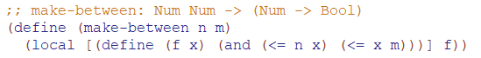
* Now, write a contract for in-discontinuous-range
* 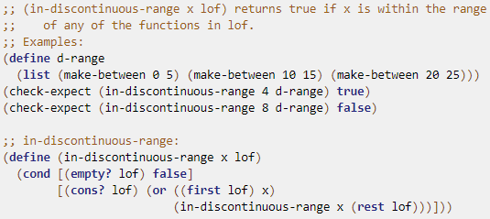
* Since In-discontinuous-range has two parameters, x and lof, we have the following:
* In-discontinuous-range: ___ ___ -> ___
* Notice the outputs are either: false, ((or ((first lof) x) (in-discontinuous-range x (rest lof)))). Clearly the false is just false, the second possible output has an or as the biggest function(the last function to be called) which produces a Bool.
* Thus In-discontinuous-range produces a Bool
* In-discontinuous-range: ___ ___ -> Bool
* Since d-range can be passed in as the argument for the lof parameter, d-range’s type is going to be the same type as lof (we’ll most of the time. Imagine if lof was (any of drange’s-type Str). Then we wouldn’t cover all the possible types of lof so keep that in mind, won’t happen often) (imagine if d-range was “hello” which has a type of Str. then we would know lof is a Str. Then we can think in a similar manner. Whatever d-range is, lof will be the same).

We can see d-range is a list so we have (listof ___ ). We also see d-range is a list of make-betweens. ***Before we try and figure out the type of d-range, consider the following contant, x:

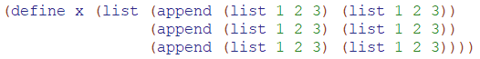

x IS NOT the following:



We don’t care about what the append function’s parameters are. We only care about what append produces which is a (listof Num) Thus, x IS the following:

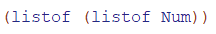***

Thus, whatever make-between produces is going to be the type of each element in d-range. We already know make-between returns a function of the form (Num -> Bool) from the example above. Thus, d-range is (listof (Num -> Bool)). Notice we don’t care what parameters make-between consumes, we only care about what make-between produces. Since d-range is (listof (Num -> Bool))

and d-range has the same type as lof, Thus, lof is (listof (Num -> Bool)). Thus, we get the following

* In-discontinuous-range: ___ (listof (Num -> Bool)) -> Bool
* Notice 4,8 can be passed in as the values for x from the check-expects. Since 4 and 8 are Nums, x is a Num as well. Also notice we have ((first lof) x). Recall lof is (listof (Num -> Bool)). Thus, (first lof) is (Num -> Bool) so (first lof) is a function that consumes a Number. x is being passed into (first lof) so x is a number. Thus, we get the following:
* In-discontinuous-range: Num (listof (Num -> Bool)) -> Bool

Now, write a contract for the following:

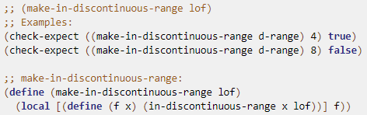

* We see that make-in-discontinuous-range has one parameter so we get the following:
* ;; make-in-discontinuous-range: ____ -> ___
* We see that make-in-discontinuous-range returns f. Well, what is f?
  + Notice f consumes one parameter so f lookings like the following:
  + ;; f: ___ -> ____
  + Notice f calls the In-discontinuous-range which has an output of boolean. Since In-discontinuous-range is the biggest function(the last function to be called), whatever In-discontinuous-range produces will be the same type that f produces. Since we know In-discontinuous-range produces a Bool from the previous example, f produces a bool. Thus we have the following so far
  + ;; f: ___ -> Bool
  + Now we need to figure out the type of x that f consumes. We notice x is being passed onto In-discontinuous-range as the first parameter. We know In-discontinuous-range consumes a number as its first parameter from the previous example. Thus, x is a number. Since f consumes x (a number) as its first parameter, we get the following:
  + ;; f: Num -> Bool
  + Now we know what f is, and since make-in-discontinuous-range returns f, we get the following:
* ;; make-in-discontinuous-range: ____ -> (Num -> Bool)
* Now, we need to figure out the type of lof. Since lof is being passed into make-in-discontinuous-range as its second parameter and we know make-in-discontinuous-range’s second parameter has a type of (listof (Num -> Bool)) from the previous example, we know lof has a type of (listof (Num -> Bool)). Thus we get the following:
* ;; make-in-discontinuous-range: (listof (Num -> Bool)) -> (Num -> Bool)

Ex:

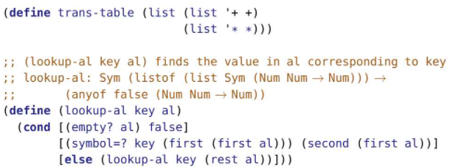



Recall: (lookup-al ‘+ trans-table) returns the built-in + function

Now write a contract for lookup

* ;; lookup-al: _______ ______ -> ____
* Looking at the code it produces false or (second (first al). Since trans-table is passed in as an argument for the al parameter. Thus, the type of al is the same as the type of trans-table. Trans-table is a (listof (list Sym (Num Num -> Num))). Thus, al is a (listof (list Sym (Num Num -> Num))). So, (first al) is (list Sym (Num Num -> Num)). So, (second (first al)) is (Num Num -> Num). So lookup-al produces false or (Num Num -> Num)
* ;; lookup-al: _______ ______ -> (anyof false (Num Num -> Num))
* Now, we will figure out the type of key. Key as its first parameter to the symbol=? function. The symbol=? has a symbol as its first parameter, so key is a symbol
* ;; lookup-al: Sym ______ -> (anyof false (Num Num -> Num))
* We know al is (listof (list Sym (Num Num -> Num))) which we determined when finding the output of lookup-al
* ;; lookup-al: Sym (listof (list Sym (Num Num -> Num))) ->
* ;; (anyof false (Num Num -> Num))



* function can be defined for zero arguments. Our system for specifying contracts doesn’t handle such functions very well.

Contracts for Higher Order Functions

* Filter consumes a function(a predicate) and a list and produces a list
* We might want to write its contract as the following which is NOT GOOD ENOUGH:



* We want to be more specific. Notice the Any is the same type throughout. So the 3 Any’s must all be Str, or all 3 must be Int, etc. Also note, the first parameter of filter, the predicate, consumes Any that is the same type as the listof the Any.
* Thus, there is a relationship among the two arguments of filter and the result of filter that we need to capture in the contract
* To do so, we can use a type variable. A type variable is simply a symbol that stands for some specific, but currently unknown, type. We’ve been using type variables since Module 06 for lists. For example, (listof X). We can use X in different places to indicate where the same type is needed.
* The difference is now that same variable is going to appear multiple times in the same contract.
* Consider the following contract for some random function:
* F: (listof X) (listof Y) -> Any
* Notice this indicates X and Y are not needed to be the same (they can be, but it is not necessary). This shows there is no relation between the parameters.
* 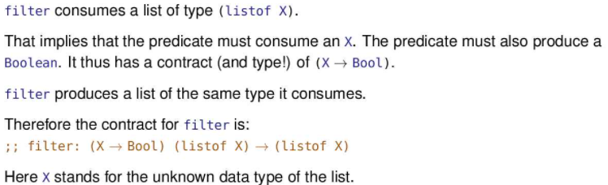
* We say filter is polymorphic or generic; it works on many different types of data
* Whenever we use higher order functions, we have to make sure to respect the contract a lot

Ex:

* Find the contract for my-filter:
* 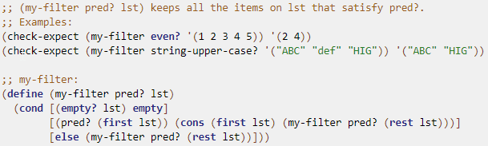
* If we don’t know what a list is, we can just say (listof X). At the end, if X doesn’t appear again, we can just replace it with Any. If X does appear somewhere else in the contract
* ;; my-filter: ____ ____ -> ________
* Since empty?, first, rest, require lists as its parameters and lst is being the argument for all 3 built in functions, lst is a list. For now, we will say (listof X)
* ;; my-filter: ____ (listof X) -> ________
* Now, let’s figure out pred?. Pred has an argument of (first lst). Since lst is (listof X), (first lst) is X. As well, pred is being used in a cond so it produces Bool. Thus pred? has a type of (X -> Bool)
* ;; my-filter: (X -> Bool) (listof X) -> ________
* The output is either empty or (cons (first lst) (my-filter pred? (rest lst))). Notice this cons creates a list so the output is (listof something) notice each element is (first lst) which is X so the output of the cons is (listof X). This, my-filter produces either empty or (listof X), but both cases are encapsulated in the (listof X)
* ;; my-filter: (X -> Bool) (listof X) -> (listof X)
* One criticism of this approach is that it uses the function’s code but the design recipe suggests writing the contract before writing the code. Writing the contract first remains good advice. As the slide shows, most if not all of the contract can be derived without looking at the code. Ideally, the contract serves as a guide to writing the code. It’s only in cases where we’re trying to reverse engineer the contract and already have the code available, that we use the code as a guide to writing the contract.
* 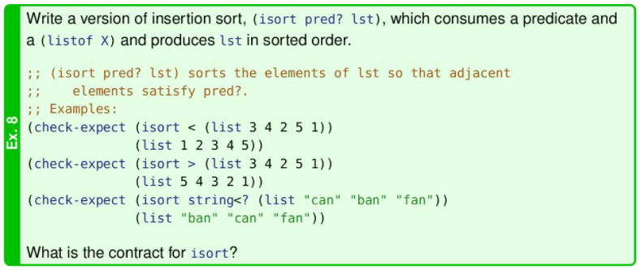
* 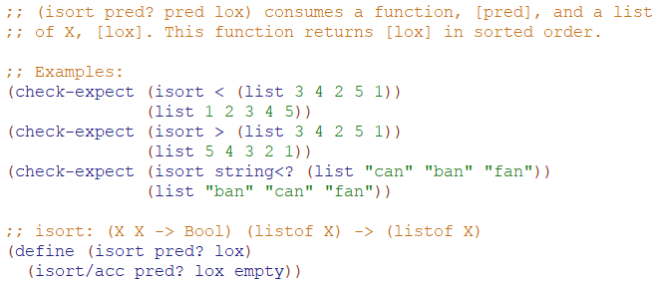
* 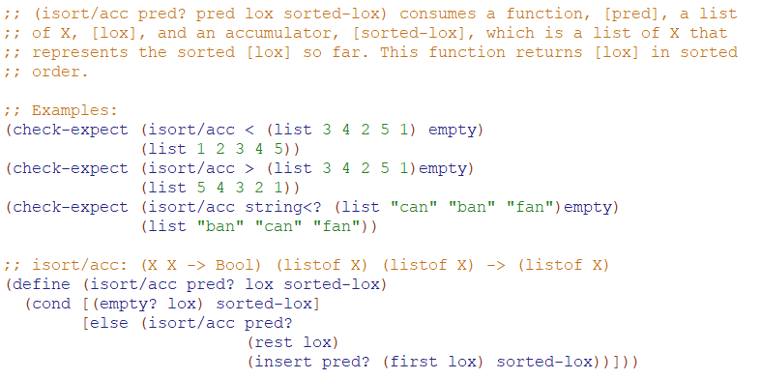
* 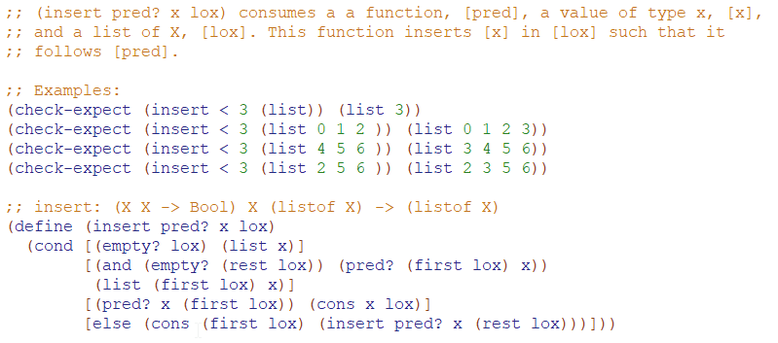

Using Functions to simulate Structures

* We can use the ideas of producing and binding functions to simulate structures
* 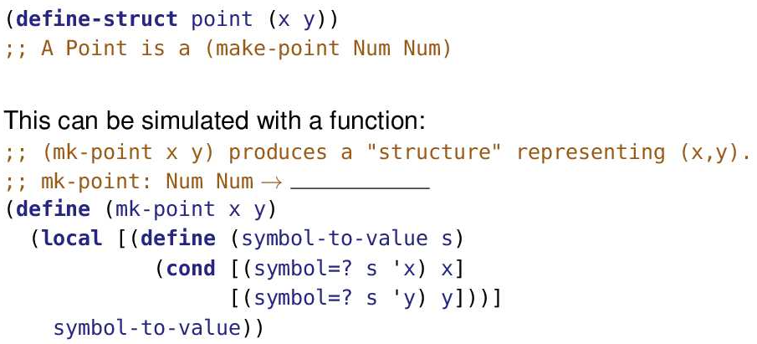
* 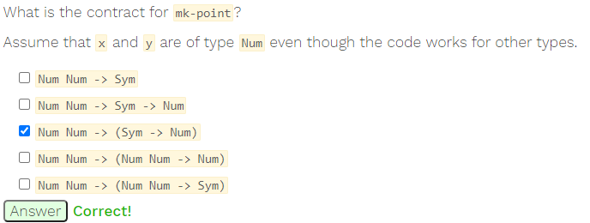
* 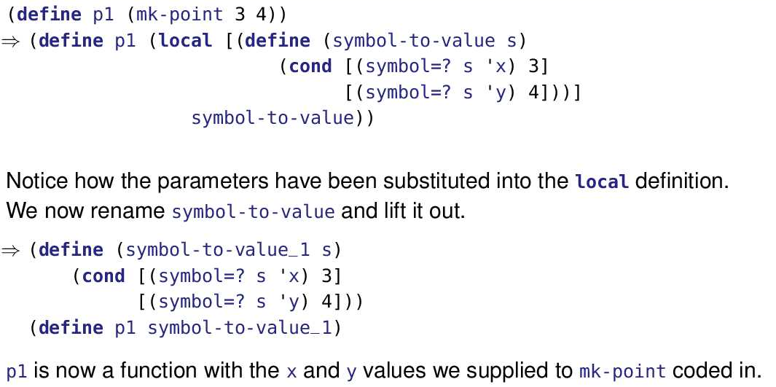
* (define p1 (mk-point 3 4)) is defining a constant, p1. Just like (define x (+ 2 3)) is evaluated to bind 5 to x, (mk-point 3 4) is evaluated before being bound to p1.
* That evaluation results in symbol-to-value being renamed and lifted to the top level. The new name, symbol-to-value_1 is bound to p1.
* 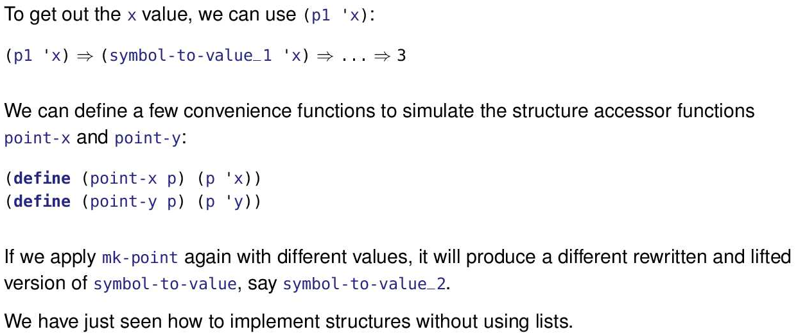
* 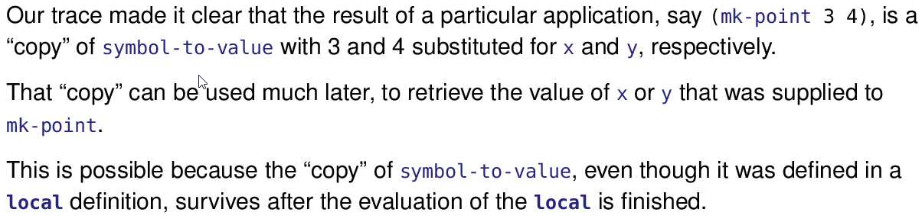
* 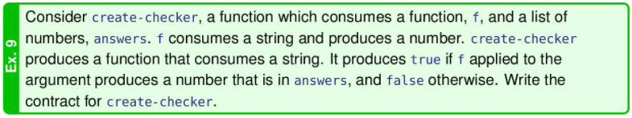

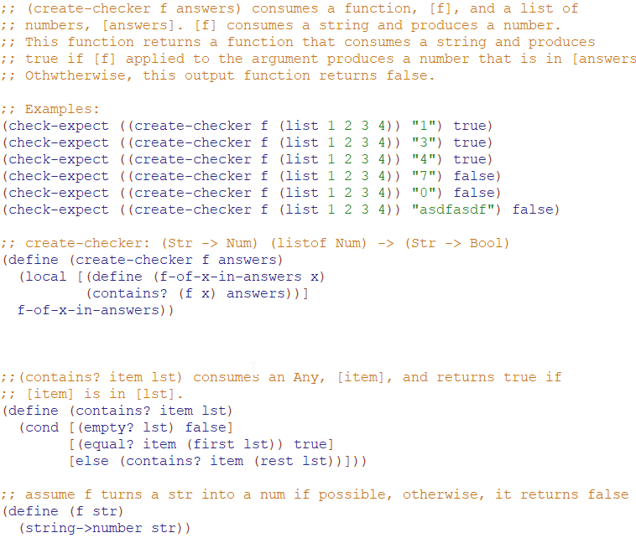

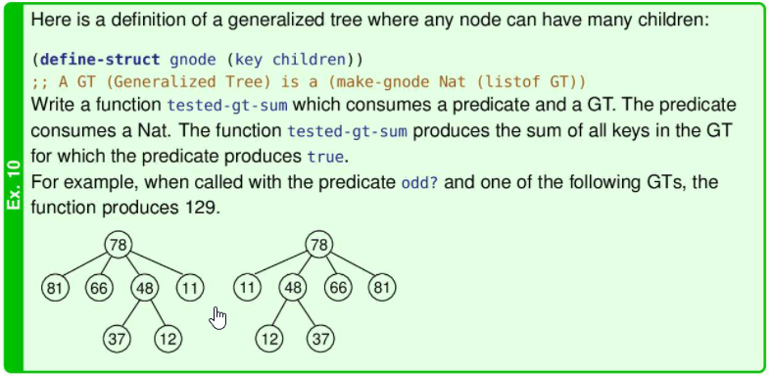

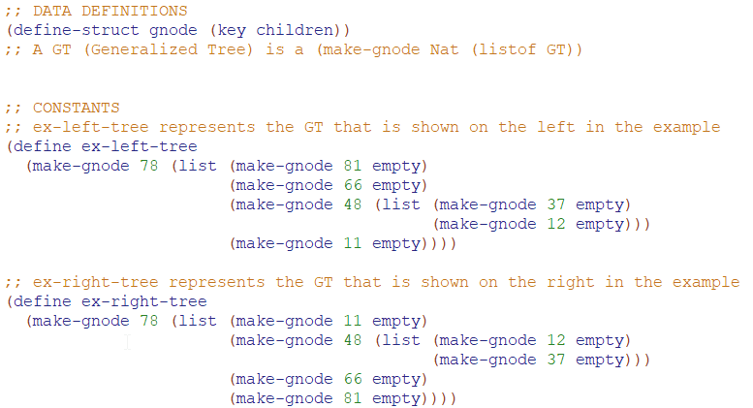

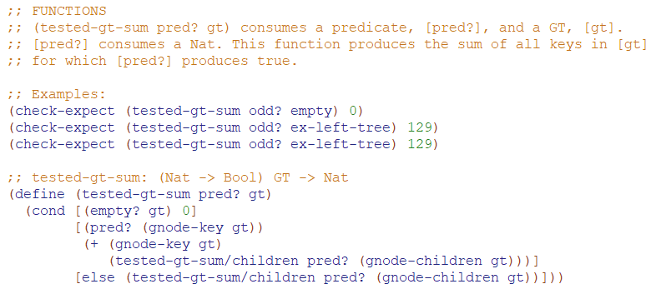

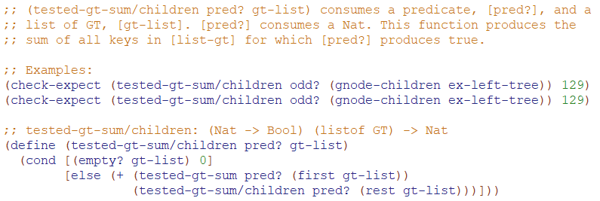

Module 16

Abstraction

* The process of finding similarities or common aspects, and forgetting unimportant differences
* Ex: writing a function
  + The differences in parameter values are forgotten, and the similarity is captured in the function body
  + We have seen many similarities between functions, and captured them in function templates
* For example, we captured similarities between functions using filter

Anonymous Function

* 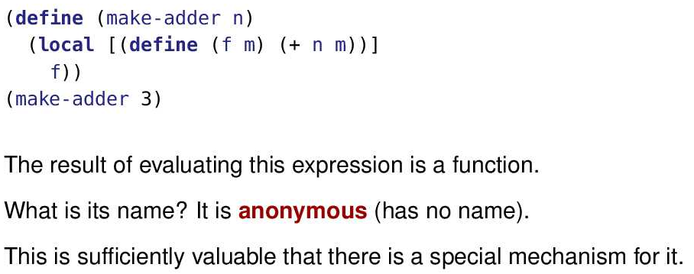
* When we do the evaluation in the substitution model, the function is given a name. But it is not a name that appears in the program and the programmer cannot predict it. So perhaps it is more accurate to say it has a secret name, which is also true of someone who is anonymous.
* Ex:
  + 
  + Recall that eat-apples, along with keep-odds, are the functions we used to motivate filter at the beginning of M15. The purpose of eat-apples is to consume a list of symbols, keeping only those that are not the symbol 'apple.
  + However, not-symbol-apple? Is basically useless outside of filter, so we can avoid cluttering the top level with such definitions by putting them in local expressions as shown below
  + 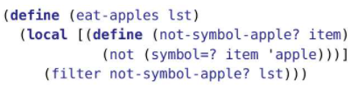
  + Now, the local function is being passed as an argument to filter
  + We could also do the following:
  + 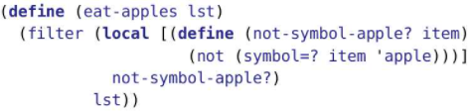
  + Both of these have a problem. While they avoid cluttering the top level, the clutter the function definition. Why should we even name not-symbol-apple? anyway, its so useless outside of the function that it’ll never be called, but so obvious inside the function it doesn’t need a name.
  + Racket provides a mechanism for constructing a nameless function which can then be used as an argument

Lambda

* When a function produced in a local is only used once, there’s a lot of code that isn’t actually needed. lambda gets rid of it.
* All we really need is a list of the parameter names and the expression using them. Add lambda and we’ve got it.
* 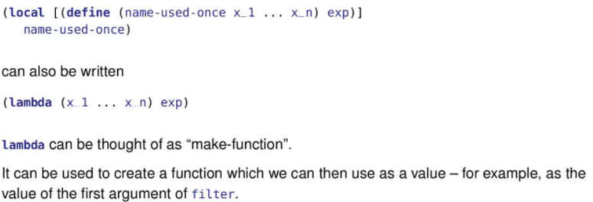
* Notice lambda avoids a lot of the clutter as it only needs parameters and the function definition, no need for local, define, return statement of the local
* 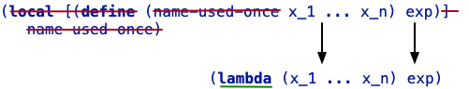
* Thus, we can use lambda to replace our eat-apples example
* 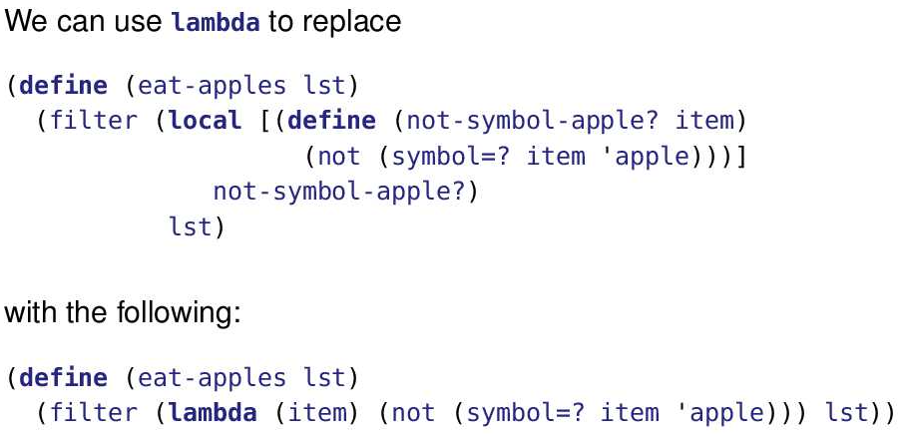
* If we trace eat-apples with ‘(pear apple) as the value for list, we get the following
* 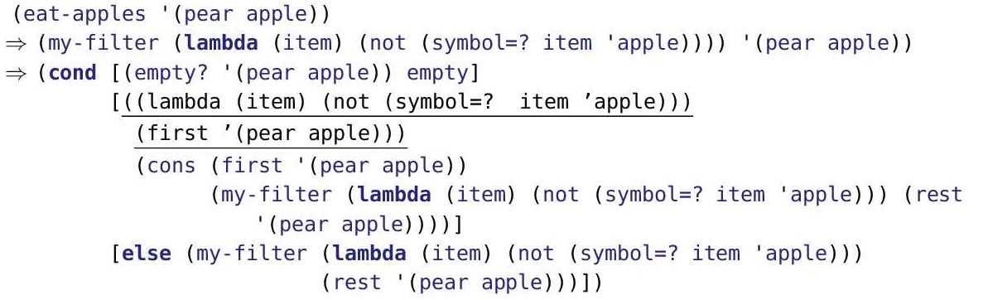
* In the trace, the first substitution step applies the user-defined function substitution rule from M05 to substitute '(pear apple) into the body of my-filter.
* The second substitution step applies the same rule, this time substituting the lambda expression every place the parameter pred? occurs in my-filter's body expression. '(pear apple) is substituted into my-filter as well. The result is the rewritten body of my-filter. It has the curious double open parentheses.
* 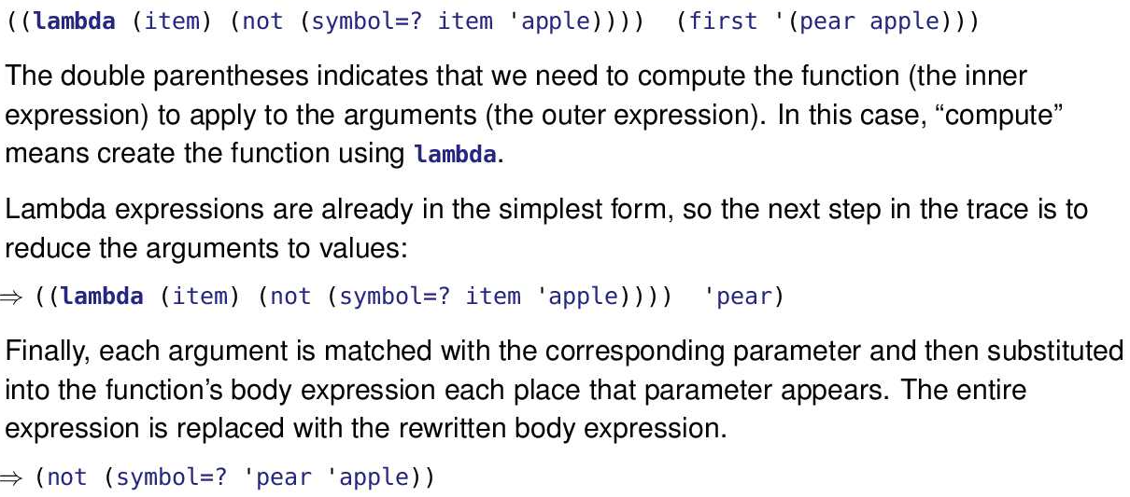
* We saw double open parentheses several times in M15. The inner pair is used to “compute” the function to use for the outer pair.
* In the past “compute” has meant lookup in a table (lookup-al from the arithmetic expression example) or using a function and local to make it (e.g. make-adder) or sometimes to use local directly.
* 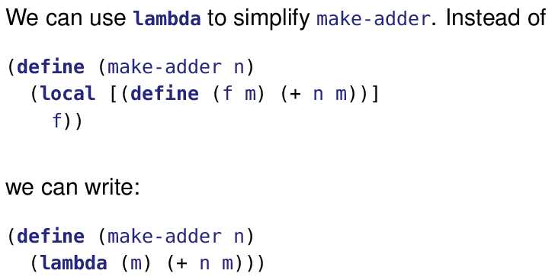
* DrRacket will also accept the Greek letter λ in place of lambda. Look in the “Insert” menu for a keyboard shortcut. Also notice the stylized λ in DrRacket’s icon

Syntax

* 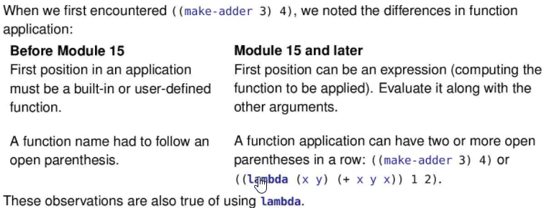

Lambda Substitution Rule

* 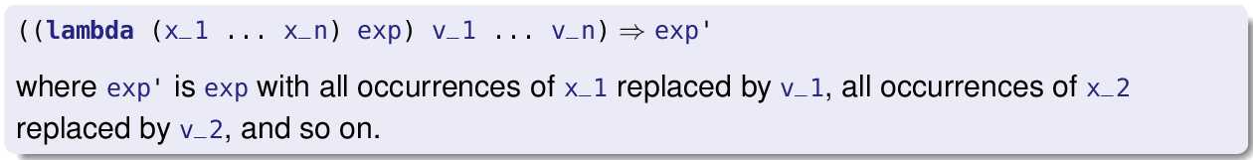
* THE IDEA IS TO TAKE THE EXP OF THE LAMBDA, and then copy paste it into the next line and remove the (( before the lambda keyword ))
* Ex:
* 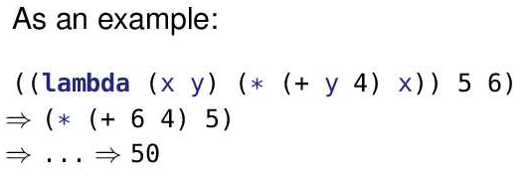
* Ex:
* 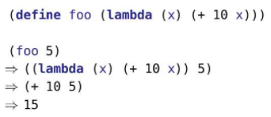
* In the example, foo is defined as a constant. The value of foo is a function, which is fine since in M15 we learned that functions are first-class values. Like any constant, its value needs to be substituted into the expression.
* Once that is done, the lambda substitution rule is applied.
* 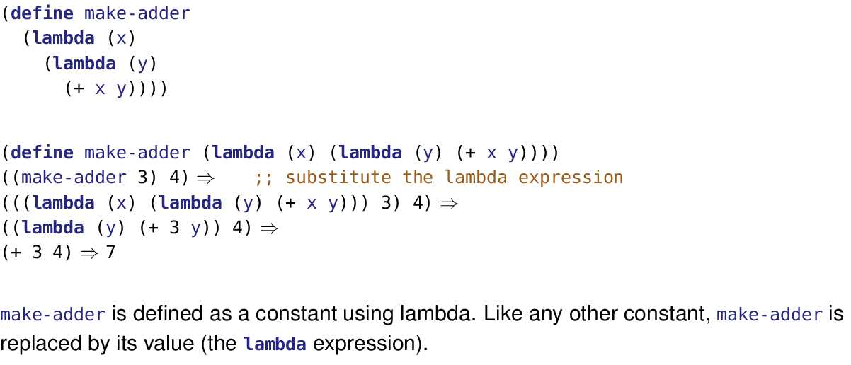
* Tracing lambda expressions can be tricky, mostly due to the deeply nested parentheses. One aid is to look for the pattern ((lambda ...) ...).
* The inner set of parentheses is defining a function. The outer set of parentheses is applying that function to the arguments represented by the last ....
* Racket allows parentheses () and square brackets [] to be used interchangeably, so long as they are nested in pairs. ([])[] is allowed but ([)] is not.
* So far we’ve used square brackets only for conditional and local expressions. You may find them helpful when parentheses become deeply nested, as well.
* Ex:
  + ((lambda (y) ((lambda (x) (+ x y)) 3)) 4)
* => ((lambda (y) ((lambda (x) (+ x y)) 3)) 4)
* => ((lambda (x) (+ x 4)) 3)
* => (+ 3 4)
* => 7
* Ex:
  + (((lambda (y) (lambda (x) (+ x y))) 3) 4)
* => (((lambda (y) (lambda (x) (+ x y))) 3) 4)
* => ((lambda (x) (+ x 3)) 4)
* => (+ 4 3)
* => 7
* 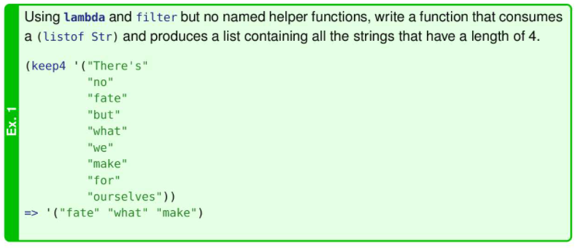
* 
* 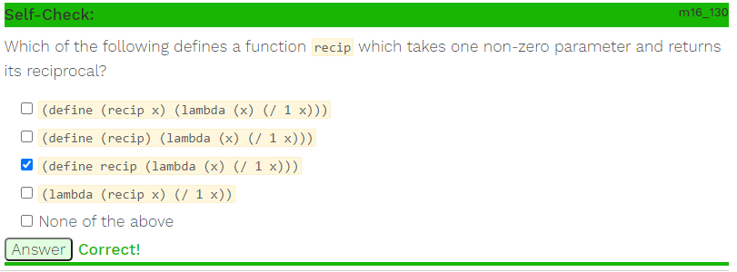
* All the options are somewhat correct
* The first option creates a function called recip which takes a parameter of x, and returns a function that evaluates the reciprocal. (recip 90) => (lambda (x) (/ 1 x)) [Note that the x is not substituted in since x is the parameter of the lambda function] This output is just a function so it doesn’t do anything, it needs a value to apply on. If we did ((recip 90) 10) => ((lambda (x) (/ 1 x)) 10) => (1/10)
* The second option creates a function called recip which takes no parameters (allowed in advanced student) and returns a function that evaluates the reciprocal (same thing as the first option but without the useless parameter).
* The third option properly creates a constant called recip which has a function as its value. The function which is its value is a lambda.
* The fourth option is just a function, doesn’t actually do anything by itself since it needs a value to be applied to.

Lambda and Function/Constant Definitions

* 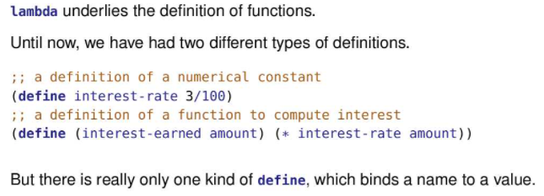
* 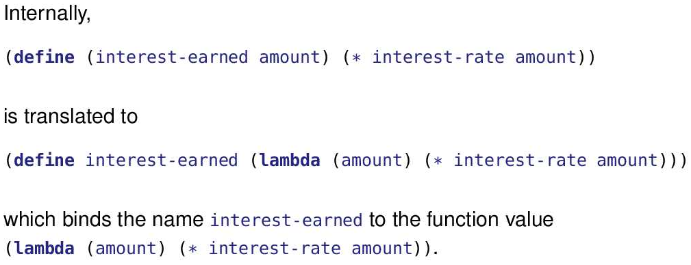
* To make the transformation in the slide more carefully, shorten the names so everything can fit on a single line. Then the original function is

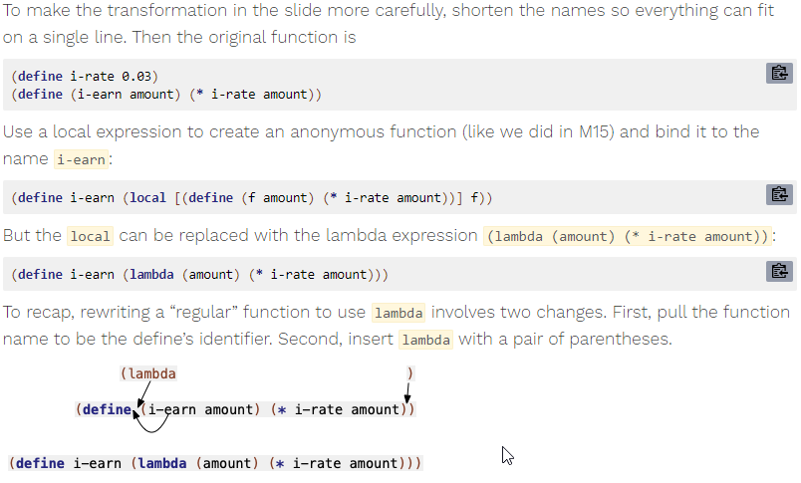

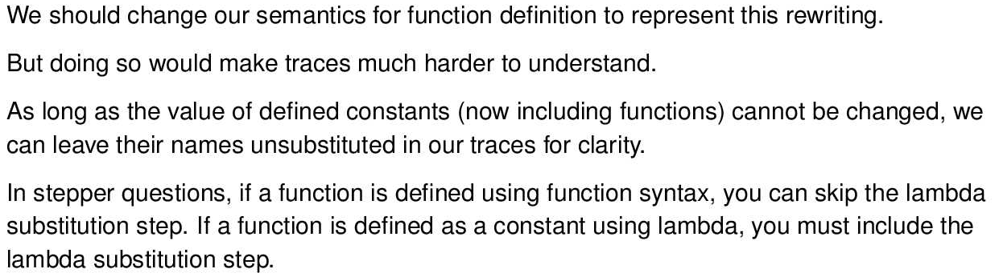

Ex:

* (define i-rate 0.03)
* (define (i-earned amount) (* i-rate amount))

(i-earned 1000)

* => (* i-rate 1000)
* => (* 0.03 1000)
* => 30

Ex:

* (define i-rate 0.03)
* (define i-earned (lambda (amount) (* i-rate amount)))
* (i-earned 1000)
* ((lambda (amount) (* i-rate amount)) 1000)
* (* i-rate 1000)
* => (* 0.03 1000)
* => 30

Transforming Strings

* Suppose we want to program a robot to do tasks in the future
* We might need a function called robot which consumes a data structure which contains all the instructions for turning left/right or whatever.
* With lambda, we can more clearly describe those instructions
* 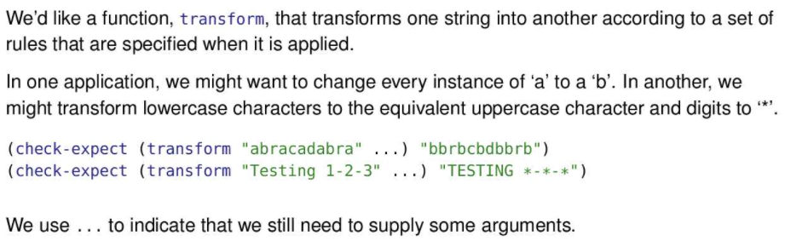
* 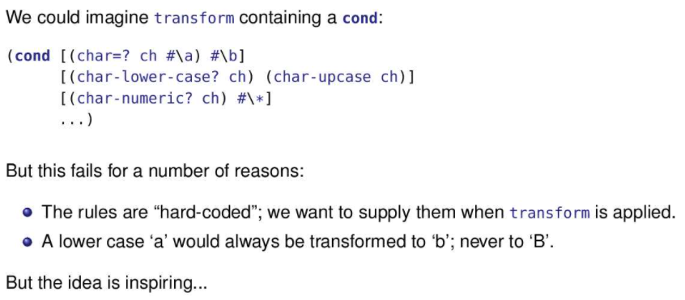
* We want to be able to supply a different set of transformations each time we apply transform.
* The fact that this code always transforms an a to a b means it will fail the “Testing 1-2-3” example. The fact that it always transforms a lowercase b to B means it will fail the “abracadabra” example.
* We can’t “hard-code” the transformation rules and still get the flexibility we want.
* Suppose transform took in a data structure called TransformSpec for its instructions
* 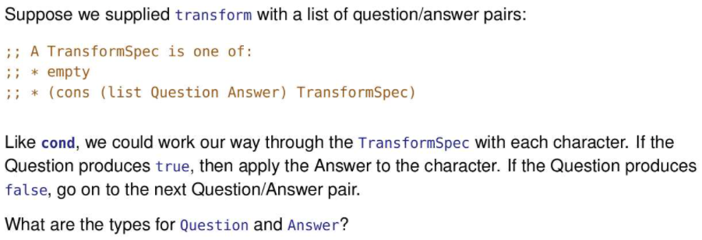
* Question will be the condition for the char and if the question is true, then we apply the answer function on a char
* 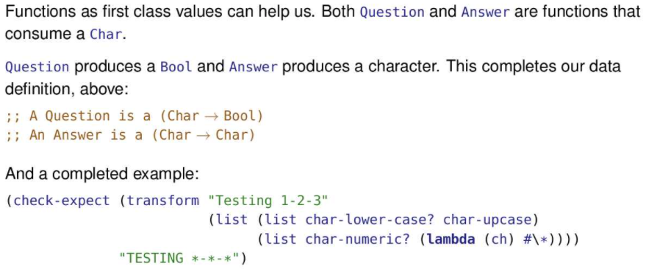
* 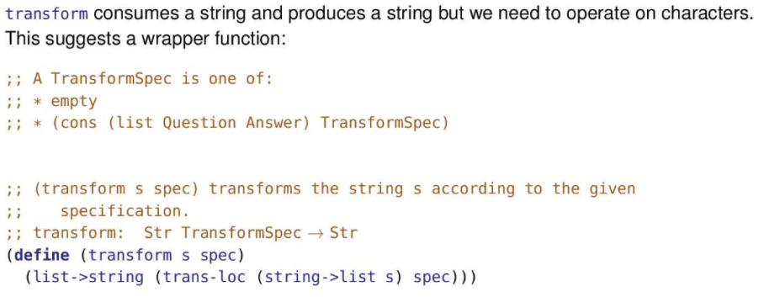
* 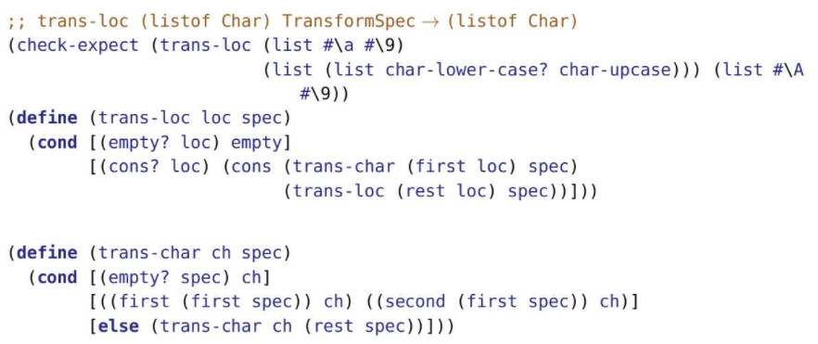
* 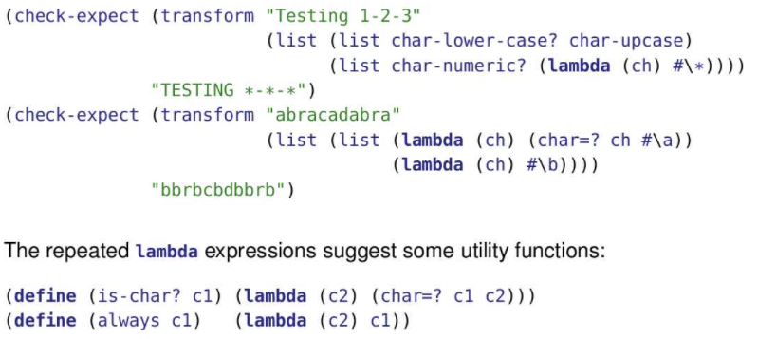

The map higher order function

* 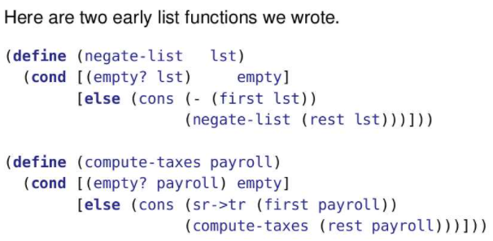
* Notice the structure is really similar. Aside from names (which we decide), the function does basically the same thing except in the third line of each function where different functions are applied to the first element in the list.
* Thus, we can create a new function that does both functions, but requires an extra parameter which is the function that is being applied to each element
* 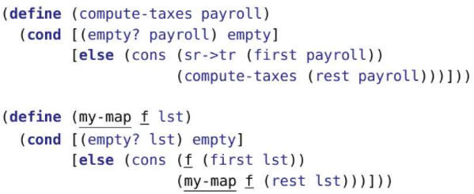
* The underlined portions of my-map are the changes required to account for the differences between negate-list and compute-taxes, after renaming parameters.
* My-map performs the general operation of transforming a list element-by-element into another list of the same length
* 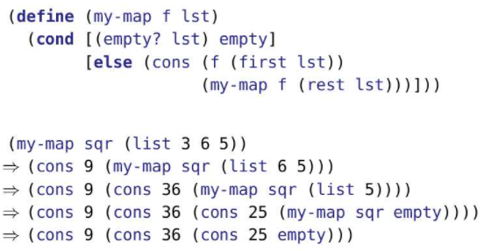
* map bears a lot of similarity to the listof-X-template. They are based on the same data definition, after all.
* (define (listof-X-template lox)
* (cond [(empty? lox) (...)]
* [else (... (first lox)
* (listof-X-template (rest lox)))]))
* The template, is more general and so leaves out some things that map includes. But both check for the empty list. Both recurse on the rest of the list. Both do something to the first thing on the list.
* 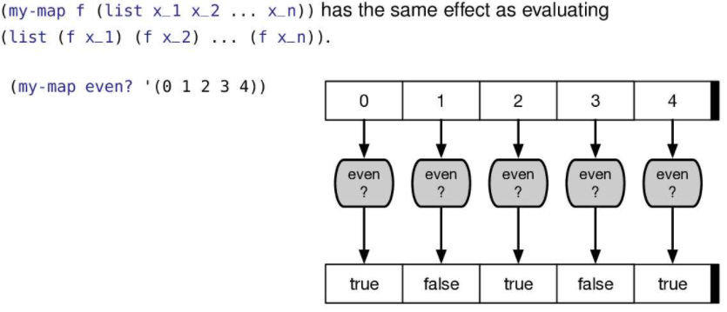
* 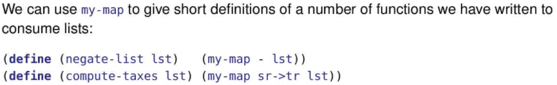
* Notice in negate-list, we pass in the minus function as a parameter for my-map
* Notice in compute-taxes, we pass in the sr->tr function as a parameter for my-map
* There is actually a built in version of map which does the same thing as my-map
* How can we use my-map to rewrite trans-loc?
* Recall the code:
  + 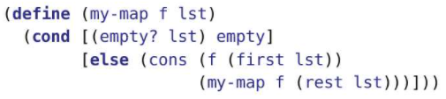
  + 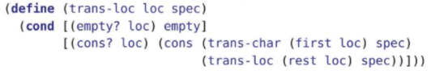
  + Notice trans-loc also has a spec parameter in addition to the function trans-char
  + We can use a lambda expression to get around it
  + 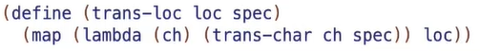
  + Map consumes a function as a parameter, and that parameter function consumes one element which is the first element in the current list. Thus, we can pass in a lambda function as a parameter for map. This means lambda has to take 1 parameter as well, which is the first element in the current list. Now, we have a lambda and a character, ch, and we want to transform it. We transform it according to the spec rules. Thus, the lambda function will return the trans-char function applied to ch. Recall the trans-char function takes a character as its parameter and a spec so we pass in spec as well. At the end, we also have to pass loc to the map function
  + Racket provides many built-in higher order functions. CS135 will discuss five of them: filter, map, foldr, foldl, and build-list. These are the only higher order functions you need for CS135. Feel free (but not obligated) to explore the rest, but don’t use them on assignments or exams unless we explicitly point you to them.
  + One difference between my-map and the built-in map is that the built-in version can consume multiple lists. The function it consumes must have the same number of parameters as there are lists. For example, (map < '(5 10 20) '(3 12 18)) ⇒ '(false true false)
  + 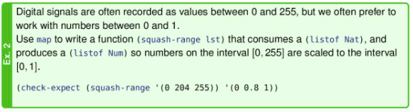
  + 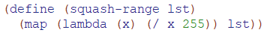
  + 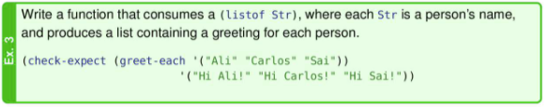
  + 
  + 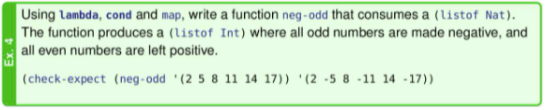
  + 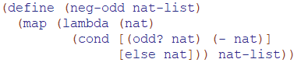

Foldr

* The higher order functions we have worked with so far consume and produces lists
* What if we want to produce simple values such as count-symbols or sum-of-numbers
* 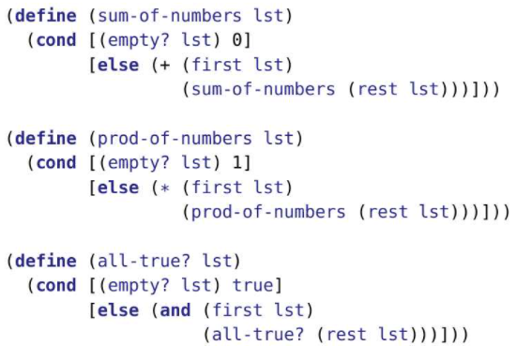
* Notice there are many similarities. However, let’s focus on the differences. The base case values are different (0, 1, true). The function used to combine the first element of the current list with the rest of the list is different as well (+, *, and). Note that and is not a function, it is a special form.
* This suggests that we need to pass two arguments to my-foldr – one to go into the base case value, and a function to combine the first and rest of the list.
* 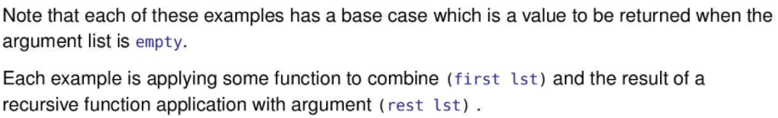
* 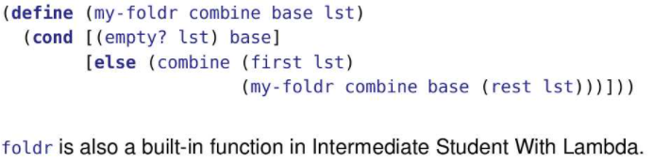
* combine: a function that combines two values, the first thing on the list and the result of processing the rest of the list.
* base: a value to provide when we hit the base case
* 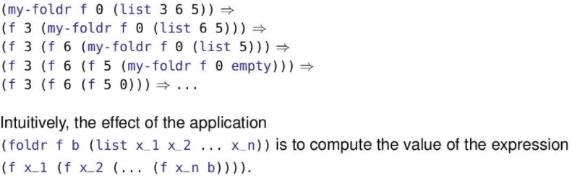
* 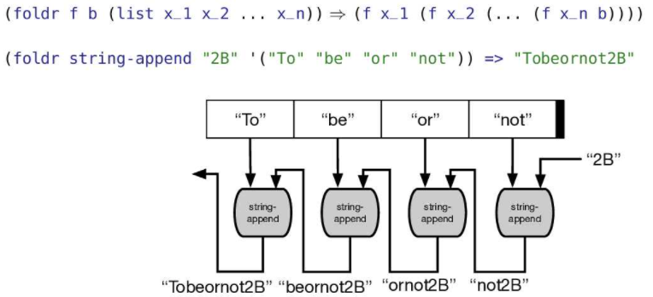
* To think of the tracing for foldr, we can start with the base value, “2B”, and the end of the list. We use the combining function, string-append, to combine the base value, “2B”, and the last element in the list,   
  “not”, to get an answer, “not2B”. Then “not2B” is combined with the second last element in the list with the combining function and so on.
* 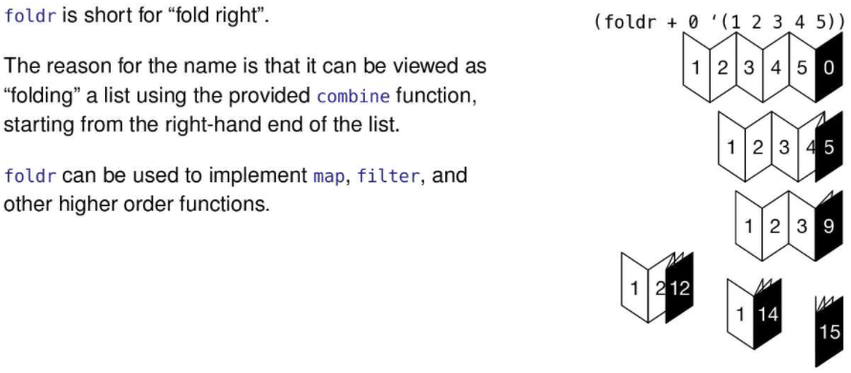

Contract for foldr

* 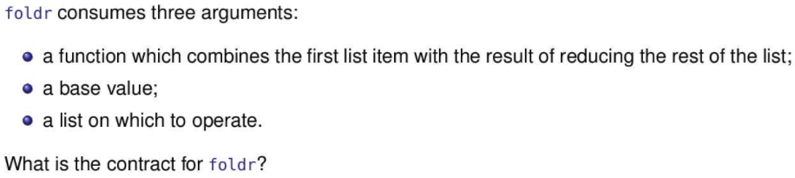
* ;; foldr: (X Y -> Y) Y (listof X) -> Y

Using foldr

* 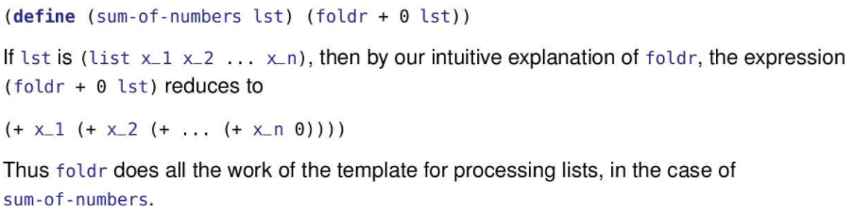
* If we were to trace sum-of-numbers, the trace would be pretty short. foldr is built-in. Like other built-in functions, its application results in a single step.
* (sum-of-numbers '(1 2 3 4))
* ⇒ (foldr + 0 '(1 2 3 4))
* ⇒ 10
* 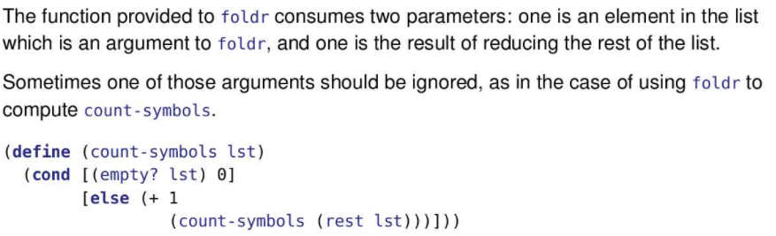
* Note that count-symbols does not use (first lst). Does that “break” foldr?
* 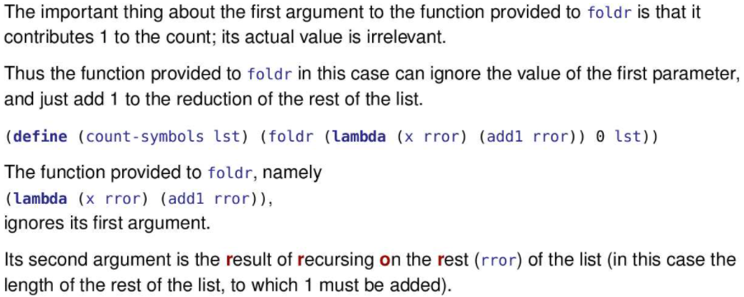
* You may notice that many of our examples use rror as the name of the second parameter of the lambda expression. That’s to remind us which parameter is which. In this case, x is the first value on the list and rror is the Result of Recursing On the Rest of the list (the part that follows x).
* Ex:
  + (foldr (lambda (x rror) (+ x rror rror)) 1 '(3 4 5))
* We take the base value, 1, and the last element in the list, 5, and apply the lambda function to it
* (+ 5 1 1) =>7
* We take the value 7, and the second last element in the list, 4, and apply the lambda function to it
* (+ 4 7 7) => 18
* We take the value 18, and the third last element in the list, 3, and apply the lambda function to it
* (+ 3 18 18) => 39 (39 is the answer)
* 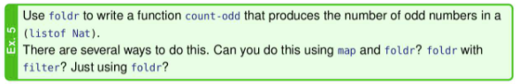
* 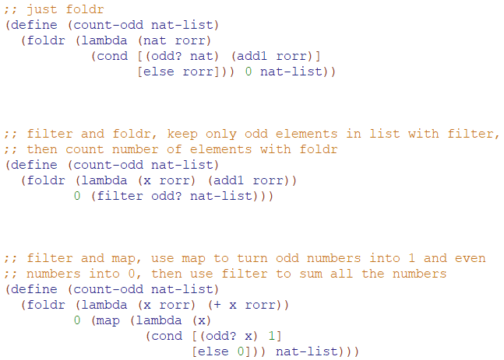
* 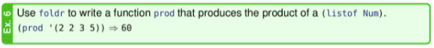
* 
* 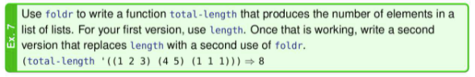
* 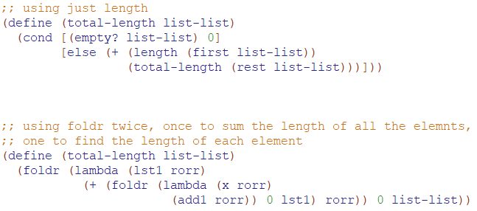
* 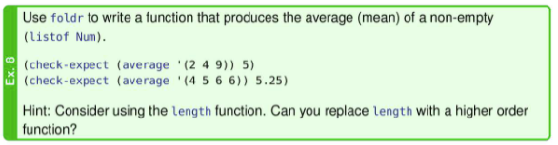
* 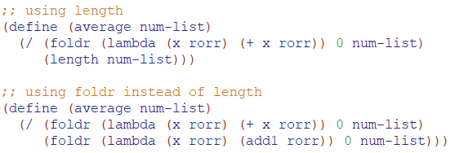
* 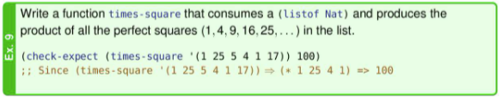
* 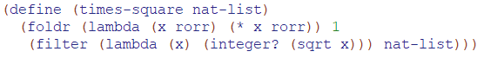

Using foldr to produce lists

* While foldr can produce numerical results, it can also produce cons expressions as well
* foldr is an abstraction of simple recursion so we can make negate-list which takes the negative of each element in a list of numbers
* 
* We’ll start to use the terminology not explicitly recursive to mean a function where recursion is done via a higher order function such as foldr.
* Moreover, we should be able to define map using foldr
* 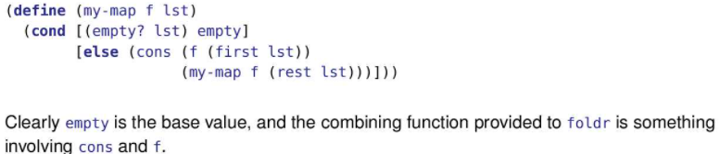
* 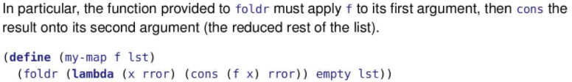
* We can also implement my-filter using foldr
* 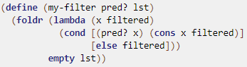
* 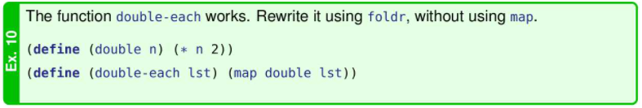
* 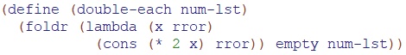
* 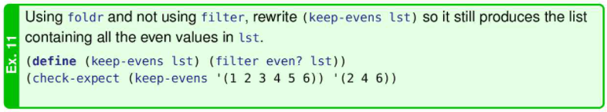
* 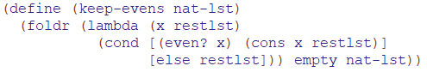
* 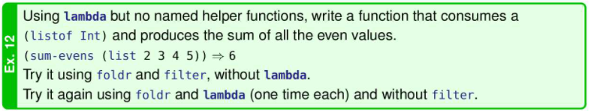
* 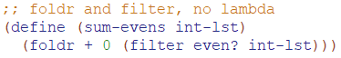
* 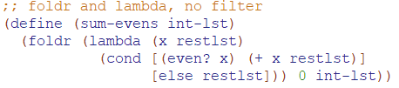
* 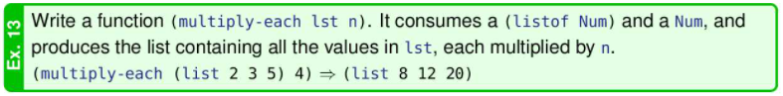
* 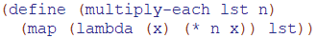
* 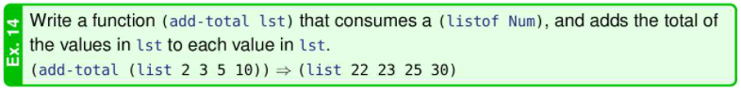
* 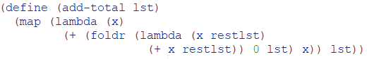
* 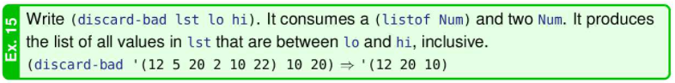
* 
* 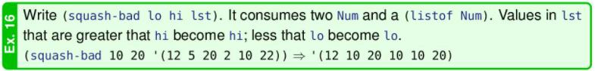
* 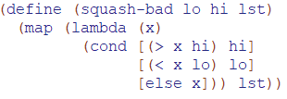
* 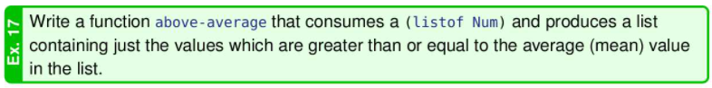
* 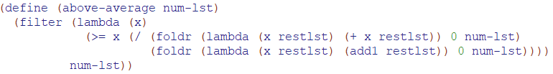
* 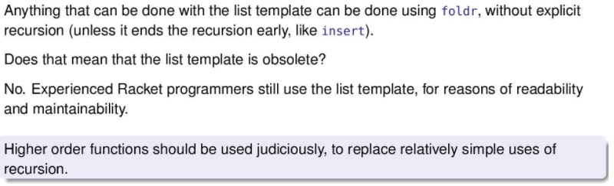

Foldl

* Generalizing accumulative recursion
* 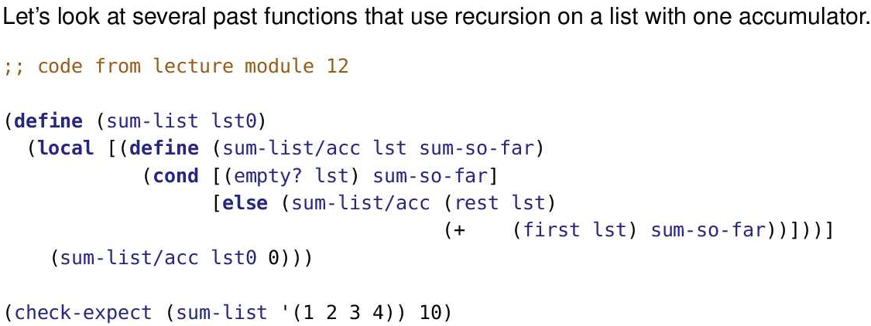
* 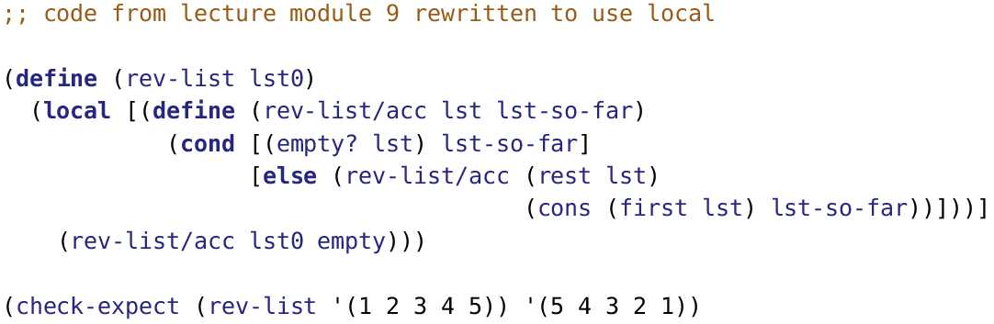
* 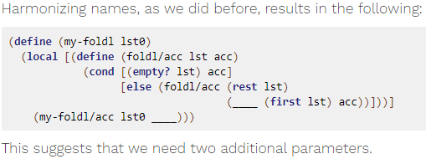
* 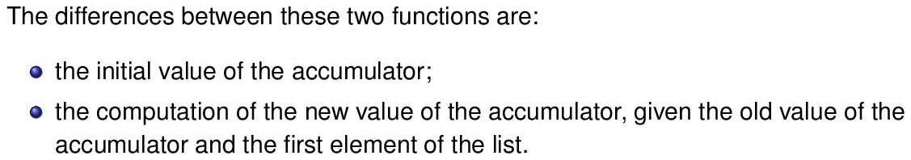
* 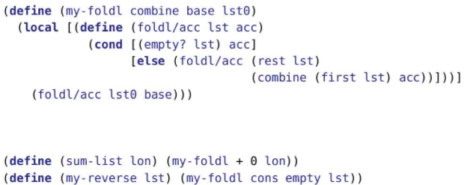
* foldl is defined in the intermediate student language and above
* What is the intuitive effect of the application of foldl?
* 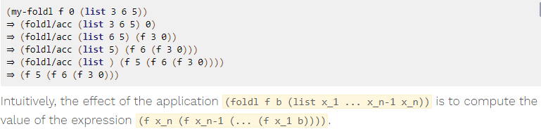
* 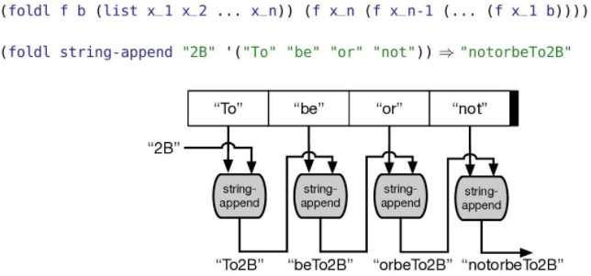
* 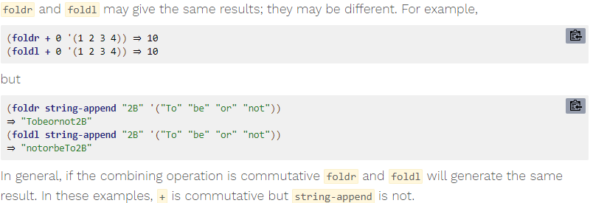
* 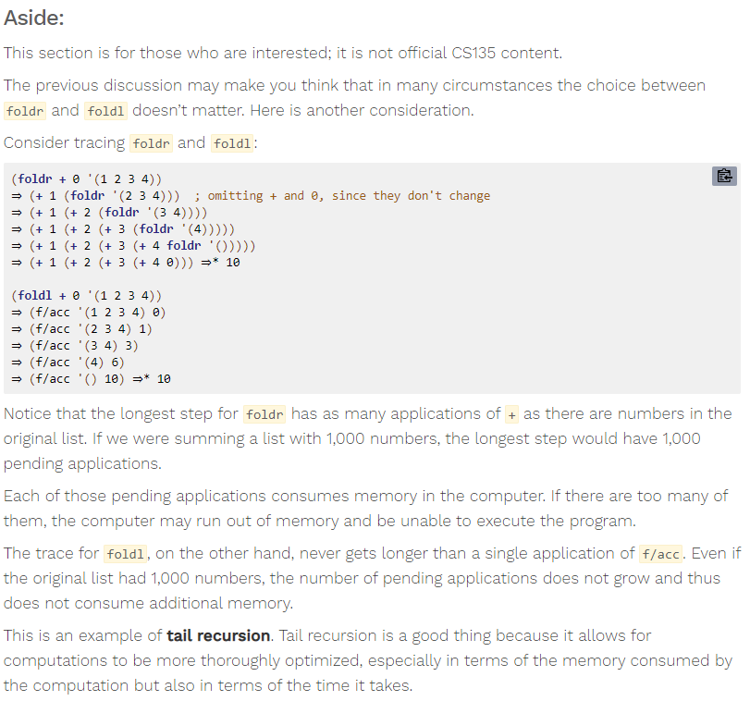
* 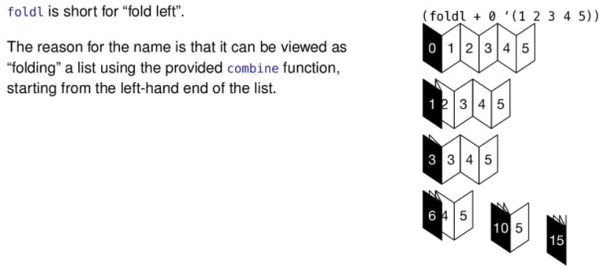
* Contract for foldl
* foldl: (X Y -> Y) Y (listof X) -> Y
* Like map, foldr and foldl can handle multiple lists provided the combining function has one parameter for each list plus the “rror” parameter.
* For example,
* 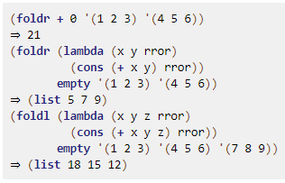

Build-list

* 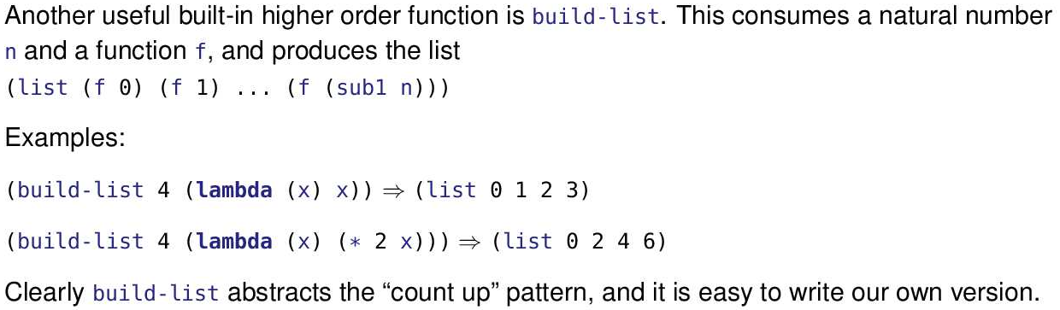
* 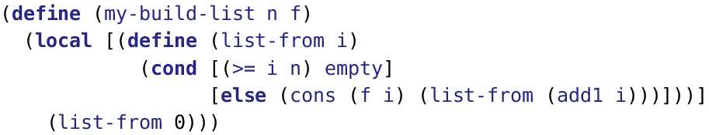
* Contract:
* ;; my-build-list: Nat (Nat -> X ) -> (listof X)
* 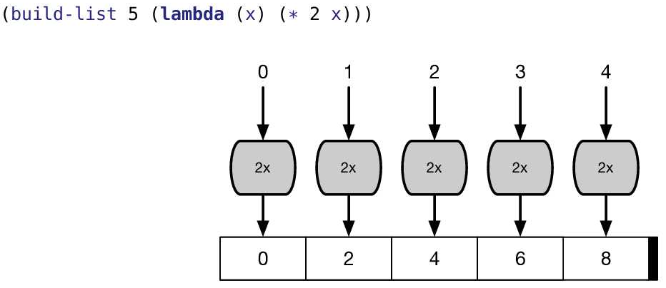
* 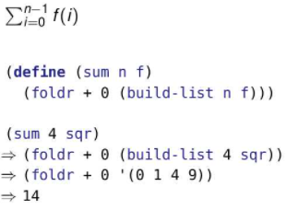
* foldr and build-list are both built in, so we don’t trace them.
* We split the summation into two parts, each handled by a higher order function. The first part is a list of f applied to each of the numbers in 0..n-1; that’s handled by build-list. The second part is summing them up; that’s handled by foldr.
* 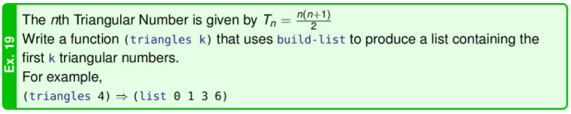
* 
* 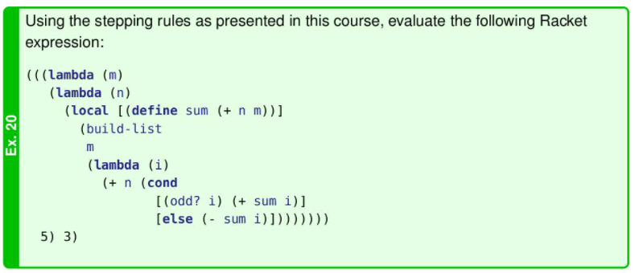

(((lambda (m)

(lambda (n)

(local [(define sum (+ n m))]

(build-list

m

(lambda (i)

(+ n (cond

[(odd? i) (+ sum i)]

[else (- sum i)])))))))

5) 3)

=>

((lambda (n)

(local [(define sum (+ n 5))]

(build-list

5

(lambda (i)

(+ n (cond

[(odd? i) (+ sum i)]

[else (- sum i)])))))) 3)

=>

(local [(define sum (+ 3 5))]

(build-list

5

(lambda (i)

(+ 3 (cond

[(odd? i) (+ sum i)]

[else (- sum i)])))))

=>

(define sum1 (+ 3 5))

(build-list

5

(lambda (i)

(+ 3 (cond

[(odd? i) (+ sum1 i)]

[else (- sum1 i)]))))

=>

(define sum1 8)

(build-list

5

(lambda (i)

(+ 3 (cond

[(odd? i) (+ sum1 i)]

[else (- sum1 i)]))))

=>

(build-list

5

(lambda (i)

(+ 3 (cond

[(odd? i) (+ 8 i)]

[else (- 8 i)]))))

=> (list 11 12 9 14 7)

Generative Recursion

* 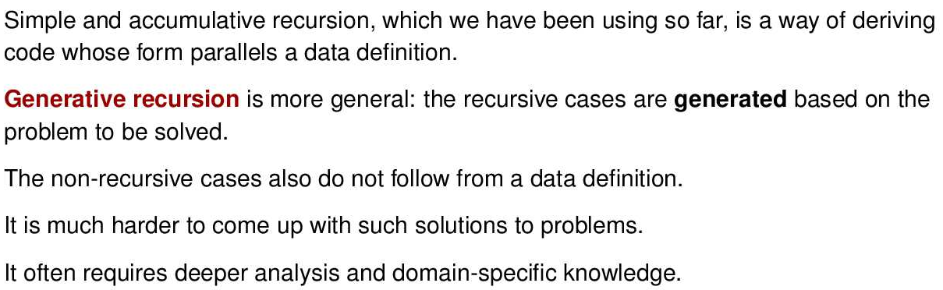
* 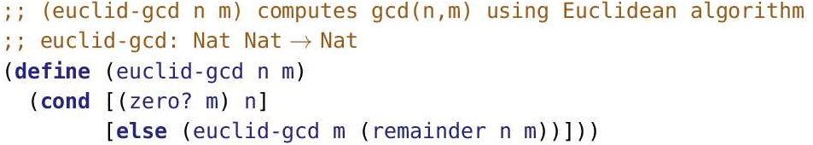
* 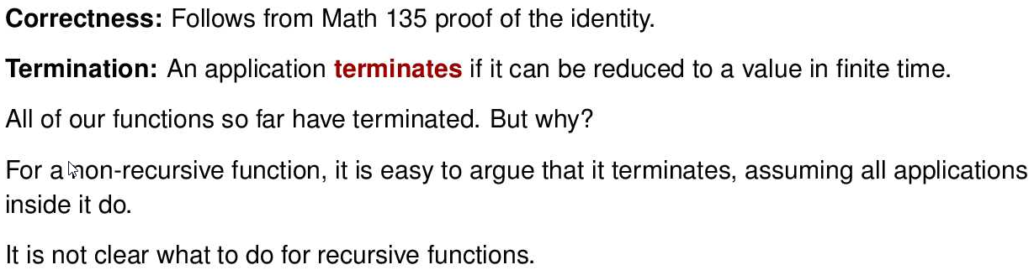
* Correctness is important because we want the right answer.
* Termination is important because we want the answer well before the universe ends.
* In a non-recursive function none of the code repeats1. So the time taken to execute the function is the sum of the time for each of the functions it calls (plus a little overhead). If each of those called functions terminates (i.e. finishes in a finite time), the sum is also finite and thus the function terminates.
* But in a recursive function the same code can be executed repeatedly. Each repetition takes some amount of time to execute. Unless we can guarantee that the number of repetitions is finite, the sum of those execution times will be infinite and the function won’t terminate.

Termination

* 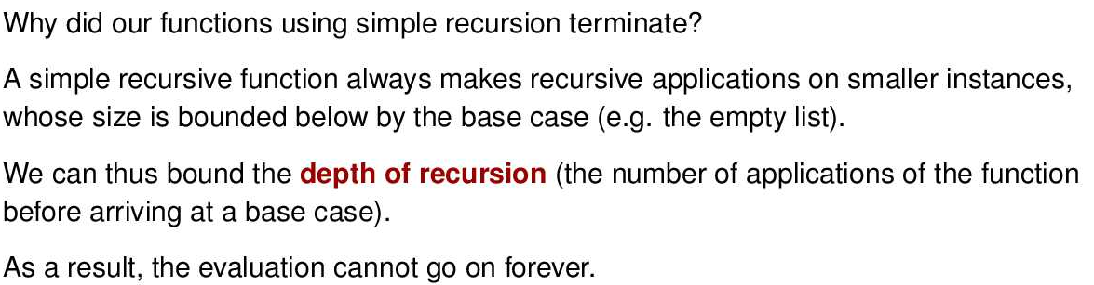
* 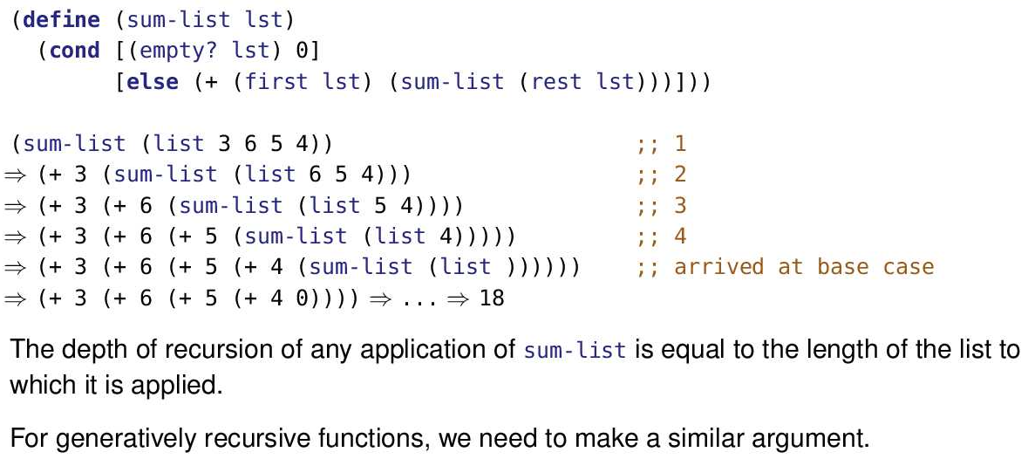
* 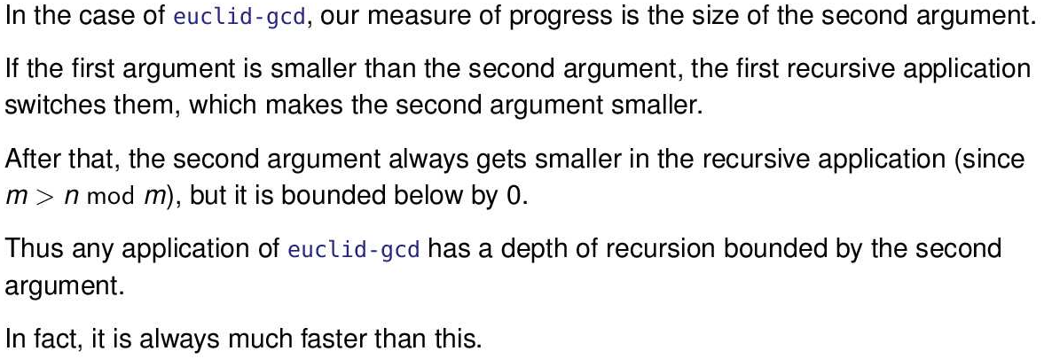
* Consider (gcd 100 85):
* (gcd 85 100)
* ⇒ (gcd 100 85)
* ⇒ (gcd 85 15)
* ⇒ (gcd 15 10)
* ⇒ (gcd 10 5)
* ⇒ (gcd 5 0)
* The second argument gets smaller and smaller, but can’t get smaller than 0. So the function terminates.
* The depth of recursion in this example is 5.
* Sometimes, some functions don’t terminate
* 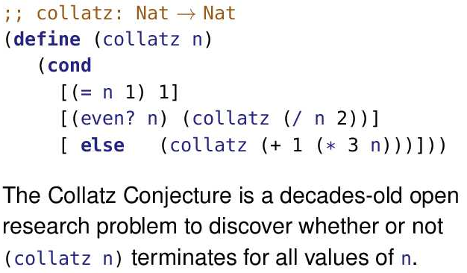
* Each of the functions we’ve considered so far have something that gets smaller and smaller until it stops. That might be the size of the list, the 2nd parameter to GCD, the parameter in count-down or the difference between the parameter and the stopping point in count-up-to.
* But here’s an example where the parameter does not keep getting smaller. Other than the base case, if the parameter is even the next application is smaller. But if it’s odd, the next application is a lot larger. Instead of a decreasing sequence, the size of the parameter oscillates.
* As of 2020, the Collatz Conjecture has been checked for all values of n up to 268. All of those values eventually terminated.
* But the question remains, does one or more of the infinite number of untested values enter a cycle that does not terminate? We don’t know.
* 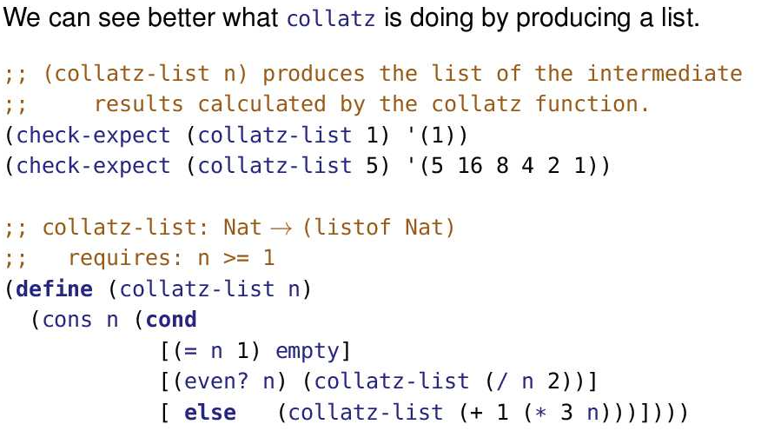
* 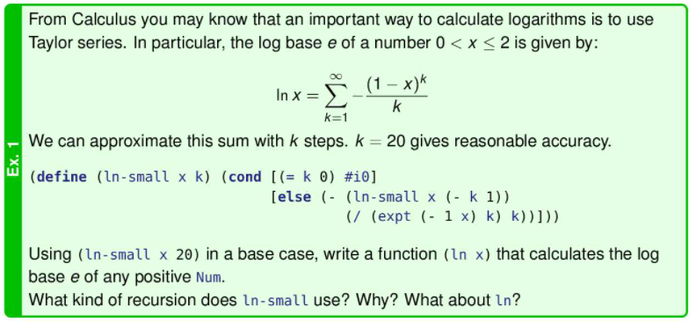
* Notice ln(x) = ln(2*(x/2)) = ln(2) + ln(x/2). Since x>0 and 1<2, x>x/2
* 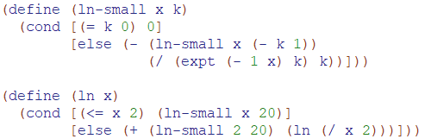

Hoare’s Quicksort

* 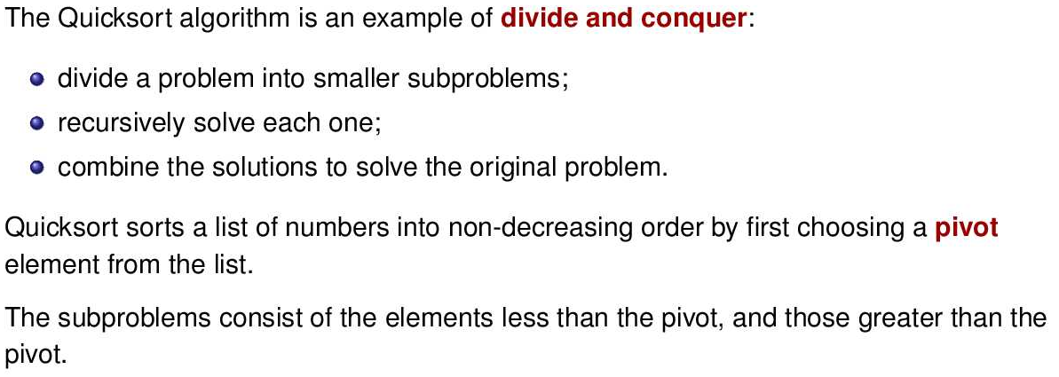
* 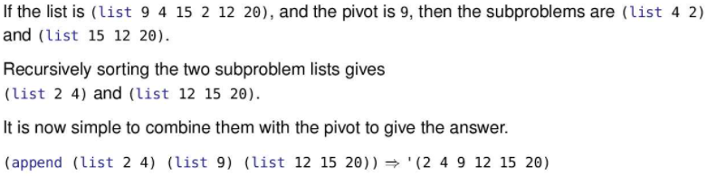
* 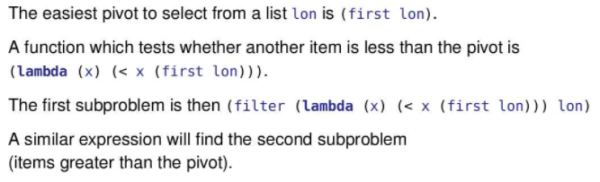
* 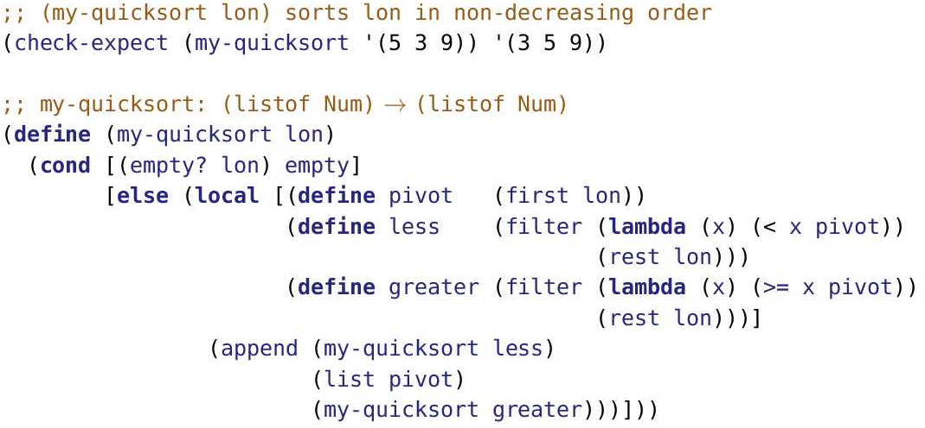
* 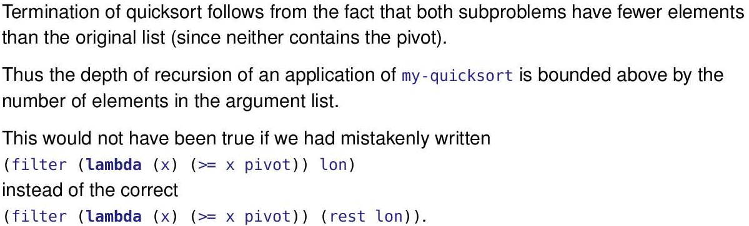
* Suppose we made the mistake noted in the slide and wrote (filter (lambda (x) (>= x pivot)) lon) instead of (filter (lambda (x) (>= x pivot)) (rest lon))
* Then (my-quicksort '(1 2 4 3)) would result in the subproblem (my-quicksort '(1 2 4 3)) instead of (my-quicksort '(2 4 3)).
* Because the recursive application is exactly the same as the original application, no progress is made and the function runs “forever”.
* 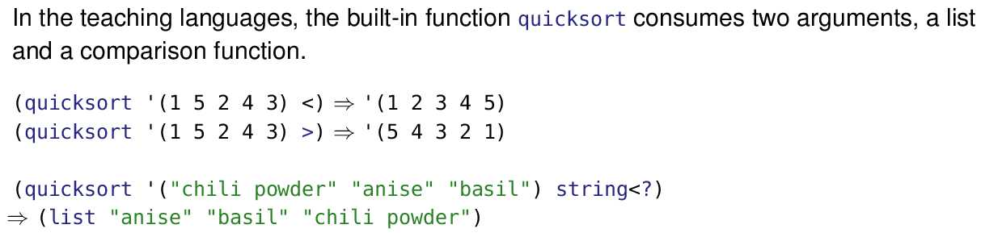
* 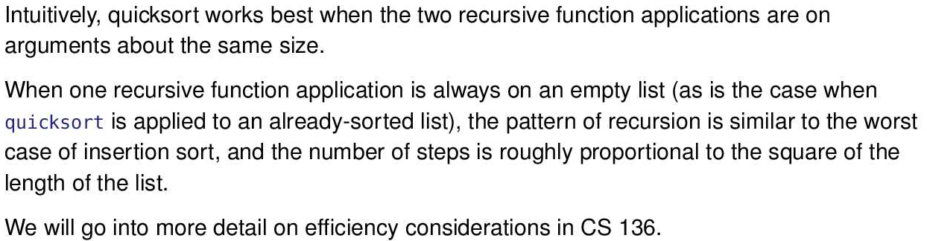
* What’s not said in the slide is that on most lists, quicksort really is quick. It’s much faster than insertion sort.
* We talked about measuring efficiency in module 09. Insertion sort’s running time is always O(n2). Quicksort runs that slowly on some lists, but most of the time its running time is in the much more efficient family of O(n log n).

Design Recipe

* 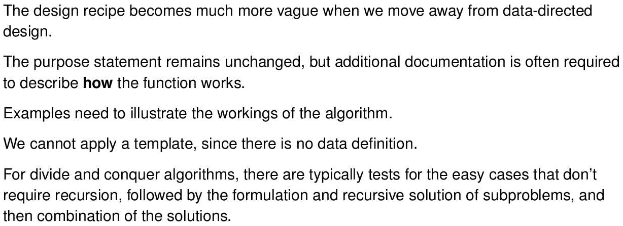
* 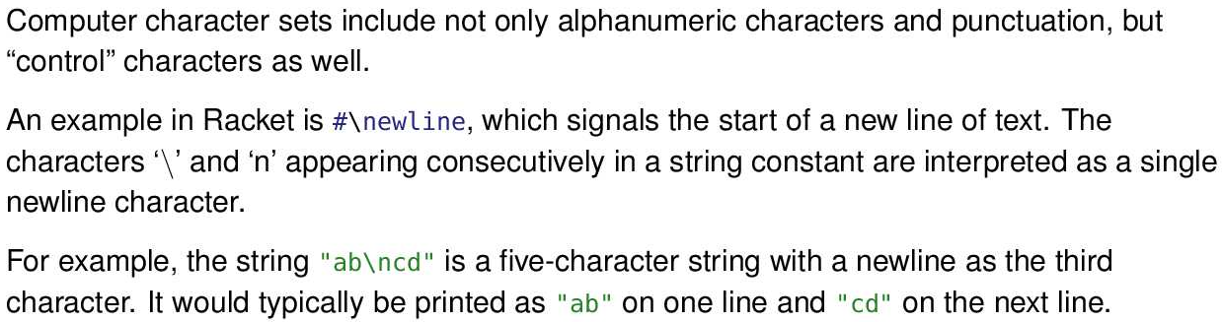
* 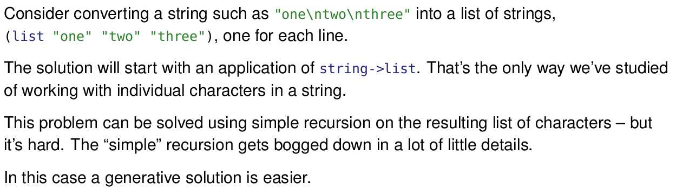
* 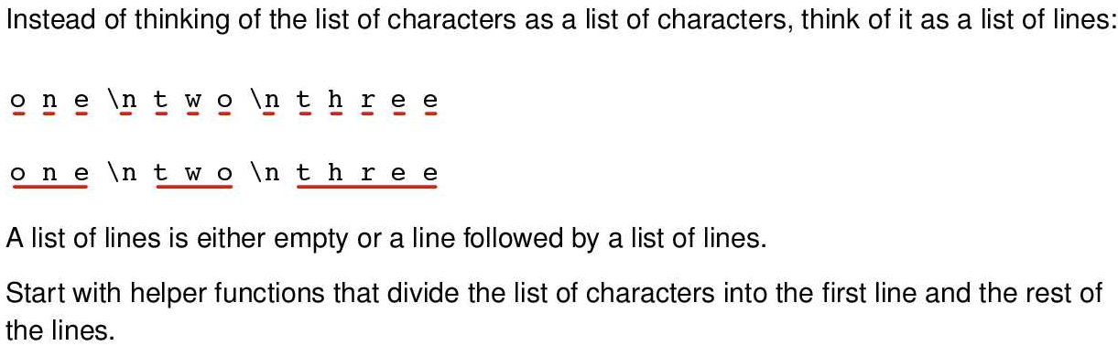
* 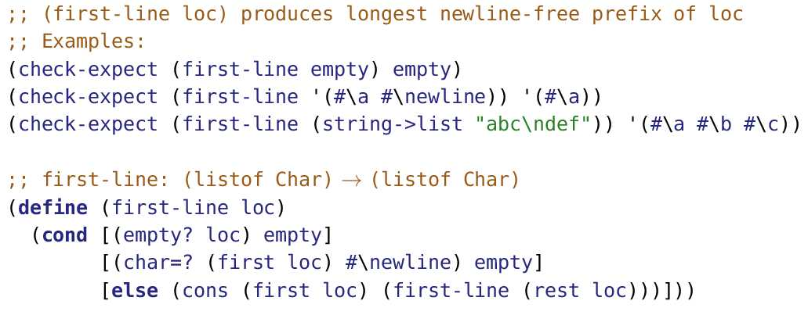
* 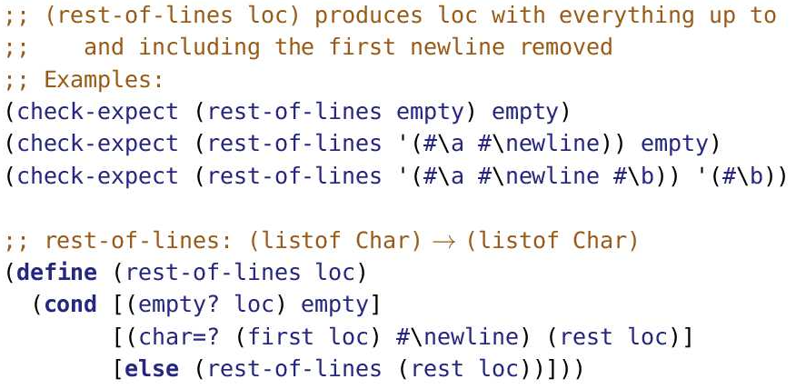
* 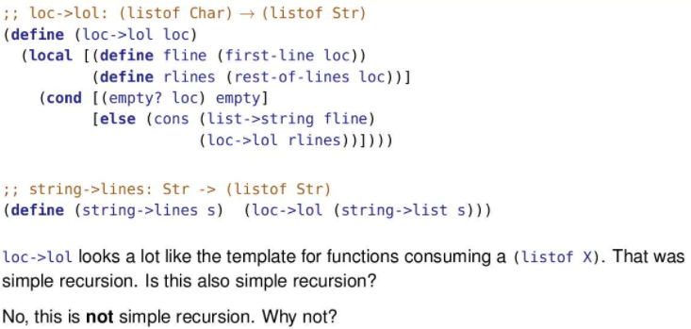
* 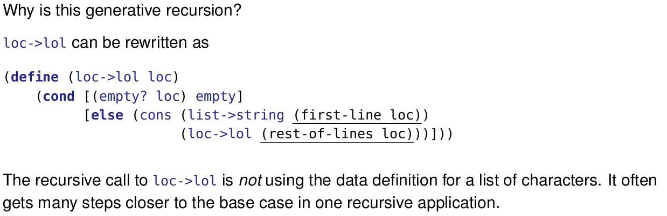
* 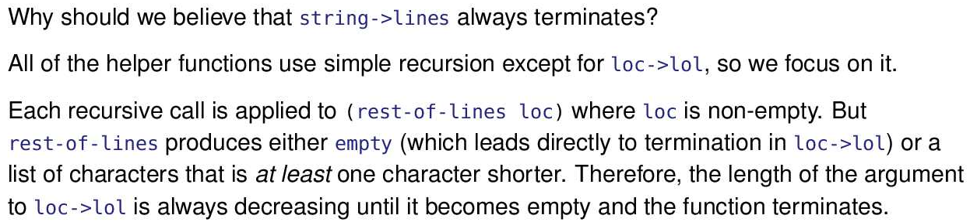

Graphs

* 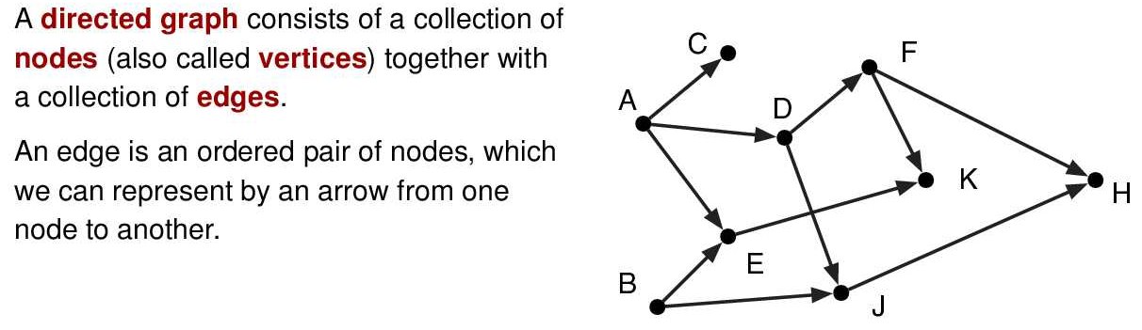
* In a directed graph each edge has a direction (indicated by the head of each arrow). In an undirected graph, edges do not have directions. This module is concerned exclusively with directed graphs.
* 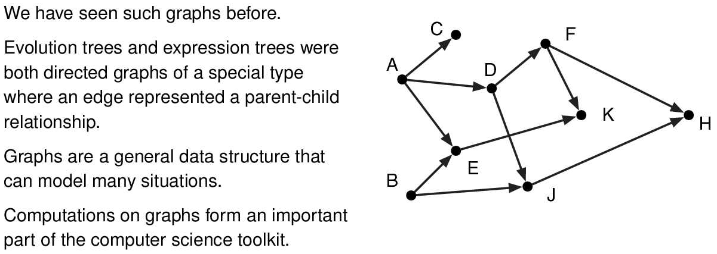
* What kinds of things are modelled with directed graphs? The water pipes in a city. Airline routes. Routes in Google Maps. Social networks of who follows who. Dependencies such as which functions in a program use which other functions or which subtasks must be completed before a specified subtask is begun.
* 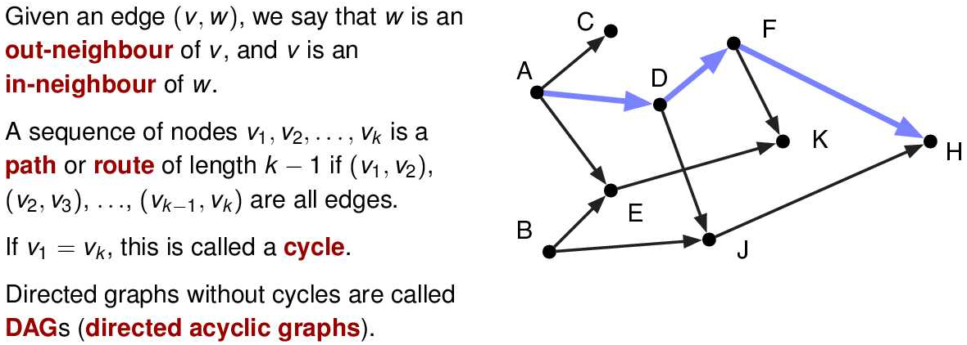
* An edge (v, w) is drawn with an arrow from v to w. For example, (A, C) is an edge in the sample graph but (C, A) is not.
* In the sample graph, E has two in-neighbours (A and B) and one out-neighbour (K).
* One path in the graph is coloured. It is the sequence of nodes (A, D, F, H).
* This particular graph does not have any cycles. However, adding an edge from J to A would be one of many ways to create a cycle. A cycle is simply a path that allows you to go in circles
* 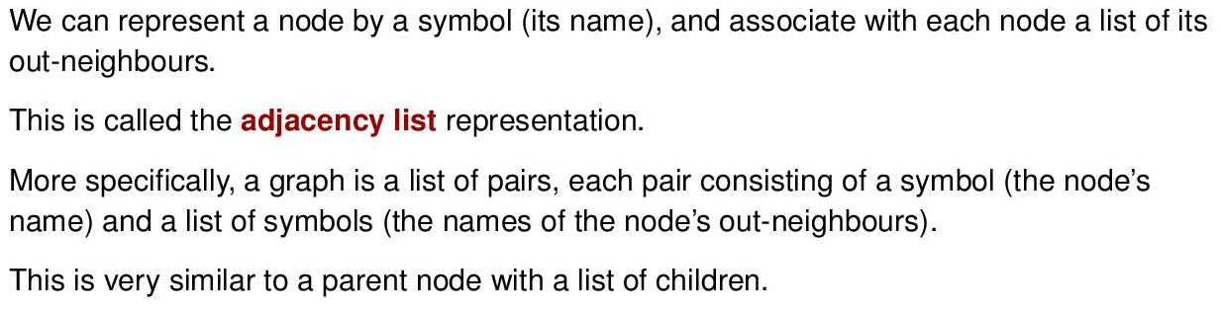
* An adjacency list is a common graph representation, but there are others. They include an “adjacency matrix”, a list of vertices together with a list of edges, etc.
* Ex:
  + 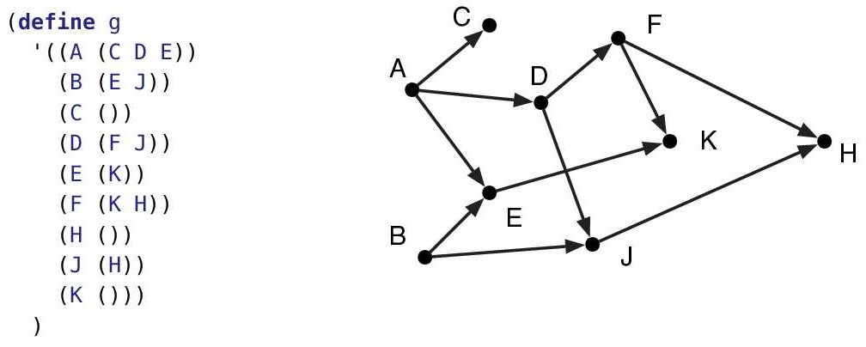
* Data Definition
  + 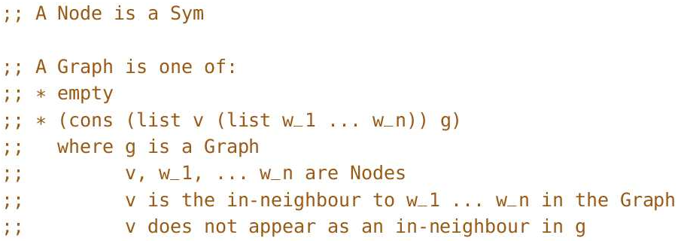
  + Some things to notice about this data definition:
    - A Graph is a (listof X) where X is a two element list, (list v (list w_1 ... w_n)). v is the first element which is a Node (a symbol that represents the node name). (list w_1 ... w_n) is the second element which is a list of Nodes that represents the nodes that are out-neighbours of Node v.
    - The order of the list of symbols (the second element in the pair) does not matter. We often put the lists of nodes - (list w_1 ... w_n) - in alphabetical order, but that’s just a convenience. Thus, (list w_1 ... w_n) and (list w_n w_n-1 ... w_1) are equally valid.
    - The order of the node and its associated out-neighbours in a pair does matter. You must have (list v (list w_1 ... w_n)) and not ((list w_1 ... w_n) list v).
    - The order of the pairs does not matter. Thus (cons (list v (list w_1 ... w_n)) (cons (list v2 (list w2_1 ... w2_n)) empty) is the same as (cons (list v2 (list w2_1 ... w2_n)) (cons (list v (list w_1 ... w_n)) empty).
    - The last requirement is just making sure that each node, v, is only listed once in the list of nodes. Thus, (cons (list v (list w_1 ... w_n)) (cons (list v (list w_1 ... w_n)) empty)) is not possible since (list v (list w_1 ... w_n)) appears twice.
    - Note if a Node is not connected to the main graph, or a Node has no out children, you still have to include that Node. For example, '((B (A)) (C (A D)) (D (A B))) is incorrect to represent the following graph:
      * 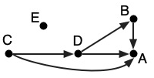
    - A list of two element lists is how we represented an association list, which is a dictionary. We could also represent a graph with other kinds of dictionaries, such as a binary search tree. The keys are the in-neighbours; the values are the lists of associated out-neighbours.
* Template
  + 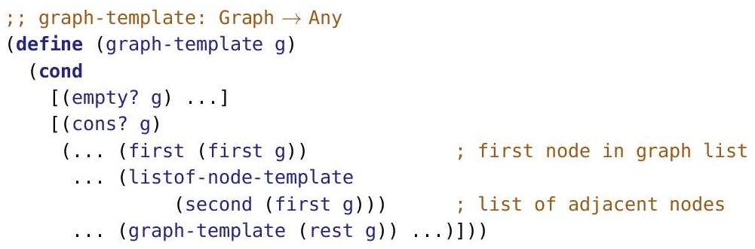
  + The use of (first (first g)) and (second (first g)) in the template and the neighbours function (next slide) is kind of gross. We might consider replacing them with short, one-liners:
  + 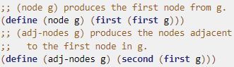
  + 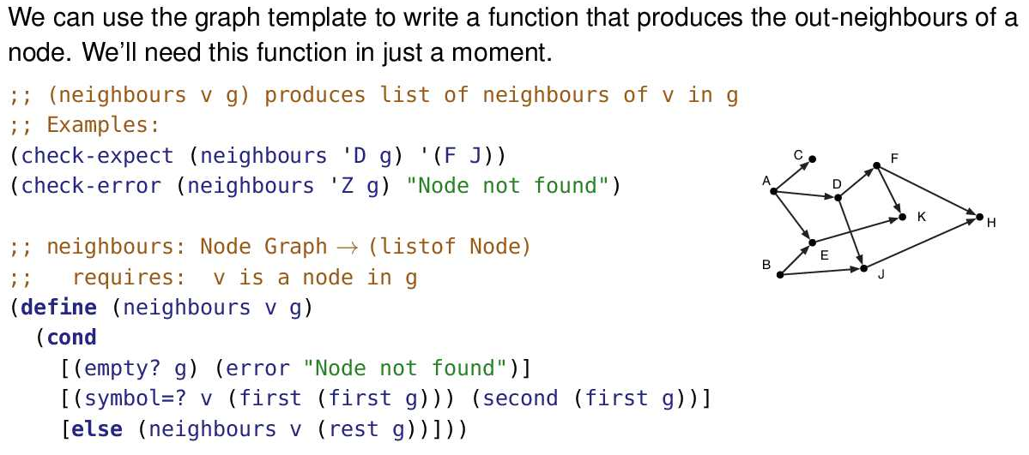
  + The code that will be using neighbours is going to assume that the provided node is in the graph. That’s reflected in the requires statement. In addition to that, we’re programming defensively and producing an error if the requirement fails.
  + We can use higher order functions to implement neighbour
    - 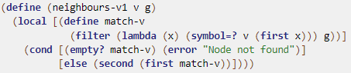
* Ex: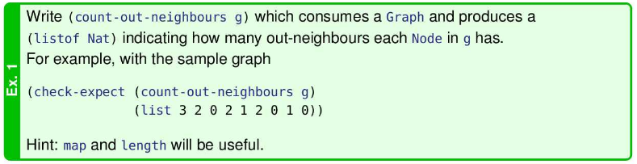
* 
* 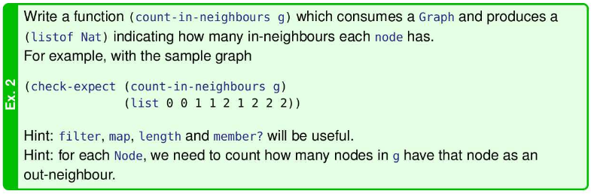
* 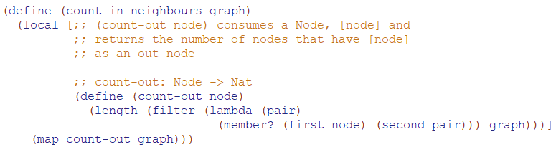

Paths v1

* 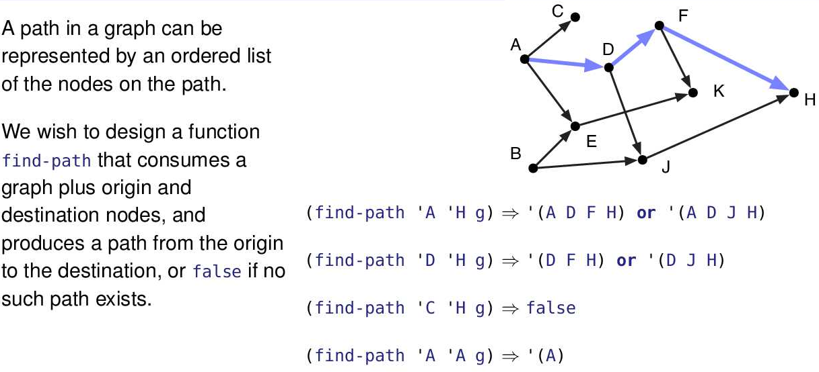
* 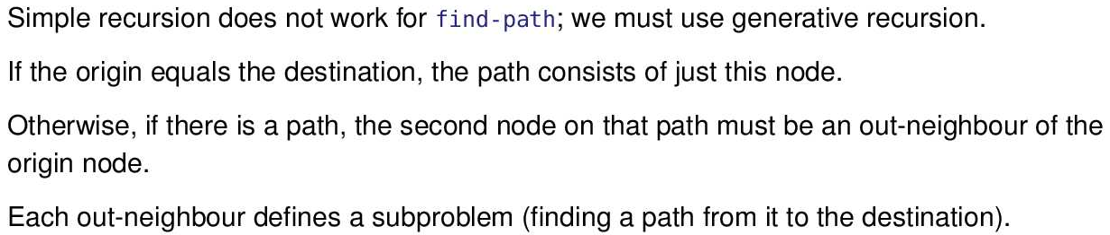
* Why is generative recursion necessary for find-path? It’s because the first step in our journey along the path is to one of the origin’s neighbours. Those neighbours are generated by applying the neighbours function, not the result of getting one step closer to the base case in the data definition.
* 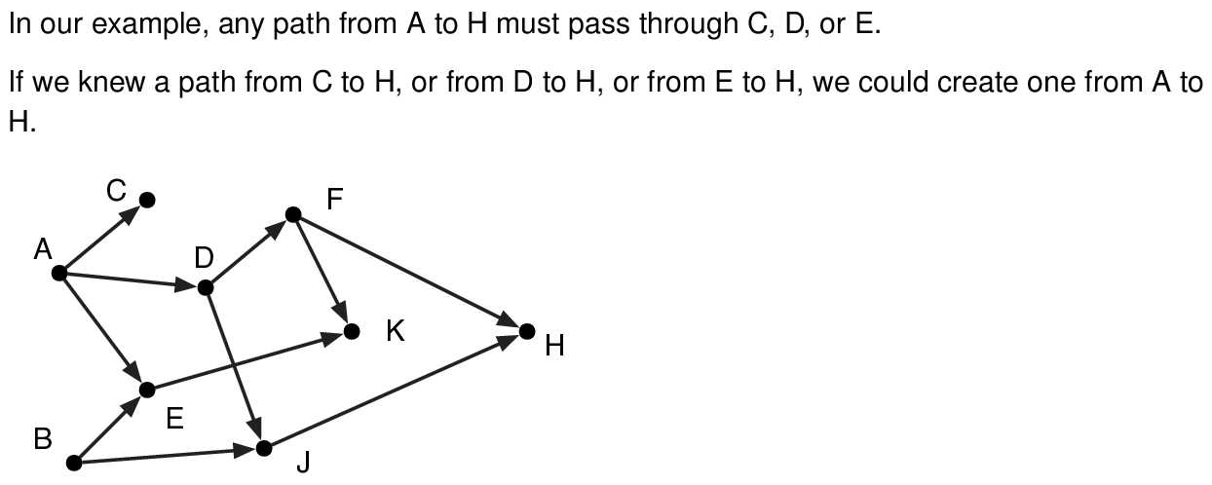
* Backtracking algorithms
  + Backtracking algorithms try to find a path from an origin to a destination.
  + If the initial attempt does not work, such an algorithm "backtracks" and tries another choice.
  + Eventually, either a path is found, or all possibilities are exhausted, meaning there is no path.
  + This isn’t the first time we’ve seen a backtracking algorithm. search-bt-path (slide 19, Module 11) searches for a path in the left side of a binary tree. If it doesn’t find it, it searches “backs up” and searches the right side of the binary tree.
  + 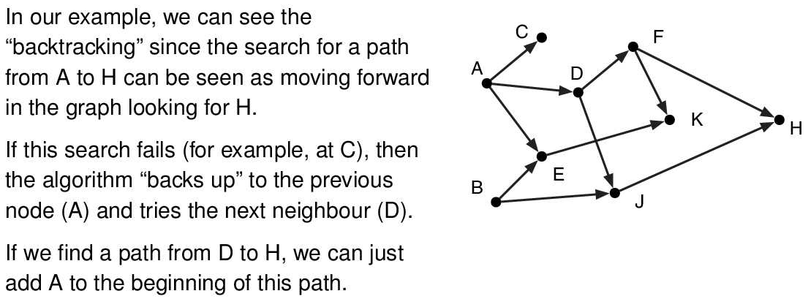
* 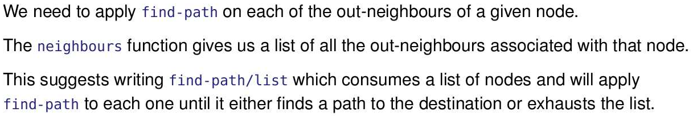
* 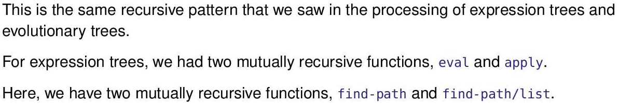
* 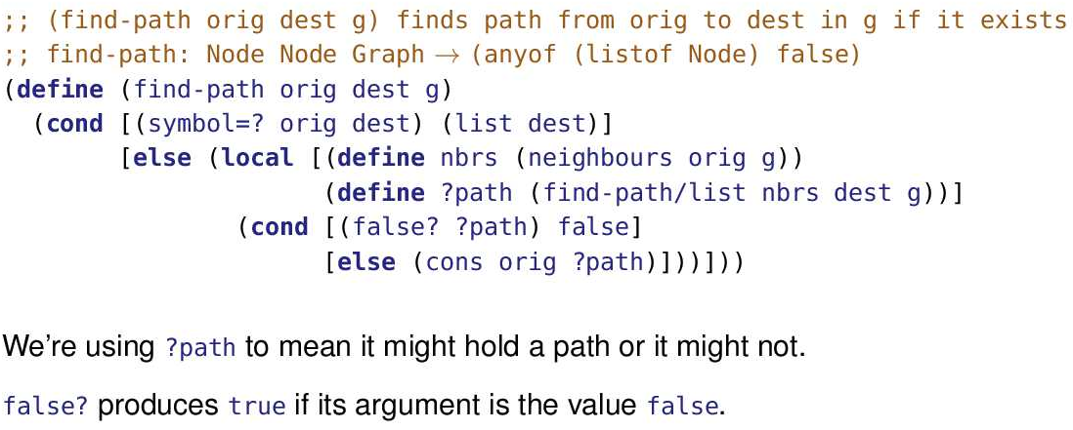
* 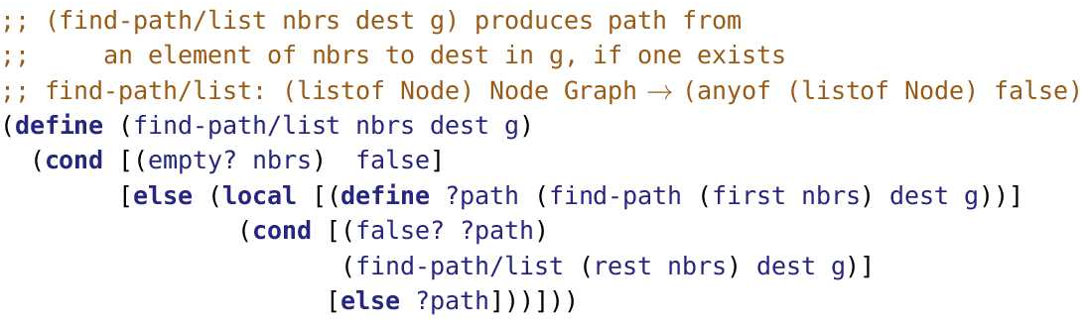
* Tracing
  + 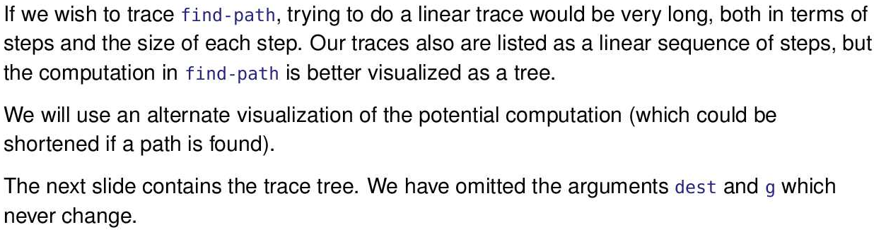
  + 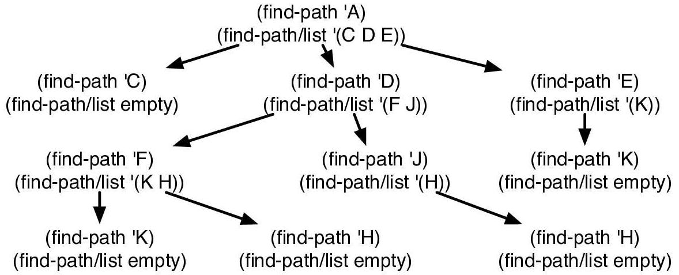
* Backtracking in implicit graphs
  + 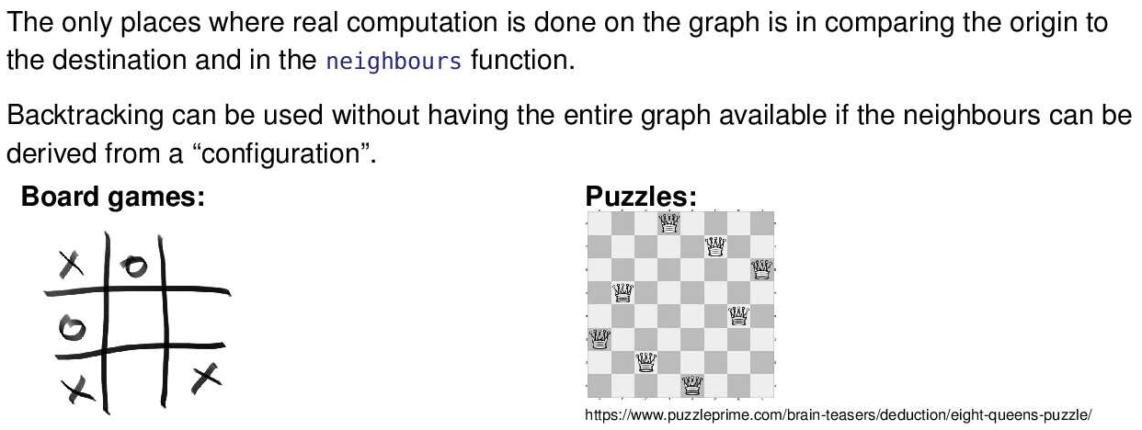
  + Notice in tic tac toe, given any state of the game, we can determine all the possible different games that can result from a current position. These types of games (or graphs) are called implicit graphs
  + 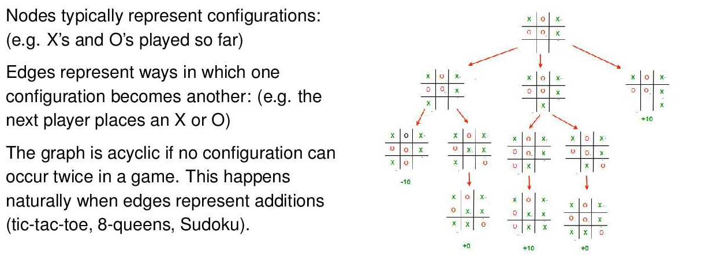
  + 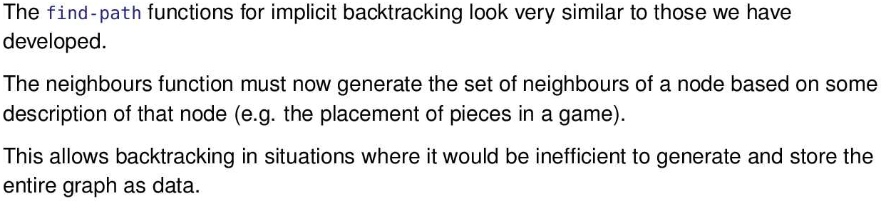
  + Note in our version of find-path, the graph isn’t used that much, it’s only really used to find out what the neighbours of a node are. Thus, we don’t really need the entire graph, we just need a node and an algorithm to figure out its children.

Termination

* find-path will always terminate on a directed acyclic graph. Once a node is considered as the origin, that node will not be considered again (otherwise there would be a cycle). So the problem is smaller. It keeps getting smaller until either you find a path or there are no nodes left and you know there’s no path.
* 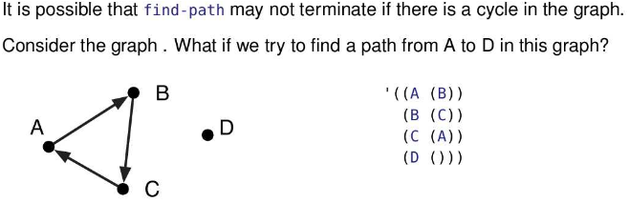
* An application of find-path to a graph with cycles will often terminate. For example, (find-path 'A 'C g) terminates just fine. The problem is that termination is not guaranteed.
* With a cycle, (find-path 'A 'D g) eventually calls (find-path 'A 'D g) again. The algorithm has no memory of having previously searched for a path starting with 'A – so it does it again. And again. And again.
* 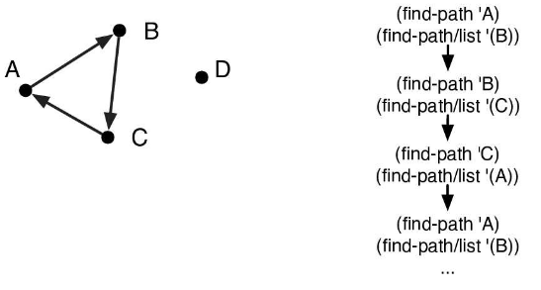
* Finding a path in a graph is like finding a path out of a maze. find-path needs to use the old trick of dropping breadcrumbs so it knows where in the “maze” it has been before. That will be our second version of find-path.

Paths v2

* 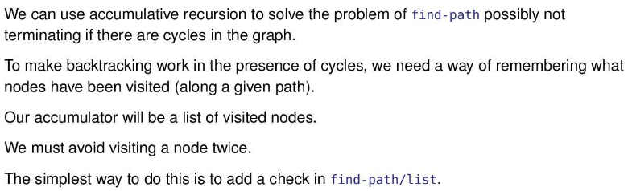
* 
* 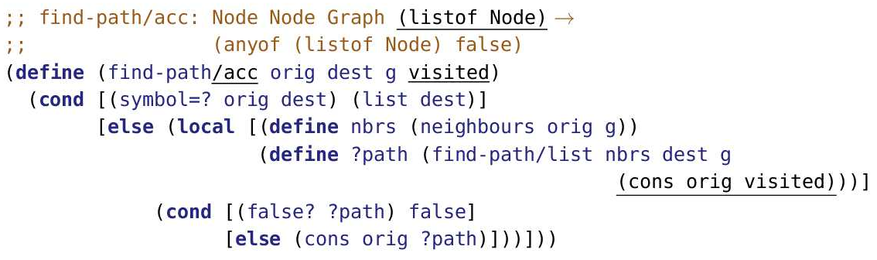
* Notice if the curr node, (origin), does not equal the destination node, we look at origin’s neighbours. We also add origin to the list, visited, to tell find-path/list that we already visited the node.
* find-path/acc is just like find-path in the first version of the algorithm except for the underlined parts:
  + Adding the visited parameter to accumulate the nodes visited so far.
  + Providing visited, updated to include the current origin, to the accumulator for find-path/list.
* Because we’re now using an accumulator that the user of find-path should not need to worry about, we provide a wrapper function with the original name.
* Even though we’re using an accumulator, we would not describe find-path as primarily using the accumulative recursion pattern. The fact that it generates parameters for the next recursive application “trumps” the accumulator, making this generative recursion that happens to also use an accumulator.
* 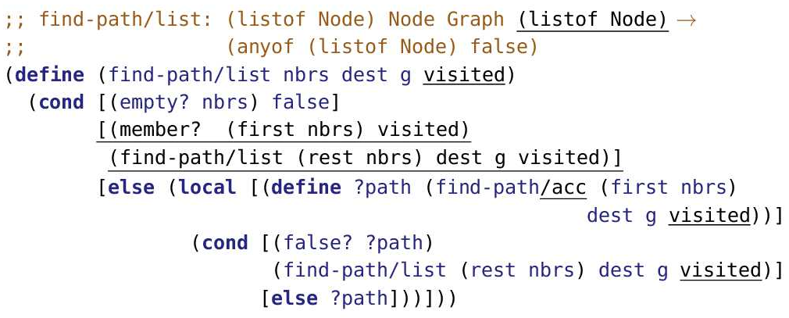
* The underlined parts of the code is what has changed.
* There is a new parameter, visited, which accumulates the nodes that have been visited so far. Those are the breadcrumbs referenced earlier.
* If find-path/list comes to a neighbouring node that we’ve already visited (member? (first nbrs) visited), we simply skip it and go on to the next neighbour on the list.
* 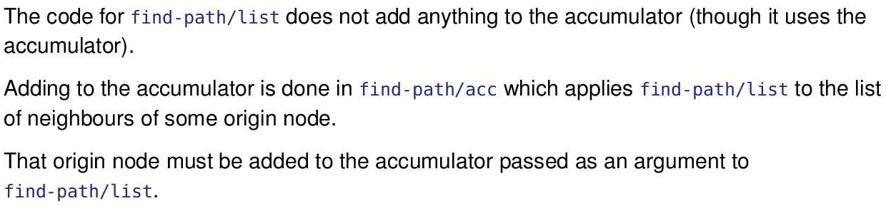

Tracing

* 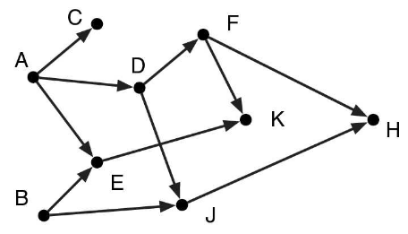
* This is the same example used earlier. We’ll trace the revised algorithm just to make sure we haven’t broken anything that used to work (something called “regression testing”). Then we’ll see if it works on a graph with cycles.
* 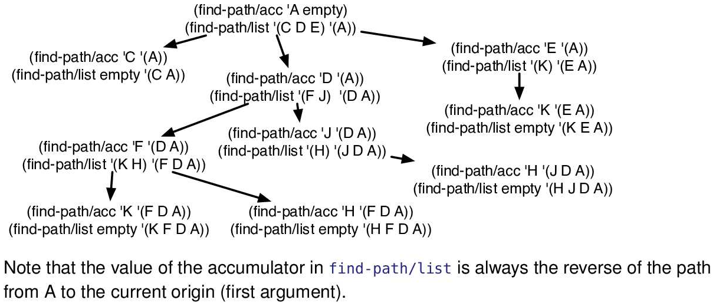
* This is the same trace as before except that it’s been augmented to include the accumulator.
* As noted, the accumulator is always the reverse of the path from the original origin ('A) to the current node. Therefore, if/when we find the destination node, we could simply reverse the accumulator and produce that as the answer.
* 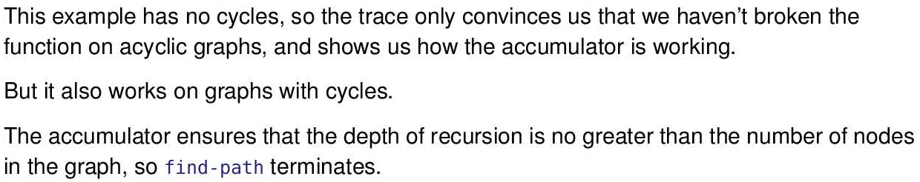
* 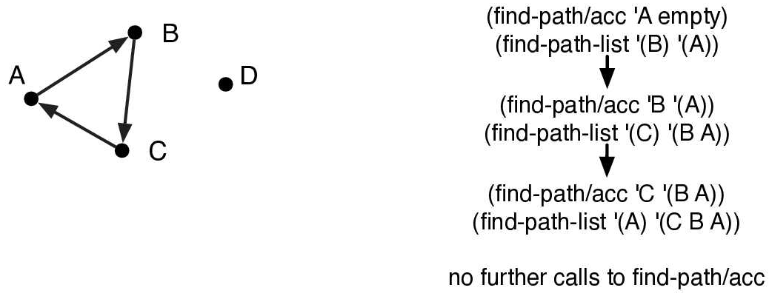
* 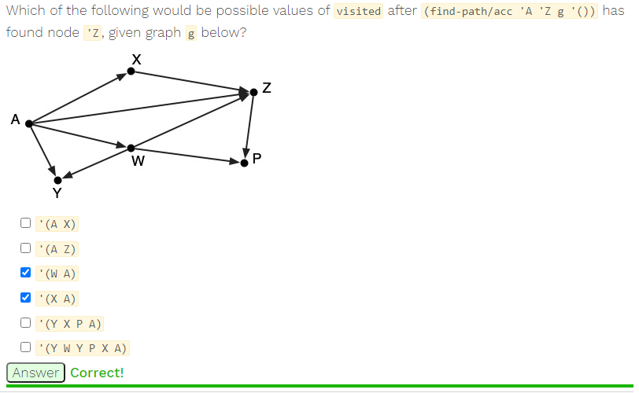
* Notice the first node in visited must be the last node visited, since the reverse of the visited is the path to Z. Thus, the only lists to consider are ‘(W A) and ‘(X A). These two lists are clearly also both valid since A, W,Z and A,X,Z are valid paths, so both are possible.
* 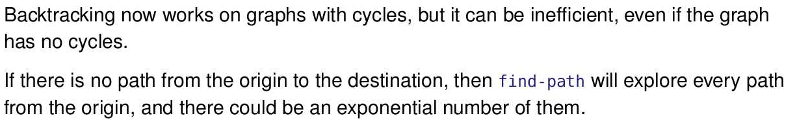
* (IF THE FOLLOWING MEANS DOGSHIT, PATHSV3 EXPLAINS IT)Notice, the program only knows the nodes that we visited in one path. For instance, from one recursive call to another, the accumulator is not kept, thus losing the nodes we visited from one recursive call to the other. When the algorithm backtracks, it forgets the nodes it visited. For example, if we already know F cannot get to the destination and F still has some nodes it leads to, the program will visit the nodes F points to and realize it’s a dead end. However, if we ever reach F again when searching another path, we should stop once we reach F since we already tried it, but the program will still search the nodes F points to and again realize it’s a dead end.

Paths v3: Efficiency

* 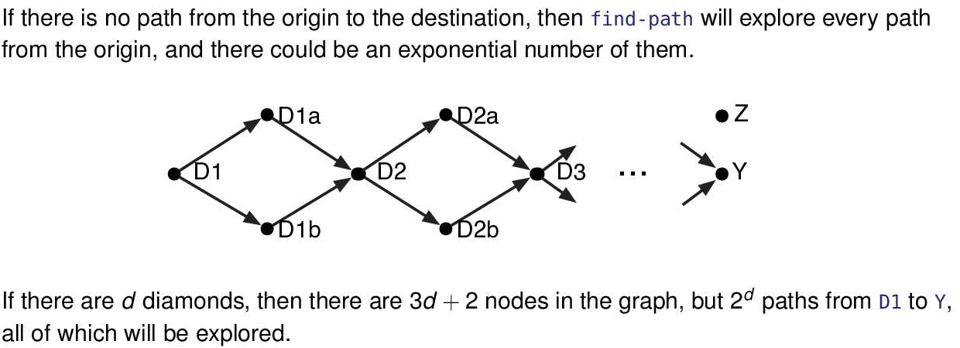
* For example, if the example graph ended at D3, we would have the following 4 paths.
* 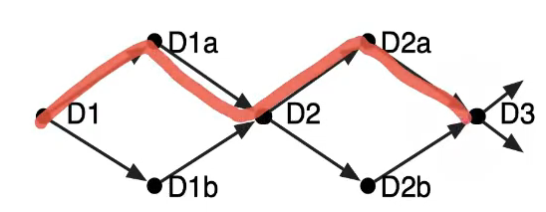
* 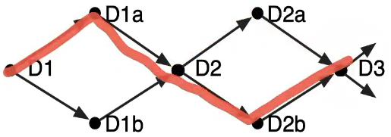
* 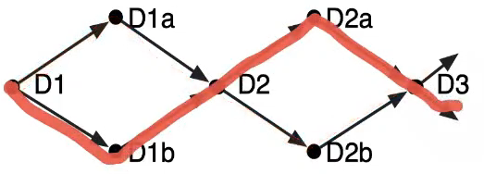
* 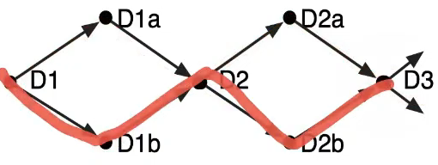
* Notice that find-path v2 simply returns false if it doesn’t find a path. Rather, we want it to return that it didn’t find a path and the nodes that it visited in that search (which means all of those nodes eventually lead to a dead end). Thus, if we ever try a new path and reach a node that was already visited but leads to a dead end, we can just stop there. However, v2 would not know that node leads to a dead end and would research that path, wasting a lot of time.
* The solution to that forgetful accumulator in v2 is to explicitly produce its contents when find-path backtracks. But how do we distinguish failure (which produces a list of the visited nodes) from success (which produces a list of nodes on the path)?
* 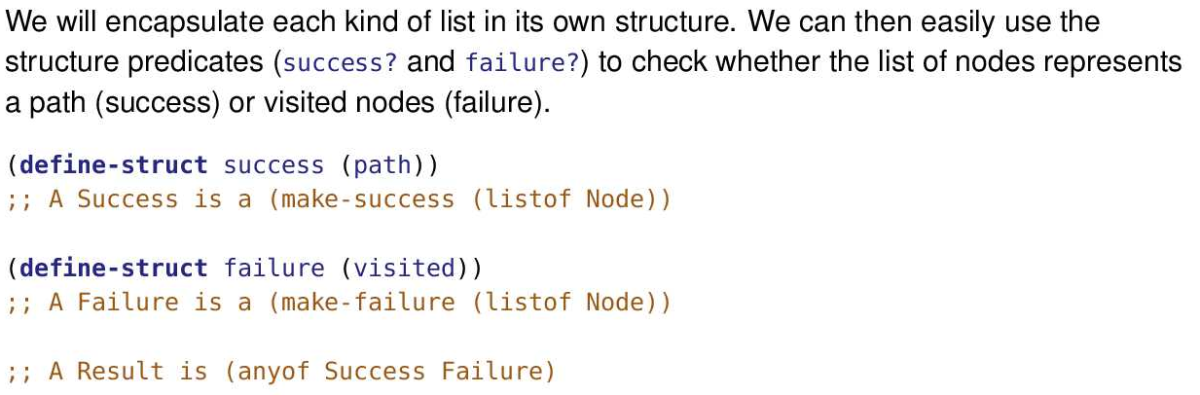
* 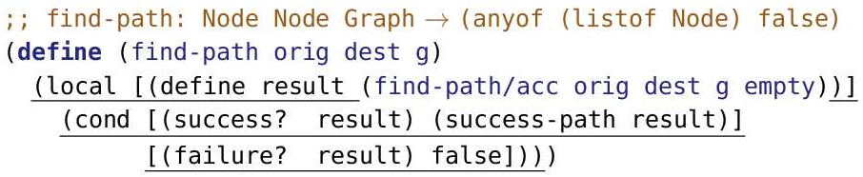
* Notice this wrapper function converts failures into false and success into the list of nodes that represent a path from orig to dest.
* 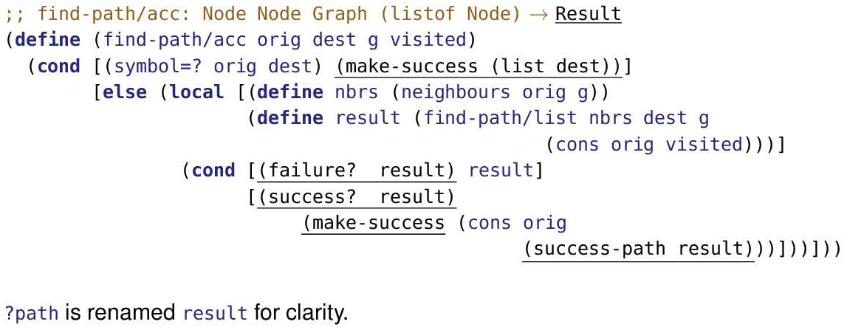
* Notice find-path/acc returns a Result, which is either a success or failure, it no longer returns (anyof false (listof Nodes))
* Notice if we are able to find a path which is the first condition, instead of just returning the list of does that lead to the destination, we wrap those list of nodes in a success structure.
* Notice instead of checking if ?path is false?, we check if result is a failure?. If result is indeed a failure, then we simply return result. Note this means result is a failure structure which contains list of all the does that it visited.
* Notice we do (success? result) which is just notation to make it parallel the failure? Predicate nicely. We could’ve also used else to replace (success? result). If result is a success, that means it is a success structure which contains a list of nodes that represent the path to the destination. We still have to add our current node, origin, onto that list of nodes which is why we (cons orig (success-path result)) make a list of nodes that represents the path to the destination and includes origin. Then we wrap that list in a success and return it.
* 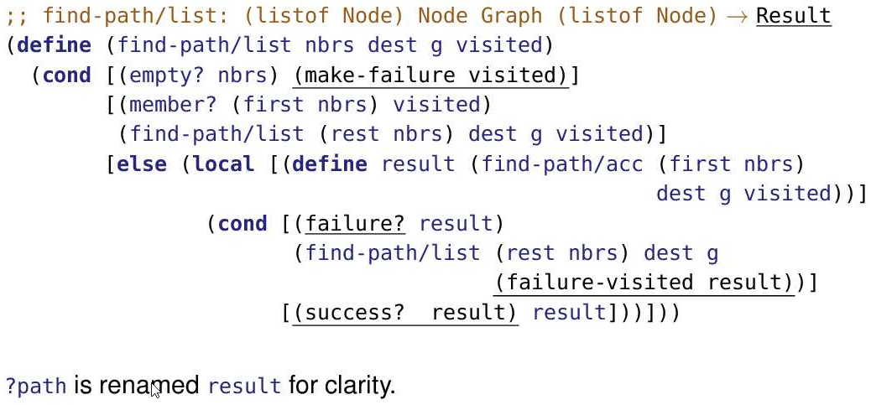
* Notice find-path/list returns a Result, which is either a success or failure, it no longer returns (anyof false (listof Nodes))
* Also, if we fail to find a path (which is the base case), we return a wrap the visited nodes in a failure structure and return that
* Notice we do (failure? result) instead of (false? ?path) since result is a either a failure or success and no longer a true/listof nodes. If the result is a failure, get the visited nodes from the failure structure (failure-visited result) and pass it onto the next application of find-path/list as an accumulator.
* Notice we do (success? result) which is just notation to make it parallel the failure? Predicate nicely. We could’ve also used else to replace (success? result).
* 
 